 |  | TITLE: | ES&H Manual
DOCUMENT ID: | 6141 Appendix T7  Below-the-Hook Lifting Devices

DRAFT
- Purpose

At Jefferson Lab below-the-hook lifting devices (BTHLD) are designed, built, and purchased to perform specific functions. This appendix outlines the requirements for the design, production, use, and modification of these devices.

- Scope

Devices that have not met the requirements of this procedure are to be referred to the Material Handling Safety Representative for inspection, testing, or appropriate use determination.

A BTHLD is not to be used without an appropriate name plate or other permanent marking; nor for anything other than its intended purpose.

Process steps are performed in coordination with ES&H Manual Chapter 6140 Material Handling Equipment Program and ES&H Manual Chapter 6141 Material Handling – Rigging, Cranes, and Hoists.

- Responsibilities
NOTE: Management authority may be delegated at the discretion of the responsible manager.

  - Material Handling Safety Representative (MHSR)
- Maintain records for all approved BTHLD at Jefferson Lab.
- Ensure a load test is performed on all BTHLDs in accordance with DOE Standard 1090-2007: Hoisting and Rigging Standard (Formerly Hoisting and Rigging Manual); Chapter 14 Below-the-Hook Lifting Devices.

  - Qualified Engineer
- Design and produce BTHLDs in accordance with the provisions of ASME B30.20, ASME BTH-1, and Jefferson Lab’s requirements.

  - BTHLD Custodian
- Ensures BTHLD under your authority are maintained, inspected, and used in accordance with this procedure.

- Process Steps

Responsibilities for each process step are outlined within the procedure.

  - Design

It is recommended that the MHSR be contacted prior to commencement of this procedure. Several BTHLD are available in storage which may be adequate for your operation.

- Submit BTHLD Design to Appropriate Engineering Department
    - Submit a draft BTHLD design concept, or description of requirements, to the engineering department.
    - An engineering drawing is developed by a qualified engineer to comply with ASME B30.20, ASME BTH-1, and per department procedures. (See also: Welding and Brazing Program Supplement.)
    - The drawing is reviewed and signed by a second qualified engineer.

- Submit Drawing to MHSR for Approval 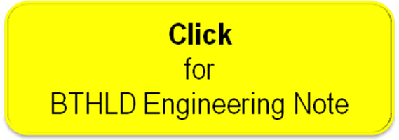

- The Engineer-of-Record – starts a BTHLD Engineering Note (Link to be established upon approval of document), and submit the note and reviewed drawing to the MHSR for approval.
- MHSR – review, and if found to be appropriate, approve the drawing for production.
  - The MHSR retains the note and a copy of the approved drawing on file.

  - Production

Unless otherwise stated the Engineer-of-Record is responsible for the following process steps:

    - Fabrication
- Assign production of the BTHLD to an in-house fabricator, or a qualified vendor (in accordance with ES&H Manual Chapter 6140 Appendix T2 Procurement of Material Handling Equipment).
- Ensure it is produced in accordance with drawing specifications.

    - Approval for Use:

If Produced In-House:
    - Schedule a Load Test with the MHSR. This is to be performed in accordance with DOE Standard 1090-2007: Hoisting and Rigging Standard (Formerly Hoisting and Rigging Manual); Chapter 14 Below-the-Hook Lifting Devices.
- Upon completion of satisfactory test, MHSR will provide a label (see Section 4.5 Labeling below) designating approval for use.

If Produced by Outside Vendor: (In accordance with ES&H Manual Chapter 6140 Appendix T2 Procurement of Material Handling Equipment.)
- Prior to acceptance of the item, schedule a review with the MHSR. Acceptance criteria includes:
  - A qualifying Load Test has been performed, and
  - Item has been properly labeled.

Upon successful completion, or confirmation, of a qualifying load test and acceptable labeling, the BTHLD custodian may take ownership of the device.

  - Maintenance, Inspection, and Use

The BTHLD Custodian is responsible for the following requirements:

- Ensure BTHLD is maintained in usable condition per department procedures.
- Perform appropriate inspections prior to each use. (See ES&H Manual Chapter 6141 Appendix T3 Inspection Procedures – Overhead & Mobile Cranes, Hoists, and Rigging.
- Ensure the BTHLD is used only for its intended purpose.

  - Alterations to BTHLD

Jefferson Lab recognizes that from time to time a BTHLD may require repair, modification, or be assigned a task other than its intended purpose. When this happens it must be designed, reviewed, approved, and produced, as if it were new.

  - Labeling

If Produced In-House: The following label (example noted below) is attached to, or otherwise denoted on, the device.

Example of Approved BTHLD Label
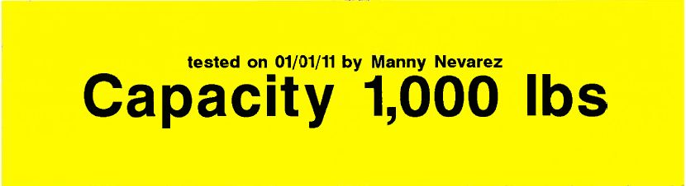

If Produced by Outside Vendor: The following information is minimally required to be attached to, or otherwise denoted on, the device:

- Manufacturer’s Name
- Manufacturer’s Address
- Serial Number
- Lifter Weight, if over 100lbs (45kg)
- Rated Load

- Revision Summary

Revision 0 – ##/##/## – This is new content.



 | ISSUING AUTHORITY | TECHNICAL  POINT-OF-CONTACT | APPROVAL DATE | EXPIRATION DATE | REV.
 | ESH&Q Division | Dave Kausch
This document is controlled as an on-line file. It may be printed but the print copy is not a controlled document. It is the user’s responsibility to ensure that the document is the same revision as the current on line file. This copy was printed on 7/30/2026.

