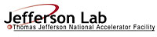 |  | TITLE: | ES&H Manual
DOCUMENT ID: | 6610 Appendix T8  Chemical Waste Control
DRAFT

Jefferson Lab has determined that working with hazardous materials carries an unmitigated Risk Code >2. At a minimum all tasks requiring hazardous materials are discussed with the supervisor prior to commencement of work. An Operational Safety Procedure (OSP) is written for work considered to be Risk Code >2 in accordance with ES&H Manual Chapter 3210 Work Planning, Control, and Authorization Process.

- Purpose

To ensure the health and safety of individuals, equipment, and the environment, chemical waste at Jefferson Lab is managed responsibly and in accordance with applicable federal, state, and local requirements. This appendix defines the process steps for determining if a chemical waste is being generated; obtaining appropriate containment; and ensuring storage and safe handling prior to disposal.

- Scope

This appendix does not apply to:
- Scrap Metal – Contact Property Management (x5430)
- Recyclable Material – Contact Property Management (x5430)
- Radioactive Material – Contact Radiation Control Department
- General Refuse – Contact Property Management (x5430)
- Medical Waste – Contact Occupational Medicine

The process steps for this procedure are performed in coordination with ES&H Manual Chapter 6610 Chemical Hygiene Program.

- Responsibilities
NOTE: Management authority may be delegated at the discretion of the responsible manager.

  - Anyone at Jefferson Lab
- Determine if you are generating a chemical waste. Request an equipment/area hazard evaluation from Industrial Hygiene if you have concerns.

  - Qualified Chemical Worker
- Receive and maintain waste training appropriate to the chemical waste being generated.
- Contain and store chemical waste in accordance with training requirements.

  - Hazardous Waste Coordinator
- Ensure that chemical waste is managed and controlled in accordance with applicable laws, rules, and regulations.
- Set-up appropriate collection points for chemical waste, this includes appropriate training.
- Remove and dispose of chemical waste in accordance with Industrial Hygiene Department procedures.

- Process Steps

Unless otherwise stated anyone at Jefferson Lab may perform the process steps as listed below:

- Determination
Request a hazard evaluation from Industrial Hygiene to identify if a chemical waste is being generated. Areas of concern include:
- Unwanted, unusable, unnecessary hazardous material.
- End of process chemicals.
- Chemicals obtained outside the authorized procurement process. (See ES&H Manual 6610 Appendix T2 Chemical Requisitioning and Receiving – Section 4.4.)

- Set-up Appropriate Containment
Contact the Hazardous Waste Coordinator to set up an appropriate collection point for the chemical waste identified. Set-up includes:
- Appropriate training for authorized individuals.
- Proper containment.
- Storage, removal, and disposal procedures.

- Storage and Disposal
Abide by the storage requirements and time limits.
- Store chemical waste in designated area per training and requirements.
- Contact the Hazardous Waste Coordinator for removal and disposal, per training requirements.

- Revision Summary

Revision 0 – ##/##/## – This is new material.

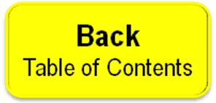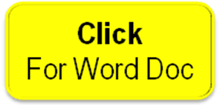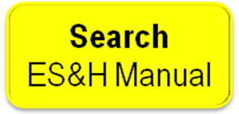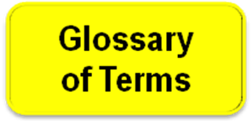

 | ISSUING AUTHORITY | TECHNICAL  POINT-OF-CONTACT | APPROVAL DATE | EXPIRATION DATE | REV.
 | ESH&Q Division | Jennifer Williams |  |  | 0
This document is controlled as an on-line file. It may be printed but the print copy is not a controlled document. It is the user’s responsibility to ensure that the document is the same revision as the current on line file. This copy was printed on 7/28/2026.

