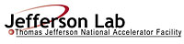 |  | TITLE: | ES&H Manual
DOCUMENT ID: | 6680 Appendix T2  Lead Handling Personal Protective Equipment (PPE) and Other Related Personal Protective Measures

DRAFT

Jefferson Lab has determined that working with lead carries an unmitigated Risk Code >2. At a minimum all tasks requiring lead are discussed with the supervisor prior to commencement of work. An Operational Safety Procedure (OSP) is written for work considered to be Risk Code >2 in accordance with ES&H Manual Chapter 3210 Work Planning, Control, and Authorization Process.
- Purpose

This appendix provides information regarding the minimum personal protection equipment (PPE) and associated control measures to be utilized during work activities. Information includes how to:

- Determine the appropriate protective measures, and
- Obtain it/them.

- Scope

This document addresses minimum PPE required for the safe handling of lead, be aware that other items may be required to address associated work activities (e.g. heavy lifting, fire prevention).

The process steps for this procedure are performed in coordination with ES&H Manual Chapter 6680 Lead Handling Program (Link to be established upon approval of document.) and ES&H Manual Chapter 6620 Personal Protective Equipment Program

- Responsibilities
NOTE: Management authority may be delegated at the discretion of the responsible manager.

  - Qualified Lead Handler
- Abide by these minimum protective measures when working with lead.

Consult with Jefferson Lab Occupational Medicine if you have an exposed wound.

  - Supervisor/Subcontracting Officer’s Technical Representative (SOTR)/Sponsor
- Ensure appropriate PPE is available and used during lead handling operations.

  - Industrial Hygiene
- Perform lead work, equipment, and area hazard evaluation and determine required mitigation.

- Process Steps

Unless otherwise stated, only Qualified Lead Workers may perform the process steps outlined below.

Individuals must not leave the workplace wearing any required protective clothing or equipment.

  - Appropriate PPE for Work Activities

Note: Lead work that exceeds Permissible Exposure Limits (PEL) is considered by Jefferson Lab to be a Risk Code >2, and therefore requires an OSP, in accordance with ES&H Manual Chapter 3210 Work Planning, Control, and Authorization Process. Contact Industrial Hygiene before moving >10 bricks for a determination. A changing area is required and equipped with separate storage facilities to protect street clothes from cross-contamination.

    - Brick Movement

      - Less than or equal to (<) 10
    - Gloves: Made of impermeable material (e.g. leather or rubber).
    - Shoe Coverings: Safety shoes may be recommended. See ES&H Manual Chapter 6620 Personal Protective Equipment Program.
    - Respiratory Protection: Voluntary use. See ES&H Manual Chapter 6630 Respiratory Protection Program for information and requirements.

      - More than (>)10
        - Contact Industrial Hygiene
        - Disposable Body Covering: Jacket, pants, or overalls (Tyvek or equivalent).
        - Gloves: Made of impermeable material (e.g. leather or rubber).
        - Shoe Coverings: Safety shoes may be recommended. See ES&H Manual Chapter 6620 Personal Protective Equipment Program.
        - Respiratory Protection: Required. See ES&H Manual Chapter 6630 Respiratory Protection Program for information and requirements.

    - Machining
- In accordance with Work Control Document.

    - Soldering
- Safety Glasses

  - Post-Work Activities
- Disposal and Recycle – Perform activities in accordance with ES&H Manual Chapter 6680 Appendix T4 Lead Clean-up Procedures (Link to be established upon approval of document.)
- Clean-Up – Wash all exposed skin surfaces (hands, face, arms, legs) thoroughly with soap and warm water.

- Revision Summary

Revision 1- ##/##/## -Updated to reflect current laboratory operations.

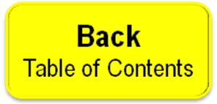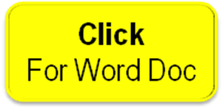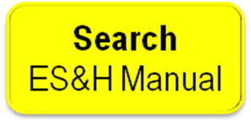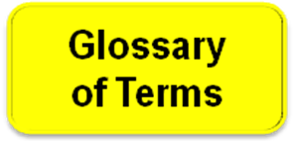

 | ISSUING AUTHORITY | TECHNICAL  POINT-OF-CONTACT | APPROVAL DATE | EXPIRATION DATE | REV.
 | ESH&Q Division | Jennifer Williams |  |  | 1
This document is controlled as an on-line file. It may be printed but the print copy is not a controlled document. It is the user’s responsibility to ensure that the document is the same revision as the current on line file. This copy was printed on 7/28/2026.

PEL <0.05mg per cubic meter of air averaged over an 8-hour period (see OSHA 1910.1025 Toxic and Hazardous Substances)

