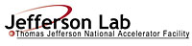 |  | TITLE: | ES&H Manual
DOCUMENT ID: | 6680 Appendix T3  Lead Use and Storage Areas –  Including Posting Requirements

- Purpose

Jefferson Lab recognizes that an area where lead, and its associated apparatus, is used and stored is considered a hazard issue. This appendix defines Jefferson Lab’s minimum lead work and storage area requirements, including postings and labels.

- Scope

It is recognized that listing the requirements for every activity involving lead at Jefferson Lab would be prohibitive, it is therefore required that Qualified Lead Workers read and follow the requirements/recommendation listed on associated Material Safety Data Sheet(s) for the material and any additional activities outlined on the associated Task Hazard Analysis or Work Control Document.

The process steps for this procedure are performed in coordination with ES&H Manual Chapter 6680 Lead Handling Program (Link to be established upon approval of document.)

- Responsibilities
NOTE: Management authority may be delegated at the discretion of the responsible manager.

  - Qualified Lead Worker
- Request an equipment/area hazard evaluation from Industrial Hygiene if compliance with these requirements is unclear.

  - Supervisor/Subcontracting Officer’s Technical Representative (SOTR)/Sponsor
- Ensure lead work and storage areas meet the requirements of this program.

  - Industrial Hygiene
- Perform equipment/area hazard evaluations and provide postings as appropriate.

- Process Steps

Unless otherwise stated the Qualified Lead Worker performs the process steps stated below.

  - Lead Area Requirements:

    - Soldering Station:
- Soldering mat.
- Approved cleaner and wipe clothes.
- Dedicated lead recycling container.
- No food or drink.
- Soldering posting (see Example 1 below).

Example 1 – Lead Solder Work Area Notice Sign
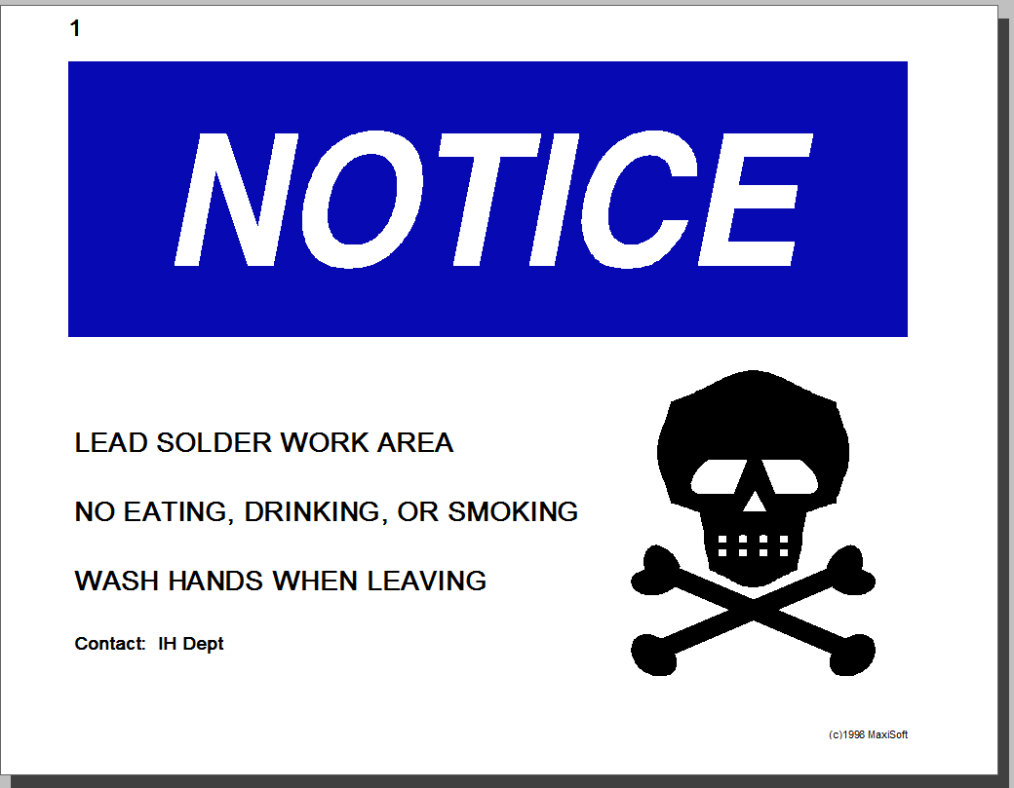

    - Area Where Lead is In-Use (i.e.: shielding)
- Posting (see Example 2 below).

Example 2 – Lead Shielding Area
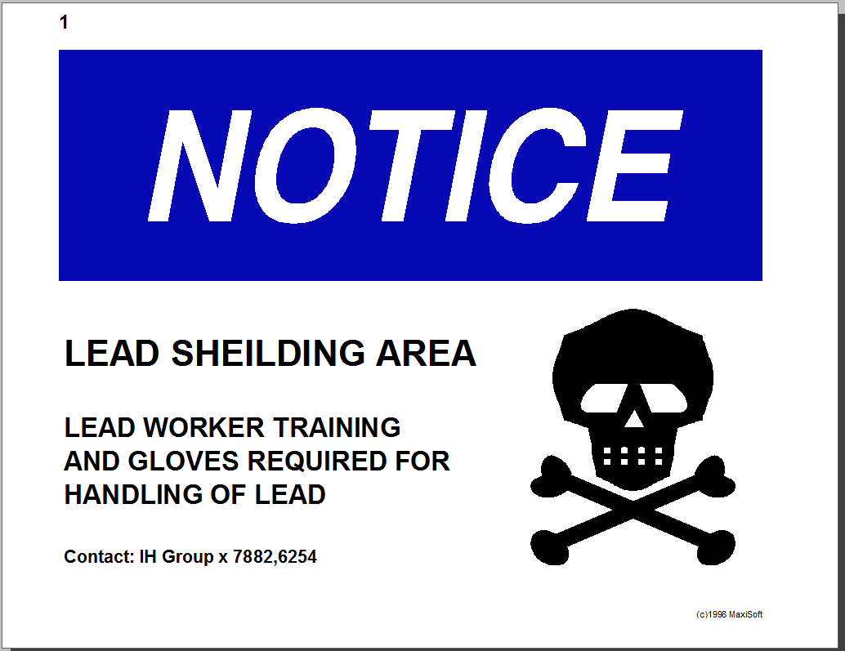

    - Area Where Lead is Being Worked On (i.e.: machining lead or moving of shielding) (Contact Industrial Hygiene for a Hazard Evaluation if air concentrations are in doubt.)

      - Concentration of Lead in Air <0.05mg per cubic meter (mg/m³)
- Surface covering (plastic sheet, cardboard, etc.).
- Cleaner and wipe clothes.
- Hazardous waste container.
- HEPA Vacuum – If more than 10 bricks are included in work scope.
- No posting requirements.

      - Concentration of Lead in Air >0.05 mg/m³
- Posting (see Example 3 below)
- Barricade (rope, cones, etc.) minimum five-foot clearance.
- Surface covering (plastic sheet, cardboard, etc.)
- Cleaner and wipe clothes.
- Hazardous waste container.
- HEPA Vacuum.
- Changing area including shower.
- Dedicated Lead Clothing Hamper (see Example 4 below).

Example 3 - Lead Work Area Warning Sign
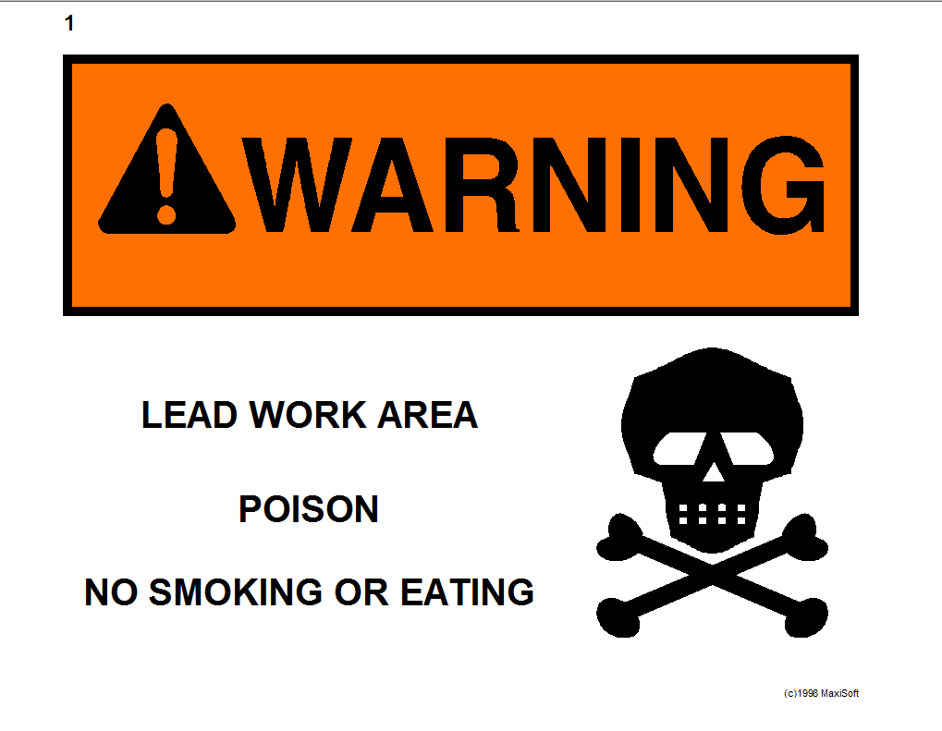

Example 4 - Lead Contaminated Clothing Caution Sign
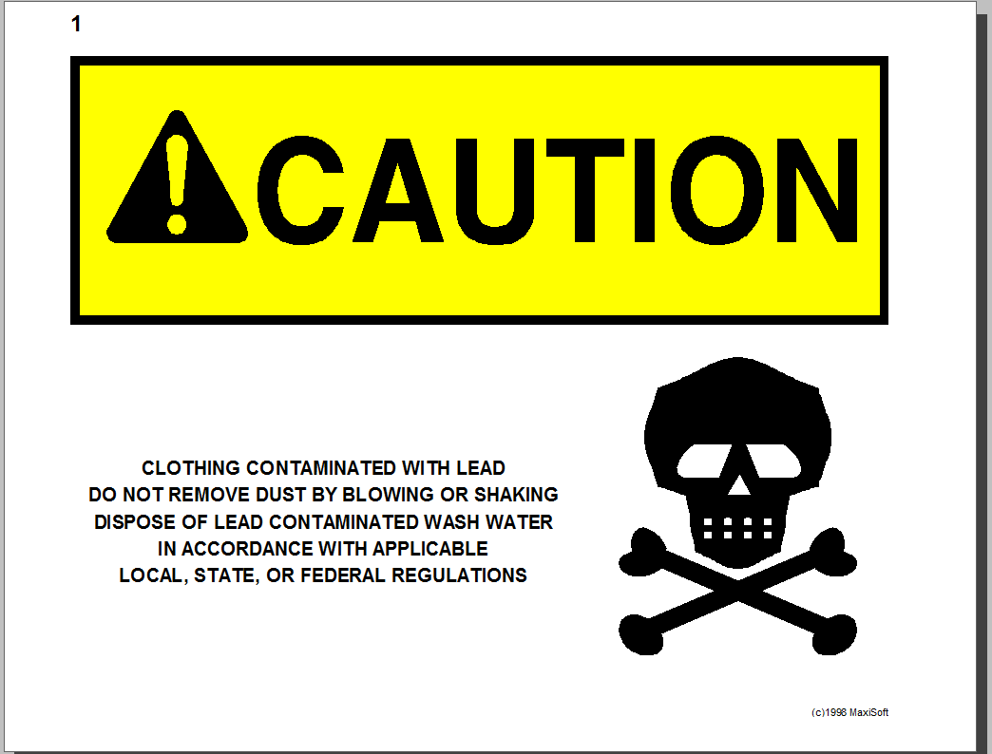

  - Short-Term* Lead Storage
*Long-Term Lead Storage is located in the Lead Storage Building (Building No. 95A). Contact the Stockroom to check lead in or out.

    - Indoor Lead Storage

- Prevent Cross-Contamination.
- No direct floor contact. (Use plastic sheeting)
- If uncoated lead - Cover with fire-retardant material.

- Keep away from drainage routes.

- Post area with notice signs (see Example 4 below).

Example 5– Lead Storage Area Notice Sign
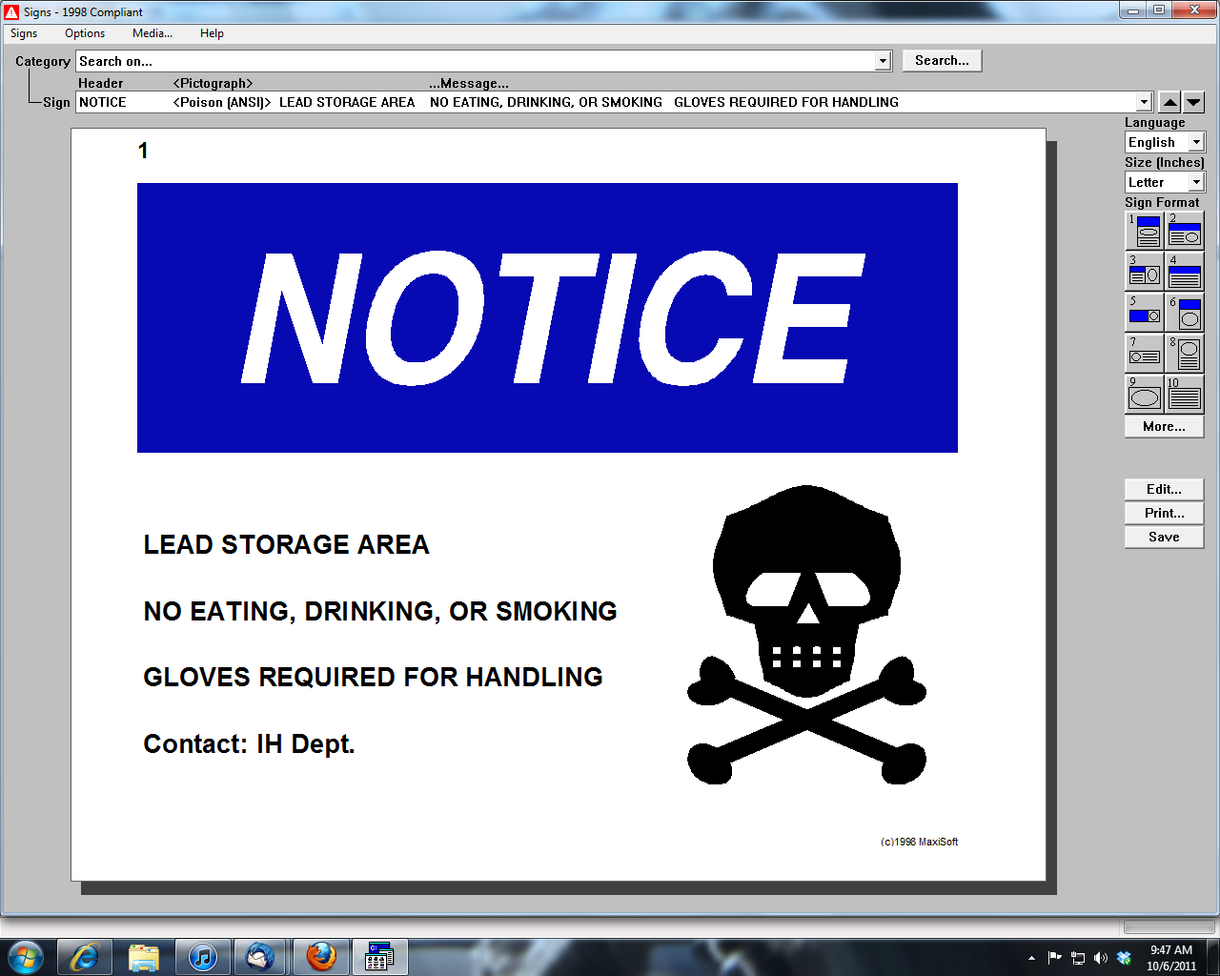

    - Outdoor Lead Storage

Outdoor storage is discouraged at Jefferson Lab and only used as a temporary measure. For extended storage issues contact the Property Manager.

- Ensure storage location is away from drainage routes.

- No direct ground contact. (Use pallets or similar)

- Cover lead completely with tarp(s) (waterproof material) to ensure there is no contact with water (rain or otherwise).

- Post signage visibly to ensure adequate segregation. (See example below.)

  - Equipment and Manufacturer’s Labels

- Do not remove manufacturers’ equipment label.
- Read and follow manufacturer’s recommendations.

  - Update, Repair, or Maintenance

Anyone at Jefferson Lab may request hazard evaluation for a new, update, repair, or maintenance to a lead work or storage area.

- Contact Industrial Hygiene and identify the area needing review.
  - If it is determined that the area is defective, Industrial Hygiene will notify the owner and provide solutions to rectify situation.
  - If no hazard is found – Industrial Hygiene will inform the concerned party(s) of the determination.

- Revision Summary

Revision 1 – ________ – Updated to reflect current laboratory operations.

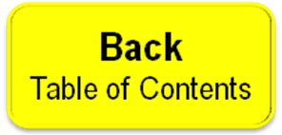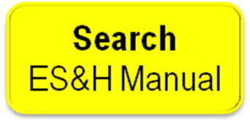

 | ISSUING AUTHORITY | TECHNICAL  POINT-OF-CONTACT | APPROVAL DATE | EXPIRATION DATE | REV.
 | ESH&Q Division | Jennifer Williams | 06/18/04 |  | 1
This document is controlled as an on line file. It may be printed but the print copy is not a controlled document. It is the user’s responsibility to ensure that the document is the same revision as the current on line file. This copy was printed on 7/28/2026.

