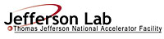 |  | TITLE: | ES&H Manual
DOCUMENT ID: | 6680 Appendix T4  Lead Clean-Up, Disposal, and Recycle Procedures

DRAFT
- Purpose

This appendix describes the accepted method for lead clean-up; and associated disposal or recycle methods. Jefferson Lab only authorizes the following clean–up activities:

- Surface Wipe Down: tools, equipment, floors, soldering or other surface cleaning.
- Vacuuming: Using HEPA vacuum

- Scope

Clean-up activities described include methods that do not allow lead particulates to become airborne, as this is prohibited at Jefferson Lab.

Contact Industrial Hygiene concerning disposal of lead and lead-contaminated material.

Dry sweeping, scraping, or compressed air, may cause lead particles to become airborne. Operations, other than those listed above, are considered to have a Risk Code >2 and require a Work Control Document.

The process steps for this procedure coordinate with ES&H Manual Chapter 6680 Lead Handling Program (Link to be established upon approval of document.)

- Responsibilities
NOTE: Management authority may be delegated at the discretion of the responsible manager.

  - Qualified Lead Handler
- Abide by clean-up procedures listed below when working with lead.

  - Supervisor/Subcontracting Officer’s Technical Representative (SOTR)/Sponsor
- Ensure appropriate clean-up procedures are incorporated into work plan and performed to prevent lead from becoming airborne.

  - Industrial Hygiene
- Provide regulatory compliant clean-up training, supplies, and equipment (e.g.: wipes, impermeable containers, HEPA vacuums).

- Process Steps

Unless otherwise stated the Qualified Lead Worker performs the process steps stated below.

  - Clean-up Procedures:

    - Surface Wipe Down

- Prior to commencement of work – obtain from Industrial Hygiene:
      - Training
      - Wet-Wipes (also available from the Stockroom)
      - Cleaning agents

- Upon completion of work, use appropriate cleaning supplies and techniques to wipe down the work surface, or in compliance with training.

- Dispose of used cleaning supplies in standard waste receptacle, or in accordance with training.

    - Vacuuming:

- Prior to commencement of work – obtain from Industrial Hygiene:
      - Training
      - HEPA vacuum cleaner
      - Impermeable container

- Upon completion of work – use HEPA vacuum to clean the work surface in compliance with training.

- Collect in the impermeable container:
- All used clean-up material
- Used work-related PPE, and
- Other disposables personal protective measures. (See ES&H Manual Chapter 6680 Appendix T2 Lead Handling Personal Protective Equipment (PPE) and Other Related Personal protective Measures Link to be established upon approval of document.)).

- Seal and label the impermeable container
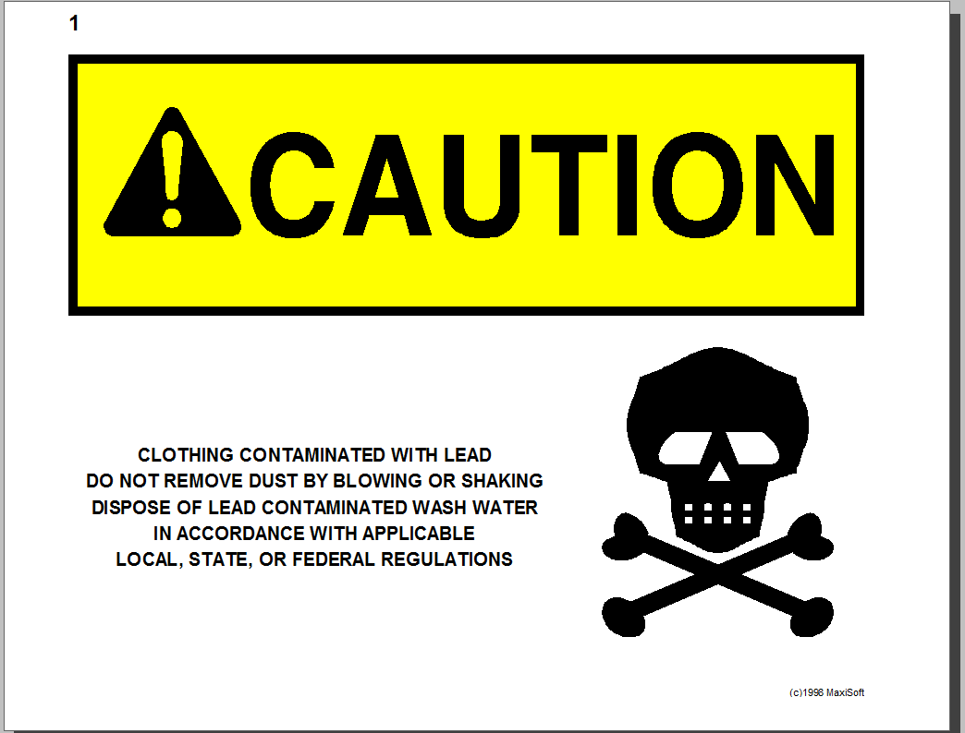
- Return HEPA vacuum and secured impermeable container to Industrial Hygiene.

  - Disposal of Other Lead Contaminated Items

Contact Industrial Hygiene for instructions regarding the disposal of lead and lead contaminated material such as:
- Rinse water used to clean lead parts.
- Used solder mats.
- Debris from machining lead brick.
- Spent HEPA filter vacuum bags used in collection of lead dust.

  - Recycling

Certain material containing lead can be recycled. Contact the Jefferson Lab Property Manager for a determination.

- Revision Summary

Revision 1 - ##/##/## - Updated to reflect current laboratory operations.

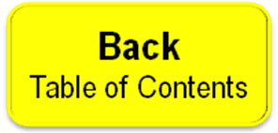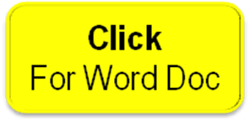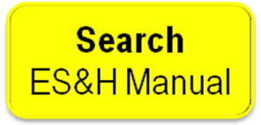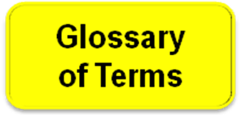

 | ISSUING AUTHORITY | TECHNICAL  POINT-OF-CONTACT | APPROVAL DATE | EXPIRATION DATE | REV.
 | ESH&Q Division | Jennifer Williams |  |  | 1
This document is controlled as an on-line file. It may be printed but the print copy is not a controlled document. It is the user’s responsibility to ensure that the document is the same revision as the current on line file. This copy was printed on 7/28/2026.

