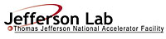 |  | TITLE: | ES&H Manual
DOCUMENT ID: | 6640 Hearing Conservation Program

DRAFT
- Purpose

High noise is a recognized hazard issue at Jefferson Lab. This hearing protection program has been established to ensure affected areas are identified, appropriate monitoring is established, and individuals are informed of the dangers and adequately protected.

This program satisfies applicable federal, state, and local requirements as outlined in ES&H Manual Chapter 2410 Appendix T1 Hazard Issues List.

- Scope

Jefferson Lab requires hearing protection when noise levels are 85 dBA or greater during an 8-hour work day.

- Responsibilities
NOTE: Management authority may be delegated at the discretion of the responsible manager.

  - Everyone at Jefferson Lab
- Request a High Noise Hazard Evaluation if you recognize possible high noise conditions.
- Utilize engineering controls such as alternate equipment/materials to avoid using hearing protection.
- Perform process steps as outlined in ES&H Manual Chapter 6640 Appendix T2 Hearing Personal Protective Equipment – Required and Voluntary Use (including Medical Monitoring) (Link to be established upon approval of document) to obtain hearing protection.
- Obtain medicine monitoring, as required. (See ES&H Manual 6800 Appendix T1 Medical Monitoring.)
- Read and abide by posting requirements.

  - Supervisor/Subcontracting Officer’s Technical Representative (SOTR)/Sponsor
- Ensure individuals under your authority, who work in, or are otherwise exposed to, high noise levels, are informed and appropriate hearing protection is utilized in accordance with ES&H Manual Chapter 6620 Personal Protective Equipment (PPE) Program and ES&H Manual 6800 Occupational Medicine.
- Review work area and equipment to determine if engineering controls such as equipment/material substitutions could adequately mitigate the hazard.
- Ensure that warning signs are posted and maintained in accordance with requirements.

  - Industrial Hygiene
- Perform High Noise Hazard Evaluations when requested, or identified.
- Provide postings as appropriate.
- Determine the required hearing protection.

  - Occupational Medicine
- Perform initial and annual audiograms in accordance with ES&H Manual Chapter 6800 Appendix T1 Medical Monitoring.
- Provide training as required.

- Technical Appendices

  - High Noise Hazard Evaluation and Monitoring
A high noise hazard evaluation and subsequent monitoring is conducted when individual exposure is suspected to be at or above 85 dBA. ES&H Manual Chapter 6640 Appendix T1 High Noise Hazard Evaluation and Monitoring (Link to be established upon approval of document) provides recognized high noise symptoms; the process steps used to schedule and obtain a hazard evaluation; and how monitoring is implemented.

  - Personal Protective Equipment (PPE) – Required and Voluntary Use (including Medical Monitoring)
Hearing protection is required at Jefferson Lab when high noise levels have been determine to be 85 dBA or greater. ES&H Manual Chapter 6640 Appendix T2 Hearing Personal Protective Equipment (PPE) – Required and Voluntary Use (including Medical Monitoring) (Link to be established upon approval of document) provides the process step used to determine the appropriate type; and when to obtain medical monitoring and training.

  - Area Posting Requirements
Jefferson Lab recognizes that high noise can yield unwanted health effects. It is therefore required that designated areas be posted to provide warning of the potential hazard. ES&H Manual Chapter 6640 Appendix T3 High Noise Posting Requirements (Link to be established upon approval of document) defines Jefferson Lab’s labeling and posting requirements; and how to update, repair, and maintain these labels.

- Revision Summary

Revision 1 – ##/##/## – Update to reflect current laboratory operations.
Revision 0 – 08/31/06 – Original content.

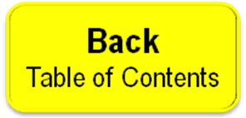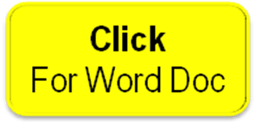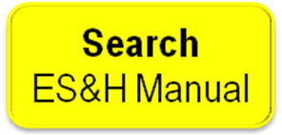

 | ISSUING AUTHORITY | TECHNICAL  POINT-OF-CONTACT | APPROVAL DATE | EXPIRATION DATE | REV.
 | ESH&Q Division | Richard Owen |  |  | 1
This document is controlled as an on-line file. It may be printed but the print copy is not a controlled document. It is the user’s responsibility to ensure that the document is the same revision as the current on line file. This copy was printed on 7/28/2026.

