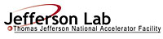 |  | TITLE: | ES&H Manual
DOCUMENT ID: | 6640 Appendix T3  High Noise Posting Requirements

DRAFT
- Purpose

Jefferson Lab recognizes that high noise can yield unwanted health effects. It is therefore required that designated areas be posted to provide warning of the potential hazard. This appendix defines Jefferson Lab’s labeling and posting requirements; and how to update, repair, and maintain these labels.

- Scope

Posting requirements apply to areas and stationary equipment.

The process steps for this procedure are performed in coordination with ES&H Manual Chapter 6640 Hearing Conservation Program (Link to be established upon approval of document.)

- Responsibilities
NOTE: Management authority may be delegated at the discretion of the responsible manager.

  - Anyone at Jefferson Lab
- Read and abide by posting requirements.

  - Supervisor/Subcontracting Officer’s Technical Representative (SOTR)/Sponsor
- Ensure that warning signs are posted and maintained in accordance with requirements.

  - Industrial Hygiene
- Perform High Noise Hazard Evaluations and provide postings as appropriate.

- Process Steps

  - Area Posting Requirements

    - If hearing protection is required prior to entry into an area, the following signage is posted outside the area of danger. Prior to entering individuals are required to don appropriate PPE or ensure other mitigation measures have been implemented.

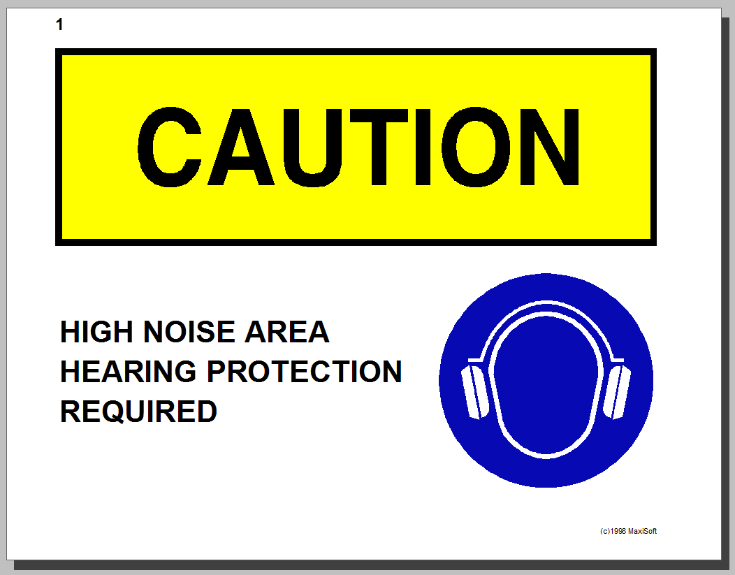 OR 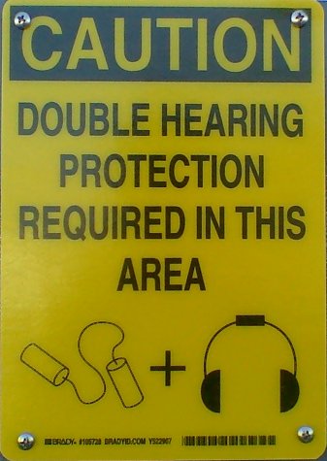

  - Activity Posting

Activities that produce high noise do not required hazard postings. (For concerns regarding high noise due to an activity see ES&H Manual Chapter 6640 Appendix T2 Hearing Personal Protective Equipment (PPE) – Required and Voluntary Use (including Medical Monitoring) (Link to be established upon approval of document).

  - Equipment Labeling

Do not remove manufacturers’ equipment label(s). Contact the manufacturer if labels are missing or damaged. Read and follow manufacturer’s warnings.

  - Update, Repair, or Maintenance to Labels

Anyone at Jefferson Lab may request new, update, repair, or maintenance to a hazard posting.

- Contact Industrial Hygiene and state the posting needing review.
  - If it is determined that the posting is defective, Industrial Hygiene will rectify the situation.
  - If posting is adequate – Industrial Hygiene informs the concerned party(s) of the determination.

- Revision Summary

Revision 1 – ##/##/## – Update to reflect current laboratory operations.
Revision 0 – 08/31/06 – Original content.

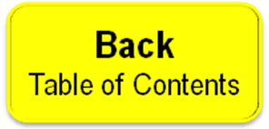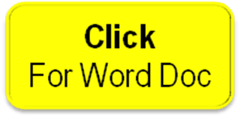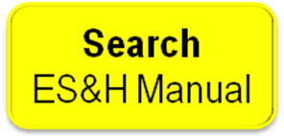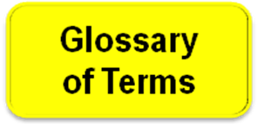

 | ISSUING AUTHORITY | TECHNICAL  POINT-OF-CONTACT | APPROVAL DATE | EXPIRATION DATE | REV.
 | ESH&Q Division | Richard Owen |  |  | 1
This document is controlled as an on-line file. It may be printed but the print copy is not a controlled document. It is the user’s responsibility to ensure that the document is the same revision as the current on line file. This copy was printed on 7/30/2026.

