 |  | TITLE: | ES&H Manual
DOCUMENT ID: | 6683 Appendix T2  Silica Training

Jefferson Lab has determined that working with silica carries an unmitigated Risk Code >2. At a minimum all tasks involving silica are discussed with the supervisor prior to commencement. An Operational Safety Procedure (OSP) is written for any work considered to be Risk Code >2 in accordance with ES&H Manual Chapter 3210 Work Planning, Control, and Authorization Process.

DRAFT
- Purpose

No one at Jefferson Lab, including subcontractors, may authorize or perform work unless they are properly trained. This appendix presents the process steps used to obtain and record the training required for work involving silica.

- Scope

SAF138 Silica Dust Hazards in Construction, or equivalent, is required every three years and includes procedures and requirements relate specifically to activities known to generate silica hazards at Jefferson Lab. Training includes hazard assessment and appropriate mitigation techniques.

Prior to commencement of work, subcontractors either provide, for review and acceptance, their silica safety program and their personnel’s training records; or use Jefferson Lab’s program.

The process steps for this procedure are performed in coordination with ES&H Manual Chapter 6683 Silica Safety Program (Link to be established upon approval of document.)

- Responsibilities
NOTE: Management authority may be delegated at the discretion of the responsible manager.

  - Qualified Silica Worker
- Complete and maintain appropriate training
- SAF138 Silica Dust Hazards in Construction, and
- Medical monitoring, as appropriate.

  - Supervisor/Subcontracting Officer’s Technical Representative (SOTR)/Sponsor:
- Assign only Qualified Silica Workers to silica work.

    - SOTR also:
- Inform subcontractors that a written Silica Program is required to be submitted prior to commencement of silica work. (Subcontractor may use and abide by Jefferson Lab’s or submits one for approval.) Program must include subcontractor’s training and qualifications, minimally to Jefferson Lab requirements.
  - If provided, submit subcontractor’s Silica Program to Jefferson Lab’s Silica Subject Matter Expert (see ES&H Manual Chapter 2410 Appendix T1 Hazard Issues List – Silica) for approval prior to commencement of work.

  - Silica Subject Matter Expert (SME)
- Oversee the on-site silica training program.
- Make silica equivalent training determination.
- Maintain listing of Qualified Silica Workers in accordance with ES&H Manual Chapter 4200 ES&H Training Overview.

- Process Steps

  - Silica Training
Unless otherwise stated anyone at Jefferson Lab may take this training. It is required for those individuals who have been recognized by their supervisors to work in or around CR silica hazard areas:

- Review on-line training module:
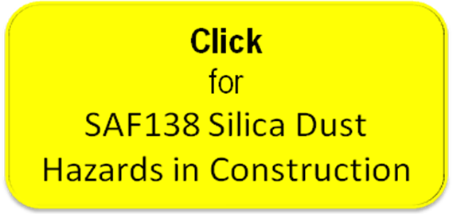

- Update Skills Requirements List (SRL) – Upon successful completion of the course, fill in the requested information to update your Skills Requirements List.

  - Equivalent Training Determination
The Silica Subject Matter Expert (SME) has the authority to make a determination that silica training obtained elsewhere is equivalent to Jefferson Lab training.

- The Supervisor/SOTR submits training equivalency documentation to the Silica SME.

- The Silica SME reviews and determines whether the training is equivalent to that of Jefferson Lab’s requirements, and provides a determination to the Supervisor/SOTR.

- The Supervisor/SOTR updates the individual’s SRL to reflect the determination.

- Revision Summary

Revision 0 – ##/##/## – Update to reflect current laboratory operations.



 | ISSUING AUTHORITY | TECHNICAL  POINT-OF-CONTACT | APPROVAL DATE | EXPIRATION DATE | REV.
 | ESH&Q Division | Richard Owen |  |  | 0
This document is controlled as an on-line file. It may be printed but the print copy is not a controlled document. It is the user’s responsibility to ensure that the document is the same revision as the current on line file. This copy was printed on 7/28/2026.

