 |  | TITLE: | ES&H Manual
DOCUMENT ID: | 6160 Appendix T1  Listing of Permit-Required Confined Space (PRCS) Locations

DRAFT

At Jefferson Lab a Confined Space Entry (CSE) Permit is considered to be a Work Control Document and thus a Standard Protecting Measure. Only when all hazard issues associated with the PRCS and the work activity are acknowledged and mitigated, in accordance with this program, can the area’s associated Risk Code be considered < 2. At a minimum, all work requiring entry into a PRCS is discussed with the entry supervisor prior to commencement.

A formal Task Hazard Analysis and Operational Safety Procedure is required for work considered to be Risk Code >2 in accordance with ES&H Manual Chapter 3210 Work Planning, Control, and Authorization Process.

- Purpose

This appendix provides a listing of Jefferson Lab’s currently known Permit-Required Confined Spaces (PRCSs). They are generally located underground and entered through manholes. Entry is infrequent and normally made by a Jefferson Lab authorized subcontractor.

- Scope

This appendix is reviewed annually however, it does not guarantee that all PRCSs are listed. Contact the Confined Space Coordinator if you have questions, concerns, or to request a hazard evaluation of an area.

Jefferson Lab defines a “PRCS” to be any area that meets all of the following criteria:

- Sufficient space for a person to enter and perform work;
- Limited/restricted means for entering/exiting;
- Not designed for continuous occupancy.

AND one or more of the following criteria:

- Contains, or has the potential to contain, a hazardous atmosphere;
- Contains a material with the potential for engulfing a person or hindering quick escape;
- Internal configuration can trap a person or lead to asphyxiation;
- Entails a safety or health risk that has been determined to be >2 and requires a formal Task Hazard Analysis and associated work control document.

The process steps for this procedure are performed in coordination with ES&H Manual Chapter 6160 Permit-Required Confined Space Entry.

- Responsibilities
NOTE: Management authority may be delegated at the discretion of the responsible manager.

  - Entry Supervisor/Subcontracting Officer’s Technical Representative (SOTR)/ Sponsor
- Know the PRCSs under your authority. Ensure they are appropriately identified and secured.

  - Confined Space Coordinator
- Maintain the listing of PRCSs.

- Locations (Click map for file version)

Non-Accelerator Site Locations
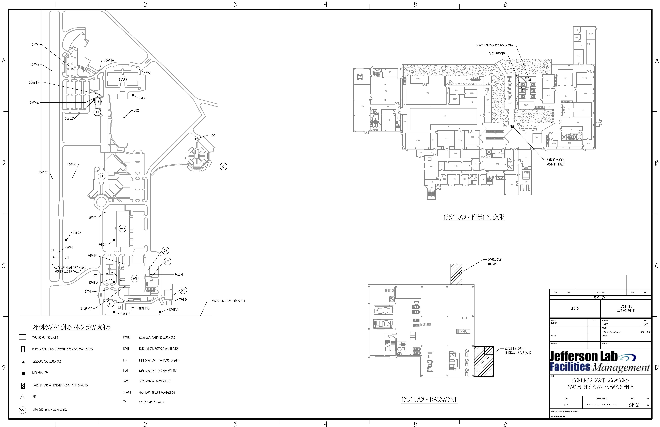

Accelerator Site Locations
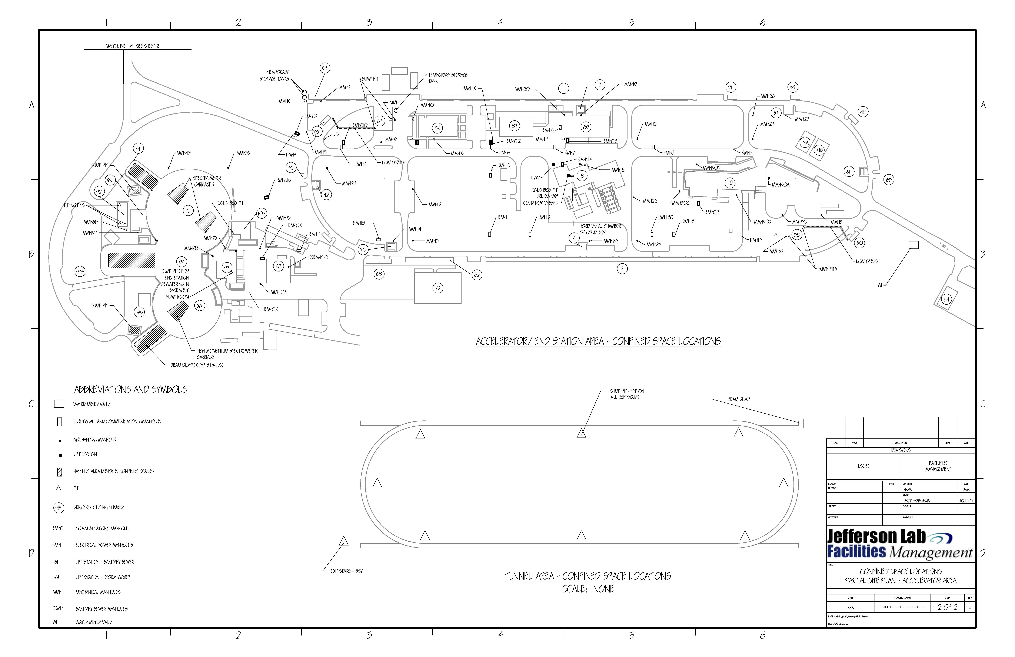

- Table Listing of PRCSs

Each PRCS is assigned a unique alphanumeric designation. The assignment is based on the PRCS’s determined category and the next consecutive number.

Table 1: Building PRCSs (B#-#)
Space Designation | Nearest Permanent Building/Location | Type of Space
B4-1 | Exit Stair #4 | Sump Pit
B7-1 | Exit Stair #1 | Sump Pit
B8-1 | CHL | Cold Box Pit
B8-2 | CHL | Cold Box Vessel
B8-3 | CHL | Cold Box Horizontal Chamber
B31-1 | Acid Storage | Sump Pit
B37-1 | Exit Stair #2 | Sump Pit
B38-1 | South Access | Sump Pit (east)
B38-2 | South Access | Sump Pit (west)
B38-3 | South Access | LCW Trench
B38-4 | South Access | Staircase Sump Pit
B53-1 | Injector Service Building | Temporary Storage Tank
B53-2 | Injector Service Building | Temporary Storage Tank
B42-1 | Exit Stair #6 | Sump Pit
B58-1 | Test Lab | Cooling Basin Underground Tank
B58-2 | Test Lab | Basement Tunnel
B58-3 | Test Lab | Shield Block Motor Space
B58-4 | Test lab | Shaft under Grating in VTA
B58-5 | Test Lab | VTA Dewar
B58-6 | Test Lab | VTA Dewar
B58-7 | Test Lab | VTA Dewar
B58-8 | Test Lab | VTA Dewar
B58-9 | Test Lab | VTA Dewar
B58-10 | Test Lab | VTA Dewar
B61-1 | Exit Stair #3 | Sump Pit
B67-1 | North Access | Sump Pit (east)
B67-2 | North Access | Sump Pit (west)
B67-3 | North Access | LCW Trench
B67-4 | North Access | Staircase Sump Pit
B67-5 | North Access | Waste Water Tank (west)
B70-1 | Exit Stair #5 | Sump Pit
B85-1 | Accelerator Tunnel | Beam Dump
B91-1 | Cooling Building, Hall A | Sump Pit
B91-2 | Cooling Building, Hall A | Entire Building
B92-1 | Service Building #1 | North Piping Pit
B92-2 | Service Building #1 | South Piping Pit
B92-3 | Service Building #1 | East Piping Pit
B94-1 | Hall B | Beam Dump
B95-1 | Cooling Building, Hall C | Sump Pit
B95-2 | Cooling Building, Hall C | Entire Building
B96-1 | Hall C | Beam Dump
B96-2 | Hall C | High Momentum Spectrometer Carriage
B99-1 | Exit Stairs-BSY | Sump Pit
B101-1 | Hall A | Beam Dump
B101-2 | Hall A | Spectrometer Carriage 1
B101-3 | Hall A | Spectrometer Carriage 2
B102-1 | End Station Refrigerator | Cold Box Pit

Table 2: Telecommunications Manholes (EMHC#)
Space Designation | Nearest Permanent Building/Location | Type of Space
EMHC1 | 28 | Utility Manhole/Vault
EMHC2 | 19 (Unverified) | Utility Manhole/Vault
EMHC3 | 12 | Utility Manhole/Vault
EMHC4 | on Jefferson Ave. near Onnes Rd. intersection | Utility Manhole/Vault
EMHC5 | 90 | Utility Manhole/Vault
EMHC6 | 58 | Utility Manhole/Vault
EMHC7 | 34 | Utility Manhole/Vault
EMHC8 | 34 | Utility Manhole/Vault
EMHC9 | 53 | Utility Manhole/Vault
EMHC10 | 67 | Utility Manhole/Vault
EMHC11 | 85 | Utility Manhole/Vault
EMHC12 | 85 | Utility Manhole/Vault
EMHC13 | 7 | Utility Manhole/Vault
EMHC14 | 8 | Utility Manhole/Vault
EMHC15 | 40 | Utility Manhole/Vault
EMHC16 | 98 | Utility Manhole/Vault
EMHC17 | 18 (Unverified) | Utility Manhole/Vault

Table 3: Electrical Power Manholes (EMH#)
Space Designation | Nearest Permanent Building/Location | Type of Space
EMH1 | 58 | Utility Manhole/Vault
EMH2 | 34 | Utility Manhole/Vault
EMH3 | 34 | Utility Manhole/Vault
EMH4 | 41 | Utility Manhole/Vault
EMH5 | 45 | Utility Manhole/Vault
EMH6 | 85 | Utility Manhole/Vault
EMH7 | 8 | Utility Manhole/Vault
EMH8 | 14 | Utility Manhole/Vault
EMH9 | 21 | Utility Manhole/Vault
EMH10 | 85 | Utility Manhole/Vault
EMH11 | 82 | Utility Manhole/Vault
EMH12 | 2 | Utility Manhole/Vault
EMH13 | 2 | Utility Manhole/Vault
EMH13C | 89 | Utility Manhole/Vault
EMH14 | 2 | Utility Manhole/Vault
EMH15 | 98 | Utility Manhole/Vault
EMH16 | 89 (Unverified) | Utility Manhole/Vault

Table 4: Lift Station-Sanitary Sewer (LS#)
Space Designation | Nearest Permanent Building/Location | Type of Space
LS1 | near Jefferson & Onnes (Unverified) | Utility Manhole/Vault
LS2 | 16 | Utility Manhole/Vault
LS3 | 6 | Utility Manhole/Vault
LS4 | 45 | Utility Manhole/Vault

Table 5: Lift station-Storm Water (LW#)
Space Designation | Nearest Permanent Building/Location | Type of Space
LW1 | 58 | Utility Manhole/Vault
LW2 | 8 | Utility Manhole/Vault

Table 6: Mechanical Equipment Manholes (MMH#)
Space Designation | Nearest Permanent Building/Locations | Type of Space
MMH1 | near Jefferson/Onnes | Utility Manhole/Vault
MMH2 | 11 | Utility Manhole/Vault
MMH2B | 40 | Utility Manhole/Vault
MMH3 | 90 | Utility Manhole/Vault
MMH3B | 101 | Utility Manhole/Vault
MMH4 | 59 (Unverified) | Utility Manhole/Vault
MMH4B | 101 | Utility Manhole/Vault
MMH5 | 52 (Unverified) | Utility Manhole/Vault
MMH5B | 93 | Utility Manhole/Vault
MMH6 | 53 | Utility Manhole/Vault
MMH6B | 93 | Utility Manhole/Vault
MMH7 | 53 | Utility Manhole/Vault
MMH7B | 97 | Utility Manhole/Vault
MMH8 | 45 | Utility Manhole/Vault
MMH8B | Unverified | Utility Manhole/Vault
MMH9 | 85 | Utility Manhole/Vault
MMH9B | 98 | Utility Manhole/Vault
MMH10 | 85 | Utility Manhole/Vault
MMH11 | 67 | Utility Manhole/Vault
MMH12 | 70 | Utility Manhole/Vault
MMH13 | 70 | Utility Manhole/Vault
MMH14 | 70 | Utility Manhole/Vault
MMH15 | 85 | Utility Manhole/Vault
MMH16 | 85 | Utility Manhole/Vault
MMH17 | 7 | Utility Manhole/Vault
MMH18 | 8 | Utility Manhole/Vault
MMH19 | 7 | Utility Manhole/Vault
MMH20 | 1 | Utility Manhole/Vault
MMH21 | 14 | Utility Manhole/Vault
MMH22 | 14 | Utility Manhole/Vault
MMH23 | 2 | Utility Manhole/Vault
MMH24 | 4 | Utility Manhole/Vault
MMH25 | 37 | Utility Manhole/Vault
MMH26 | 21 | Utility Manhole/Vault
MMH27 | 37 | Utility Manhole/Vault
MMH30 | 38 | Utility Manhole/Vault
MMH30A | 18 (Unverified) | Utility Manhole/Vault
MMH30B | 18 (Unverified) | Utility Manhole/Vault
MMH30C | 18 (Unverified) | Utility Manhole/Vault
MMH30D | 18 (Unverified) | Utility Manhole/Vault
MMH31 | 38 | Utility Manhole/Vault
MMH32 | 38 | Utility Manhole/Vault
MMH33 | 18 | Utility Manhole/Vault
MMH34 | 53 | Utility Manhole/Vault
MMH35 | 53 | Utility Manhole/Vault
MMH36 | 39 | Utility Manhole/Vault
MMH37 | 63 | Utility Manhole/Vault
MMH38 | 38 | Utility Manhole/Vault
MMH39 | 2 | Utility Manhole/Vault
MMH40 | 2 | Utility Manhole/Vault
MMH41 | 56 | Utility Manhole/Vault

Table 7: Sanitary Sewer Manholes (SSMH#)
Space Designation | Nearest Permanent Building/Locations | Type of Space
SSMH1 | 28 | Utility Manhole/Vault
SSMH1A | ARC | Utility Manhole/Vault
SSMH1B | VARC | Utility Manhole/Vault
SSMH1C | 19 | Utility Manhole/Vault
SSMH2 | near Jefferson & Hofstadter | Utility Manhole/Vault
SSMH3 | near Jefferson Avenue | Utility Manhole/Vault
SSMH4 | 12 | Utility Manhole/Vault
SSMH5 | near Jefferson Avenue | Utility Manhole/Vault
SSMH6 | near Jefferson Avenue | Utility Manhole/Vault
SSMH7 | 58 (Unverified) | Utility Manhole/Vault

Table 8: Water Meter Vault (W)
Space Designation | Nearest Permanent Building/Locations | Type of Space
W1 | near CEBAF Blvd. & Canon Blvd. | Utility Manhole/Vault
W2 | 28 | Utility Manhole/Vault
W3 | near Jefferson & Onnes | Utility Manhole/Vault

- Designations

Type of Space | Designator
Buildings | B - followed by the building number, hyphen, and then consecutive numbers starting with 1
Communications Manholes | EMHC - followed by consecutive numbers starting with 1
Electrical Power Manholes | EMH - followed by consecutive numbers starting with 1
Lift Station-Sanitary Sewer | LS - followed by consecutive numbers starting with 1
Lift Station-Storm Water | LW - followed by consecutive numbers starting with 1
Mechanical Manholes | MMH - followed by consecutive numbers starting with 1
Sanitary Sewer Manholes | SSMH - followed by consecutive numbers starting with 1
Water Meter Vault | W - followed by consecutive numbers starting with 1
Other Kinds of Vault | V - followed by consecutive numbers starting with 1
Unverified means precise location or hazard potential has not been fully verified by Laboratory ESH&Q staff.

- Revision Summary

Revision 1 - ##/##/## - Update to reflect current laboratory operations; annual review to maintain content
Revision 0 – 08/30/06 – Update to Web Version



 | ISSUING AUTHORITY | TECHNICAL  POINT-OF-CONTACT | APPROVAL DATE | EXPIRATION DATE | REV.
 | ESH&Q Division | John Kelly | 08/30/06 | Annual Review | 1
This document is controlled as an on line file. It may be printed but the print copy is not a controlled document. It is the user’s responsibility to ensure that the document is the same revision as the current on line file. This copy was printed on 7/28/2026.

