 |  | TITLE: | ES&H Manual
DOCUMENT ID: | 6160 Appendix T4  Atmospheric Testing and Ventilation

DRAFT

At Jefferson Lab a Confined Space Entry (CSE) Permit is considered to be a Work Control Document and thus a Standard Protecting Measure. Only when all hazard issues associated with the PRCS and the work activity are acknowledged and mitigated, in accordance with this program, can the area’s associated Risk Code be considered < 2. At a minimum, all work requiring entry into a PRCS is discussed with the entry supervisor prior to commencement.

A formal Task Hazard Analysis and Operational Safety Procedure is required for work considered to be Risk Code >2 in accordance with ES&H Manual Chapter 3210 Work Planning, Control, and Authorization Process.

Atmospheric testing for oxygen, toxics, and flammables, and subsequent ventilation to ensure proper levels, is mandatory during Permit-Required Confined Space (PRCS) entry. This appendix provides the process steps used to ensure adequate controls are implemented and maintained during entry.

- Scope

The process steps for this procedure are performed in coordination with ES&H Manual Chapter 6160 Permit-Required Confined Space Entry.

- Responsibilities
NOTE: Management authority may be delegated at the discretion of the responsible manager.

  - Authorized Attendant/Qualified Entrant
- Perform air monitoring during PRCS work as designated by the Entry Supervisor.

  - Entry Supervisor/Subcontracting Officer’s Technical Representative (SOTR)/ Sponsor
- Determine the testing method and designate the person (the Authorized Attendant, Qualified Entrant, or yourself) to be responsible for performing the initial and subsequent tests.

  - Industrial Hygiene
- Ensure monitoring instruments are appropriately maintained and calibrated.
- Only issue monitoring instruments to Authorized Entrant, Qualified Attendant, or Entry Supervisor.
- Provide instruction on monitoring instrument operation(s) prior to issuance.

- Process Steps

The following process steps can only be performed by Qualified Entrant, Authorized Attendant, or Entry Supervisor.

  - Air Monitoring Procedure

- Obtain Monitoring Instrument and Accessories
Obtain monitoring instrument(s) and accessory devices from Industrial Hygiene. (Accessories include: tubing adequate for the PRCS’s depth; auxiliary sampling pumps; and spare battery(s) adequate for the estimated duration of the work.)

Provide Industrial Hygiene with the following information:
- Work processes taking place in, around, or near the PRCS, particularly those generating toxic or asphyxiating gases or vapors, such as CO₂, helium, refrigerants, etc.
- Estimated duration of work.
- Known depth and “worst-case” condition(s) of the PRCS.
- Permanent mechanical ventilation or other Engineering Controls in PRCS, if functioning.
- Need for other toxic-detection capability (e.g.: colorimetric indicator tubes) for conditions such as: acetylene, hydrogen, NO_{x} or ozone.
- Any additional information, as provided by the system owner, area manager, Confined Space Coordinator, or others.

NOTE: Jefferson Lab offers multi-function gas meters. These monitoring instruments are able to detect the following parameters:

- Oxygen Concentration (in percent O2)
- Flammability (in percentage of lower explosive limit)
- Carbon Monoxide Concentration (in parts per million (ppm)
- Hydrogen Sulfide Concentration (also in ppm)

- Verify Adequacy of Monitoring Instrument:
Industrial Hygiene will ensure monitoring instrument and auxiliary sampling pumps are functioning adequately and provide instruction to individuals as required. This will include, but not be limited to:

- Turning the instrument on in an uncontaminated area.
- Ensuring there is ample power for duration of work. (For safety, consider continuous operation limit to be no more than five hours. A spare set of batteries is always recommended).
- Allowing instrument to perform self-diagnostics.
- Performing a bump test to force the alarm to sound.
- Ensuring all functions are operating normally.

- Initial Atmospheric Test
Ensure all entrants, who will use or rely on, the monitoring instrument understand its display and audible alert(s) and they observe the initial atmospheric test.

- Prior to ventilating or otherwise disturbing the air, perform the initial atmospheric test from outside the PRCS. (If this cannot be done contact the Confined Space Coordinator.)
- Denote the readings on the first column of the permit.

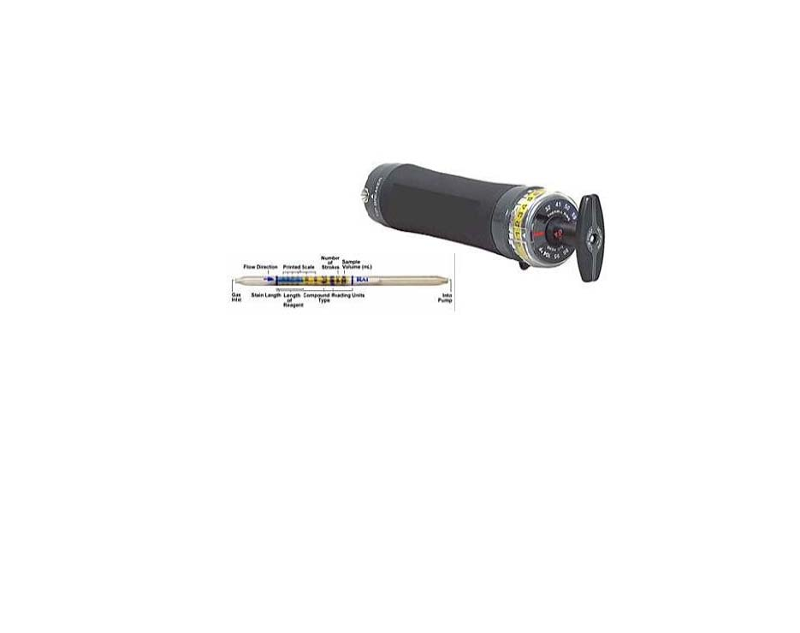 | NOTE: If you are using colorimetric indicator tubes, promptly write down the concentration as indicated by the length and degree of color change. The stained area will likely continue to change (+) after exposure, and the tube will become useless as a record.  Be sure you read the tube instructions carefully for proper sample volume (pump strokes), interfering substances, and any temperature/humidity corrections that may be required. Also check the expiration date for the tubes; do not use them if the date has passed.

- Ventilation
Set-up blowers in accordance with training.
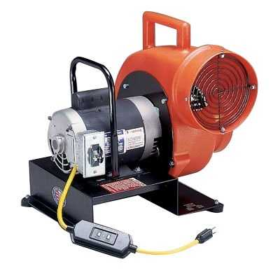
Figure 1 Example of a typical ventilation set-up

- Hourly Tests
Minimally test atmosphere every hour of PRCS continual occupancy. Any interruption in operations requires re-test before re-entry.

The two acceptable methods include:
- Continuous Monitoring - carry the instrument into the space and document results at appropriate intervals.
- Hourly/Interval Testing – Perform test at designated intervals from outside the PRCS and document the results at appropriate intervals.

NOTE: When atmospheric conditions are out-of-specification, immediately evacuate the PRCS and inform the entry supervisor.

- Conclusion
When the entry is concluded, return the monitoring instrument to Industrial Hygiene and the completed confined space entry permit to the Confined Space Coordinator.

- Revision Summary

Revision 1 – ##/##/## – Update to reflect current laboratory operations.



 | ISSUING AUTHORITY | TECHNICAL  POINT-OF-CONTACT | APPROVAL DATE | EXPIRATION DATE | REV.
 | ESH&Q Division | John Kelly |  |  | 1
This document is controlled as an on-line file. It may be printed but the print copy is not a controlled document. It is the user’s responsibility to ensure that the document is the same revision as the current on line file. This copy was printed on 7/28/2026.

