 |  | TITLE: | ES&H Manual
DOCUMENT ID: | 3210 Work Planning, Control, and Authorization Process

DRAFT
- Purpose

No work at Jefferson Lab is completely without risk; therefore, all work requires forethought, planning, and authorization. Identification of work hazards and understanding their risks is an essential part of this process. This document defines Jefferson Lab’s work planning, control, and authorization process. This process is commensurate with the laboratory’s commitment to achieve the highest standards of safety and quality.

- Scope

This process applies to all work done by employees, users, or subcontractors to ensure safety and quality of work. It is used in coordination with the Jefferson Lab Assurance Program Description, and other appropriate processes. These processes include, but are not limited to:

- Department documented procedures
- Maintenance of quality records
- Work tracking tools

- Responsibilities
NOTE: Management authority may be delegated at the discretion of the responsible manager.

  - Everyone at Jefferson Lab
- Identify work in accordance with standard procedures.
- Review lessons learned and promote continuous improvement.
- Perform preliminary planning for assigned tasks. (Use ES&H Manual Chapter 3210 Appendix T1 Work Planning, Control, and Authorization Procedure to identify task steps and possible consequences. Solicit the advice of ES&H professionals and Subject Matter Experts to recognize and mitigate hazards.)
- Utilize task lists as appropriate.
- Analyze hazards prior to performing work.
- Ensure all documentation and approvals are obtained prior to performing work.
- Ensure adequate and appropriate training in accordance with Jefferson Lab’s requirements.
- Read and abide by associated, approved Work Control Document (WCD).
- Monitor work during performance. Re-evaluate the scope and Task Hazard Analysis (THA) if appropriate.
- Solicit and provide feedback for future reference.
- Adequately documents lessons learned per the group’s and/or lab procedures.

  - Supervisor/Subcontracting Officer’s Technical Representative (SOTR)/Sponsor:
- Ensure work is performed in accordance with this process by requiring implementation of its associated procedures.

  - Lead Worker
- Performs pre-job safety briefing.

  - Work Control Document (WCD) Author
- Ensure all affected workers read, understand and sign associated documents.

  - Environmental, Safety, Health, and Quality (ESH&Q) Division: Assist organizations in implementing this process.

- Technical Appendices

  - Work Planning, Control, and Authorization Procedure
ES&H Manual Chapter 3210 Appendix T1 Work Planning, Controls, and Authorization Procedure defines Jefferson Lab’s work process and control methods, and outlines how Jefferson Lab implements its Integrated Safety Management System (ISMS) into the planning and execution of work. Process steps include:

- Defining the Scope of Work
- Analyzing the Hazards
- Developing and Implementing Hazard Controls
- Performing Work Within Controls
- Providing Feedback and Continuous Improvement.

By utilizing the Task Hazard Analysis (THA) Worksheet individuals are able to effectively analyze work hazards and develop effective controls.

  - Assigning a Risk Code to Work
Identification of work hazards and understanding their level of risks is an essential part of Jefferson Lab’s work process. ES&H Manual Chapter 3210 Appendix T2 Risk Code Assignment demonstrates the accepted method for determining the Risk Code for task steps identified during a Task Hazard Analysis.

  - Use the Graded Approach Procedure to determining the degree of rigor appropriate for work control in a particular situation.

- Revision Summary

Revision 1.0 - ##/##/## - Update to include Temporary Work Permits a Work Control Document.
Revision 0.0 – 10/05/09 – Written to document current laboratory operational procedure.

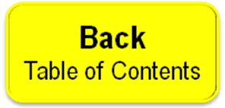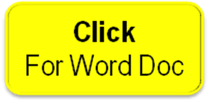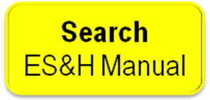

 | ISSUING AUTHORITY | TECHNICAL  POINT-OF-CONTACT | APPROVAL DATE | EXPIRATION DATE | REV.
 | ESH&Q Division | Harry Fanning | 10/05/09 | 10/05/12 | 1
This document is controlled as an on line file. It may be printed but the print copy is not a controlled document. It is the user’s responsibility to ensure that the document is the same revision as the current on line file. This copy was printed on 7/29/2026.

