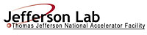 |  | TITLE: | ES&H Manual
DOCUMENT ID: | 2500 Appendix T1  Safety Warden Inspection Requirements

DRAFT
- Purpose

Jefferson Lab requires all work areas and safety equipment be inspected on a regular basis. Safety Wardens are assigned to perform these inspections; confirm safe condition or request appropriate repair, maintenance, or disposal. This appendix provides the minimum Safety Warden Inspection requirements for common areas and safety equipment.

- Scope

This appendix provides the minimal inspection requirements for common areas (e.g.: stairways, hallways, storage/copy rooms) and safety equipment (e.g.: fire extinguishers, eyewash stations, emergency showers). Additional area-specific hazard may require inspection at the direction of the area’s supervisor according to activities, materials, systems, and equipment. Requests are reviewed by the Safety Warden Coordinator for relevance to the Safety Warden Program and added to an area’s inspection list as appropriate.

- Responsibilities
NOTE: Management authority may be delegated at the discretion of the responsible manager.

  - Everyone at Jefferson Lab
- Request support from the Division Safety Officer to determine sufficient Safety Warden resources for a given area.
- Determine area specific hazards and ensure the Safety Warden can recognize the hazard mitigation requirements.
- Request a mitigation determination for facility and equipment safety concerns from the Safety Wardens assigned to an area.
- Cooperate with your area Safety Warden in resolving safety issues.

  - Safety Warden
    - Perform and document Safety Warden Inspections in accordance with requirements.
    - Maintain Safety Bulletin Board(s).

  - Safety Warden’s Supervisor
- Ensure adequate time is allocated to perform required inspections.

  - Safety Warden Coordinator
- Coordinate Quarterly Inspections with Safety Warden.
- Review area specific hazard mitigation requirements with area Supervisor and ensure these are included in the Safety Warden’s inspection.

  - Division Safety Officer (DSO)
- Ensure monthly Safety Warden Inspections are performed in all areas for which the division is responsible, regardless of Safety Warden’s affiliated division.

- Requirements

  - Safety Warden Inspections
Safety Wardens perform equipment inspections, at designated intervals, to ensure prompt hazard mitigation:

    - Weekly Inspections
- Plumbed-in eye wash – Test adequacy of water flow. (Contact Industrial Hygiene for the area’s equipment specific requirements)
- Plumbed-in Emergency showers – Test adequacy of water flow. (Contact Industrial Hygiene for the area’s equipment specific requirements)

    - Monthly Inspections
- Fire extinguishers – properly charged, stored, and accessible. (Submit a Facilities Management Work Request for non-compliance issues.)
- Common areas – free of fire and evacuation hazards. (Submit a Facilities Management Work Request for non-compliance issues.)
- Hazard issue postings (including evacuation postings) – relevant, accurate and in good condition. (Submit a request to Industrial Hygiene for non-compliance issues.)
    - Equipment Storage Issues: (to include, but not limited to)
      - Ladders and scaffolds - properly stored and maintained. Contact Industrial Safety for non-compliance issues. See ES&H Manual Chapter 6132 Ladder and Scaffold Safety
      - Lock, tag, try configurations –secure. Contact the Electrical Safety Engineer for non-compliance issues. See ES&H Manual Chapter 6110 Lock, Tag, Try Program.
      - Gas cylinders and their associated piping systems – secure and appropriately labeled. Submit a Facilities Management Work Request for non-compliance issues, or contact Industrial Hygiene for labeling issues. See ES&H Manual Chapter 6150 Compressed, Liquefied, and Solidified Gas Program.

    - Quarterly Inspections
Perform area walk-through with ESH&Q staff member having relevant hazard issue expertise. Discuss hazard mitigation and compliance issues.

  - Documentation of Safety Warden Inspections

Upon completion of a Safety Warden Inspections, the Safety Warden performs the following process steps:
- Document the Safety Wardens Inspection upon the conclusion of the inspection.
- Submit a Facilities Management Work Request for issues requiring repair or maintenance.
- Initiate a Corrective Action Tracking System (CATS) for issues requiring “resolution.”

  - Safety Bulletin Boards
Bulletin Boards are provided in common areas for posting of pertinent ES&H topics. These boards are maintained by the area’s Safety Warden in a clean and organized manner with current information relating to ES&H. The Safety Warden Coordinator can provide ideas for current and relevant topics.

- Resources:

Safety Warden Inspection Checklists
Safety Warden Inspection Reports
Facilities Management Work Request
Corrective Action Tracking System (CATS)

- Revision Summary

Revision 1 - ##/##/## - Updated to reflect current laboratory operations.

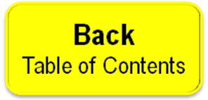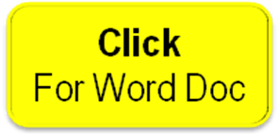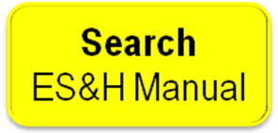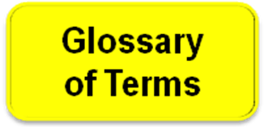

 | ISSUING AUTHORITY | TECHNICAL  POINT-OF-CONTACT | APPROVAL DATE | EXPIRATION DATE | REV.
 | ESH&Q Division | Tina Menefee |  |  | 1
This document is controlled as an on line file. It may be printed but the print copy is not a controlled document. It is the user’s responsibility to ensure that the document is the same revision as the current on line file. This copy was printed on 7/28/2026.

For the purpose of this chapter common areas are considered to be those areas where access is not restricted. Examples include: hallways, stairways, loading docks, copy rooms, and kitchen areas.

