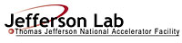 |  | TITLE: | ES&H Manual
DOCUMENT ID: | 6420 Appendix T3  Engineering and Administrative Controls for Magnetic and Radio Frequency – Including Posting Requirements

DRAFT
- Purpose

Jefferson Lab recognizes that magnets, and any associated external fringe static magnetic fields, may be dangerous. It is therefore required that they be controlled and the designated area provides warning of the potential hazards. This appendix defines Jefferson Lab’s minimum engineering controls for this type of equipment; the administrative controls – including area postings; and how these are updated, repaired, and maintained.

- Scope

The process steps for this procedure are performed in coordination with ES&H Manual Chapter 6420 Non-Ionizing Radiant Energy (i.e.: Radio Frequency (RF), Microwave, and Static Magnetic Fields (Link to be established upon approval of document.)

- Responsibilities
NOTE: Management authority may be delegated at the discretion of the responsible manager.

  - Anyone at Jefferson Lab
- Request an equipment/area hazard evaluation from the Magnet Owner if compliance with these requirements is unclear.

  - Magnet Owner
- Perform equipment/area hazard evaluation and provide appropriate mitigation. Ensure it is in place and functioning.

  - Supervisor/Subcontracting Officer’s Technical Representative (SOTR)/Sponsor
- Ensure controls are in place in accordance with requirements.

  - Industrial Hygiene
- Perform Magnetic Field Surveys and provide training and mitigation as required.

- Process Steps

  - Engineering Controls

    - Quench Protection
A superconducting magnet quenches when most of its superconducting wire changes to and remains in the non-superconducting state due to a rise in temperature or exposure to excessive magnetic field. When called for by analysis, a system is installed to detect the quench and trigger a lowering of the current and withdrawal of the stored magnetic energy to preclude burnout of the conductor. Usually this system includes isolation contactor(s) and a diode/dump resistor system. Quenches usually cause cryogen boil-off and rapid current change, inducing voltages higher than the normal magnet charging voltage. How the quench protection system works and how hazards are mitigated are documented within the magnet’s work control document. (See ES&H Manual 6420 Appendix T2 Operational Safety Procedure for Qualifying Static Magnetic Fields (Link to be established upon approval of document)

    - Energization Warning
Electromagnets at Jefferson Lab are designated by a red flashing warning light that turns on when the magnet is energized. Magnets that create strong static magnetic field are typically de-energized when personnel exposures could occur (i.e.: during lengthy down-times associated with accelerator operations). Circumstances that require the magnet to remain energized are considered a Risk Code >2 and require a Work Control Document. See ES&H Manual 6420 Appendix T2 Operational Safety Procedure for Qualifying Static Magnetic Fields (Link to be established upon approval of document)

  - Administrative Controls

    - Magnetic Field Hazard Controls
      - Industrial Hygiene performs a magnetic field survey when necessary and provides hazard mitigation requirements to magnet owners. These include:
- Area Designation (i.e. tape or rope indicating hazard zone)
- Posting Caution Signs - at work areas where the magnetic field exceeds 0.5 mT (5 G).

Figure 1 Bioelectronic Device Hazard Area and Ferromagnetic Tool Hazard
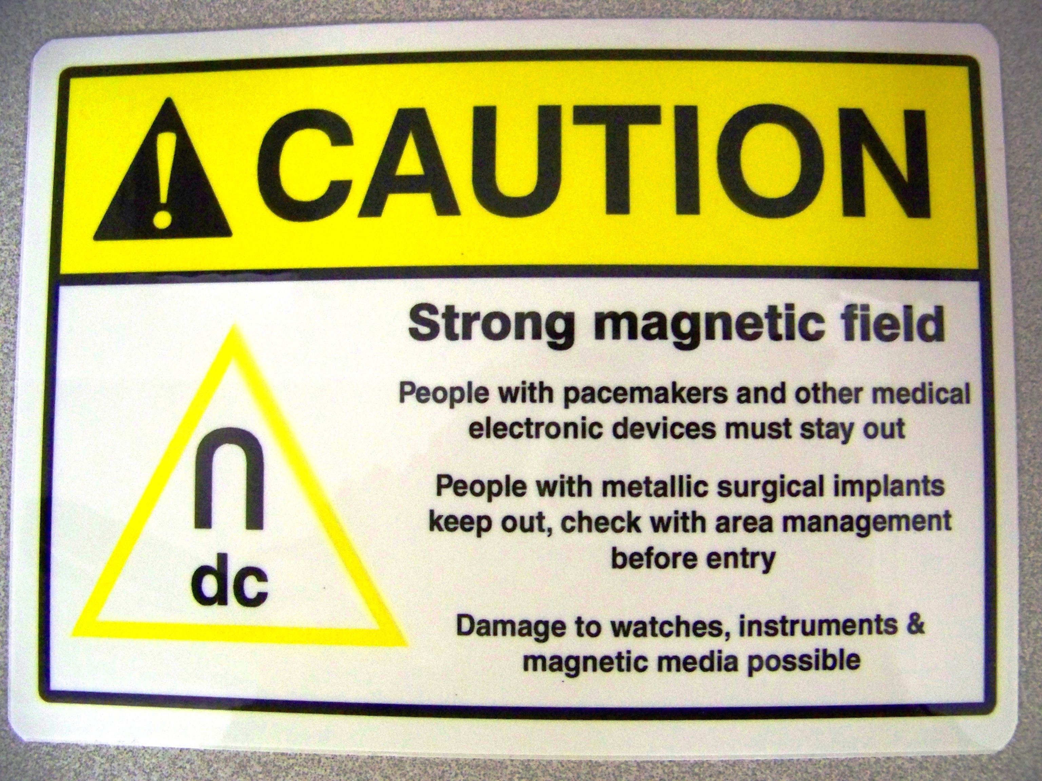

    - Radio Frequency (RF) Hazard Controls
      - Industrial Hygiene performs a RF survey when necessary and provides hazard mitigation requirements to owners. These include:
- Area Designation (i.e. tape or rope indicating hazard zone)
- Posting Caution Signs (See below)

Figure 2 RF Posting
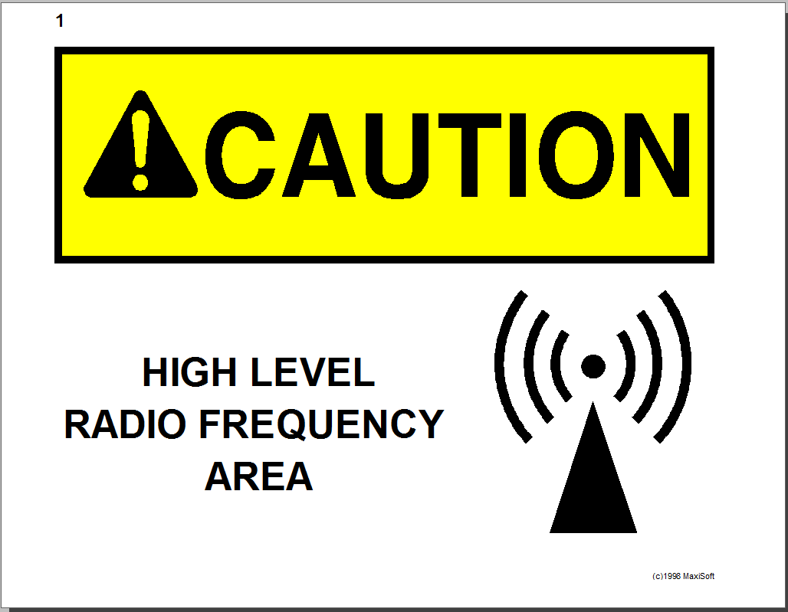

  - Update, Repair, or Maintenance to Warning Beacons and Labels
Anyone at Jefferson Lab may request new, update, repair, or maintenance to a magnetic field area hazard label.

- Contact the Magnet Owner and state the location of beacon or label needing review.
  - If it is determined that the device is defective, the owner will rectify the situation.
  - If no hazard is found – the owner informs the concerned party(s) of the determination.

- Revision Summary

Revision 1 – ##/##/## – Updated to reflect current laboratory operations.

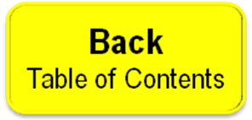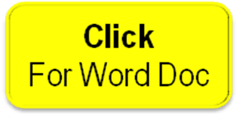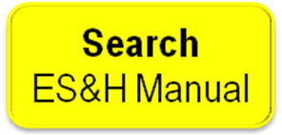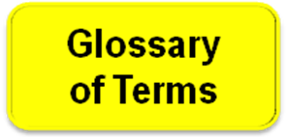

 | ISSUING AUTHORITY | TECHNICAL  POINT-OF-CONTACT | APPROVAL DATE | EXPIRATION DATE | REV.
 | ESH&Q Division | Jennifer Williams |  |  | 1
This document is controlled as an on-line file. It may be printed but the print copy is not a controlled document. It is the user’s responsibility to ensure that the document is the same revision as the current on line file. This copy was printed on 7/28/2026.

