 |  | TITLE: | ES&H Manual
DOCUMENT ID: | 6420 Appendix T1  Radio Frequency Survey
DRAFT

Jefferson Lab has determined that working with non-ionizing radiant energy carries an unmitigated Risk Code >2. At a minimum all tasks requiring with non-ionizing radiant energy are discussed with the supervisor prior to commencement of work. An Operational Safety Procedure (OSP) is written for work considered to be Risk Code >2 in accordance with ES&H Manual Chapter 3210 Work Planning, Control, and Authorization Process.

- Purpose

Jefferson Lab considers radio frequency (RF) energy to be a hazard issue. The degree of danger from RF energy is directly related to: the source power level; distance and shielding; and the frequency, or wavelength, of the radio waves. This appendix provides the process steps for determining when an RF survey is required; how to schedule it; performance and documentation requirements; and when follow-up actions are required.

- Scope

Sources of RF energy at Jefferson Lab include:

- Accelerator components, and
- Microwave ovens*

*This appendix does not apply to microwave ovens located a “common” or “break” areas, which are used in accordance with manufacturer’s instructions. Enter a Facilities Management Work Request if break area equipment is damaged or not working properly. Use of a microwave oven for other than manufacturer’s instructions is considered a Risk Code >2 and requires a Work Control Document.

RF is denoted with the following signage:

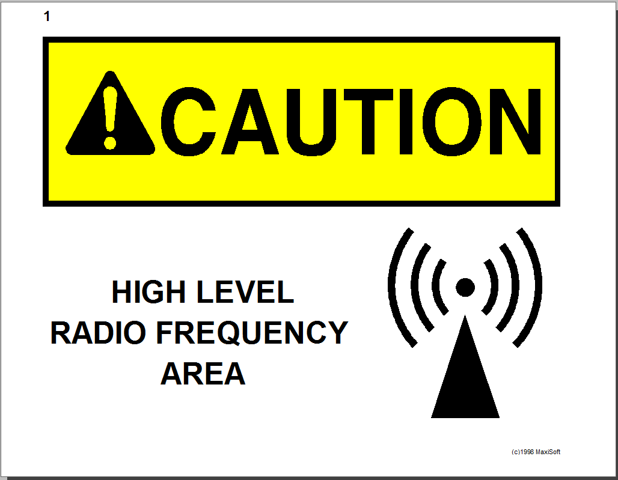

Jefferson Lab recognizes that listing the requirements for every RF source would be prohibitive, it is therefore required that an RF survey be performed on all sources; and safety mitigation established and observed by all workers.

The process steps for this procedure are performed in coordination with ES&H Manual Chapter 6420 Non-Ionizing Radiant Energy (i.e.: Radio Frequency (RF), Microwave, and Electro Magnetic) (Link to be established upon approval of document.)

- Responsibilities
NOTE: Management authority may be delegated at the discretion of the responsible manager.

  - Qualified RF Surveyor
- Complete and maintain appropriate RF Survey Training.

  - Industrial Hygiene
- Provide appropriate RF Survey Training.

- Process Steps

Unless otherwise stated anyone may perform the following process steps:

  - RF Survey

- Determine if a RF Survey is Required
An RF Survey may be performed at any time, is recommended for any of the following conditions, and is required per department procedures:

- Prior to commissioning new RF equipment;
- After installation leak test of high-power RF equipment, including waveguides;
- After changes to operating power for equipment set-ups.

NOTE: Check the RF emission frequency with the manufacturer; you may need to monitor for induced currents.

- Schedule
Contact a Qualified RF Surveyor (See Industrial Hygiene for a list of Qualified RF Surveys)

NOTE: It is recommended that safety interlocks be incorporated into RF equipment design and installation. Whenever feasible, high-power waveguides must be pressurized, with loss of pressure automatically deactivating the RF source.

- Perform and Document
Surveys are performed and recorded in accordance with documented department procedures that have been reviewed by Industrial Hygiene. (See Industrial Hygiene Supplement – RF Survey – Non-Ionizing Radiation for an example.)

Minimum survey requirements include:
- Date and Time – Provide both current and most recent
- Source Description
  - RF emission frequency
  - duty cycle
  - power
- Source Description/Schematic
- Safety Controls (i.e. interlocks, signs, Work Control Documents)
- Meter/Probe Information:
  - Model Number
  - Serial Number
  - Last Calibration Date
- Measurement
- Technician signature

- Follow-up
Contact Industrial Hygiene when fields exceed the occupational exposure limit below.

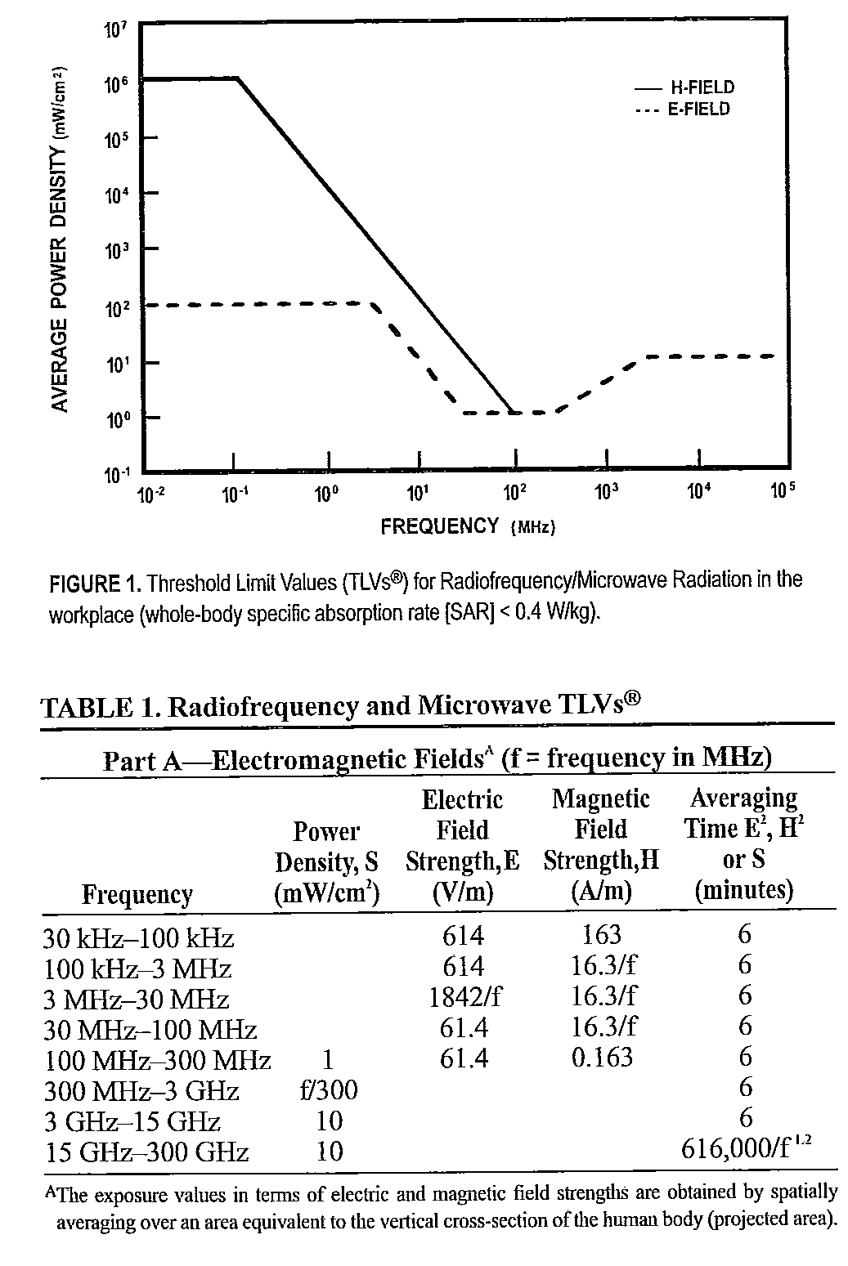

- References

ACGIH – 2005 TLVs and BEIs – Based on the Documentation of the Threshold Limit Values for Chemical Substances and Physical Agents and Biological Exposure Indices.

- Revision Summary

Revision 1 - ##/##/## - Updated to reflect current laboratory operations.

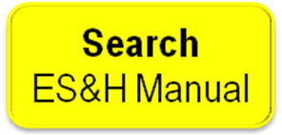

 | ISSUING AUTHORITY | TECHNICAL  POINT-OF-CONTACT | APPROVAL DATE | EXPIRATION DATE | REV.
 | ESH&Q Division | Jennifer Williams | 12/13/04 | 12/13/07 | 1
This document is controlled as an on line file. It may be printed but the print copy is not a controlled document. It is the user’s responsibility to ensure that the document is the same revision as the current on line file. This copy was printed on 7/31/2026.

