 |  | TITLE: | ES&H Manual
DOCUMENT ID: | 6112 Appendix T1  Interlock Bypass Procedure
DRAFT
- Purpose

Jefferson Lab’s Interlock Bypass Policy requires that bypasses be identified by an applied Interlock Bypassed tag and/or electronic entry in the Accelerator Bypassed-Interlocks Log (ABIL). Jefferson Lab employs the fail-safe practice of identifying bypasses before being installed and uninstalling bypasses before removing the associated identification.

This procedure outlines the administrative requirements for the identification, installation, and tracking of bypassed interlocks on equipment at Jefferson Lab.

NOTE: This policy does not apply to equipment associated with the Personnel Safety System (PSS), which is governed by the Jefferson Lab Personnel Safety System Configuration Control Policy.

Any maintenance or service work associated with hazardous energy sources is subject to Lock, Tag, and Try (LTT) as described in ES&H Manual Chapter 6110 Lock, Tag, Try (LTT) Program.

- Scope

It can be difficult to determine if a specific item is an interlock. For example, a water valve is not an interlock, but an associated sensor that detects water flow, temperature, pressure, or valve position and constrains the operation is part of an interlock.

Bypassing interlocks can be accomplished by installing a physical wire or jumper, modifying software, or changing process variables or setpoints. The specific steps to be used when bypassing system interlocks are determined by the status of the equipment (i.e., whether the equipment is “in-service” or “out-of-service”).

This appendix provides the process steps for safely installing and removing system interlock bypasses according to the status of the equipment.

This appendix is written in coordination with ES&H Manual Chapter 6112 Interlock Bypass Policy. All applicable content within the chapter applies to the procedure outlined in this appendix.

- Responsibilities

  - Qualified Individuals
- Determine the status of equipment for which the bypass is to be installed and follow the applicable process steps.
- Before installing bypass on equipment, ensure completed Interlock Bypassed tag is attached to equipment and/or an ABIL entry is made.
- After removing bypass on equipment, ensure Interlock Bypassed tag is removed and/or ABIL entry is updated.

- Process Steps

  - Status of Equipment

    - In-Service Equipment

Equipment is “in-service” when the physical, critical connections remain in place, even if a switch is thrown or a fuse is removed. Only actions like physically removing the equipment or disconnecting critical cabling change the status to “out-of-service”.

An Interlock Bypassed tag and ABIL entry are required for each bypass installed on “in-service” equipment, with exceptions outlined in Table 1.

Table 1 - Exceptions
IF | THEN
Changing a software process variable (e.g., masking a fast shutdown (FSD) node or bypassing an ODH head through software) | - ABIL entry is required.  - Interlock Bypassed tag is not required.
Immediate maintenance (i.e., bypasses made during repairs to correct conditions that impede the scheduled program) | - Interlock Bypassed tag is required.  - ABIL entry is not required.
- Interlock Bypassed tag is required.
- ABIL entry is required.

- Add new entry in ABIL (see 4.2.2).
      - If this is immediate maintenance, ABIL entry is not required; go to Step 2.
- Apply Interlock Bypassed tag (see 4.2.1).
      - If changing a software process variable, ABIL entry is required, but Interlock Bypassed tag is not required; go to Step 3.
- Install bypass.
- If equipment is still “in-service” at conclusion of immediate maintenance event:
  - Add new entry in ABIL (see 4.2.2).
  - Record serial number on applied tag.

    - Out-of-Service Equipment

An Interlock Bypassed tag is required for each bypass installed on “out-of-service” equipment. An ABIL entry is not required, unless the equipment is placed in service while the bypass is still in place.

- Apply Interlock Bypassed tag (see 4.2.1).
- Install bypass.
- If equipment is placed in service while bypass is still in place:
  - Add new entry in ABIL (see 4.2.2).
  - Record serial number on applied tag.

  - Identification of Bypass

    - Interlock Bypassed Tag (Figure 1)

- Complete Interlock Bypassed tag for each bypass:
  - Serial number generated by ABIL, if applicable;
  - Name of person installing bypass;
  - Date;
  - Purpose;
  - Location of the jumper; and,
  - Comments, as appropriate.

- Apply Interlock Bypassed tag in a location obvious to anyone who would be removing the bypass. This location may be on a larger piece of equipment that includes the equipment for which the bypass is installed.

Figure 1 - Interlock Bypassed Tag
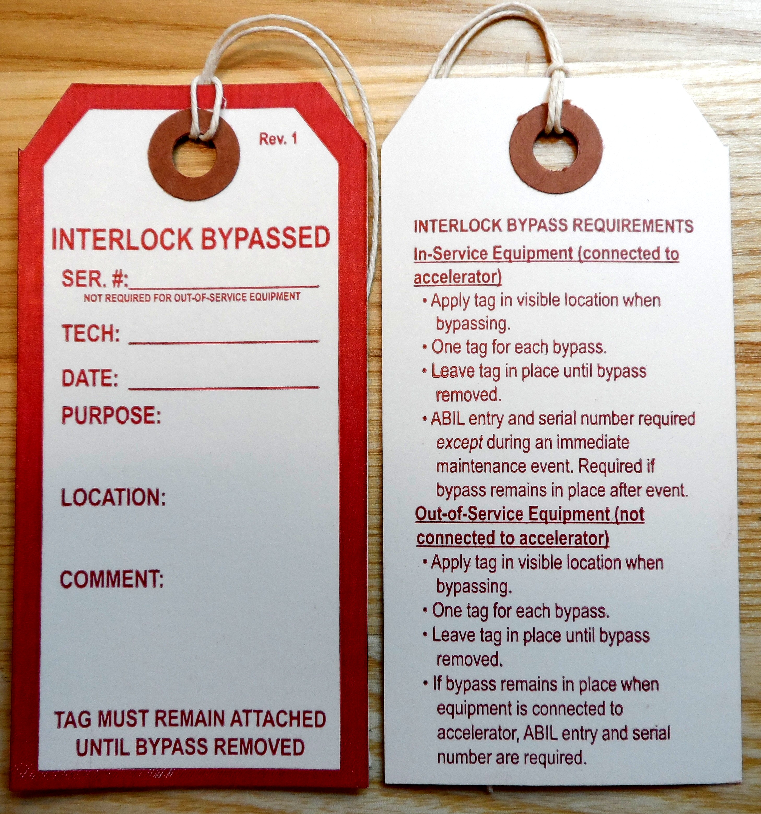
Front Back

    - ABIL Entry (Figure 2)
- Hover mouse over gray tabs near top of webpage for description/examples of fields.
- Click “Add New” in the Accelerator Bypassed-Interlocks Log (ABIL).
- Enter requested information, and be sure function and purpose are clear. “Function” describes what the interlock does; “Purpose” describes the reason for leaving bypass installed.
- Record serial number generated by ABIL on associated Interlock Bypassed tag, if applicable.

Figure 2 - Screen Shot of ABIL
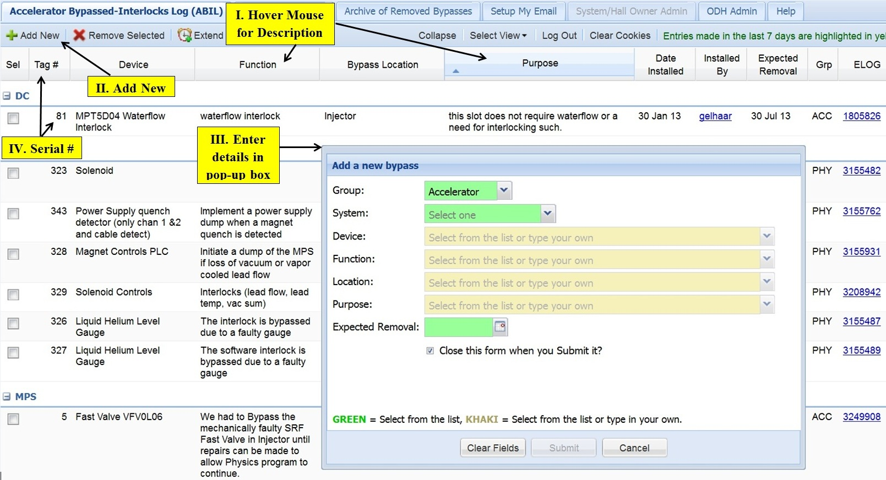

  - Removal of Bypass

When a system interlock bypass is removed from the equipment, perform the applicable step(s):

- Uninstall bypass.
- Remove applied Interlock Bypassed tag from equipment.
- Update appropriate ABIL entry.

Revision 0 – ##/##/## – New content written to reflect current laboratory operations.



 | ISSUING AUTHORITY | TECHNICAL POINT-OF-CONTACT | APPROVAL DATE | REVIEW REQUIRED DATE | REV.
 | ESH&Q Division | Ron Lauze | ##/##/13 | ##/##/16 | 0
This document is controlled as an on line file. It may be printed but the print copy is not a controlled document. It is the user’s responsibility to ensure that the document is the same revision as the current on line file. This copy was printed on 7/29/2026.

