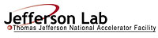 |  | TITLE: | ES&H Manual
DOCUMENT ID: | 6200 Appendix T6  Electrical Code Equivalency Procedure
- Purpose

When compliance with electrical codes or standards cannot be satisfied Jefferson Lab allows alternative mitigation to be considered (as long as it provides the same or greater level of protection). This procedure provides the process steps for initiating a request, and its review and approval, to ensure an adequate level of safety.

- Scope

The Electrical Authority Having Jurisdiction (EAHJ) uses this procedure when electrical work cannot comply with electrical codes or standards.

This procedure is used to granting special permissions (equivalencies) regarding implementation of rules and practices of Occupational Safety and Health Administration, National Fire Protection Association, and other standards applicable to site electrical facilities, systems, equipment, and operations.

Perform the process steps for this procedure in coordination with ES&H Manual Chapter 6200 Jefferson Lab’s Electrical Safety Program.

- Responsibilities
NOTE: Management authority may be delegated at the discretion of the responsible manager. EAHJ responsibilities cannot be delegated without TJSO acceptance.

  - Anyone at Jefferson Lab
- Initiate an electrical code equivalency request using the Electrical Code Equivalency Request Form.

  - Supervisor/Mentor (Sponsor)
- Review equipment, installation, or process to determine legitimacy of request.

  - Electrical Authority Having Jurisdiction (EAHJ)
- Provide a determination for Electrical Code Equivalency Requests.
- Distribute the completed form as appropriate.

  - Electrical Safety Committee (ESC):
- Review and provide comments, as warranted, to requests.
- Discuss and record equivalency determinations as part of ESC Minutes.

- Process Steps
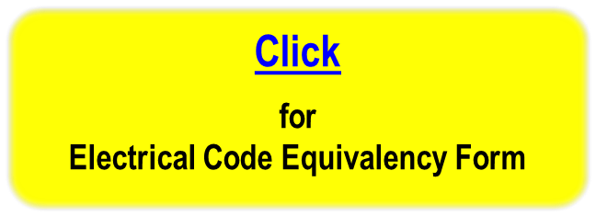
  - Initiate the Request

- Identify the Equipment, Installation, or Process
Be as specific as possible. Include diagrams, pictures, etc. if appropriate, to identify the issue.

- Location of the Work
Be as specific as possible. Include the building number, room number, or distance from the nearest landmark.

- Description of the Work
Provide details as to the work assignment and its objective.

- State the Specific Problem or Question. List the specific code and section(s) that requires equivalency.
Describe why the work cannot be accomplished in accordance with the code.

- Describe the Proposed Mitigation – to satisfy the electrical safety equivalency.
Provide a description of what could be done to mitigate the hazard to a level at or below that provided by the Code.

- Signatures
Discuss the request with the work supervisor. If, upon review, it is agreed that the request is legitimate, sign as indicated and submit to the EAHJ.

- Submittal
Submit the form to the EAHJ for determination.

  - Determination

Review the request. Provide copies to members of the Electrical Safety Committee for review and comment if appropriate.

- Scope Statement
Grant or deny the request for the identified equipment, installation, or process. If the request is applicable to other issues, describe.

- Specific Code and Section(s) Used
Provide a justification for the determination whether “Approved” or “Denied”.

- Explain Determination
IF  Request is: | THEN
Approved | - Include an explanation of the electrical safety aspects.  - Enter determination into the Jefferson Lab Corrective Action Tracking System (CATS) including an inspection date to ensure compliance.
Denied | - Provide reasoning and, if applicable, alternative(s).

  - Signatures
- Both the EAHJ and the Electrical Safety Committee Chair sign and date the “Determination” to denote an adequate review.

  - Distribution
- The EAHJ retains the final requests. (These records are available at https://jlabdoc.jlab.org/docushare/dsweb/View/Collection-19892 ).
- Distribute copies of the completed form to individuals as appropriate.

- Revision Summary

Revision 0 – ##/##/## – New content to reflect current laboratory operations.
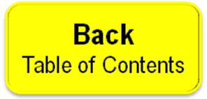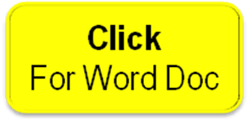
 | ISSUING AUTHORITY | TECHNICAL POINT-OF-CONTACT | APPROVAL DATE | REVIEW REQUIRED DATE | REV. | Page  4 of 4
 | ESH&Q Division | Todd Kujawa |  |  | 0 | Page  4 of 4
This document is controlled as an on line file. It may be printed but the print copy is not a controlled document. It is the user’s responsibility to ensure that the document is the same revision as the current on line file. This copy was printed on 7/30/2026.

