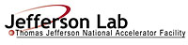 |  | TITLE: | ES&H Manual
DOCUMENT ID: | 6200 Appendix T7  Electrical Authority Having Jurisdiction (EAHJ)
- Purpose

This procedure outlines the responsibilities of the Electrical Authority Having Jurisdiction (EAHJ) position at Jefferson Lab.

- Scope

The EAHJ provides electrical codes clarification or equivalency determinations when requested.

The EAHJ’s authority does not extended to regulation, standards or codes that fall under the regulatory authority of Occupational Safety and Health Authority (OSHA) unless incorporated by reference and includes an EAHJ, or similar, provision.

Perform the process steps for this procedure in coordination with ES&H Manual Chapter 6200 Electrical Safety Program.

- Responsibilities
NOTE: Management authority may be delegated at the discretion of the responsible manager.

  - Anyone at Jefferson Lab
- Initiate an electrical code equivalency request to the EAHJ for a code equivalency determination.

  - EAHJ
- Receive requests for code equivalency.
- Provide clarification or equivalency determinations.
- Standing member of the Electrical Safety Committee.

  - Environment, Safety, Health, and Quality Associate Director
- Nominate an individual, in compliance with requirements.

  - Laboratory Director
- Submit nomination to Thomas Jefferson National Accelerator Facility – Site Office (TJSO) for acceptance.
- Upon TJSO acceptance, authorize the EAHJ appointment.

- Process Steps

  - Receive Request

- The EAHJ receives requests formally (e.g., via Electrical Code Equivalency Form) or informally (e.g., via verbal discussion, e-mail) for Code Clarification or Equivalency by anyone at Jefferson Lab.
- The EAHJ determines the appropriate response, either a Clarification or an Equivalency.

  - Determine Clarification or Equivalency

    - Clarification

- Determine if a code applies, but is misunderstood.
- Can the code be followed?

IF | THEN
YES | Provide clarification to Requestor.
NO | Considered this an equivalency. Go to 4.2.2 Equivalency. Provide equivalency requirements per ES&H Manual Chapter 6200 Appendix T6 Electrical Code Equivalency Procedure include documenting activities within the Jefferson Lab Corrective Action Tracking System.

- Report Clarification to Electrical Safety Committee for documentation.

    - Equivalency

- Determine if a code applies.

IF | THEN
YES | Considered this a clarification. Go to 4.2.1 Clarification.
NO | Provide equivalency requirements per ES&H Manual Chapter 6200 Appendix T6 Electrical Code Equivalency Procedure including documenting activities within the Jefferson Lab Corrective Action Tracking System.

- Report Equivalency to Electrical Safety Committee for documentation.

  - Flow Chart

- References

- National Fire Protection Association (NFPA) 70E
- NFPA 70 National Electric Code
- Occupational Safety and Health Administration
- National Electrical Safety Code

- Revision Summary

Revision 0 – ##/##/## – New Content to reflect current laboratory operations.
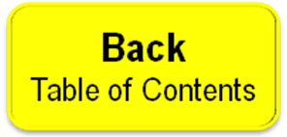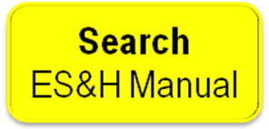
 | ISSUING AUTHORITY | TECHNICAL POINT-OF-CONTACT | APPROVAL DATE | REVIEW REQUIRED DATE | REV.
 | ESH&Q Division | Todd Kujawa |  |  | 0
This document is controlled as an on-line file. It may be printed but the print copy is not a controlled document. It is the user’s responsibility to ensure that the document is the same revision as the current on line file. This copy was printed on 7/28/2026.

