**Initial Setup**

Put halls on warm return (Requires Action by the Individual Halls)

Isolate cold returns to halls (Closing CEV6721A/B/C)

Isolate ESR1 LN2 supply in valvebox (Closing CEV675SC, CEV6751A/B/C)

Shutdown T1 and T2, Isolate coldbox HP and let coldbox and halls depressurize to LP/recovery

Open dewar vaporizer (CEV6764)

**Pull U-tubes from Cold Box.**

ESR CB Primary Return

* Verify PV6637 is closed (it should be from when T1 was turned off)
* Verify that pressure is low via CPI672
* Pull U-Tube

ESR CB Primary Supply

* Verify PV6618 is closed.
* Verify that pressure is low via CPI671
  + (If not, open CEV6761 or CEV6712+CEV6713)
* Pull U-tube

ESR CB 15K Supply

* Verify PV6614 is closed
* Verify pressure is low via CPI6614/CPI673
* Pull U-tube

ESR CB 20K return

* Verify that CBX MP Return MV662 is closed and pressures CPI6621/CPI6624/CPI674 show depressurized (One can exclude CPI6624 if T1 Outlet valve is closed)
* Pull U-tube

ESR CB LN2 Supply

* Verify that CEV675SC is closed.
* Verify that pressure CPI675 is low.
* Pull U-tube.

ESR CB VN2 Jumper

* Verify that CEV675SC is closed.
* Verify that pressure CPI675 is low.
* Pull U-tube.

**Install ESR2 TL Primary Return**

* **Verify that PI672 is low and that ESR2 CPI61019 is low.**
* **Install Utube**

**Install VN2 supply to ESR2 TL**

* Reconfigure valve box EV to look at ESR2 boiler set point = ~60%, limit max ~30%?
* **Install Utube**

**Pull dewar u-tubes (subcooler supply and return)**

* Shutdown ESR2 T3 and T4, clamp T4 bypass closed to let PS depressurize
* Verify depressurization of both sides with CPI671 and CPI61034
* **Pull Utubes**

**Install ESR2 dewar subcooler return u-tube**

* Isolate ESR1 dewar supply CEV6761

Isolate halls supplies (maybe just let their supply valves go to the minimum and do nothing with them…) CEV6711A/B/C

* Allow T4 bypass to pressurize PS
* Restart T3 and T4
* Open hall supply valves to cool the lines to warm return. (this happens on its own if we do nothing)
* Reconfigure ESR1 dewar to control liquid level in dewar (try to crack valve to keep it cold?)

**Install CHL 4K supply to ESR2 U-tube**

* Stick utube
* Cool and fill halls, transition them back onto cold return

**Inside U-tubes**

Pull:

ESR CB Primary Return

ESR CB Primary Supply

ESR CB 15K Supply

ESR CB 20K return

ESR CB LN2 Supply

ESR2 Xferline VN2 Jumper

Stick:

ESR1 VB Primary Return to ESR2 Transferline

ESR1 VB VN2 to ESR2 Transferline

**Outside U-tubes**

Pull:

Dewar 1 Subcooler Supply

Dewar 1 Subcooler Return

Stick:

Dewar 2 Subcooler Return

Dewar 2 CHL 4K Supply

**Break, recover plant and halls**

**ESR2 Target U-tubes**

Pull:

Test Heater Supply

Test Heater Return

Stick:

ESR2 15K supply to TS1

**ESR1 Target U-tubes**

Stick:

ESR1 VB Target Return to ESR2 Transferline

ESR1 VB Target Supply to ESR2 Transferline

**Optional**

Pull:

TS2 turn-around jumper

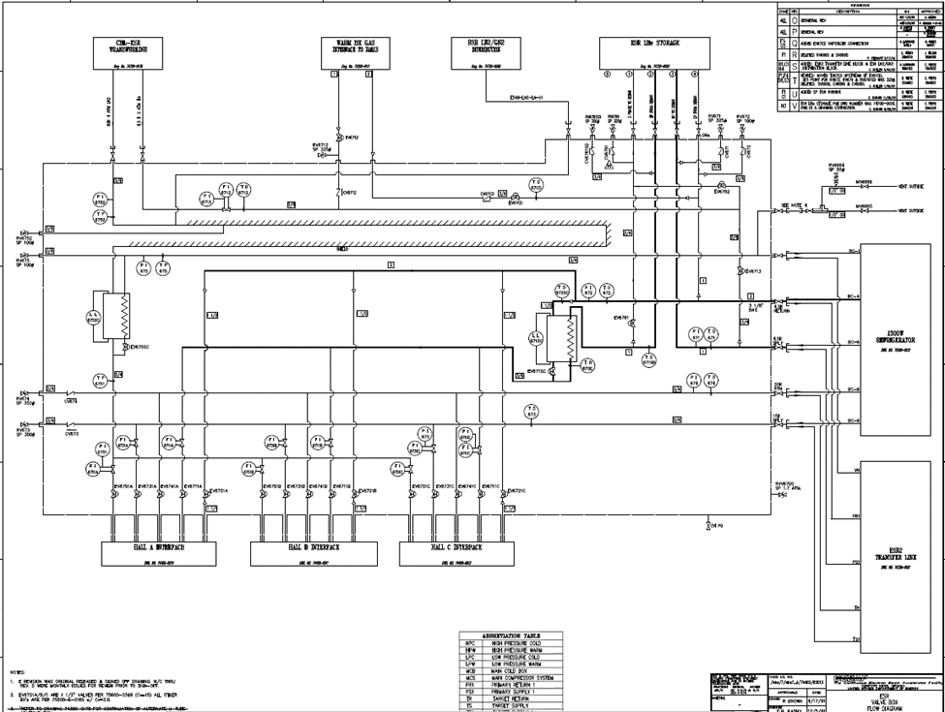

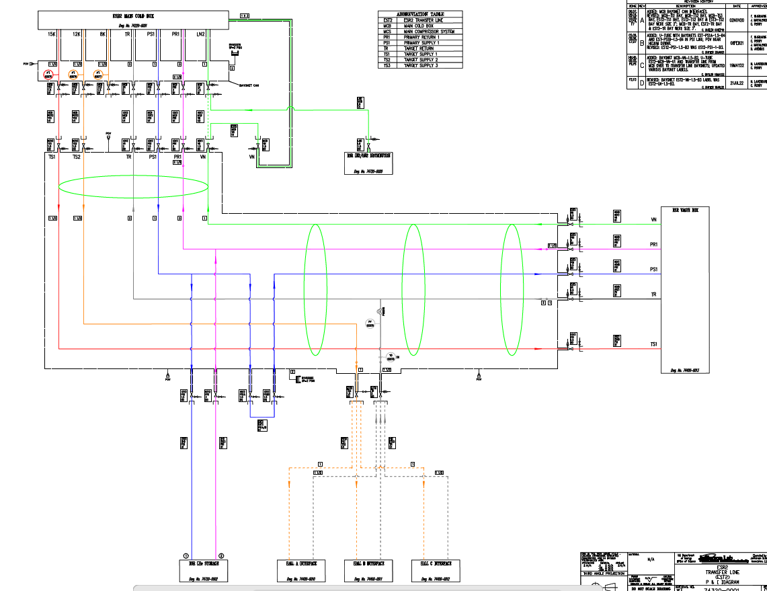

Test heater

Heater

Heater