FFA@CEBAF Working Group | Minutes

Meeting date | time 1/28/2022 | 11 AM EST | Meeting location (virtual) https://jlab-org.zoomgov.com/j/1614898082?pwd=TnUzMS81M2sxbDZIbERJU01tYkJCQT09
 | Attendees  Ryan, Kitty, Vasiliy, Andrei, Jay, Stephen, Scott, Dejan,
  Meeting called by | Alex
  Type of meeting | Weekly Meeting
  Facilitator | Ryan
  Note taker | Ryan
  Timekeeper | Alex

Intro discussion
.

Agenda topics

Time allotted | 45 minutes | Agenda topic Adiabatic Arc | Presenter Vasiliy/Randi
- Couple of solutions, but Vasiliy doesn’t like them.
  - 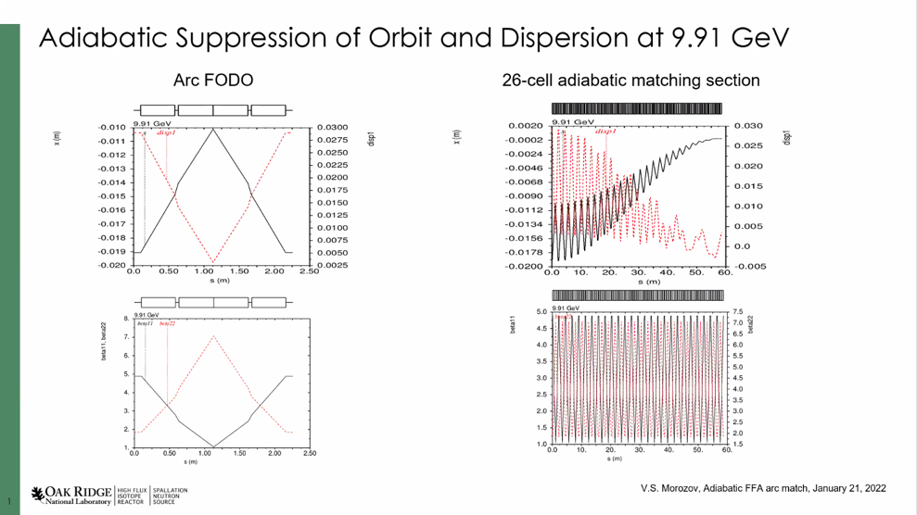
  - Looks like best approach is to break into two parts: 1st match orbits and suppress dispersion
    - Works well with adiabatic matching procedure from BNL colleagues
    - Phase advance/cell basically constant
      - Offset on dispersion goes down, transverse optics basically constant
      - True for all energies:
      - 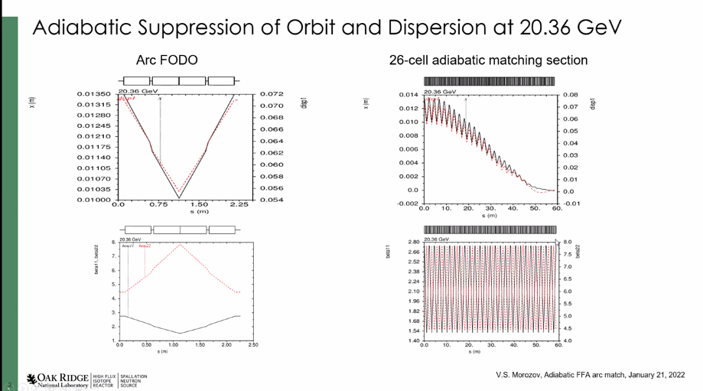
    - Then need to match beta
      - Can’t keep phase advance constant
      - 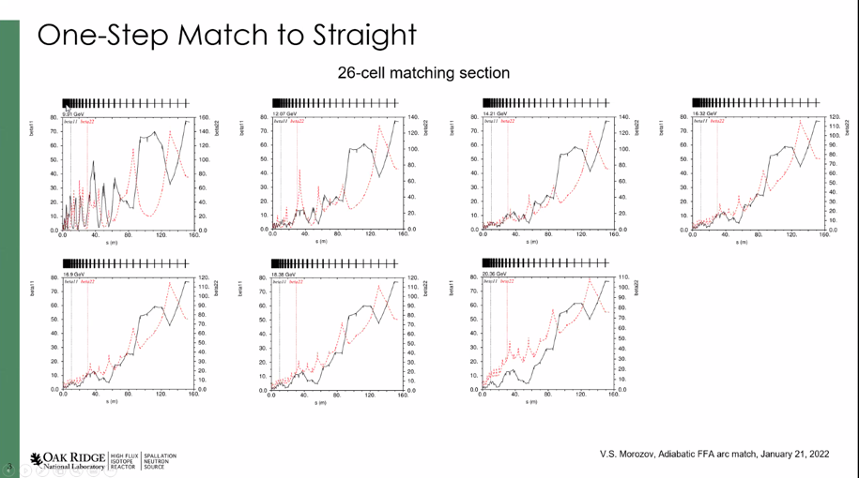
      - Adjusted using the scaling factor from adiabatic matching procedure
        - Cell length gets longer, approaches the geometry of the straight cells
    - Another attempt:
    - Start from straight, gradually reduce length of cells until beta drops to the right level
    - 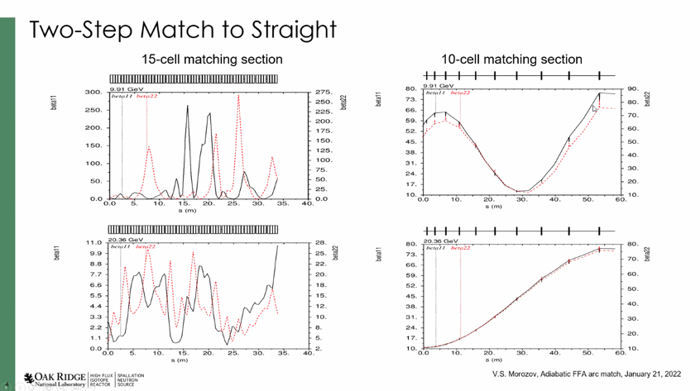
    - Match exit of first part into the linac
      - Looks ugly at lower energy
      - Shorter/more compact (70 m savings)
- Another look at matching:
  - Relaxed the strengths of the quads in the matching significantly so that the betas grow at the top energy and at the lowest, there’s only 1 oscillation
  - 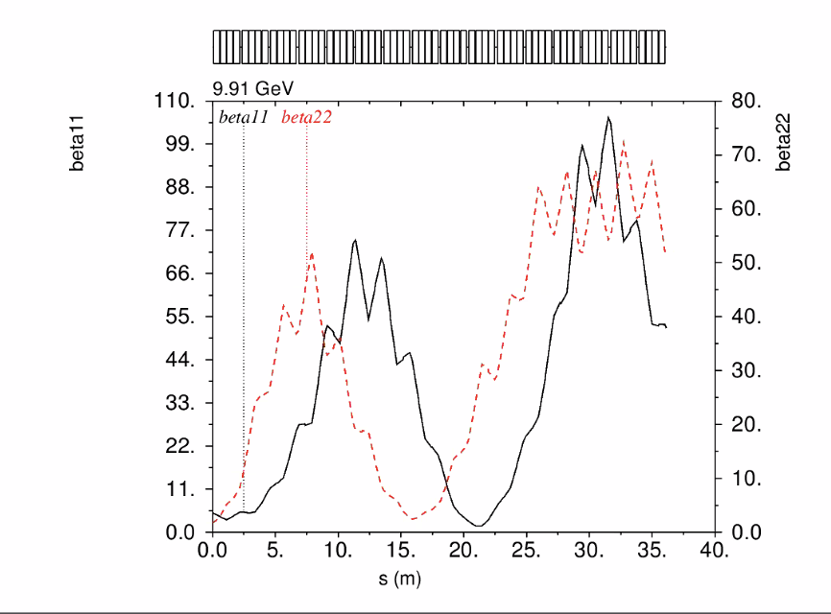
  - 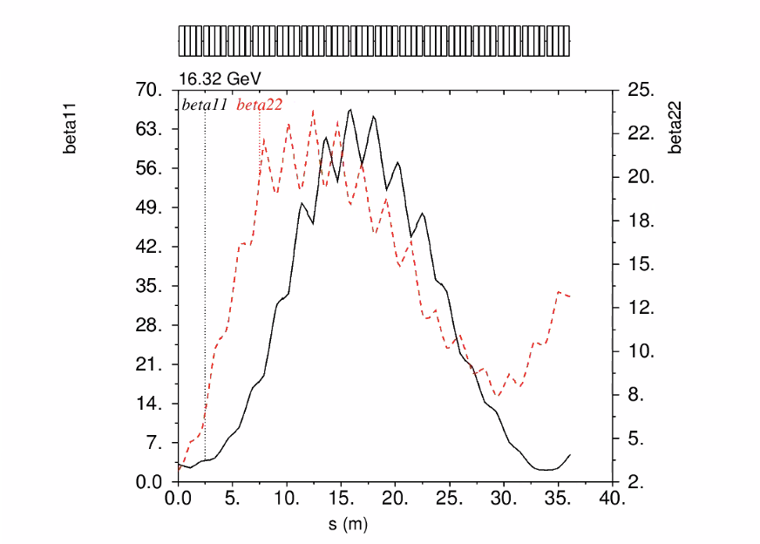
  - 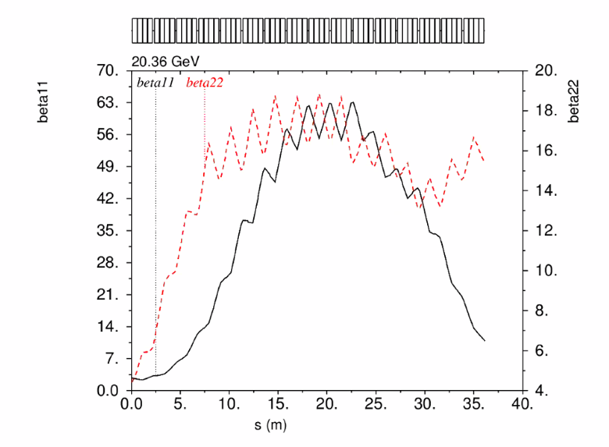
- Dejan – the optics are between the cryomodules?
  - Yes
  - At Cornell, the modules were all 9 m. What I gave to Vasiliy, I was able to match the betas and orbit adiabatically
    - But the distance between the quads was ~3-5 m instead of ~9 m that we have.
    - Is the range too large to deal with?
  - Can we change the LINAC optics a bit to better accommodate the arc-to-linac matching?
- Stephen: LINAC optics at the highest energy is basically a drift anyway. Not much else you can do with the linac
  - In ERIC – we matched, but had a splitter for every energy.
  - Might need something like this for matching anyway
  - So do some matching, then remainder of matching in splitter lines. (11 lines in total)
- We’ll need to split the beams apart anyway, so why not quads in separate lines?
  - Can we combine 2 passes into each splitter?
  - Scott: main issue with focusing in splitter lines is R56 control. Comes down to how tightly you want/need to combine that.
    - Can combine 2ish passes in a line and it’ll be ok, depending on needs.
    - Stephen: also need TOF, so there will be some places where they all need to be separate. Will definitely need a separate line for each pass at some point.
      - Dejan: not against matching TOF and R56 in separate part of splitters. But the area is very dense, and we may need to combine in some areas.
    - Scott: subdividing, subdividing, subdividing
- Vasiliy: 6 passes split into 2-3 lines, split further for TOF and R56, etc…
- Jay: Linacs are ~260 m
- Let’s forget about Dejan’s method and focus on splitting. We’ll need this for turn-by-turn tuning anyway.
  - Stephen has magnets that can help with this.
- How do the RF separators work? Stephen and Jay discussed
  - Not too much different for extraction for FFA vs RF Sep.
  - Could we put an RF deflector in an FFA line that already has 3-4 beams in it? Better than separate lines?
  - What energies do the halls want?
    - Jay will ask
    - Do they want/need different energies? Dynamic, or infrequent changes?
      - If infrequent, we can just remove magnets. But it’ll require more space if they need dynamic changes.
- Dave D. put 30 modules in the NL, and 20 in the SL to free up 50 m at the end of the SL for higher E separation and extraction.
  - This might necessitate getting rid of Hall D…maybe? Maybe re-design that section to Hall D instead?
Conclusion
Getting this matching done is becoming more complicated, but is high-priority.
Action items | Person responsible | Deadline

Time allotted | 15 minutes | Agenda topic AOB | Presenter All
- Let’s organize a tour of the lab once things settle down COVID-wise.
  - Could be virtual in the meantime, but in-person would be far more beneficial.
- We have a new email list, to simplify emailing the group. If you simply email ffa_cebaf_collab@jlab.org, it will come to everyone in the group.
  - If anyone is to be added or removed, please let Ryan or Alex know and we can do so. Or we can make you a moderator as well.
Conclusion

Action items | Person responsible | Deadline

Special notes

Pathway to Repository: https://jeffersonlab-my.sharepoint.com/:f:/r/personal/tristan_jlab_org/Documents/Grad%20Student%202019/Graduate%20Student%20Steering/CEBAF%20FFA%20Working%20Group?csf=1&web=1&e=78bf9R

