FFA@CEBAF Working Group | Minutes

## Meeting date | time 2/4/2022 | 11 AM EST | Meeting location (virtual) <https://jlab-org.zoomgov.com/j/1614898082?pwd=TnUzMS81M2sxbDZIbERJU01tYkJCQT09>

|  |  |  |  |  |  |  |  |  |  |  |  |
| --- | --- | --- | --- | --- | --- | --- | --- | --- | --- | --- | --- |
| |  |  | | --- | --- | | Meeting called by | Alex | | Type of meeting | Weekly Meeting | | Facilitator | Alex | | Note taker | Ryan | | Timekeeper | Alex | | Attendees  Ryan, Scott, Kitty, Stephen, Kirsten, Andrei, Randika, Dejan, Alex B., Vasiliy, |

# Intro discussion

# Agenda topics

## Time allotted | 45 minutes | Agenda topic Pathlength Chicanes | Presenter Scott

* Let’s do better!
* Splitters: what do they do?
  + 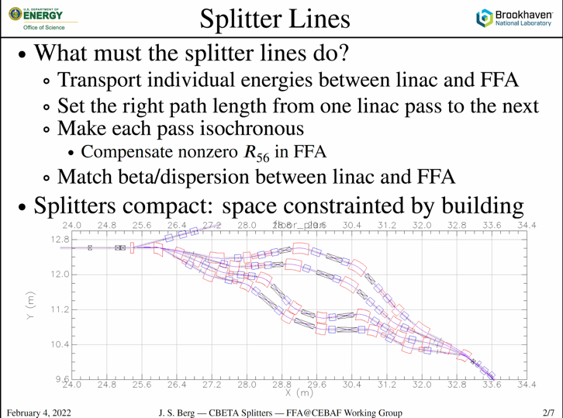
  + FFA gives you an R56 that you’re stuck with
    - Return arc at CEBAF is a bit longer
  + CEBAF will also have space constraints
  + All of the space in the above is actually occupied. There is not any unoccupied space
* ALLOW AS MUCH SPACE AS YOU CAN ALLOW! Be generous – you’ll need it.
* FFA Path Length, R56
  + 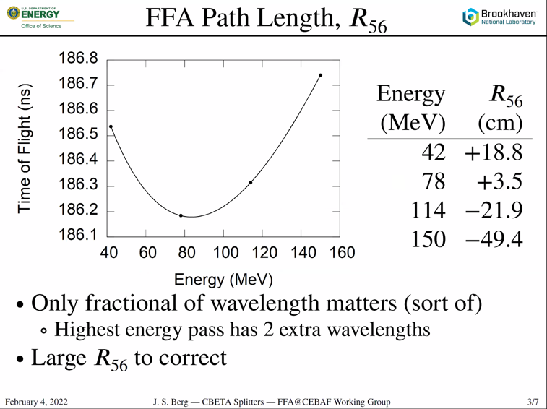
  + Shouldn’t be this bad in CEBAF – but won’t be much better either
    - FFA could only go so far in helping
  + Fractional wavelength is the only thing that matters – probably won’t have this many constraints unless RF extraction makes problems
  + Top line was 2.5 wavelengths longer, for example
  + R56s are huge – trying to fix them in very compact splitter lines.
    - Note, there are positive and negative values
* Matches:
  + 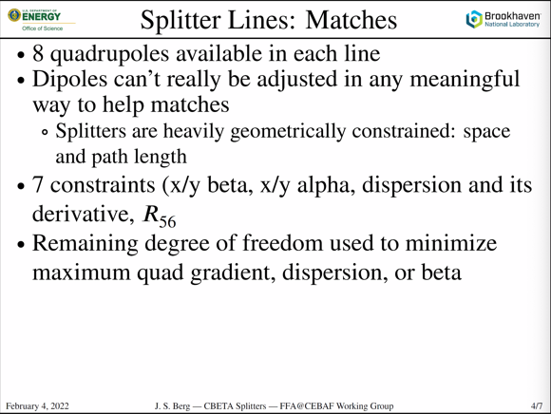
  + Alex: if you can do this symmetrically, then some will cancel
    - But we can’t be symmetric at CBETA
  + Beta function from linac is ~22 m, but in the FFA is ~1 m in CBETA
* 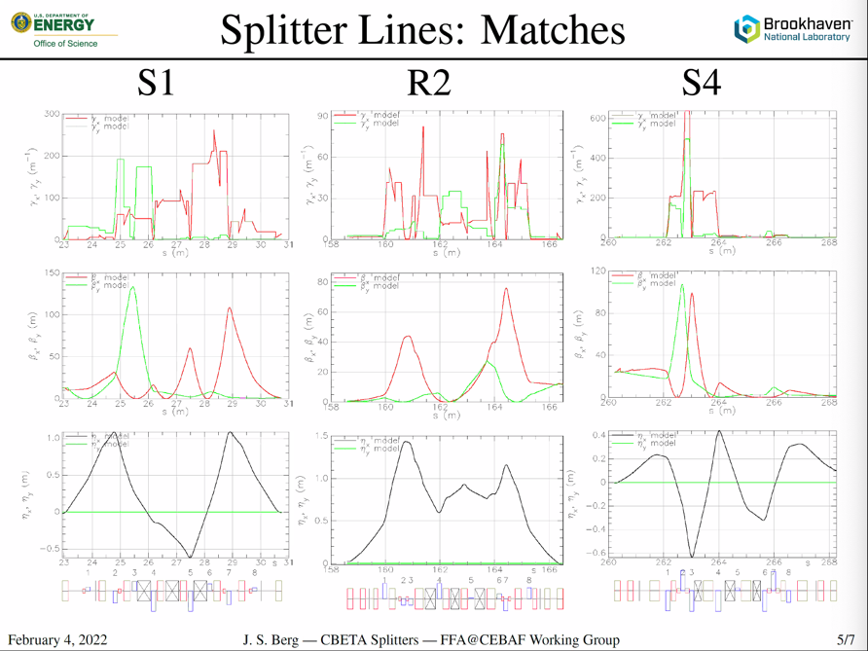
  + Middle is beta, bottom is dispersion, top is Twiss gamma (related to chromaticity)
  + This is BAD – but could be worse
  + What’s causing the chromaticity? See how the beta drops to 0? Desperation matches
    - Dispersion combined with R56 is what’s killing you
* 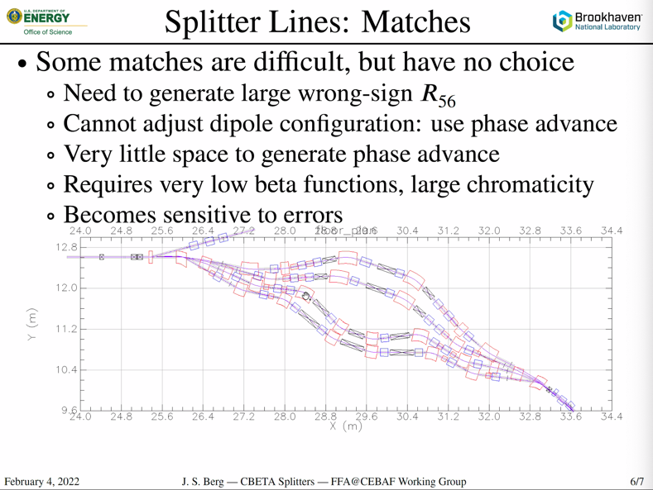
  + Central dipoles are doing the heavy lifting for dispersion correction
  + Also crucial for getting from A to B – so stuck with them
  + Very limited controls over the start/end dipoles because they are simply for controlling the beam trajectory coming in/exiting the splitter
  + Quads end up having to help more than “normal”
    - Use phase advance to move around the “normalized dispersion plane” – once you get to a dipole, you have to be at the right place to change the dispersion
      * Impacts R56 and dispersion closure
* At high E, positive momentum is positive. Opposite at low E
  + Need to generate opposite momentum compactions at each end
    - Need negative dispersion at the two central dipoles for the high E
      * Wrong directions at each place due to separation dipoles – gotta think about this. Can take the scenic route!
  + If the splitter went in the other direction, it would have been much nicer
* Would be good to come into this already addressing some of the dispersion, etc… concerns. So we should be aware of this early, and be ready to “break walls” if needed.
  + There will likely still be some brute-force matching
* Multi-function magnets MAY help, or may create more problems in the cross-planes. Worth looking into.
* Separation:
  + 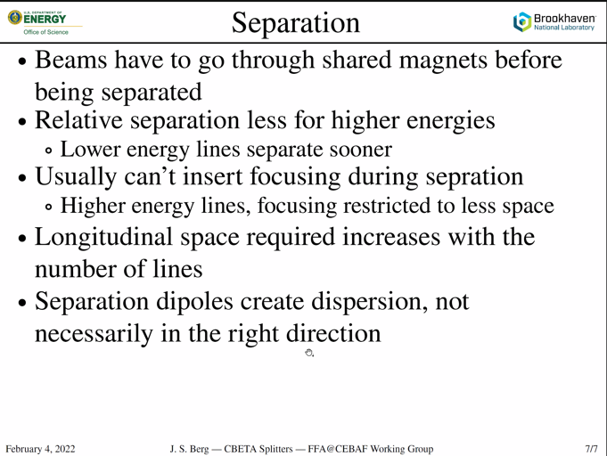
* Bring the splitters into consideration sooner than later, since they may take up more room than expected.
* Stephen, CEBAF will be ~144 times larger – if you stretch this by 12X, you’d have a splitter that works for CEBAF.
  + Take length (~8 m) by 12 = 96 m.
  + Assuming same lattice used
  + At least the CEBAF beams will be closer in relative energy to each other – will make things easier
* Might need defocusing or multifunction more than dipoles
  + Remember defocusing does wrong thing to dispersion
* You’re trying to create path length difference, which is created by angle. So you do need to have some amount of bend angle
  + Angle X Length is pathlength difference
* CBETA max orbit separation was 5 cm from one side to the other
* ~2 m difference between lowest and highest E beamlines at CEBAF
* Stephen Magnets:
  + 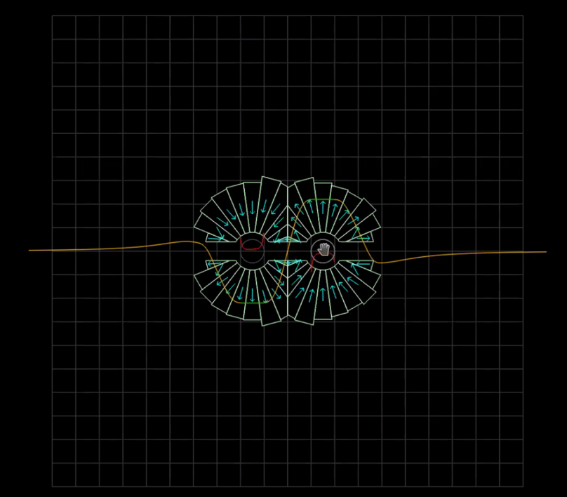
  + Open midplane – fields opposite, 3 cm separation between beams
  + Whole two magnets are less than 20 cm
* Might be worth looking at arc cell design that sits around minimum of parabola
  + Magnets already on the edge of being possible…but optimizing for TOF might make magnet and SR concerns worse
* Using combined-function magnets:
  + Dejan had 2 designs for momentum compaction = 0
    - 1 done with combined function magnets
      * Dramatically better
      * Better packing
      * Better dispersion
      * Better beta
  + In the middle of the splitter is where it is best to use combined function magnets
    - On the ends, not really in a place where you can help anything except orbit separation
  + Stephen – will we have 2 or 4 splitters?
* We need well defined point A and point B in order to do this.
  + Define canvas based upon drawings, etc…

Conclusion

Need to determine boundary conditions first, then move forward!

|  |  |  |
| --- | --- | --- |
| Action items | Person responsible | Deadline |
| Get the files for the optics around the splitter/matching | Kitty/Ryan |  |

## Time allotted | 15 minutes | Agenda topic AOB | Presenter All

* Not in meeting, but mentioning:
  + Be aware of DOE rules for travel. Looking into options for a tour/visit of CEBAF, but will rely heavily on DOE travel restrictions.
  + Requires some relatively significant planning time, but have started looking into it here at JLab.

Conclusion

|  |  |  |
| --- | --- | --- |
| Action items | Person responsible | Deadline |
|  |  |  |

## Special notes

Pathway to Repository: <https://jeffersonlab-my.sharepoint.com/:f:/r/personal/tristan_jlab_org/Documents/Grad%20Student%202019/Graduate%20Student%20Steering/CEBAF%20FFA%20Working%20Group?csf=1&web=1&e=78bf9R>