FFA@CEBAF Working Group | Minutes

## Meeting date | time 2/11/2022 | 11 AM EST | Meeting location (virtual) <https://jlab-org.zoomgov.com/j/1614898082?pwd=TnUzMS81M2sxbDZIbERJU01tYkJCQT09>

|  |  |  |  |  |  |  |  |  |  |  |  |
| --- | --- | --- | --- | --- | --- | --- | --- | --- | --- | --- | --- |
| |  |  | | --- | --- | | Meeting called by | Alex | | Type of meeting | Weekly Meeting | | Facilitator | Alex | | Note taker | Ryan | | Timekeeper | Alex | | Attendees  Ryan, Alex, Kitty, Jay, Probir, Todd, Andrei, Scott, Dejan, Stephen |

# Intro discussion

Positron Source Review: <https://arxiv.org/abs/2202.04939>

Nonlinear dynamics modeling/expt using MADX <https://arxiv.org/abs/2202.04864>

# Agenda topics

## Time allotted | 30 minutes | Agenda topic Real Estate 4 Chicanes | Presenter Alex/Kitty

* 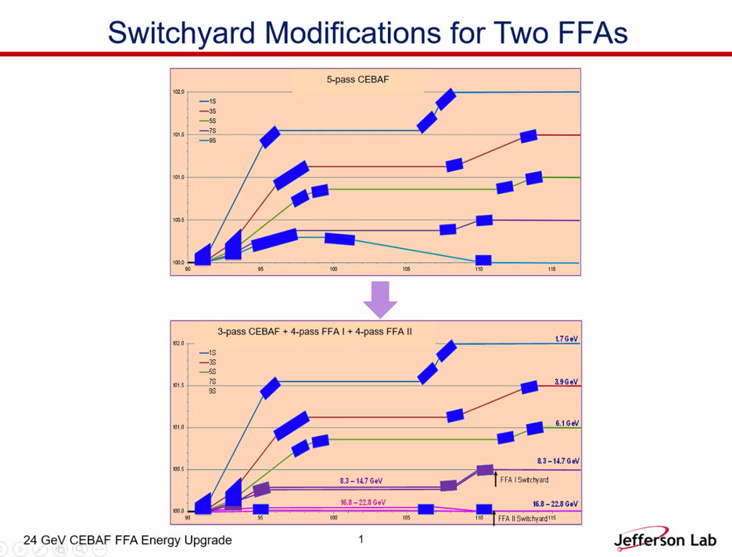
  + SE corner switchyard
  + Will need to be modified, maybe like bottom
* 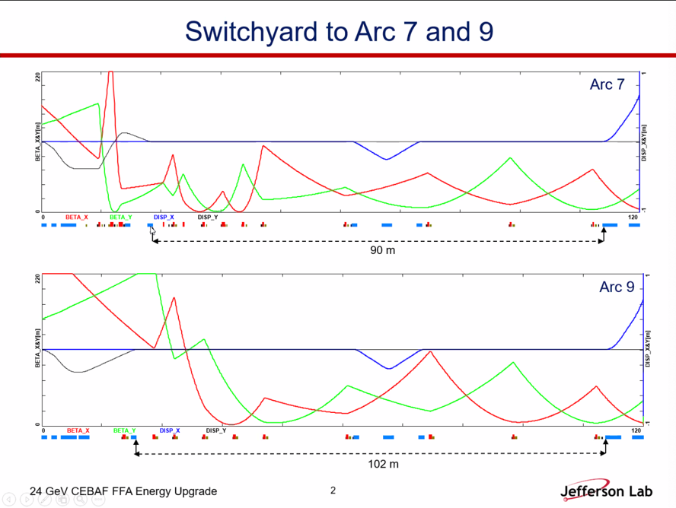
* We have about 90 m of longitudinal space to start configuring chicanes
  + Presently have a dogleg here
  + FODO structure to do matching from spreader to arc
* The question is: what do we have for transverse space?
* 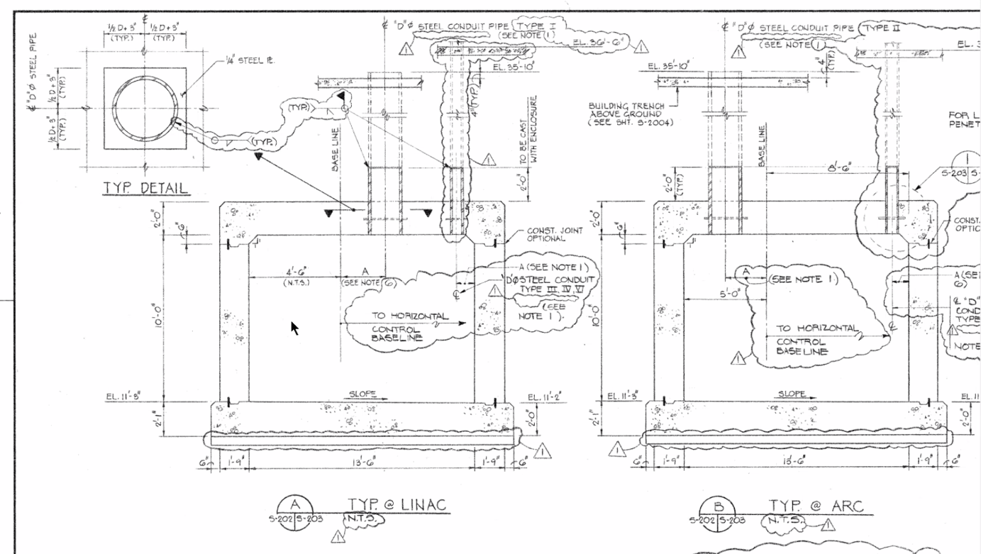
  + 13’6” X 10’ tall in linac
  + 15’6” X 10’ in ARCs – but maybe actually 13’6” (?)
  + Penetrations on wall side
* NE Junction:
  + 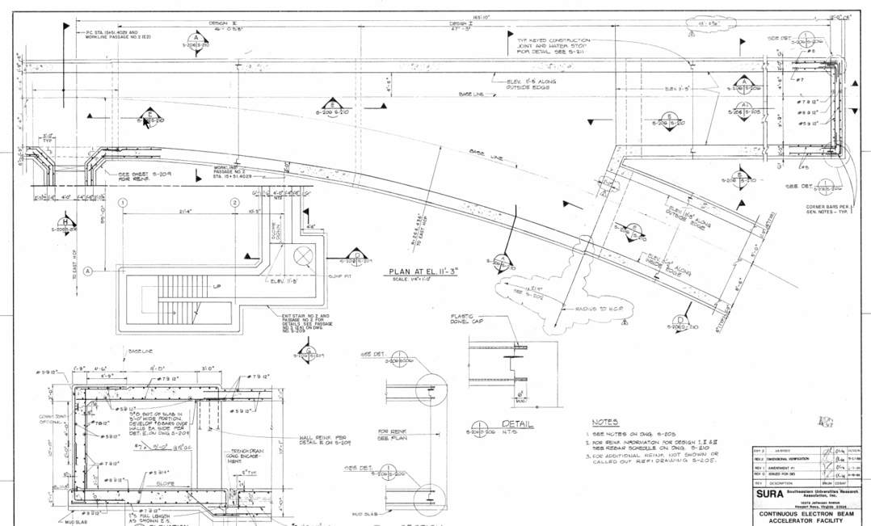
  + 5’6” added on
  + 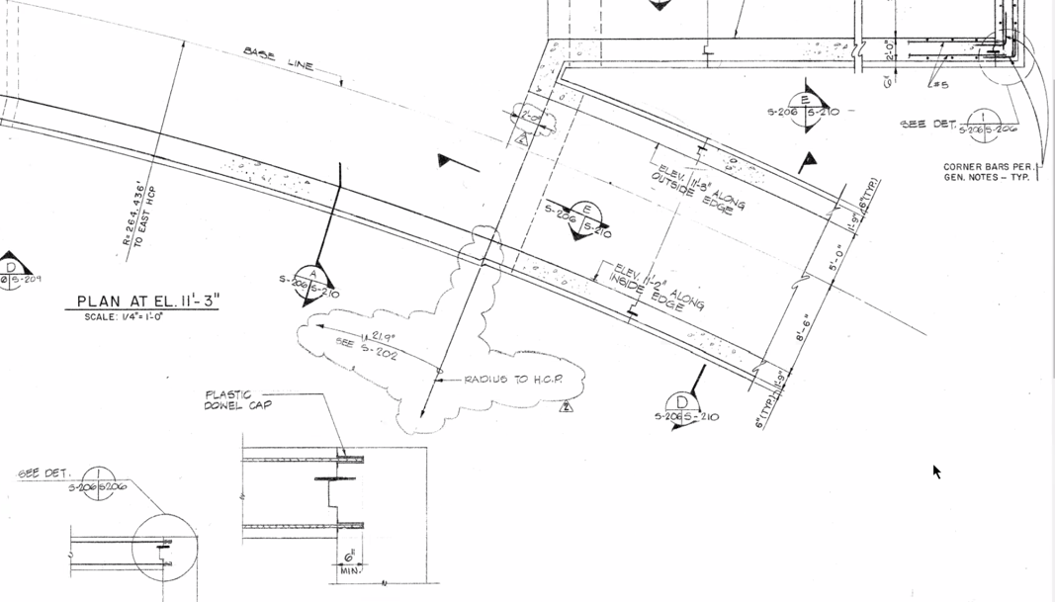
  + There is some real estate between the arc and D line for some beamlines to widen then come back together
* Jay - 4 EM (10 GeV) passes and 1 FFA (10.1 > ~21 GeV) – and Hall D goes away
  + This may have to happen if we can’t get the 2 FFA option to work.
* JLab Origin at the center of the accelerator. Origin is 0,100,0.
  + 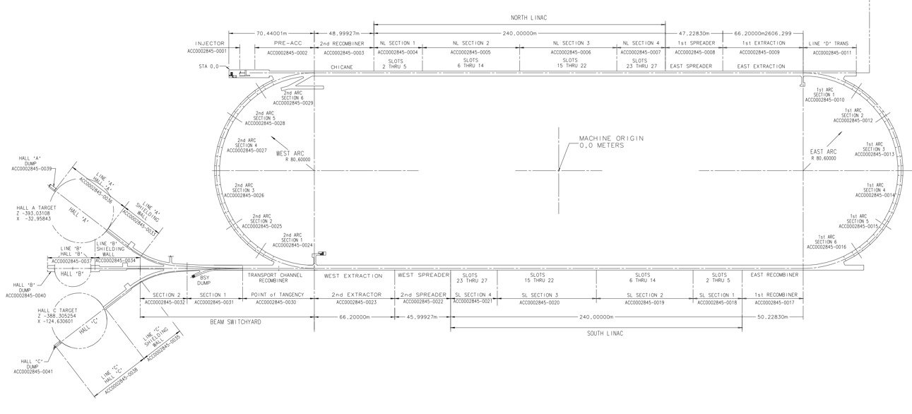
  + This map was sent around – it is clickable.
* Given geometry – temptation to run all lines in the same direction.
* Highest E line at CBETA is 2.5 wavelengths longer than the less – nothing wrong with adding another wavelength
  + Have each line be ~1 wavelength longer
* First thing – just lay it out, see where end up, then make adjustments to get exact pathlength
* SW end has beamlines still – 5 stacks of magnets
  + 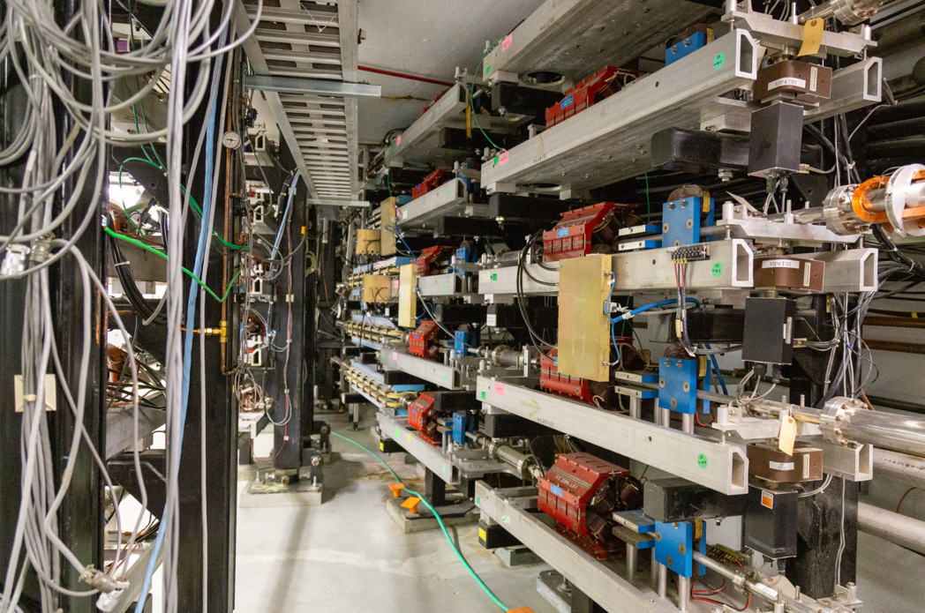
  + Extraction chicanes are upstream (horizontal bend 40 cm then back)
* M56 is the problem – 1 chicane has to do all of M56 instead of splitting into two.
  + Usually in the wrong direction
* West Side (NW corner) you have injector coming in
* Maybe looking at SW corner for the design first, see if we can make it fit/work
* NW, NE, SE all have the same amount of room, SW corner is tight –
  + If we can fit things into the SW corner, it’ll work everywhere else.
  + If it doesn’t, then we look at NW and SE corners as the place to do things.
* That nose of concrete is really good real estate for beamlines – can we cut it down?
  + We did for Hall D – dug down to that point, knocked out 2’ wall at the end of the stub, poured a ramp, etc…
* Before, we were trying to get adiabatic match all the way to the LINAC. But now, we have a smaller energy range.
  + Now, adiabatic merging of orbits done very nicely, as long as we can do betas as well
  + Once orbits are all merged, can separate with dipoles
* Propose NE corner layout of chicanes –
  + Nose can be knocked off, can infringe on Hall D line
  + First we need to actually laying something down.
* One problem – estimated where could put quads on Hall D line
  + Spata corrected quad locations a few cm – we don’t have exact drawings of where the faces of the stands are
  + We may run into issues when laying things out
  + Every stand in the machine may have to change anyway.
* Magnesium diboride at 20 Kelvin can do what we need – may be the way to go
  + <https://arxiv.org/abs/2201.09501>
  + 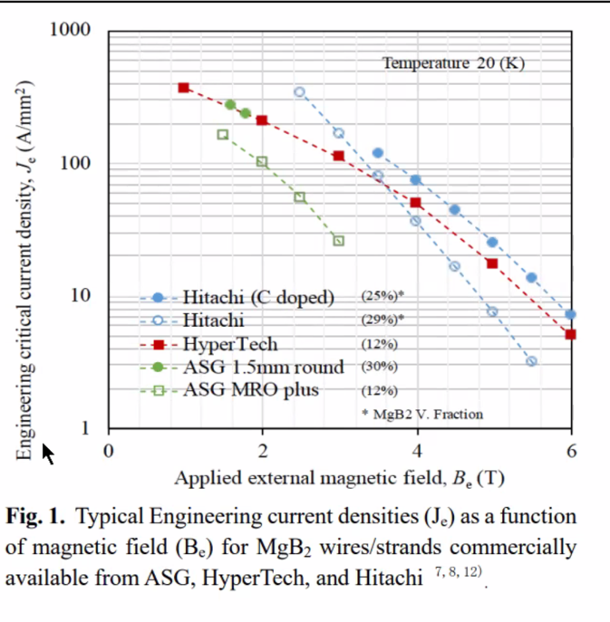
  + Commercially available MgB2 wire
* We should start doing a layout of the NE corner and make sure we can make it work on the easy part. Then “stuff it into” to SW corner if it’ll fit.

Conclusion

|  |  |  |
| --- | --- | --- |
| Action items | Person responsible | Deadline |
|  |  |  |

## Time allotted | 5 minutes | Agenda topic AOB | Presenter All

* FOA – Maybe we could do a joint proposal to see if we can get some funding for magnets, etc..
  + <https://science.osti.gov/np/Funding-Opportunities?utm_medium=email&utm_source=govdelivery>
  + <https://science.osti.gov/np/-/media/grants/pdf/foas/2022/SC_FOA_0002670.pdf>
* We could also look at what happens when we put out beam through a smaller beam pipe
  + Aperture is important.
  + We did see halo out to 10 sigma
  + In FFA – halo shrinks too

Conclusion

|  |  |  |
| --- | --- | --- |
| Action items | Person responsible | Deadline |
|  |  |  |

## Special notes

Pathway to Repository: <https://jeffersonlab-my.sharepoint.com/:f:/r/personal/tristan_jlab_org/Documents/Grad%20Student%202019/Graduate%20Student%20Steering/CEBAF%20FFA%20Working%20Group?csf=1&web=1&e=78bf9R>