FFA@CEBAF Working Group | Minutes

## Meeting date | time 2/18/2022 | 11 AM EST | Meeting location (virtual) <https://jlab-org.zoomgov.com/j/1614898082?pwd=TnUzMS81M2sxbDZIbERJU01tYkJCQT09>

|  |  |  |  |  |  |  |  |  |  |  |  |
| --- | --- | --- | --- | --- | --- | --- | --- | --- | --- | --- | --- |
| |  |  | | --- | --- | | Meeting called by | Alex | | Type of meeting | Weekly Meeting | | Facilitator | Alex | | Note taker | Ryan | | Timekeeper | Alex | | Attendees  Ryan, Alex, Stephen, Scott, Andrei, Randika, Kirsten, Dejan, Kitty, Jay, Vasiliy, Mike |

# Intro discussion

Email list problem – solved by using the “munge” option. Thanks Scott!

Alex – We wanted to look at the NE corner so we can have a real section of beamline to look at and really study.

* Alex is looking at the LINAC
* Ryan is looking at the spreaders
* Scott is looking at the TOF chicane
* Vasiliy/Randi looking at the adiabatic matching
* Stephen is looking at the ARC
* Together, these will give us all a half pass to really study!

# Agenda topics

## Time allotted | 30 minutes | Agenda topic Adiabatic Arc | Presenter Vasiliy/Randi

* 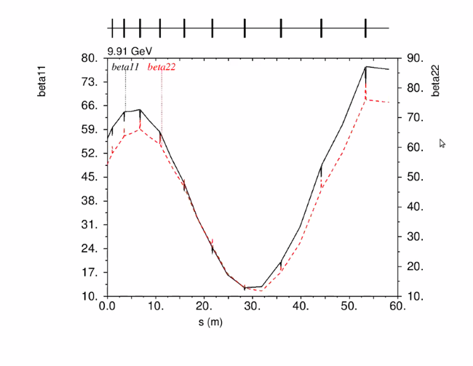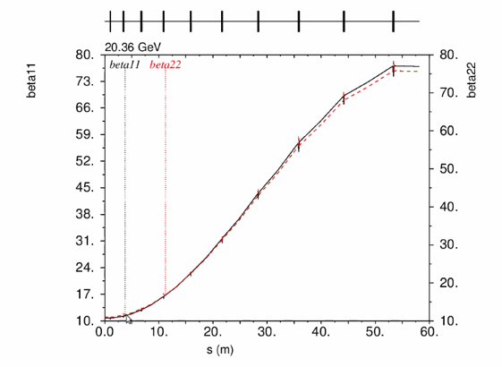
  + Started from the right hand side and worked backwards – goal was to bring the beta down to simplify matching
  + Lowest and highest energy above – started at high E then did low E
* 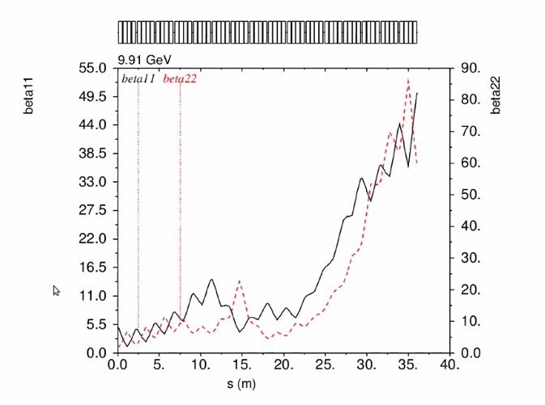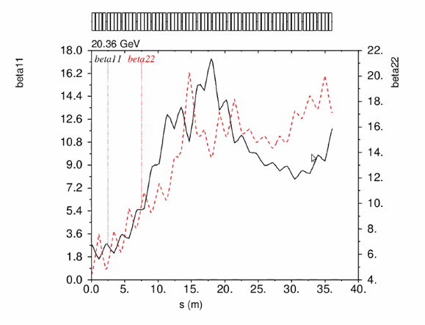
  + Already had 2 solutions, but didn’t like them b/c at low E overfocused
  + Started with much lower quad strength to allow beta to grow
  + At 50 m in both planes which is what is needed to match
  + Gradually goes from lowest to highest
  + Will be more compact than other solutions
  + This is a multivariable solution – converges very slowly
  + Started adding central quad triplet strength for more matching
* 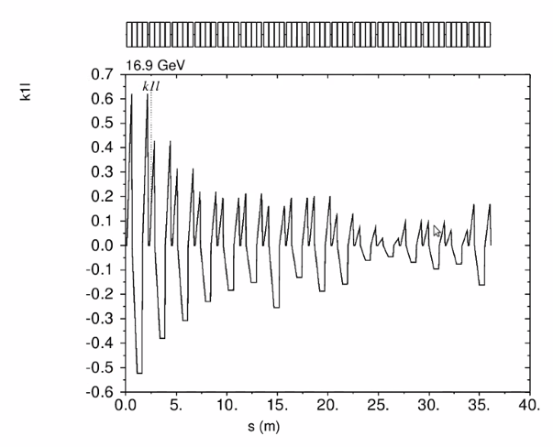
  + Quad strength settings as of now
  + On one side, it’s FODO, but most of the arc is made of (pseudo?) triplets
    - Center varied, and two outer quads varied together so same (like a triplet)
* This is looking much nicer compared to previous
  + No over focusing
  + Chromatic effects lower
* Randi is converting MADX to BMAD
  + Scott warns that sometimes, the converters tend to be “enthusiastic” with trying to emulate each other
    - There will be some strange elements in lattice at times
    - Scott prefers hand conversions – basically just putting semicolons at ends of lines
    - Dejan prefers by hand as well

Conclusion

This is becoming quite a good solution – most promising yet. Not quite there yet, but very close.

|  |  |  |
| --- | --- | --- |
| Action items | Person responsible | Deadline |
|  |  |  |

## Time allotted | 30 minutes | Agenda topic AOB | Presenter All

* Stephen uploaded FFA1 and FFA2 folders – July 2021 is the one he uses now
  + Not final, but a good representation of what you’ll get
  + Muon1 output files
  + Big table shows matched alphas, betas, phase advance, etc…
  + Stephen’s file is a cell – so we can read that and try to write to other formats as needed
    - Dejan will send older version in BMAD
* We have 0th order SR loss
  + Still don’t have the dynamic effects (transverse emittance dilution, energy spread, etc…)
  + Kirsten will take a look in the coming weeks
  + Alex assumed constant bend radius for his curly-H – so only roughly estimated
* FOA – Jay is writing up the JLab end, given his conventional magnet background
  + Looking at putting together joint proposal for magnet side of things
  + Lots of preliminary investigations done
  + Stephen’s LDRD is at a modest level – prototype and measurement
    - FOA would extend this
  + Dejan – it’s important that we have full support of both BNL and JLab management
    - Andrei – 100% agree that it’s a great chance for a joint proposal
    - Spata – gearing up to support the submission process
      * We have about 7 weeks for the NP call
    - We have to be very clear why this is necessary
      * What do the experimenters want?
        + Jay and Alex have been speaking with the experimentalists, and we’ve received feedback

We got some good reads from Hall C

* + - Positrons – ongoing discussion
      * What energy should we be aiming for? Some experiments happy at 10 GeV
      * 2-bore magnets???
        + Takes twice the material for 2 apertures

You save by having a single vacuum chamber, etc… so less than twice the cost

* + - * Already tight in LINAC, but if we can go in the same direction for both, this would make things much better
      * Emittance requirements for positrons?
      * Jay – electroweak needs e+ and e- with same beam characteristics (capture either e- or e+ from conversion target)
        + Doesn’t work to have a clean e- beam and a “bad” e+ beam
        + In response to comment about “no positrons with FFA”

Sent Eric songsheet with injector

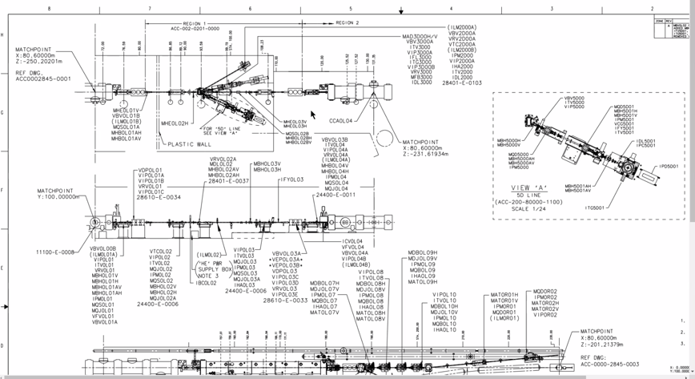

55 m to start of NL

Positrons will have to pull them off and have ~20 feet coming out of second cryo, peel off through wall, turn around, conversion, etc… it’s too tight

* + - * + Andrei – maybe “totally incompatible” is too strong a statement – can’t we expand in length/width?

Jay – yes, we could do it

* + - * + Andrei – example, FACET at SLAC – they designed and plan to install damping ring inside tunnel

<https://inspirehep.net/literature/1469831>

* + - * + Also angled recirculation in injector had been looked at (30 and 60 degrees from horizontal)
      * If there’s an insistence in same direction as e-, then the 2 bore magnets might be the best way forward.
* Mike: FOA lead?
  + Jay for JLab, Stephen for BNL ?
    - Magnesium Diboride for septum because we can’t run more through the copper coils
  + Dejan thought Alex and Dejan should take lead
  + Jay plans to gather data/info in the coming week, double BDLs in same real estate, etc…
  + Defer to next week
    - But we need a well-defined plan

Conclusion

There’s a lot of important plans coming up, and a lot depends upon what the users want/need. Still, things are moving in a good direction. We do need to focus on the items on the list Alex made so that we can narrow down some of our plans.

|  |  |  |
| --- | --- | --- |
| Action items | Person responsible | Deadline |
|  |  |  |

## Special notes

Pathway to Repository: <https://jeffersonlab-my.sharepoint.com/:f:/r/personal/tristan_jlab_org/Documents/Grad%20Student%202019/Graduate%20Student%20Steering/CEBAF%20FFA%20Working%20Group?csf=1&web=1&e=78bf9R>