FFA@CEBAF Working Group | Minutes

## Meeting date | time 2/25/2022 | 11 AM EST | Meeting location (virtual) <https://jlab-org.zoomgov.com/j/1614898082?pwd=TnUzMS81M2sxbDZIbERJU01tYkJCQT09>

|  |  |  |  |  |  |  |  |  |  |  |  |
| --- | --- | --- | --- | --- | --- | --- | --- | --- | --- | --- | --- |
| |  |  | | --- | --- | | Meeting called by | Alex | | Type of meeting | Weekly Meeting | | Facilitator | Alex | | Note taker | Ryan | | Timekeeper | Alex | | Attendees  Ryan, Alex B, Jay, Stephen, Kitty, Geoff, Randika, Alex C, Vasiliy, Kirsten, Andrei, Spata |

# Intro discussion

Early conversation with Jay and Alex B about proposal – focusing on magnet tech.

# Agenda topics

## Time allotted | 30 minutes | Agenda topic FOA Proposal | Presenter All

* 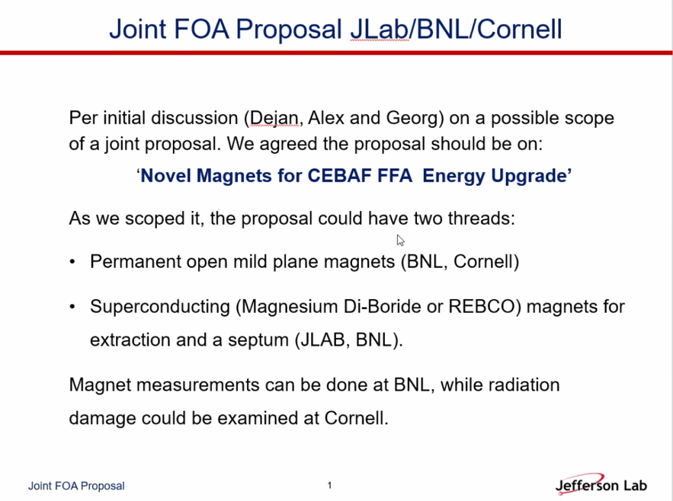
  + May need to separate into two separate packages
  + For permanent magnets, measurements at BNL, radiation damage studies at Cornell
  + Bob Rimmer said not had success with Magnesium diboride
    - Niobium Tin or just niobium?
    - Moving ahead with a draft to work on conductively cooled SRF separator
    - Would be a 3rd FOA
* 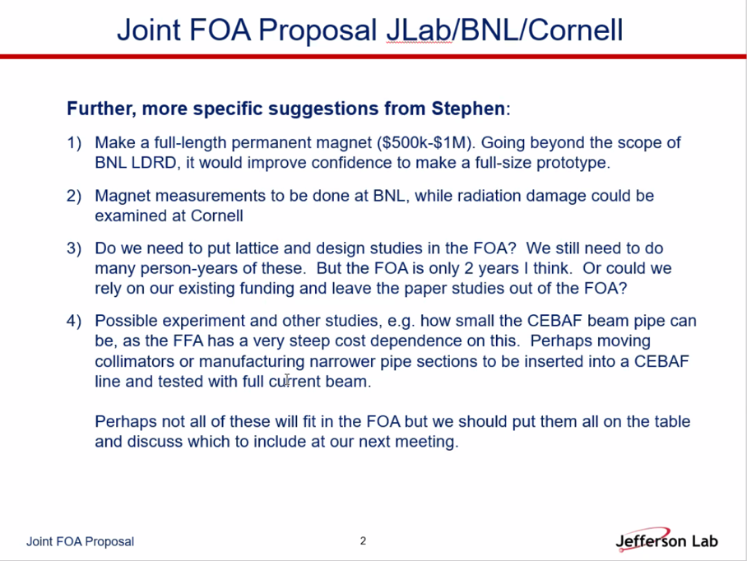
* We need the full lattice so we can have the geometric emittances and make sure they’re correct
* Seems like a good package
* Geoff – taking the attitude that there will be 3 collabs: JLab, BNL, Cornell
  + This can be “organized” where submission done in 2 ways:
    - One institution is called “lead” then we subcontract to the other two
      * Recommend against this, because sub-agreements take time that complicates things
    - “Collaboration Mode” – there is 1 lead institution, but money goes from DOE to collaborators – this is what we are envisioning
      * What do you need?
        + An official JLab, BNL, and Cornell budget – someone must make an official budget – official document scoping costs and budget justification

Administrators usually do much of this (at least at labs)

* + - * + If you look at the FOA, for JLab and BNL – need letter of permission from site office stating that they know we are collaborating (at JLab it’s Deborah Dowd (sp?))

There’s already sample text in the FOA for this letter

* + - * + Assign these three people ASAP
      * Proposal itself is simple after all this
        + All documentation from places are identical (all text identical), except official budgets and justifications from each place.
      * Those 3 official budgets must be summarized in an additional page which goes into the proposal and goes into a table for the total cost of the collab proposal.
  + Rely on Mike and Deborah (at JLab), and relevant people at BNL.
    - It takes time, so start now.
  + Site office letter can start now. For approval they might ask for the budget (roughly).
    - Kelly or Annie usually develop the budgets – rely on Spata for this.
  + PI is PI, then other two are co-instigators
    - Must be listed as such on proposal summary
* Spata – What is the draw, who are the people, etc?
  + Can take lead to make sure budget analysts, etc… are part of the team.
  + What’s the scale, who are the people?
    - Sounds like small effort
    - Paralleled by LDRD in some ways?
  + On our side, there’s a simple form (high-level) which describes the basics.
* Alex: do we need to cast this into a form?
  + Yes, especially for point 4
* Andrei: 3 different submissions?
  + Yes – Bob/Gigi seem to be running on RF separator, Permanent magnets, and superconducting magnets
    - Ramesh Gupta is contact point at BNL
  + If you need contact with division head, let Andrei know.
* Spata: timing – is it too early for this proposal? 24 GeV CEBAF isn’t even on the long-range plan yet.
  + Jay – can’t make any higher energy work without higher E RF separators, etc…
    - This gives credibility to the proposal
    - Maybe gets us mentioned in next LRP
    - Could wait 2 years, but might be more beneficial now
  + These developments don’t JUST feed into FFA@CEBAF – this development can help other projects (maybe?)

Conclusion

Call to action! Posthaste!

|  |  |  |
| --- | --- | --- |
| Action items | Person responsible | Deadline |
|  |  |  |

## Time allotted | 30 minutes | Agenda topic Magnet Upgrades | Presenter Jay

* 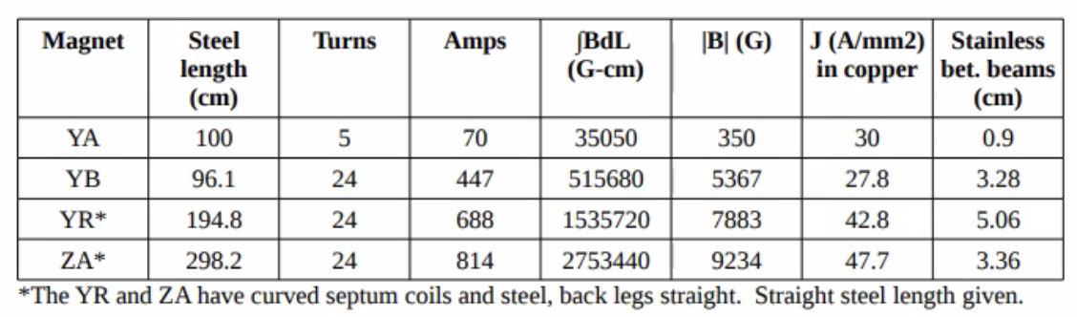
* For normal SC magnets – 10 A / mm^2
* At peak tested current
* Can buy conductor that can do 100 A/mm^2, 3.5 mm section at 2 T and 20 K
  + We need to double
* Clearance similar – would reduce scraping
* Have to go superconducting, given the amount of real estate we have.
* Conventional stuff would be cumbersome, especially with cooling

Conclusion

Good statement. Conversation starter!

|  |  |  |
| --- | --- | --- |
| Action items | Person responsible | Deadline |
|  |  |  |

## Special notes

Pathway to Repository: <https://jeffersonlab-my.sharepoint.com/:f:/r/personal/tristan_jlab_org/Documents/Grad%20Student%202019/Graduate%20Student%20Steering/CEBAF%20FFA%20Working%20Group?csf=1&web=1&e=78bf9R>