FFA@CEBAF Working Group | Minutes

## Meeting date | time 3/4/2022 | 11 AM EST | Meeting location (virtual) <https://jlab-org.zoomgov.com/j/1614898082?pwd=TnUzMS81M2sxbDZIbERJU01tYkJCQT09>

|  |  |  |  |  |  |  |  |  |  |  |  |
| --- | --- | --- | --- | --- | --- | --- | --- | --- | --- | --- | --- |
| |  |  | | --- | --- | | Meeting called by | Alex | | Type of meeting | Weekly Meeting | | Facilitator | Alex | | Note taker | Ryan | | Timekeeper | Alex | | Attendees  Ryan, Alex B, Kitty, Stephen, Randika, Andrei, Alex C, Dejan, Vasiliy, Jay, |

# Intro discussion

Play places and adults playing on kid’s toys! ☺

# Agenda topics

## Time allotted | 30 minutes | Agenda topic FOA Proposal | Presenter All

* Re-hash last week’s chat:
* 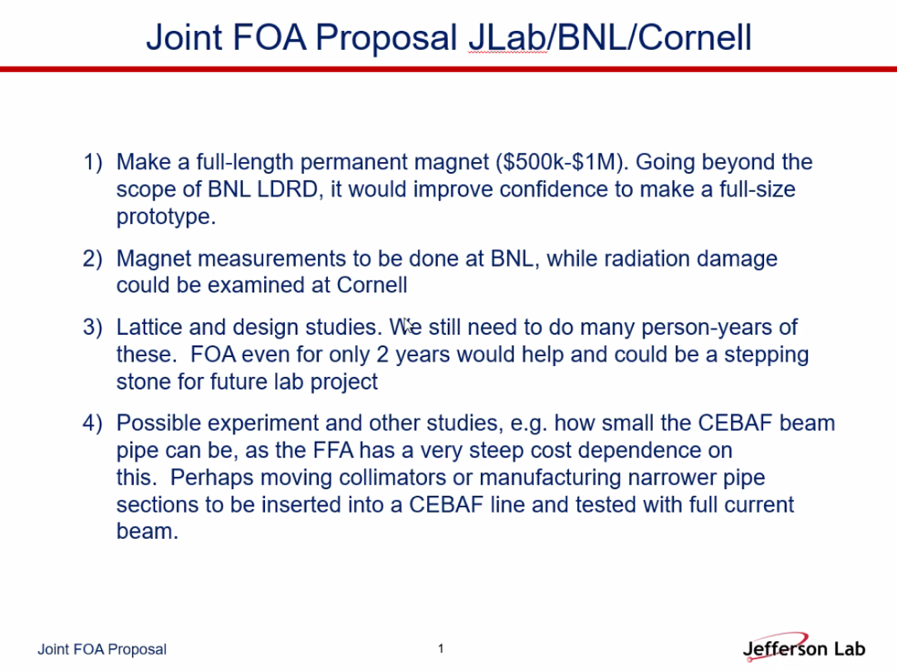
  + Magnesium Diboride package wrapped into another FOA with SRF group
* 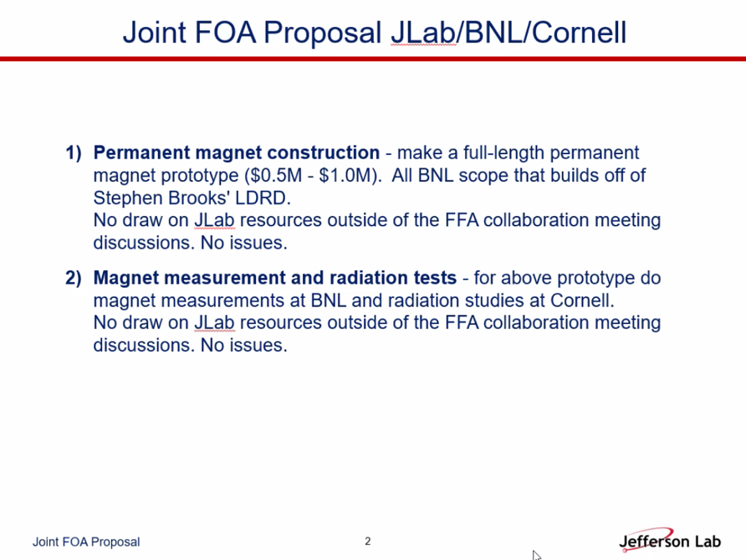
  + JLab leads with BNL and Cornell
  + Spata had tentative budget and “streamlined” the proposal and language
* 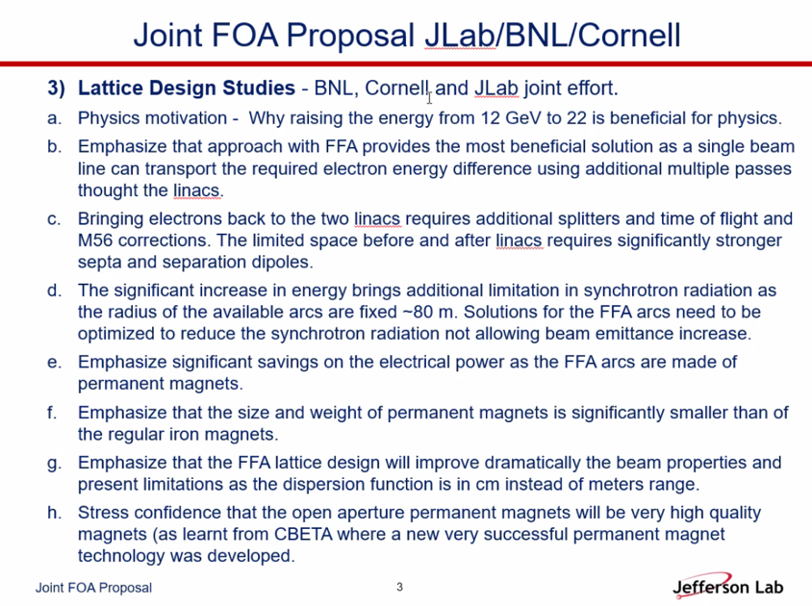
  + Carefully decoupled from JLab LDRD – Must be complimentary with minimal overlap
  + At least half a dozen physics needing ~20 GeV
* Side discussion about putting magnets under present arcs
  + Technically room for small permanent magnets
  + Can’t have single FFA to go from 10-22 GeV – magnets can’t handle that range
    - Also SR problems
    - Split into 2 FFAs still the current baseline, but will evolve
* Andrei contacted division director at BNL (and one other) – got message from Dr. Gupta (after Jay’s initial message) – they are organizing details
  + Favorable outlook
  + Wolfram already said this is a good opportunity for joint work.
* 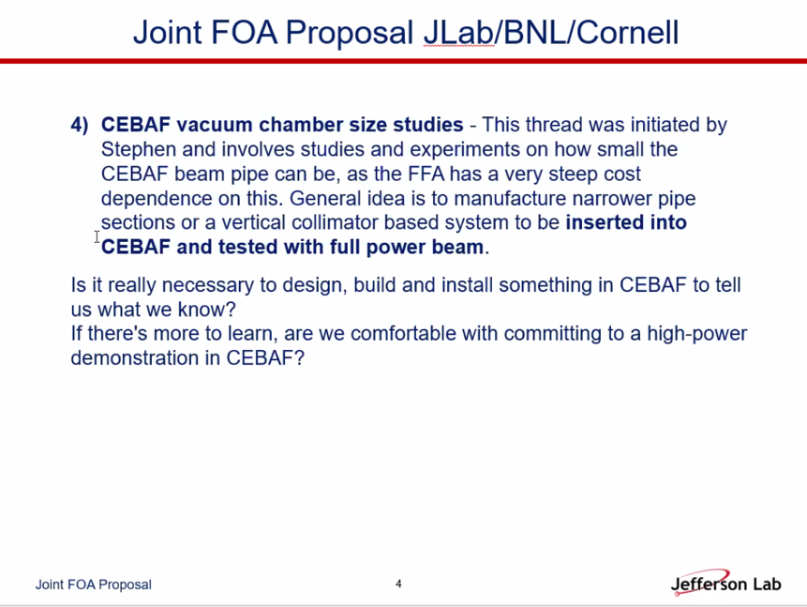
  + This could likely fit into timeline of funding
  + Need to design beampipe
  + Starting emittances
  + Jay: we have some tight apertures that we know about
    - Vertical plane at end of 5th pass, 2/3 above design emittance, etc…
    - SR dominant in horizontal
    - Have a feel and many measurements to show how it shrinks/grows in first 3 passes
    - Already have too much on the plate, so maybe strike this
    - Stephen really needs to know the aperture for the magnet design
      * Care about vertical size, and it could be sizeable
      * After 3 passes, geometric is ~ 1nm
      * Stephen only cares about arcs
    - What’s the design rule?
      * Rule of thumb: 10 sigma
    - 3 mm total gap ok?
      * No – steering allowance etc…
  + So we DO need to find the answers for Stephen – we don’t have them right now
  + Magnet costs are going up drastically
  + We could do this now? Maybe through beam studies?
    - Dennis Turner may have some answers already.
* Deadline for application is in April
  + Let’s make a deal that we have at least a draft finished before third week of March
    - Already happening on JLab’s side
* What is consensus?
  + 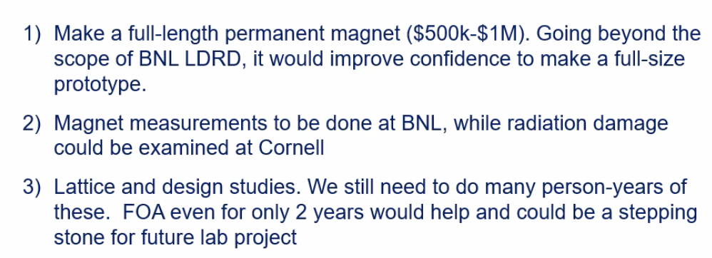
* Stephen:
* 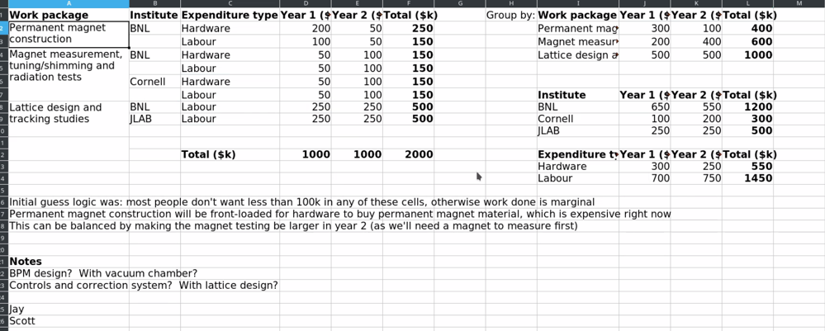
  + Not final version, but during conversation this screenshot was taken
  + Please see Stephen’s final version once it’s available
  + Need to discuss Cornell’s contribution – zeroed for now.

Conclusion

|  |  |  |
| --- | --- | --- |
| Action items | Person responsible | Deadline |
|  |  |  |

## Special notes

Pathway to Repository: <https://jeffersonlab-my.sharepoint.com/:f:/r/personal/tristan_jlab_org/Documents/Grad%20Student%202019/Graduate%20Student%20Steering/CEBAF%20FFA%20Working%20Group?csf=1&web=1&e=78bf9R>