FFA@CEBAF Working Group | Minutes

## Meeting date | time 3/18/2022 | 11 AM EST | Meeting location (virtual) <https://jlab-org.zoomgov.com/j/1614898082?pwd=TnUzMS81M2sxbDZIbERJU01tYkJCQT09>

|  |  |  |  |  |  |  |  |  |  |  |  |
| --- | --- | --- | --- | --- | --- | --- | --- | --- | --- | --- | --- |
| |  |  | | --- | --- | | Meeting called by | Alex | | Type of meeting | Weekly Meeting | | Facilitator | Alex | | Note taker | Ryan | | Timekeeper | Alex | | Attendees  Ryan, Alex B, Stephen, Randika, Jay, Andrei, Kitty, Alex C, Kirsten, Dejan, |

# Intro discussion

Meeting started early, prior to my arrival.

# Agenda topics

## Time allotted | 30 minutes | Agenda topic FOA Proposal | Presenter All

* 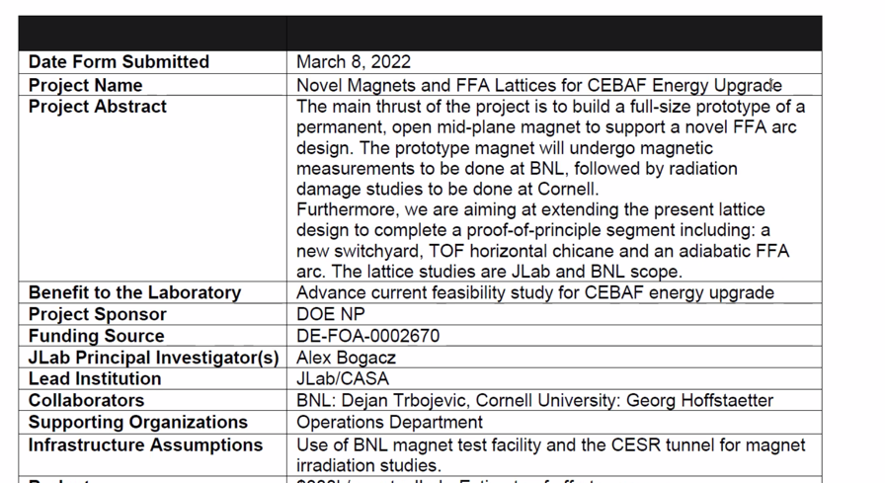
* 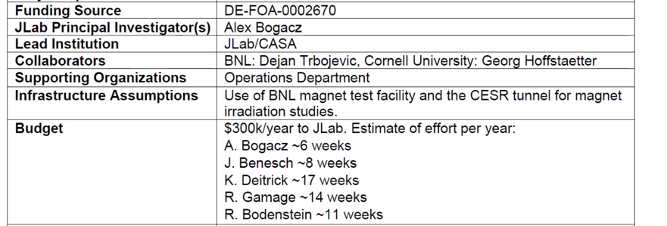
* 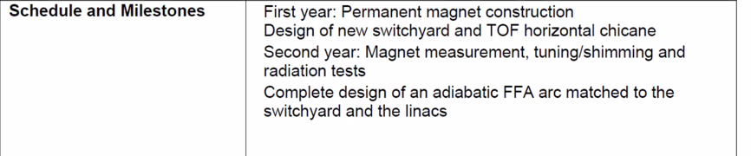
* 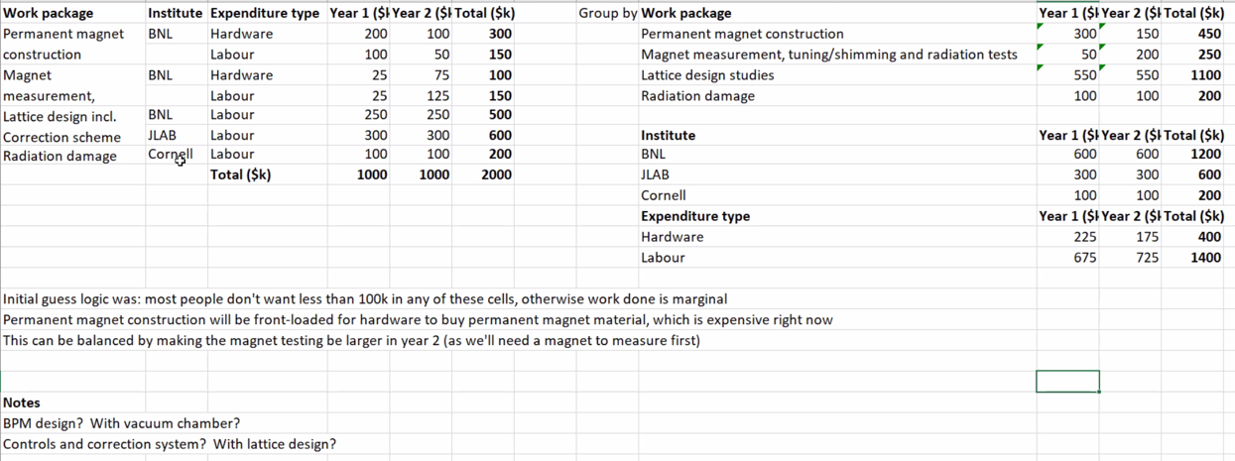
  + Tentative budget, will be in proposal
* We need similar from Cornell and BNL
  + Preliminary, itemized budget breakdown, similar to above
  + Please put in shared area
* Repository link is at the bottom of these minutes.
* We will finish ASAP so that edits, etc… can be made as needed.
* Skeleton of proposal should be ready by next week.
* Alex will provide limits, requirements, etc…

Conclusion

|  |  |  |
| --- | --- | --- |
| Action items | Person responsible | Deadline |
|  |  |  |

## Time allotted | 30 minutes | Agenda topic Spreaders | Presenter Ryan

* These notes are added after the meeting, because I can’t take notes and present at the same time ;).
* 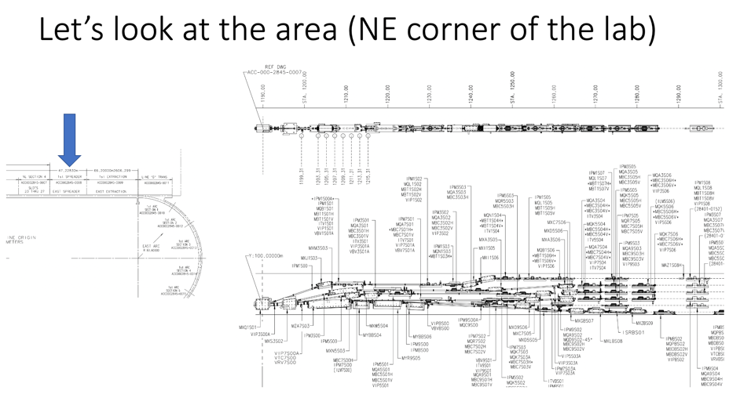
  + Space is very tight between dipoles.
* 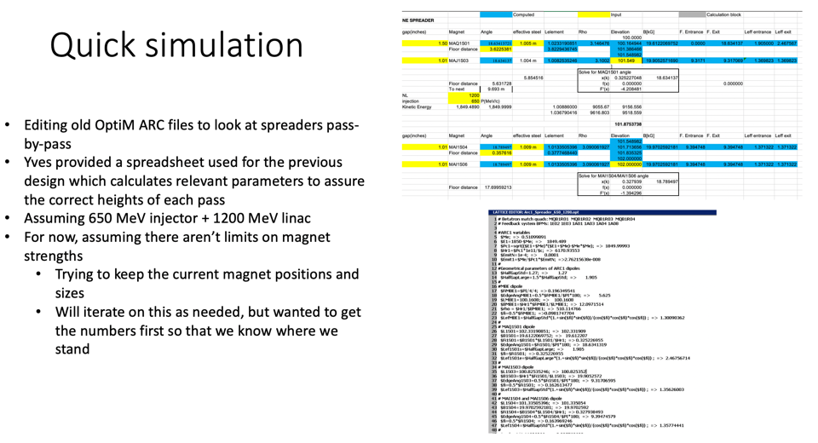
  + Dipoles are going to ~2 T at the 650+1200 MeV option. Will require lengthening magnets significantly
  + Jay mentions using different magnet tech, which may relieve some of the stress on this
  + Jay mentions previous 12 GeV design, which took space from after the doglegs and made more space – should reduce the necessary strength(s) in the magnets, though maybe not enough
    - Look at SVN (Yves maintains this) for older design
* 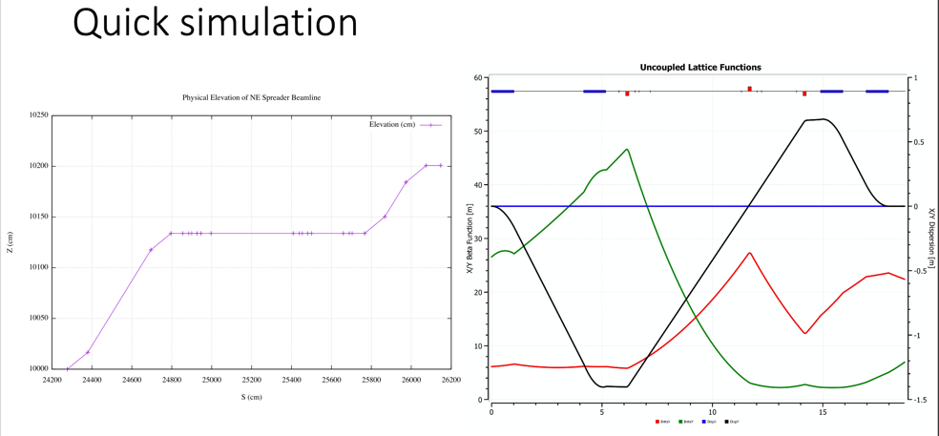
  + Close to “target” height of 2 m. 4.4 mm over height, due to path length differences and need to adjust drifts (likely).
  + Will tweak a bit further, but will likely start back with older design, and re-design more “properly” for this energy
* Will look into incoming optics and adjust as needed. Will likely start earlier, and adjust the incoming optics to make room for larger magnets.
* Will eventually switch from OptiM to BMAD
  + May want to get “first pass” basics done first, so that the lattice can be transferred. Then will do more detailed design studies.

Conclusion

|  |  |  |
| --- | --- | --- |
| Action items | Person responsible | Deadline |
|  |  |  |

## Time allotted | 30 minutes | Agenda topic Positrons | Presenter Stephen

* 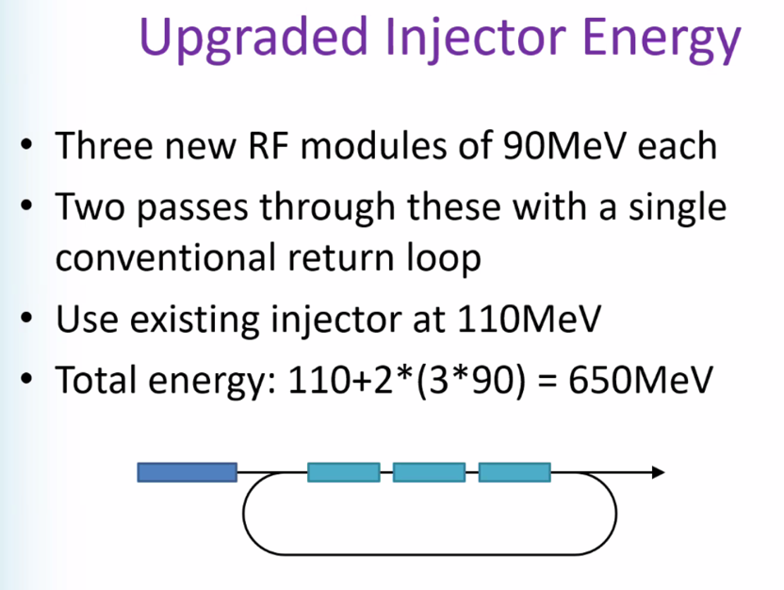
* 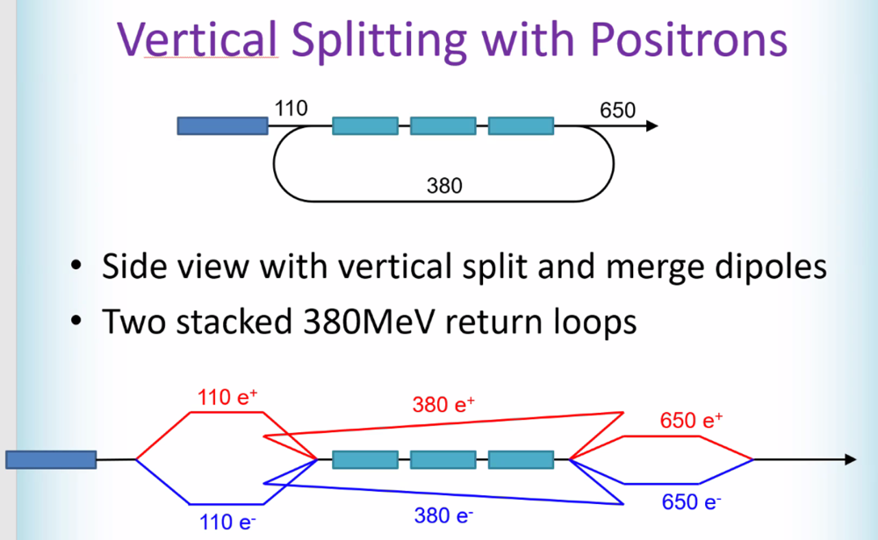
* Would be a great option for both higher polarization e+, and simultaneous if needed.
* Could recirculate the 650 e- around into a target, then bring the e+ from that target around into a lower energy line and re-accelerating.
* Dual-bore FFA magnets would allow for same-direction e+ and e-
  + Basically flip current designs and attach them

Conclusion

|  |  |  |
| --- | --- | --- |
| Action items | Person responsible | Deadline |
|  |  |  |

## Time allotted | 30 minutes | Agenda topic AOB | Presenter All

* Tour – let’s try to plan a visit.
* Finish proposal first
* Have to do it by end of April, since we’re locking up in May for testing. Physics starts early June.

Conclusion

|  |  |  |
| --- | --- | --- |
| Action items | Person responsible | Deadline |
|  |  |  |

## Special notes

Pathway to Repository: <https://jeffersonlab-my.sharepoint.com/:f:/g/personal/tristan_jlab_org/EqZ5MeS-nipCgPfZB5p0oS4B9Is67d3nQb9sLJI3Zyev9g>