FFA@CEBAF Working Group | Minutes

## Meeting date | time 3/25/2022 | 11 AM EST | Meeting location (virtual) <https://jlab-org.zoomgov.com/j/1614898082?pwd=TnUzMS81M2sxbDZIbERJU01tYkJCQT09>

|  |  |  |  |  |  |  |  |  |  |  |  |
| --- | --- | --- | --- | --- | --- | --- | --- | --- | --- | --- | --- |
| |  |  | | --- | --- | | Meeting called by | Alex | | Type of meeting | Weekly Meeting | | Facilitator | Alex | | Note taker | Ryan | | Timekeeper | Alex | | Attendees  Ryan, Alex B, Scott, Jay, Kitty, Andrei, Kirsten, Dejan, Stephen, Todd, Vasiliy, |

# Intro discussion

# Agenda topics

## Time allotted | 25 minutes | Agenda topic FOA Proposal | Presenter Alex

* Discussion of abstract for FOA
  + 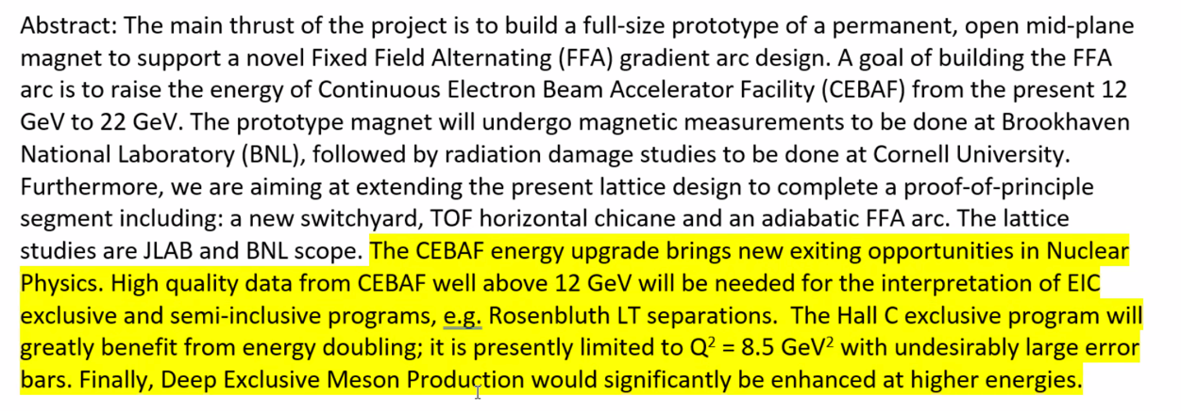
  + Includes physics case
  + Lee says there are people in the EIC community which do LT separations. Simply assume that there’s no transverse to worry about
    - Suggests “conventional Rosenbluth LT separations”
    - Folks at DOE won’t get confused that way
      * Jay will provide a reference for us to know what that means
  + Posted in work area
  + Could expand to a page if necessary
  + Looking good so far
* 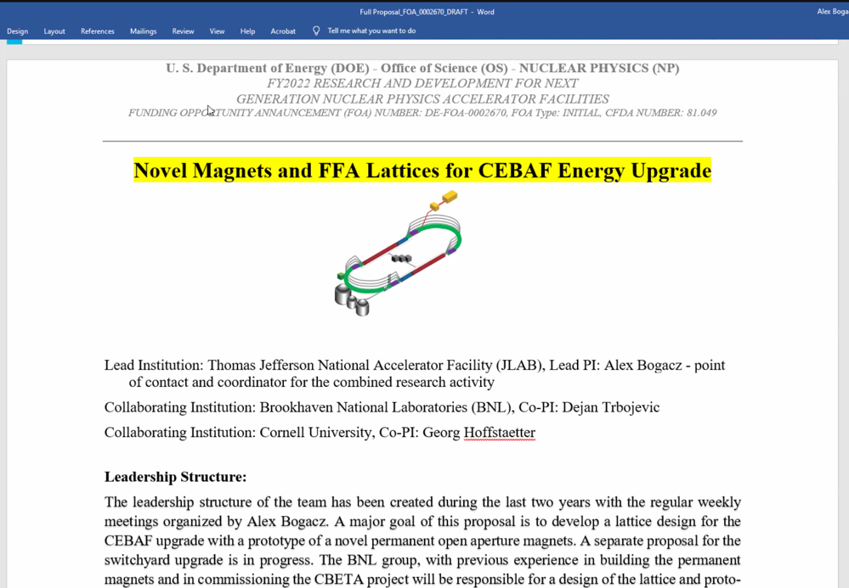
  + Working draft
  + Format and structure of final document
  + Still needs wordsmithing, but this is the “meat”
  + Will need to look into the proper JLab graphics for main title page
* Will have 3 separate documents, almost exactly a copy except the budget
* Lead PI – Is that for the whole project (Alex), or for each institution?
* Looking into specifics, including in the JLab FOA development sharepoint
* Jay will look into the emphasis on why we are using permanent rather than EM magnets – needs gradient value(s).
  + Will look at simple scaling, cut it down to a meter, etc…
  + Section 3.3 has gradients needed.
  + 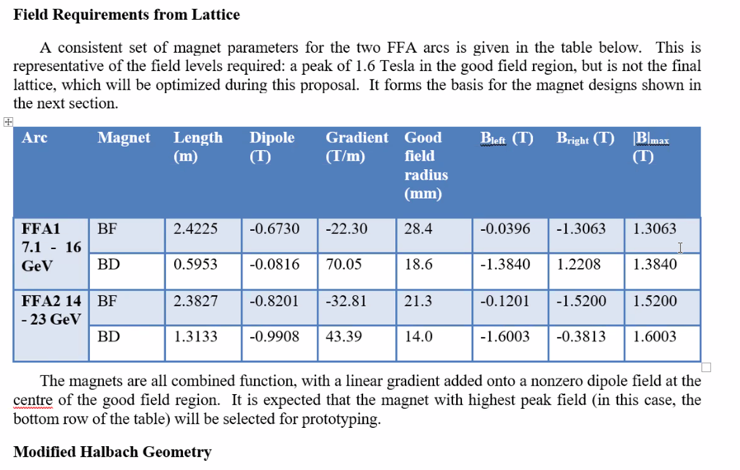
* Can also look at power bill reduction
* 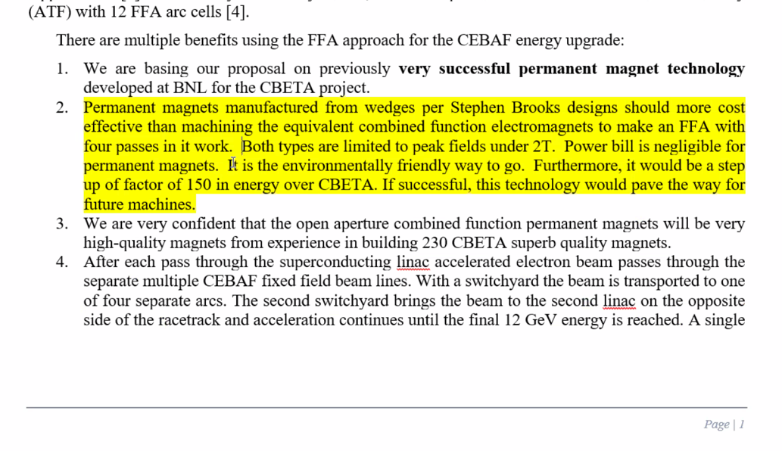
  + Maybe Jay/Stephen clean up the highlighted section above?
  + Split into 3 bullets
    - Strength
    - Power bill
    - Future machines
* 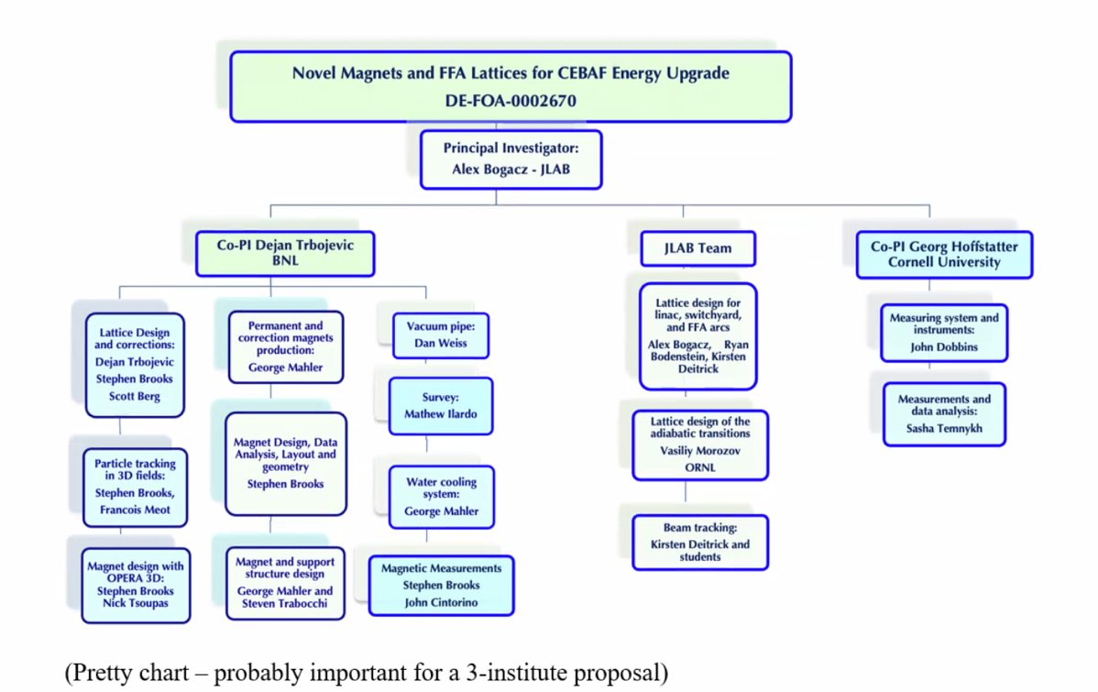
  + Will be updated. Dejan will send the file to Alex to update.
* For references, Jay will provide for physics case
* Will merge some of Stephen’s references in his section to main references
* Example document uploaded to our shared workspace as JLab_Proposal_example.docx
* Do we all need to have our CVs added to the form?
  + If so, let’s upload them into the shared area so they can be copy/pasted.
  + Whoever is listed on section A of proposal (senior???)
    - JLab: Alex B, Jay, Kirsten, Randy, Ryan
    - Formatted properly
* Need ~6 pages for 3.1 lattice design section
  + Dejan then Stephen, then Alex to add JLab part.

Conclusion

|  |  |  |
| --- | --- | --- |
| Action items | Person responsible | Deadline |
|  |  |  |

## Time allotted | 25 minutes | Agenda topic Emittance Dilution | Presenter Kirsten

* Time up…maybe next time?

Conclusion

|  |  |  |
| --- | --- | --- |
| Action items | Person responsible | Deadline |
|  |  |  |

## Special notes

Pathway to Repository: <https://jeffersonlab-my.sharepoint.com/:f:/g/personal/tristan_jlab_org/EqZ5MeS-nipCgPfZB5p0oS4B9Is67d3nQb9sLJI3Zyev9g>