FFA@CEBAF Working Group | Minutes

## Meeting date | time 4/1/2022 | 11 AM EST | Meeting location (virtual) <https://jlab-org.zoomgov.com/j/1614898082?pwd=TnUzMS81M2sxbDZIbERJU01tYkJCQT09>

|  |  |  |  |  |  |  |  |  |  |  |  |
| --- | --- | --- | --- | --- | --- | --- | --- | --- | --- | --- | --- |
| |  |  | | --- | --- | | Meeting called by | Alex | | Type of meeting | Weekly Meeting | | Facilitator | Alex | | Note taker | Ryan | | Timekeeper | Alex | | Attendees  Ryan, Alex B, Spata, Andrei, Kirsten, Kitty, Alex C, Randika, Jay, Vasiliy, Dejan, Stephen, Scott |

# Intro discussion

We’ve gotta all update to the right formats!

# Agenda topics

## Time allotted | 25 minutes | Agenda topic FOA Proposal | Presenter Alex

* Can Ryan check for compliance on biosketches, etc…?
  + Yes
* Spata: Only those listed in Part A need to have biosketches.
* Spata:
  + 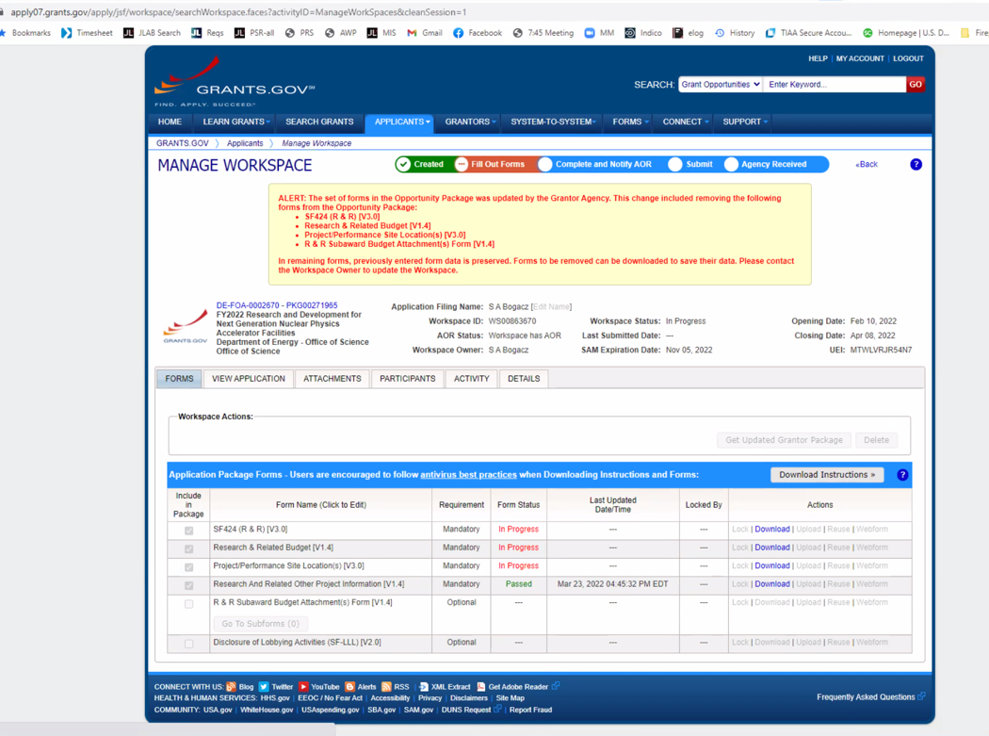
  + Update to system, things not looking right.
* Missing section 4.4 from Cornell
  + Georg said Stephen will add it. Stephen wrote half (general terms) and sent it to Georg for details.
* Missing separate 1 page summary.
  + Stephen will try to get this done.
* Missing one key sentence in physics case: luminosity expected in context of 22 GeV accelerator
  + We have slides for this
  + Jay has the number – basic number at higher energy still with 900 kW is of order 10^38
  + Jay in chat: luminosity at 22 GeV ~1E38 cm-2 s-1 with cryotargets
  + 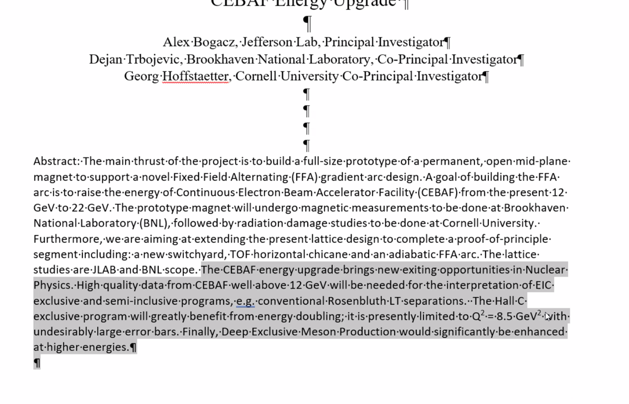
    - This will be added to the common area
* Title pages: 1 main, one collaborative. Our second page is the first title. The second should look:
  + 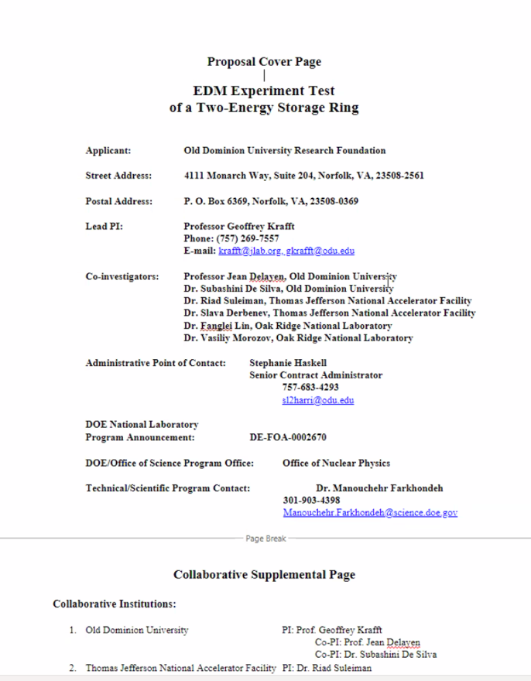
  + Take our “pretty” page, and make it look like above.
  + Follow the example file.
* BNL: Stephen, Dejan, Scott in the Part A – so need those bios
* Cornell: ??
* JLab:
* Spata goes through the grants.gov site to show what we need.
  + Top 2 are identical
  + Each lab has its own budget, etc…
* Is Deborah Dowd the person who “pushes the button” at JLab?
  + Yes
  + Only budget analysts and Dowd are allowed to actually submit.
  + We can upload files/etc…
* No more PAMS – just grants.gov
* Alex will add Ryan to the workspace
* Ryan needs to register (Spata will get together with him) then can do it.
* We are going OK, need budget for JLab, some administrative stuff.

Conclusion

|  |  |  |
| --- | --- | --- |
| Action items | Person responsible | Deadline |
|  |  |  |

## Time allotted | 25 minutes | Agenda topic Emittance Dilution | Presenter Kirsten

* Delayed again…

Conclusion

|  |  |  |
| --- | --- | --- |
| Action items | Person responsible | Deadline |
|  |  |  |

## Special notes

Pathway to Repository: <https://jeffersonlab-my.sharepoint.com/:f:/g/personal/tristan_jlab_org/EqZ5MeS-nipCgPfZB5p0oS4B9Is67d3nQb9sLJI3Zyev9g>