FFA@CEBAF Working Group | Minutes

## Meeting date | time 4/8/2022 | 11 AM EST | Meeting location (virtual) <https://jlab-org.zoomgov.com/j/1614898082?pwd=TnUzMS81M2sxbDZIbERJU01tYkJCQT09>

|  |  |  |  |  |  |  |  |  |  |  |  |
| --- | --- | --- | --- | --- | --- | --- | --- | --- | --- | --- | --- |
| |  |  | | --- | --- | | Meeting called by | Alex | | Type of meeting | Weekly Meeting | | Facilitator | Alex | | Note taker | Ryan | | Timekeeper | Alex | | Attendees  Ryan, Alex B, Kitty, Alex C, Kirsten, Randy, Jay, Spata, Dejan, Stephen, Scott, Georg, Vasiliy |

# Intro discussion

FFA workshop, general discussion

# Agenda topics

## Time allotted | 10 minutes | Agenda topic FOA Proposal | Presenter All

* 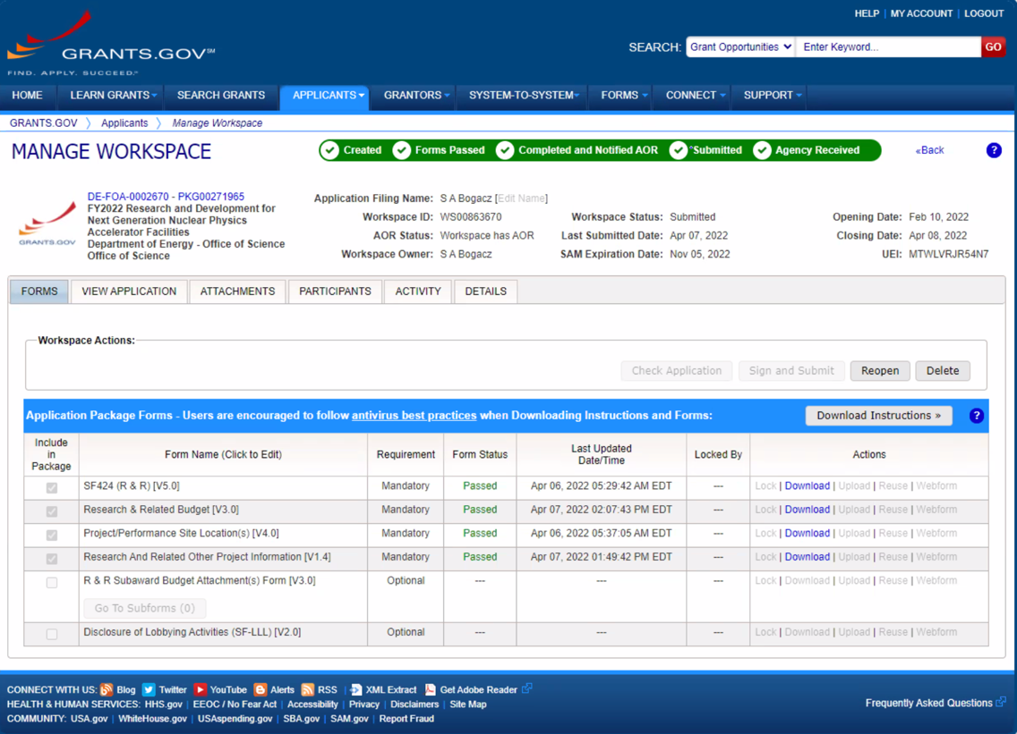
  + JLab
* 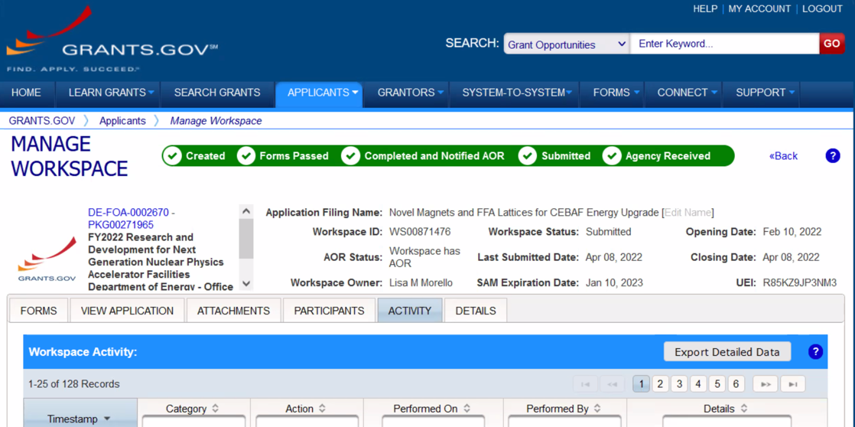
  + BNL
* Thanks to Mike Spata!
* Cornell is fully submitted as well.

Conclusion

Work well done!

|  |  |  |
| --- | --- | --- |
| Action items | Person responsible | Deadline |
|  |  |  |

## Time allotted | 25 minutes | Agenda topic Emittance Dilution | Presenter Kirsten

* 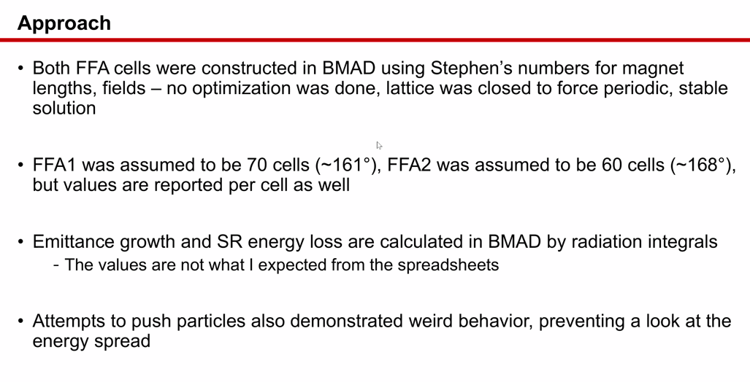
* 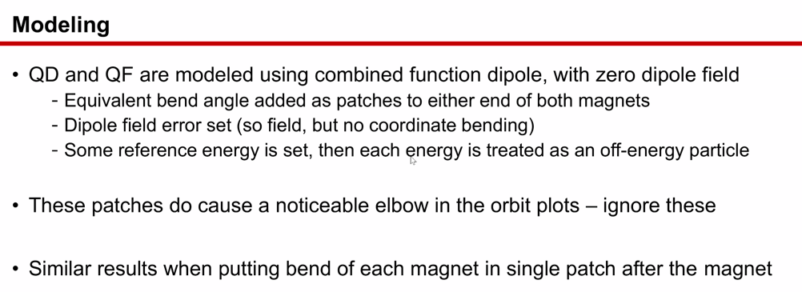
* 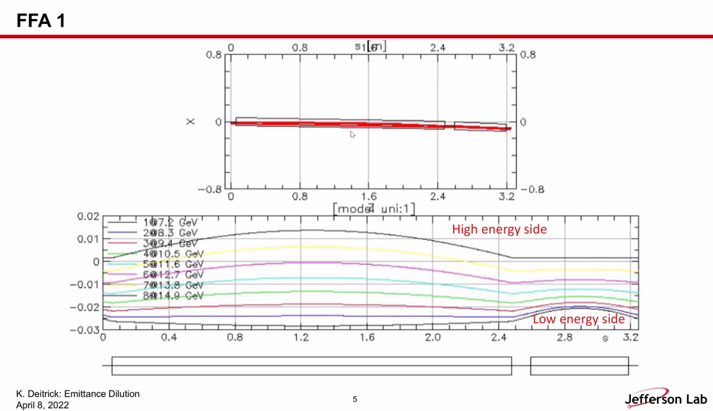
  + FFA1 was the “slightly funny lattice” there might be something a little strange of this one
  + Wasn’t totally sure what to do with 0.025 fringe field and entering it into BMAD
    - Without a field map, you can ignore to 0th order. To first order, can use “fringe mode”
      * Length is related to tanh
    - BMAD fringe field
      * 1 includes first order effects of any fringe fields
      * There are other parameters having to do with the extent of the fringe fields, but you can’t make a straightforward translation from Muon1
* 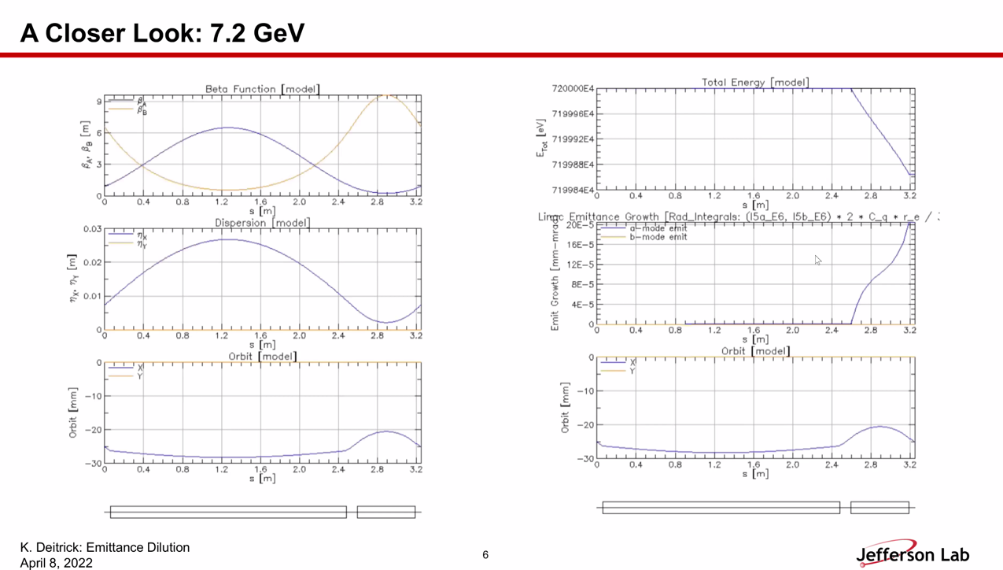
  + Most of bending in second magnet
* 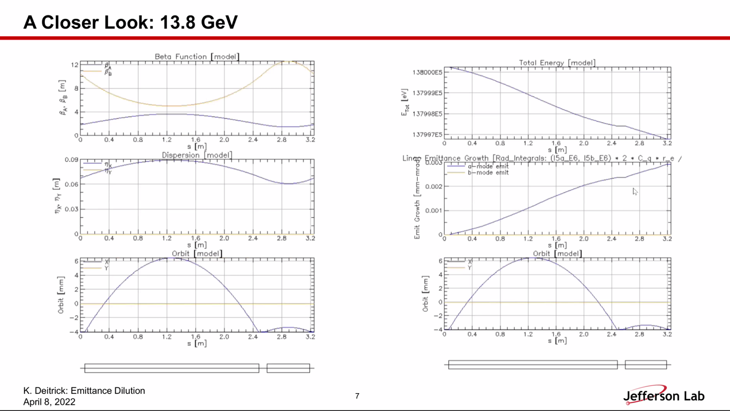
* Alex: if you calculate curly-H, you can get pretty close numbers (ballpark)
  + Slice by slice of magnet calculations
* Bending radius is not constant for each magnet, so wonky
  + You’d have to add them together
* Check order of magnitude – formulas in BMAD are likely correct
* Do you also get the momentum spread?
  + Yes
  + Haven’t found yet – emittance blew up and not sure why
* How much energy spread increase?
  + Total energy loss we have.
* 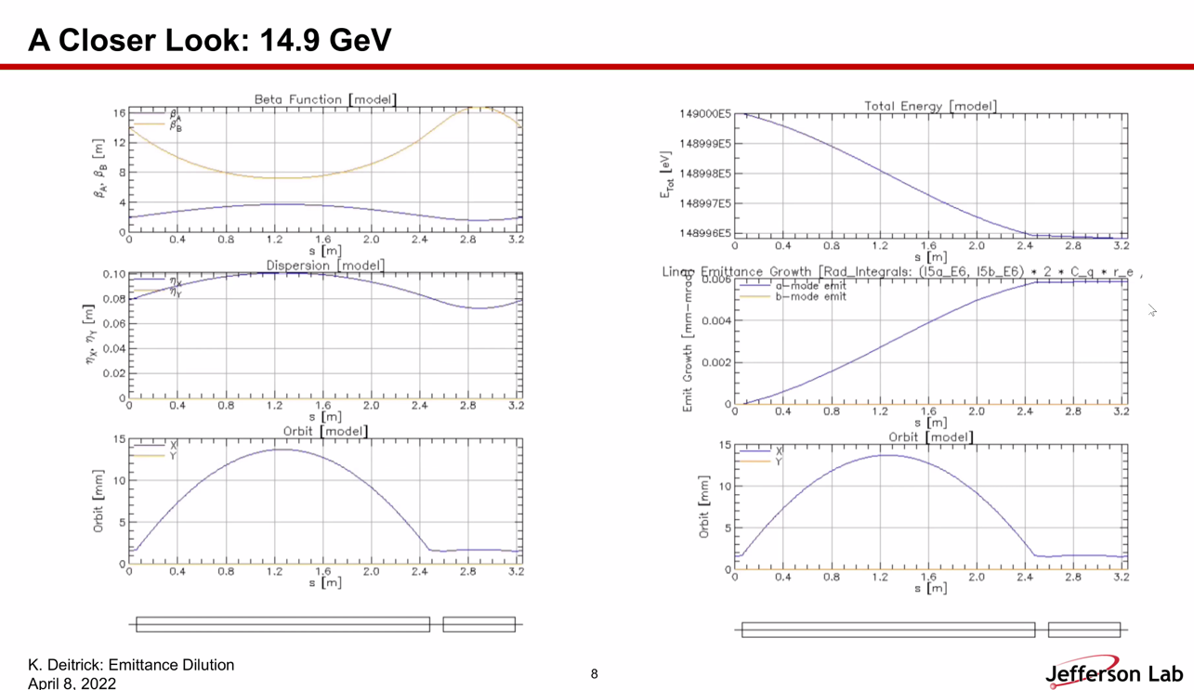
  + Can get radius of curvature from this picture
* When Stephen uploaded the cell descriptions, there are spreadsheets with numbers for SR loss
  + These are larger than that, by about 2X-ish, but same ballpark
  + Stephen wonders why the code optimized to a short magnet
* Possible differences: maybe BMAD converged on a closed orbit solution
  + Kirsten: it could also be an implementation problem
  + Maybe looking for closed orbit
* BMAD takes right bending for orbit, but takes it at end of magnet. If you want to make it more precise, split the magnet into sections
  + Kirsten used 10 markers per magnet – should be fine.
* As long as we know Twiss and local bend, we can calculate from first princ.
* Alex Share:
  + 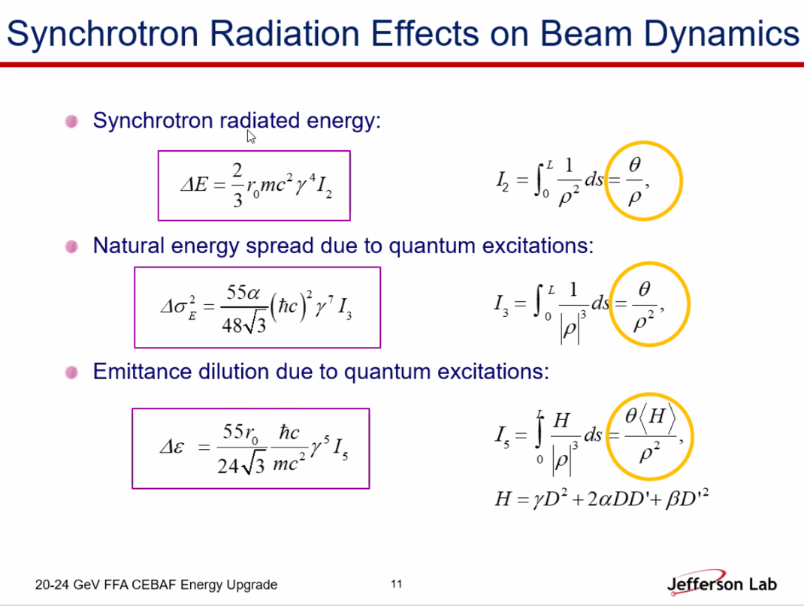
  + Take this precisely from magnet – slice the magnets as needed – get integral
    - Each of these are likely printed in many programs
* Kirsten: if discrepancy:
  + Maybe different rho
  + Maybe different orbits
  + Tunes?
  + MAD-like codes need dipole and angle are related, not MUON1
    - MUON does fringe fields too
  + This is likely a good first rough number
* BMAD has another way of calculating: particle tracking with SR and check if emittance growth is in agreement
  + It isn’t right now. (Not with PTC, but BMAD standard)
  + Get significant emittance blowup with standard BMAD tracking
    - 70 cells gets 4 orders of magnitude normalized emittance growth
* Let’s check basics first. Maybe slightly different orbits, etc…
* Particle tracking and patches?
  + Scott: they *shouldn’t* do anything
* 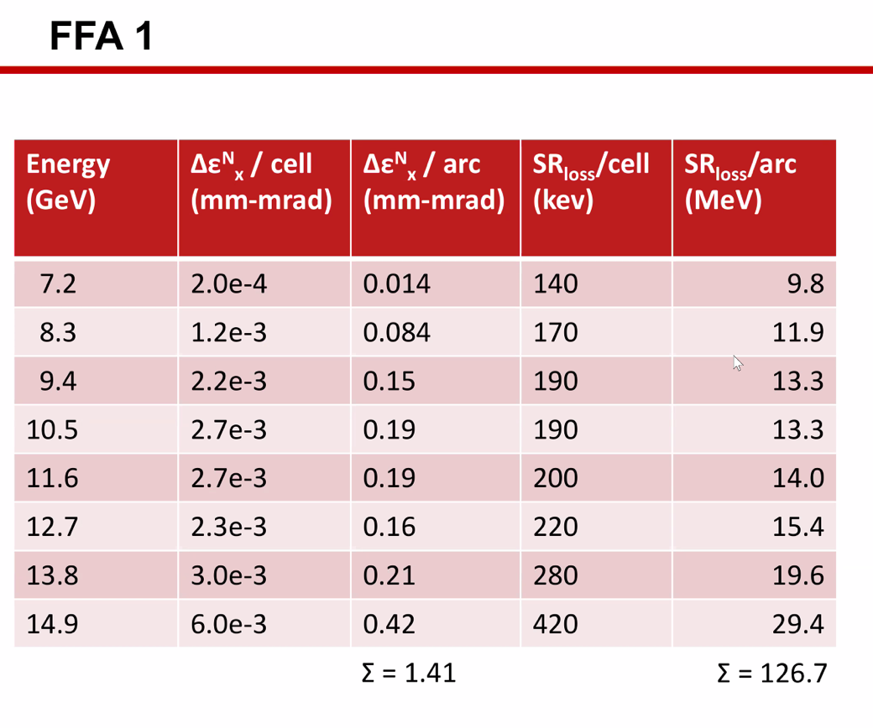
  + This isn’t full 180-degree bend, because other arc components
  + Seems *somewhat* realistic – gamma^4 at end (suppressed in middle of range)
    - Crazy orbits at low E
    - Low E will bend wrong way!
* Not perfect numbers, but within the ballpark
* 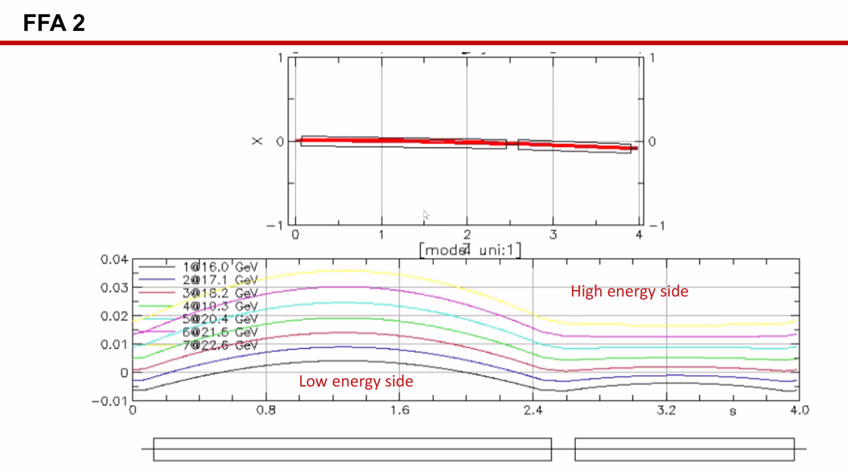
* 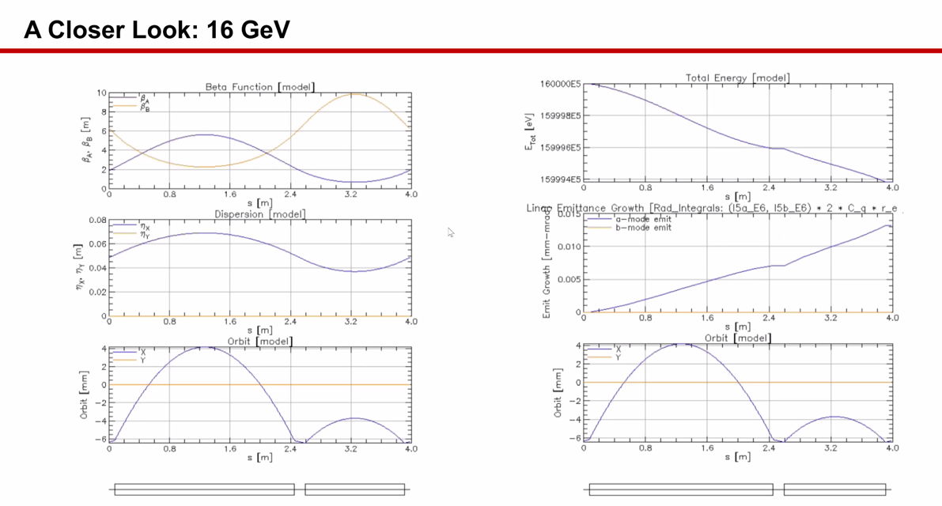
* 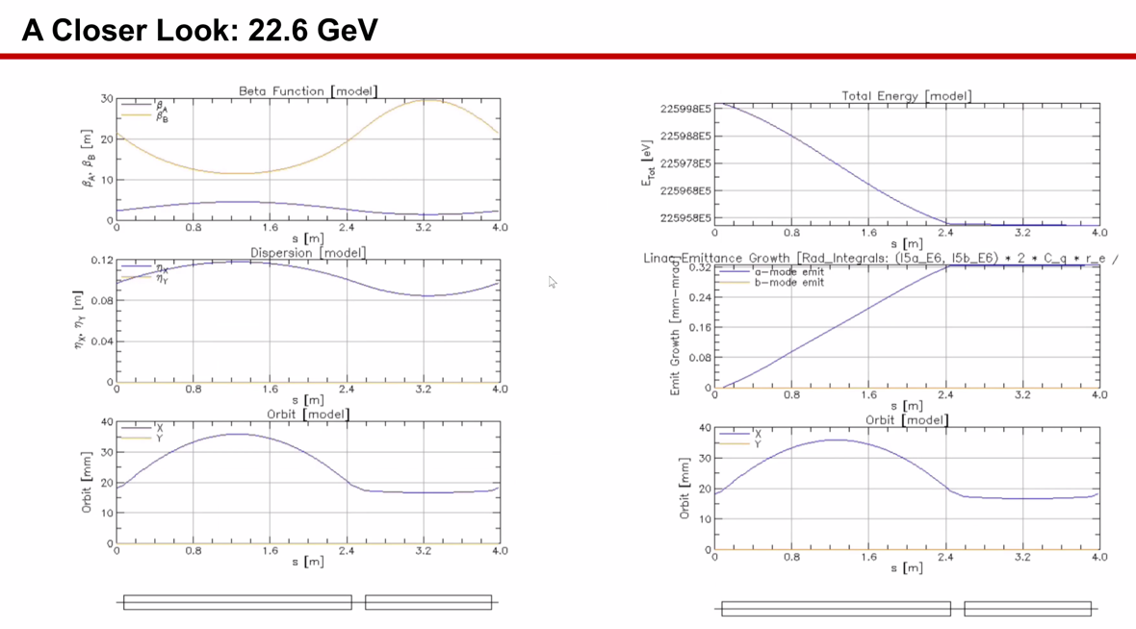
* 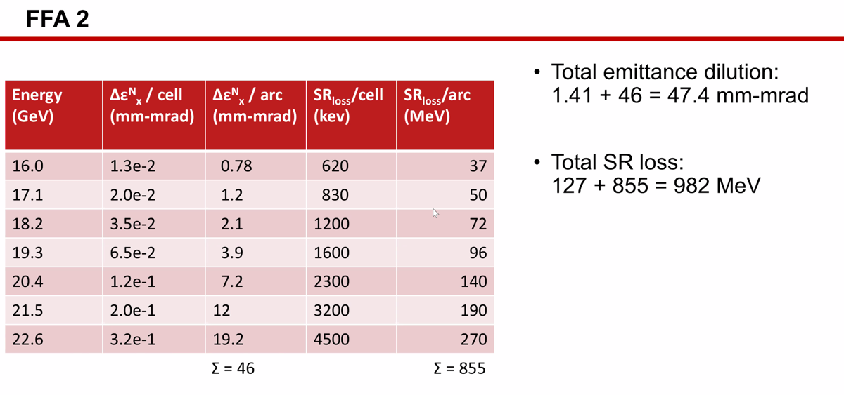
  + Much higher than FFA1, but still under Alex’s simple calculation
  + Doesn’t match anything exactly, but right order of magnitude
* Might be emittance dilution from other places (splitters, etc…)
* Jay: in the last pass, basically you’re in the last arc with 50 uA, things would be interesting
  + 900 W over length of cell
  + Most E loss in 2.5 m – so even worse
  + 300-400 W per meter
  + Losing quarter of energy gaining in last pass
  + We need to look seriously at these implications
    - Exit at 21.5 GeV and go to halls or get 22.6 at Hall D
    - Heat load would be reduced for Hall D since it’s low current
    - Current limit on each energy
    - Engineering implications will need to be considered
      * Why Jay uses 22 GeV because it’s strongest reasonably sensible magnet he could put in
      * Look at J-Future talks – some use 22 some use 24 GeV
* Alex: could be pull out curly-H for completeness?
  + Kirsten will look through the manual

Conclusion

Great first go at these simulations/calculations. Will follow-up with Stephen for more details before next attempt.

|  |  |  |
| --- | --- | --- |
| Action items | Person responsible | Deadline |
|  |  |  |

## Time allotted | 25 minutes | Agenda topic Spreader Re-design | Presenter Ryan

* No time

Conclusion

|  |  |  |
| --- | --- | --- |
| Action items | Person responsible | Deadline |
|  |  |  |

## Special notes

Pathway to Repository: <https://jeffersonlab-my.sharepoint.com/:f:/g/personal/tristan_jlab_org/EqZ5MeS-nipCgPfZB5p0oS4B9Is67d3nQb9sLJI3Zyev9g>

NO MEETING NEXT WEEK!