FFA@CEBAF Working Group | Minutes

## Meeting date | time 4/22/2022 | 11 AM EST | Meeting location (virtual) <https://jlab-org.zoomgov.com/j/1614898082?pwd=TnUzMS81M2sxbDZIbERJU01tYkJCQT09>

|  |  |  |  |  |  |  |  |  |  |  |  |
| --- | --- | --- | --- | --- | --- | --- | --- | --- | --- | --- | --- |
| |  |  | | --- | --- | | Meeting called by | Alex | | Type of meeting | Weekly Meeting | | Facilitator | Alex | | Note taker | Ryan | | Timekeeper | Alex | | Attendees  Ryan, Alex B, Scott, Kitty, Dejan, Alex C, Randika, Kirsten, Andrei, Mike, Jay, Vasiliy |

# Intro discussion

Higgs factories, RLAs, and past good ideas ;)

Thanks to Kirsten for the calculations from last time.

# Agenda topics

## Time allotted | 10 minutes | Agenda topic Spreader Re-Design | Presenter Ryan

* 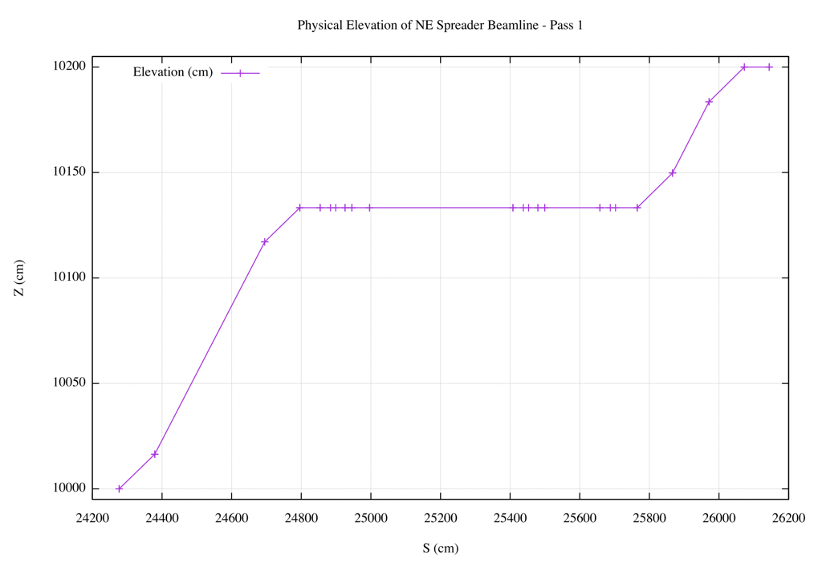
* 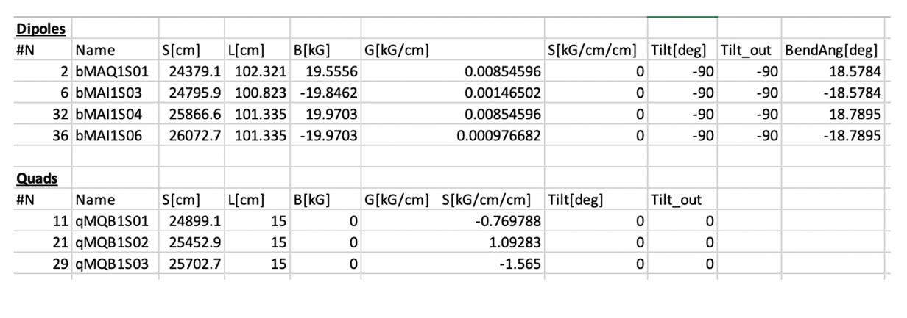
* Review of previous work
  + Shows that the dipoles would be at ~2 T, which isn’t attainable
  + Current ratio of first and second step is very tight
  + 1:1 would be too tight
  + 3:1 might work well
* Photos uploaded into shared area. Ryan will add more later.
* 1 or 2 FFA arcs?
  + 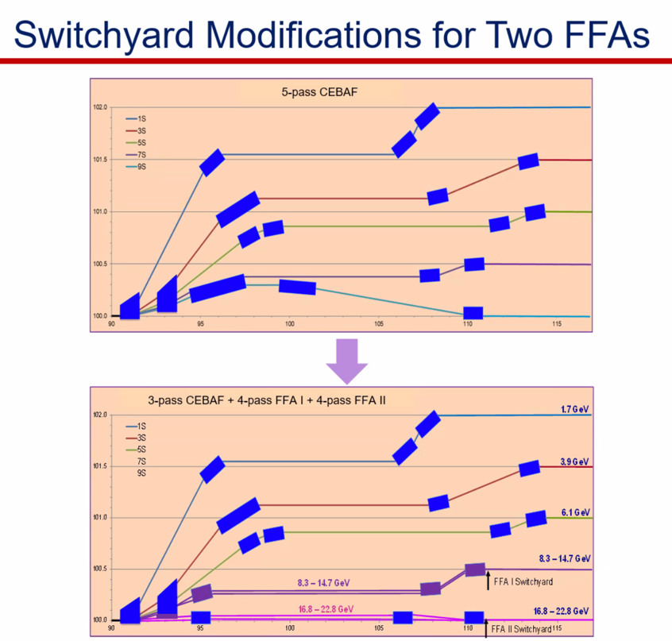
  + 2 FFAs is current baseline
  + Can we bring the 5th pass up toward the 4th pass line (in current configuration) now?
    - You’d need to figure out how to cancel dispersion (with combined function magnets)
  + Used to do 4 EM passes and 1 FFA pass
    - Dejan proposes 5 pass CEBAF + FFA
* Can we put the FFA below the 5th pass if we move up the magnets a few (~10) cm?
  + Maybe, but this might be the tail wagging the dog
* Splitters: they take up a lot of real estate
* Advantage of 2 FFA solution is that you have two sets of splitters at different levels with relatively modest number of passes
  + 4 splitter lines in each – more attractive in terms of real-estate
  + More splitters drastically increases cost
* Jay’s 1 FFA proposal is to stop at <20 GeV.

Conclusion

Get the first three EM arcs done first to see how much room we have to play. Then, we can decide 1 vs. 2 FFA arcs, etc…

|  |  |  |
| --- | --- | --- |
| Action items | Person responsible | Deadline |
|  |  |  |

## Time allotted | 25 minutes | Agenda topic Alt. Arc Transport | Presenter Jay

* Almost there on Hall C – 1 cm off on a pivot.
* Will continue working and present later
  + Get fields needed for lambertson, etc…
* No new drawings, so based off old drawings.
* Has been discussing with Doug about experiments needs, extraction plans, etc…

Conclusion

Necessary work to see if we can get the beam out!

|  |  |  |
| --- | --- | --- |
| Action items | Person responsible | Deadline |
|  |  |  |

## Special notes

Pathway to Repository: <https://jeffersonlab-my.sharepoint.com/:f:/g/personal/tristan_jlab_org/EqZ5MeS-nipCgPfZB5p0oS4B9Is67d3nQb9sLJI3Zyev9g>