FFA@CEBAF Working Group | Minutes

## Meeting date | time 4/29/2022 | 11 AM EST | Meeting location (virtual) <https://jlab-org.zoomgov.com/j/1614898082?pwd=TnUzMS81M2sxbDZIbERJU01tYkJCQT09>

|  |  |  |  |  |  |  |  |  |  |  |  |
| --- | --- | --- | --- | --- | --- | --- | --- | --- | --- | --- | --- |
| |  |  | | --- | --- | | Meeting called by | Alex | | Type of meeting | Weekly Meeting | | Facilitator | Alex | | Note taker | Ryan | | Timekeeper | Alex | | Attendees  Ryan, Alex B, Dejan, Jay, Kitty, Andrei, Alex C, Randy, Vasiliy, Stephen, Kirsten, Scott |

# Intro discussion

# Agenda topics

## Time allotted | 10 minutes | Agenda topic Alt. Arc Transport | Presenter Jay

* 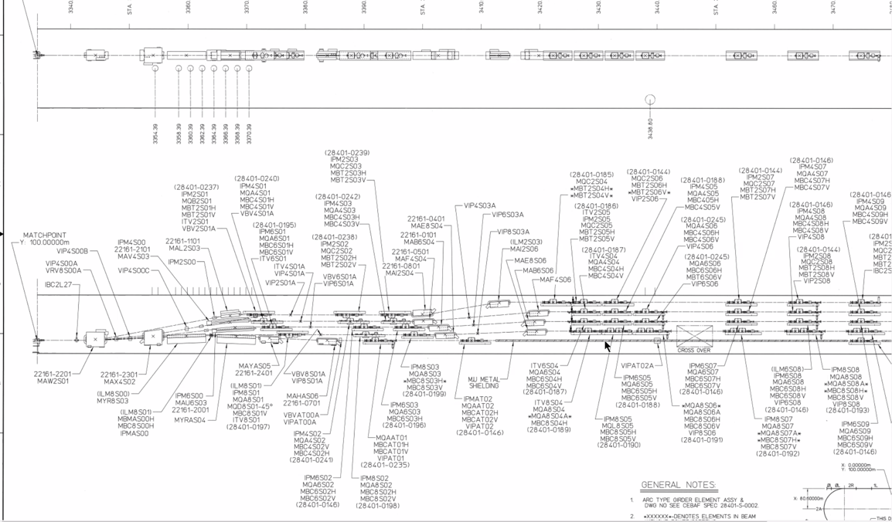
* Still think 4 EM and 1 FFA arc is the right way
* Used to have a long drift coming to the vertical RF separators
  + At JFuture meeting, most were Hall B and D
  + Put vertical RF separators (conductively cooled superconducting) and septa to push the B Beam down
* 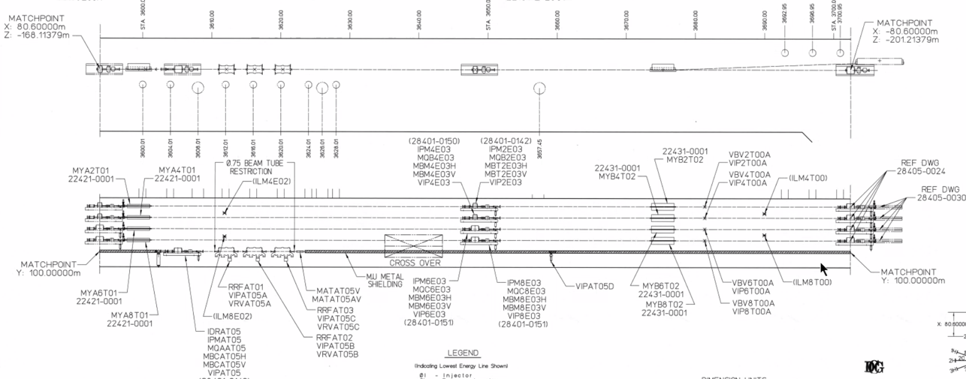
  + Put SRF separators upstream into drifts so the septa can go where the RF are now
    - Now will have multiple magnets for C
    - Allow A 5th, B 5th, and C could go symmetric to Hall A, or pushed out further to Hall D
    - So, either A, B, C at 20 GeV and nothing for D or A, B getting 20 and either C or D getting the rest.
* After drift from RF separators (~100 ft)
* Maybe we can just double everything?
  + YBs and YRs – get enough kick to get beyond beamline
  + Would be easier to have the conductively cooled units
  + Maybe double first 3 passes?
  + Assuming can only extract at the end of the FFA, not in TOF
    - End meaning after 4 passes in one FFA
    - Stephen: should be separable
    - Splitter lines can extract whatever pass (maybe easier said than done)
      * Maybe can’t do that and maintain higher energy for other halls.
    - Could put RF kickers when beams are separate, then you’d need more of them, etc…
      * Real estate might be too tight

Conclusion

This is complicated, but important to understand.

|  |  |  |
| --- | --- | --- |
| Action items | Person responsible | Deadline |
|  |  |  |

## Time allotted | 25 minutes | Agenda topic Adiabatic Arc | Presenter Vasiliy

* 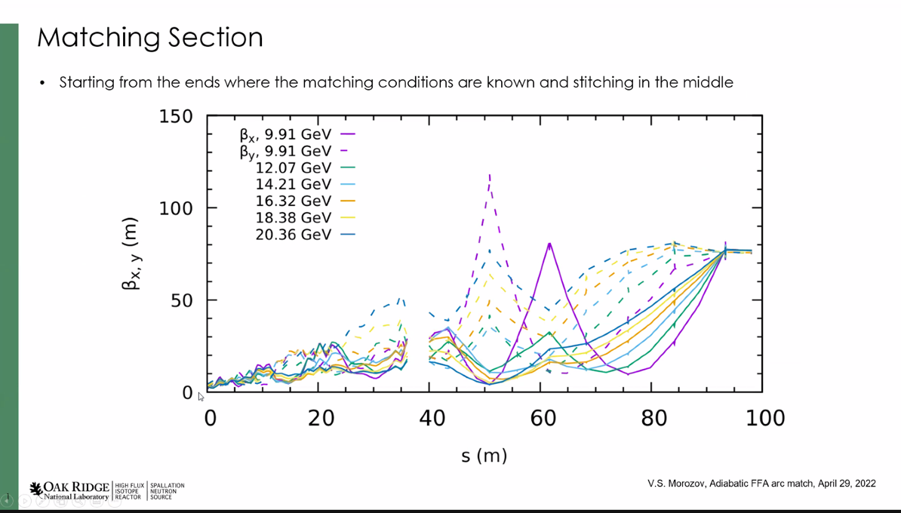
  + What’s the best way to connect?
* 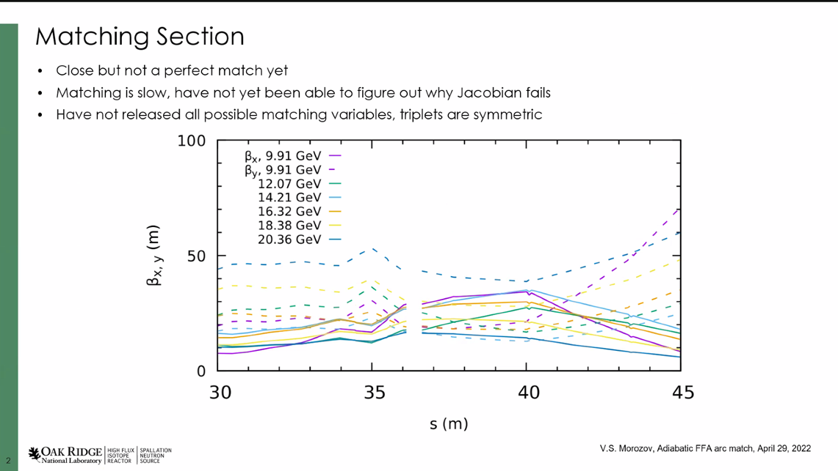
  + Jacobian fails when using it
* Come to LINAC with high beta function
  + Lower passes have slightly lower beta – still periodic structure in the linac
    - Might help
* This solution accounts for the linac triplet cells design
  + Different in normalization with old MADX and BMAD
    - MADX normalized to reference E
    - BMAD is normalized to pass energy
  + In PTC, if you change reference energy, beta also change and shouldn’t
* Long term – find a more clever/faster way
  + Total number of parameters is 52
  + Still haven’t released all the available variables yet
* 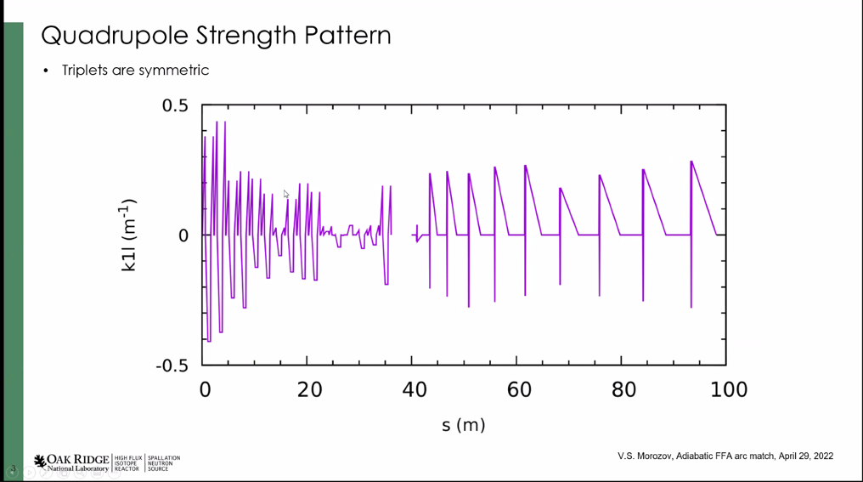
  + Stengths of triplets
* 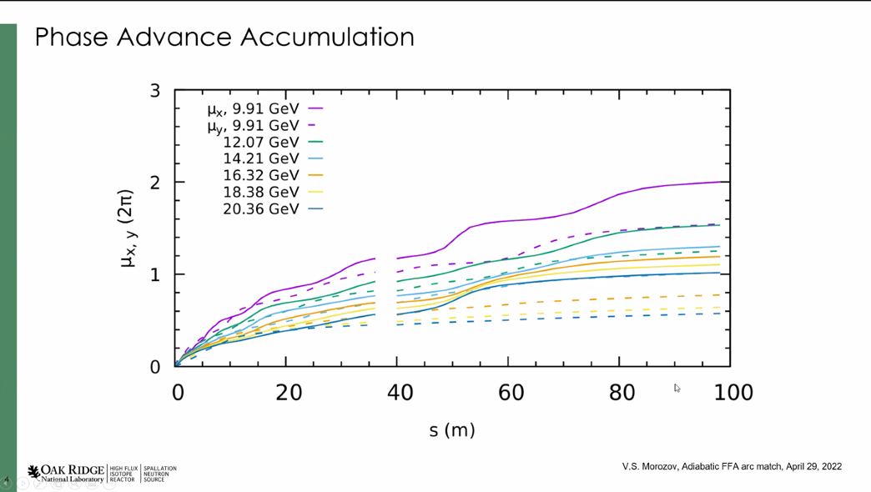
* 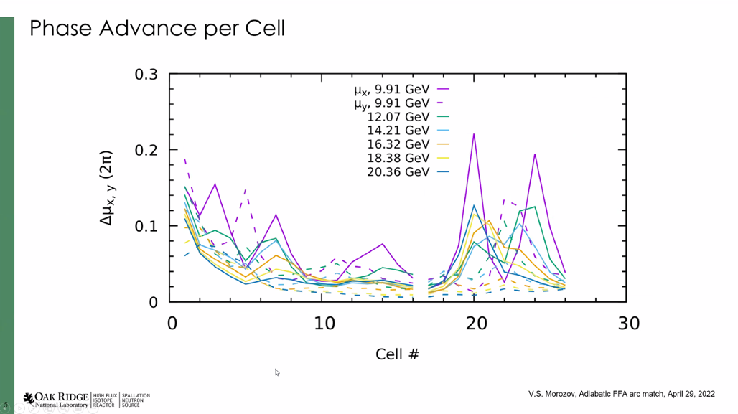
  + Not sure what to make of this yet
  + May provide hints on how to do things more systematically
* Looks much better than in the past.
* This is a sequential process, so farm won’t help.
* Simplex is slow, but consistent
* Scott: interesting feature:
  + Phase advance per cell varies significantly as you go down the line. In some ways this isn’t particularly adiabatic
    - Not sure what to make of it, or if it means anything.
  + Different object than CBETA matches. Not better/worse, just different
    - May have interesting beam dynamics impact
  + Will be interesting to mismatch parameters as a function of energy
* Tried smooth change of phase advance per cell, but unsuccessful
* 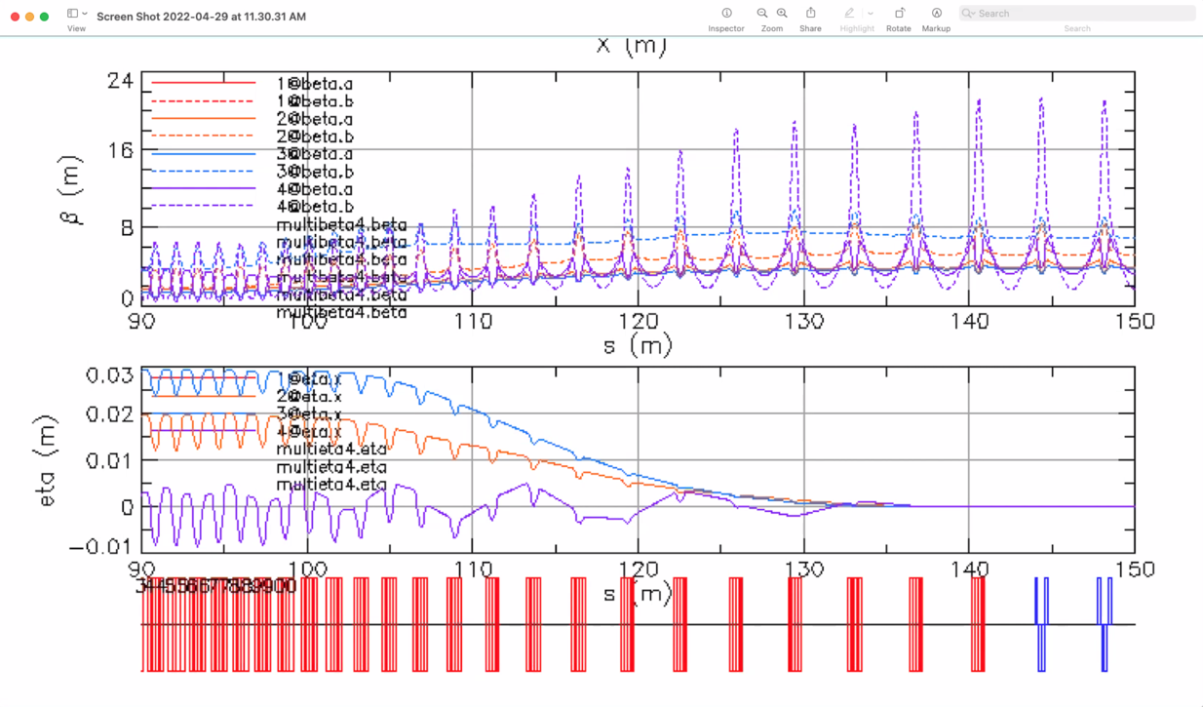
  + Orbits merged, but went up to ~23 m
  + Might be first stage to allow you to get 160 m.

Conclusion

Significant improvement over previous.

|  |  |  |
| --- | --- | --- |
| Action items | Person responsible | Deadline |
|  |  |  |

## Time allotted | 10 minutes | Agenda topic Alt. Arc Transport | Presenter Jay

* 
* Still think 4 EM and 1 FFA arc is the right way
* Used to have a long drift coming to the vertical RF separators
  + At JFuture meeting, most were Hall B and D
  + Put vertical RF separators (conductively cooled superconducting) and septa to push the B Beam down
* 
  + Put SRF separators upstream into drifts so the septa can go where the RF are now
    - Now will have multiple magnets for C
    - Allow A 5th, B 5th, and C could go symmetric to Hall A, or pushed out further to Hall D
    - So, either A, B, C at 20 GeV and nothing for D or A, B getting 20 and either C or D getting the rest.
* After drift from RF separators (~100 ft)
* Maybe we can just double everything?
  + YBs and YRs – get enough kick to get beyond beamline
  + Would be easier to have the conductively cooled units
  + Maybe double first 3 passes?
  + Assuming can only extract at the end of the FFA, not in TOF
    - End meaning after 4 passes in one FFA
    - Stephen: should be separable
    - Splitter lines can extract whatever pass (maybe easier said than done)
      * Maybe can’t do that and maintain higher energy for other halls.
    - Could put RF kickers when beams are separate, then you’d need more of them, etc…
      * Real estate might be too tight

Conclusion

This is complicated, but important to understand.

|  |  |  |
| --- | --- | --- |
| Action items | Person responsible | Deadline |
|  |  |  |

## Time allotted | 25 minutes | Agenda topic AOB | Presenter All

* What’s the cost of one of these arcs?
  + No idea right now because the price is fluctuating drastically.
* What’s the cost on building/testing/etc…?
  + Companies to do building and corrector magnets – for 200 magnets no more than $1M – but that’s a *very* good price. May not get close to that.
* $4M for 230 magnets back in CBETA days, but likely over $10M now.
  + Only 12 cm long
* Vasiliy shows a report on Halbach magnets
* Stephen: cost of magnets:
  + $4.48/cm^3 before, now $30+/cm^3
  + Scaling the worst case to CEBAF, $220M!!
* Andrei:
  + Recent discussions with management: can we consider a staged commissioning. First 1 arc, then another?
  + Keep it under $200M per pass, then do it scaled.
* Ryan naïve question: are there other magnetic materials we could use or blend?
  + Not really, but maybe. There is one that may be more expensive, but this is something to look into

Conclusion

|  |  |  |
| --- | --- | --- |
| Action items | Person responsible | Deadline |
|  |  |  |

## Special notes

Pathway to Repository: <https://jeffersonlab-my.sharepoint.com/:f:/g/personal/tristan_jlab_org/EqZ5MeS-nipCgPfZB5p0oS4B9Is67d3nQb9sLJI3Zyev9g>