FFA@CEBAF Working Group | Minutes

## Meeting date | time 5/6/2022 | 11 AM EST | Meeting location (virtual) <https://jlab-org.zoomgov.com/j/1614898082?pwd=TnUzMS81M2sxbDZIbERJU01tYkJCQT09>

|  |  |  |  |  |  |  |  |  |  |  |  |
| --- | --- | --- | --- | --- | --- | --- | --- | --- | --- | --- | --- |
| |  |  | | --- | --- | | Meeting called by | Alex | | Type of meeting | Weekly Meeting | | Facilitator | Alex | | Note taker | Ryan & Alex C | | Timekeeper | Alex | | Attendees  Ryan, Alex B, Todd, Jay, Randy, Alex C, Kitty, Kirsten, Scott, Andrei, Dejan, Stephen, Vasiliy |

# Intro discussion

# Agenda topics

## Time allotted | 40 minutes | Agenda topic Staging | Presenter Alex B

* Director’s council update:
  + 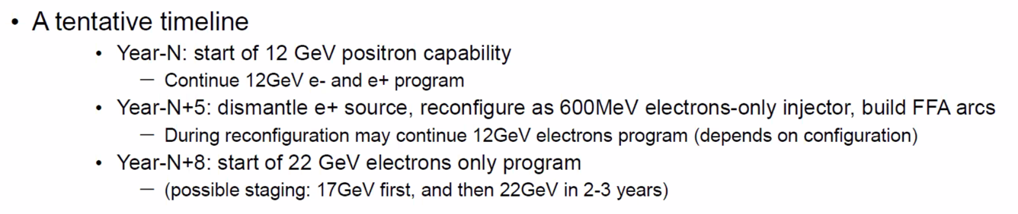
    - 12 GeV estimated ~5 years of program left
  + Intertwined with positron program
* 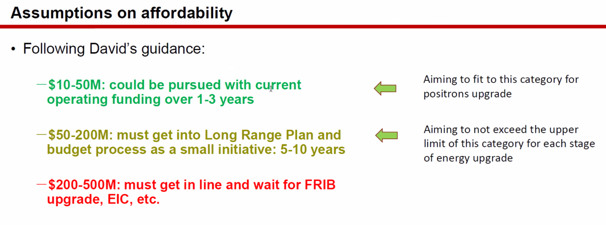
* First stage for us would be upgraded injector, then 1 FFA up to 17 GeV, then add the second FFA
* Stephen: how can positron target be less than $50M?
  + Might be in category 2 as well
* 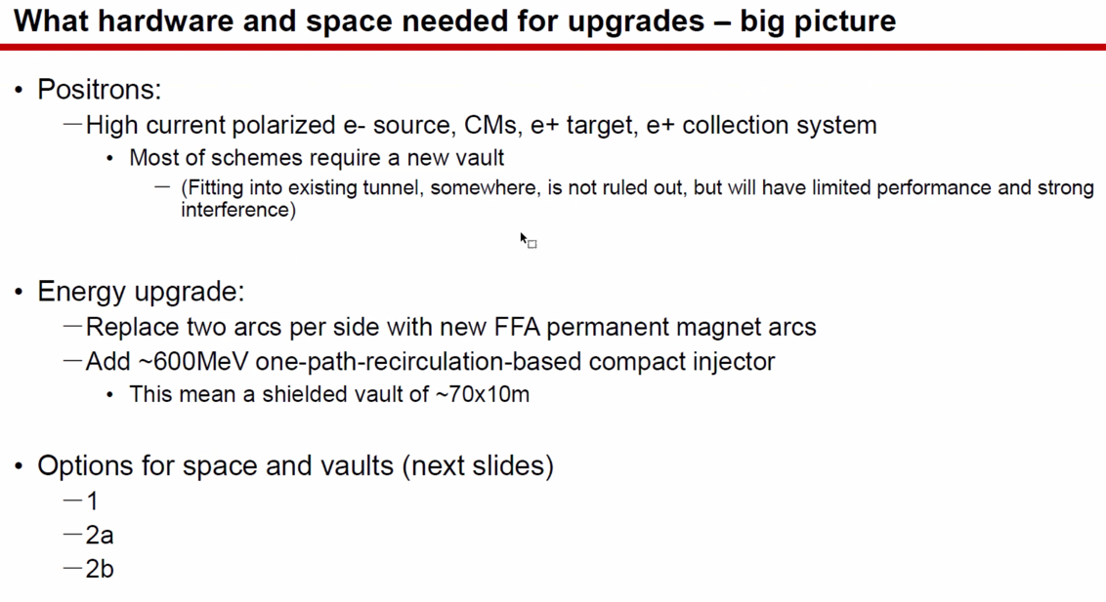
* 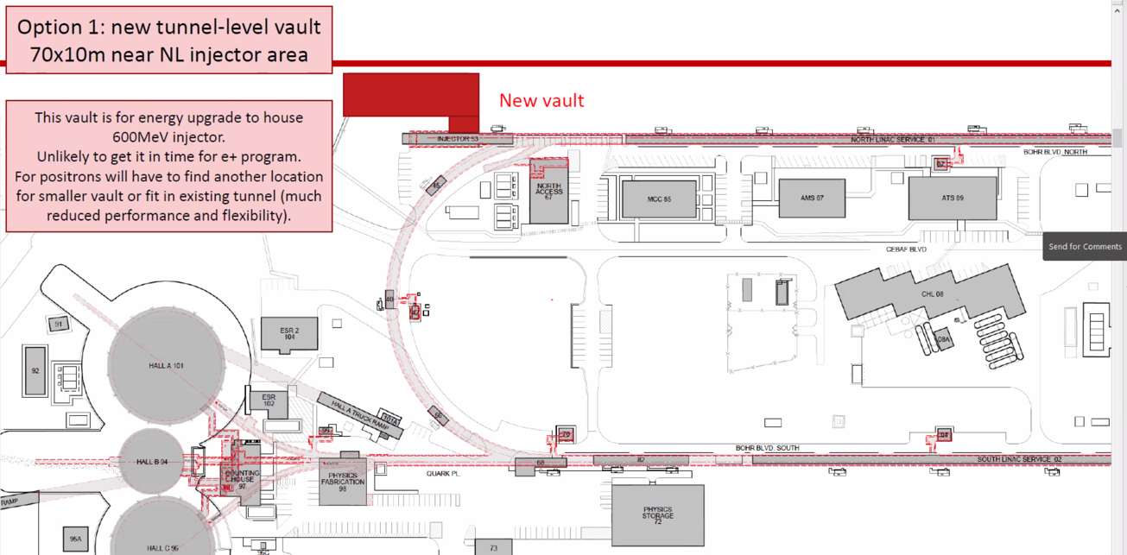
* 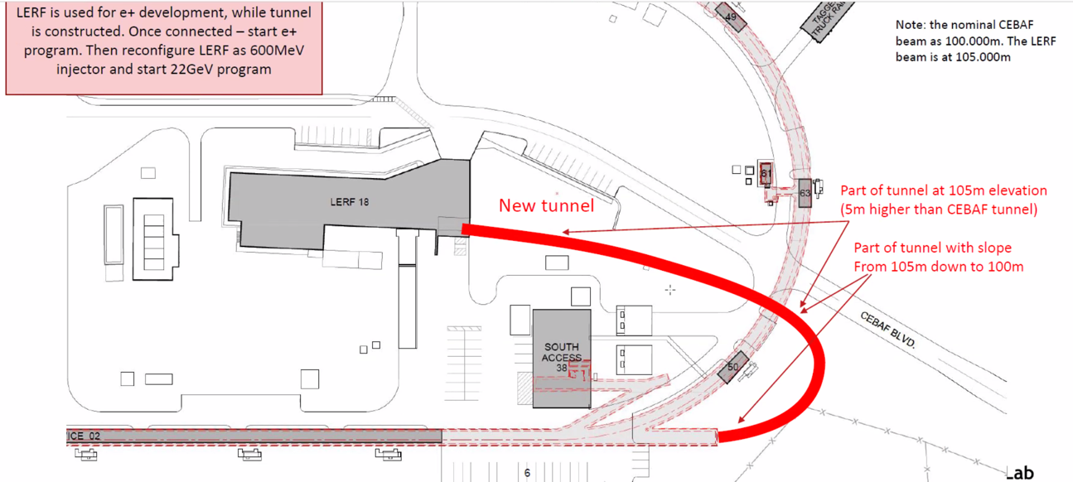
* 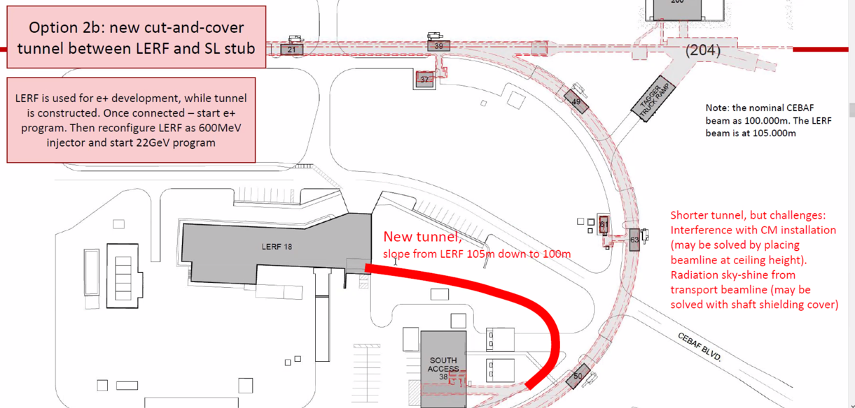
* Would the 650 injector fall under $50M?
  + Jay: first, move that box representing the injector over to where the “New Vault” text currently is placed
  + Estimating $10M for just the vault at that size (if we can fit the bends in 10 m)
  + Plus internals and rest, maybe build it all for $50M
    - Couldn’t do anything for spreaders or recombiners
    - No benefit until spreaders and recombiners reworked
* How did SLAC do positrons?
  + Andrei: SLAC method wouldn’t work – damping ring, etc…
    - We also need polarized positrons here
* ***Physics has decided no positrons above 12 GeV***
* Bringing the positrons into the SL at 123 MeV, use about 700 m of positron transfer line, then inject into NL.
* Jay working on Hall magnets and lines
  + Few mm off at pivot and beam dump
  + Will have OptiM file to hand off
* During positrons, B will get polarized, Hall A and C get unpolarized
* Alex will post the slides into “presentations” folder

Conclusion

This news disentangles us from needing to consider positrons. We can also consider pricing for stages.

|  |  |  |
| --- | --- | --- |
| Action items | Person responsible | Deadline |
|  |  |  |

## Time allotted | 20 minutes | Agenda topic NE Spreader | Presenter Ryan

* Overview of the present design
  + 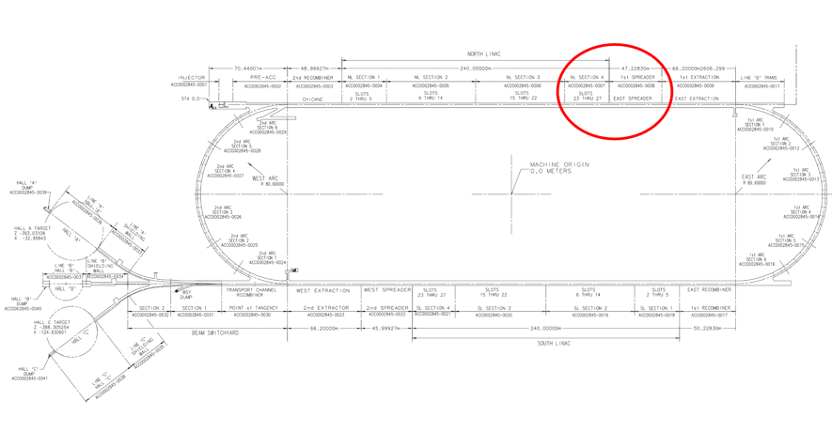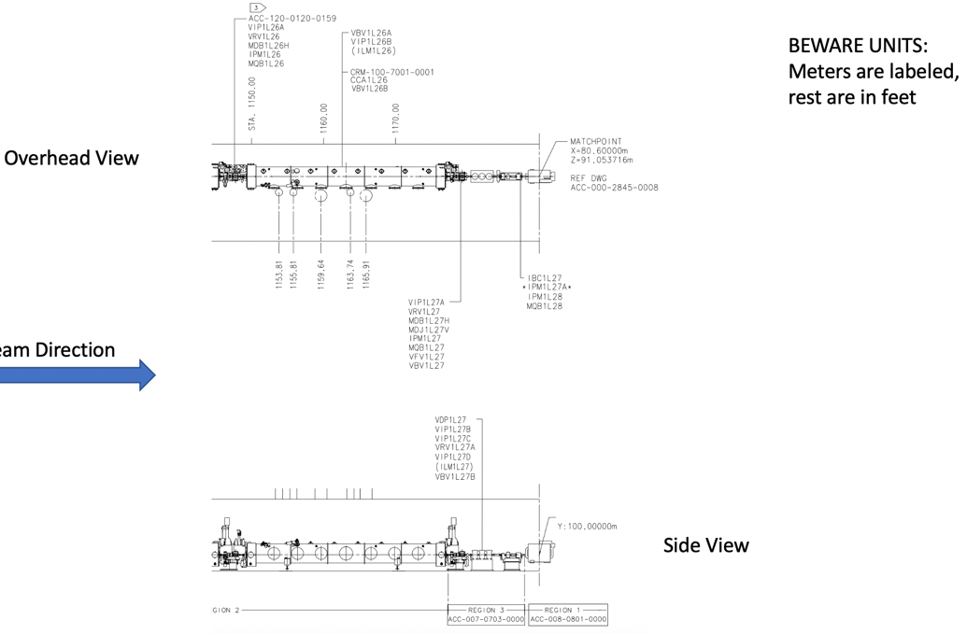
  + 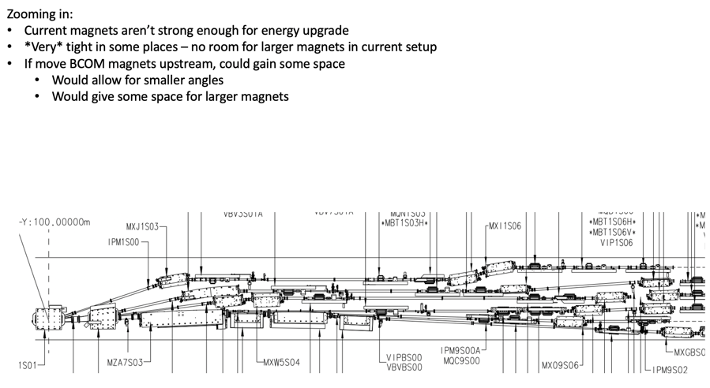
  + 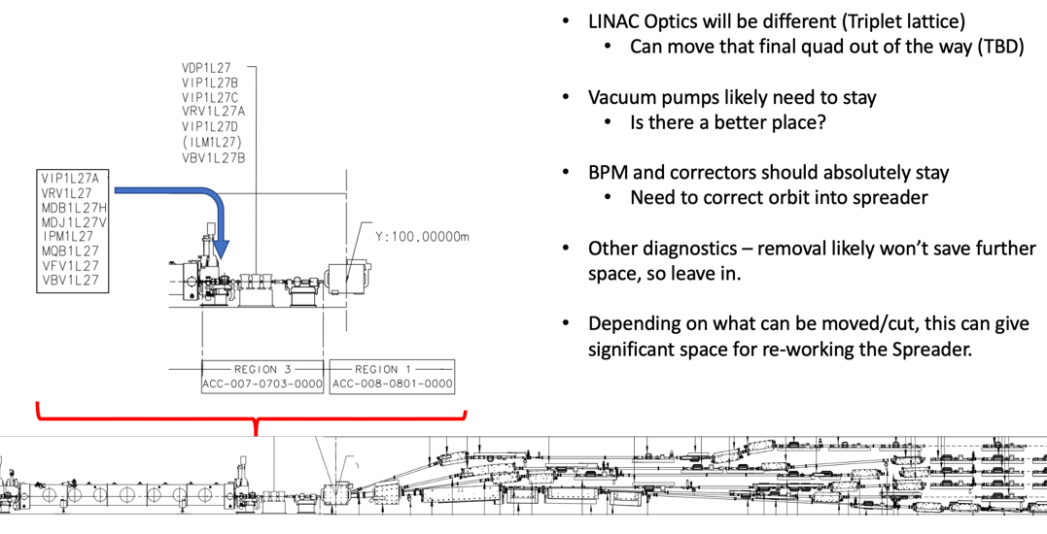
* BCOM magnet – move it upstream
  + Present magnets won’t work for the FFA, requires ~2T
  + Can we move the BCOM back and gain some space?
  + Dejan says we need a triplet near the end of the LINAC
    - We will have triplet lattice in general for linacs
    - Jay says permanent magnets for the triplet infeasible
    - Stephen reminds us that it really depends on beta function requirements
  + Can reduce the number of vacuum pumps to 2
  + Could use different BPMs to save room
  + Other diagnostics required, probably can’t save more space
  + May be able to gain up to a meter or a bit more (1.4 m for girder)
* What if a dipole is added to start the spread earlier with another dipole?
  + Solve some of the issues with the BCOM?
  + Jay thinks replacing the whole spreader system is better
  + Changing drifts in the arcs is how he gained space
  + Maybe best to start with new magnets overall, save some if required or actually useful
    - Alex B concurs with Jay
    - Alex B notes that matching section may be modified/replaced because we still need a splitter
  + Is it more cost effective to reuse magnets?
    - … sometimes.

Conclusion

Ryan will start with a semi-green field design, using new magnets, more space, etc… This will focus on the first 3 EM passes first, then FFA passes.

|  |  |  |
| --- | --- | --- |
| Action items | Person responsible | Deadline |
|  |  |  |

## Time allotted | 25 minutes | Agenda topic Emittance Dilution | Presenter Kirsten

* No time – next time?

Conclusion

|  |  |  |
| --- | --- | --- |
| Action items | Person responsible | Deadline |
|  |  |  |

## Special notes

Pathway to Repository: <https://jeffersonlab-my.sharepoint.com/:f:/g/personal/tristan_jlab_org/EqZ5MeS-nipCgPfZB5p0oS4B9Is67d3nQb9sLJI3Zyev9g>