FFA@CEBAF Working Group | Minutes

## Meeting date | time 5/13/2022 | 11 AM EST | Meeting location (virtual) <https://jlab-org.zoomgov.com/j/1614898082?pwd=TnUzMS81M2sxbDZIbERJU01tYkJCQT09>

|  |  |  |  |  |  |  |  |  |  |  |  |
| --- | --- | --- | --- | --- | --- | --- | --- | --- | --- | --- | --- |
| |  |  | | --- | --- | | Meeting called by | Alex | | Type of meeting | Weekly Meeting | | Facilitator | Alex | | Note taker | Ryan | | Timekeeper | Alex | | Attendees  Ryan, Alex B, Kirsten, Jay, Kitty, Alex C, Andrei, Randy, Vasiliy, Dejan, Scott, Stephen, Eric, Todd |

# Intro discussion

# FFA workshop upcoming – deadline August 1 for registration

# ARW workshop upcoming (reliability) – will be in NN in October. Might be good to have representation here, since reliability during upgrades is a topic.

# Agenda topics

## Time allotted | 25 minutes | Agenda topic Emittance Dilution | Presenter Kirsten

* Second look at previous work: update on transverse emittance growth, loss, energy spread
  + All radiation integral based
* 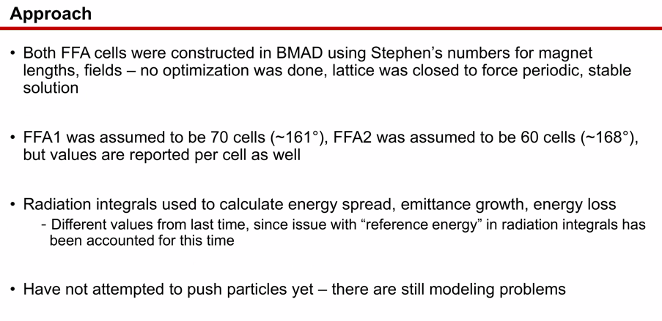
* 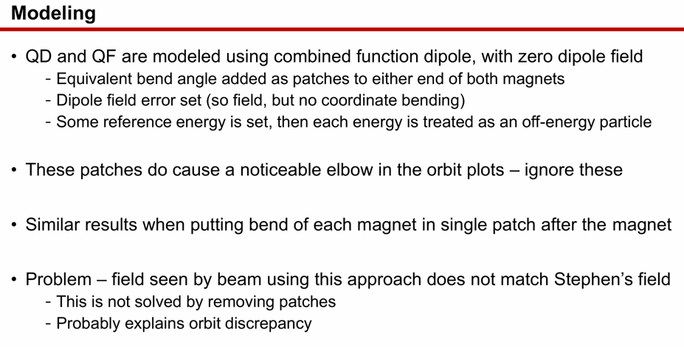
  + Not solved bending field problem yet
  + Removing patches makes it work
  + How to define magnets in BMAD to get “right field”
    - Could compare theoretical field to what you’re getting, see which code diverges the most
    - Previously, BMAD agreed well with Muon1
      * Send to Dejan to check code?
      * Scott uses different approach, but always gets the same result
      * Set reference energy (Dejan’s method), Scott uses each universe separately
      * Scott: You’re using a DB field? – yes
      * Tried B-field nonzero, added edges, went poorly
      * Problem in BMAD with rectangular vs sector
        + Scott: Want to represent magnet properly (as designed) generally involves there is no geometric bend, but electric field, then adding geometric bend into patches. I think there’s something simple going wrong here.
        + Probably simple to fix, once you find it.
        + Send file to Dejan and Scott.
  + Concern of using FFA1 reference energy of 11.5 GeV – 70 cells with SR to find good solution, you’ll need a reference energy closer to 7 Gev, because you’ll get the wrong loss.
    - If calculating by pushing particles, doesn’t matter about reference energy
    - For a “first pass” – here’s 70 cells, turn on SR, how to get particles/angles right
      * Do this before pushing particles.
      * Get in the ballpark with radiation “on”
  + Dejan calls circular orbit the reference energy, Scott and Stephen don’t quote reference energy
    - Scott: no intrinsic assumption on circular orbit
* 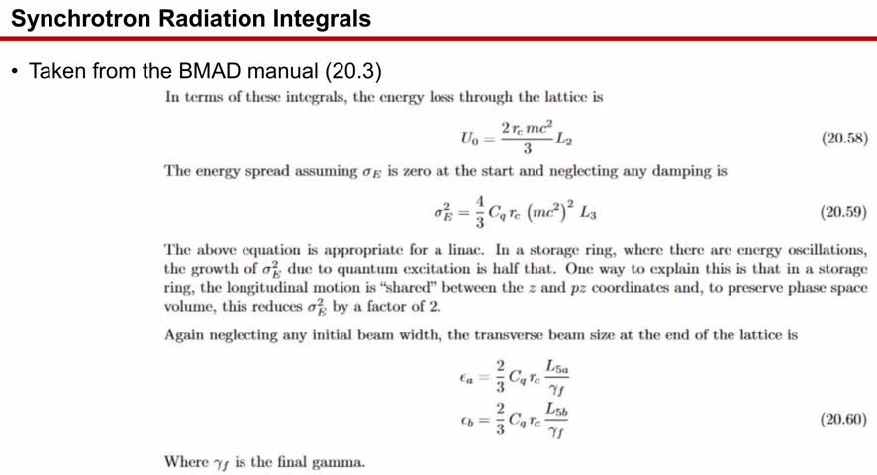
  + BMAD manual
  + Will get sorted when pushing particles
* 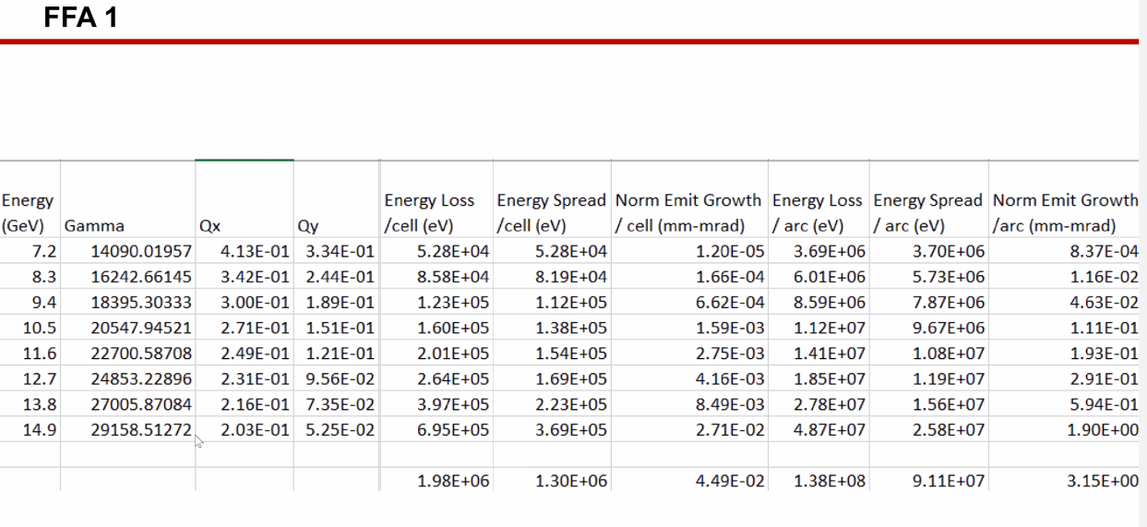
* 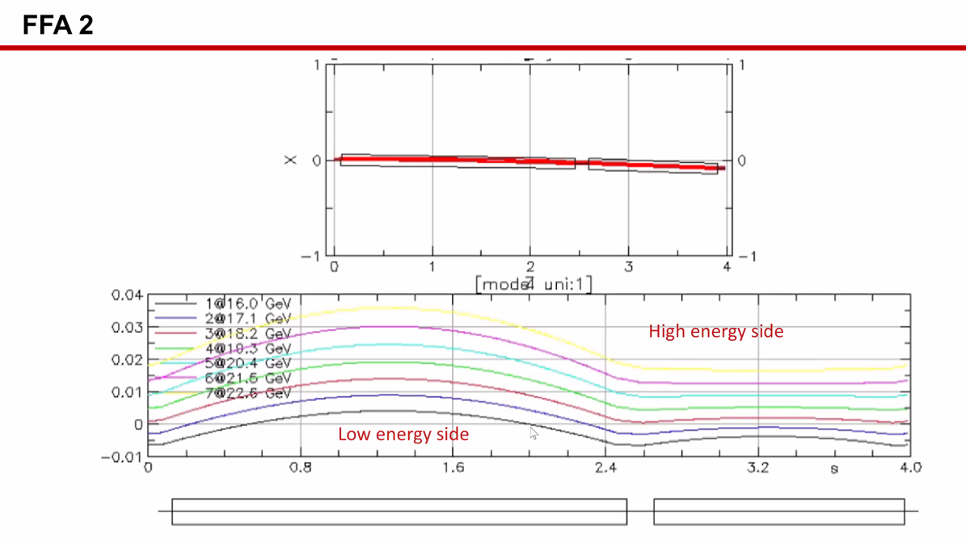
  + Dejan: this isn’t the orbit I’d like to see.
    - This isn’t the right orbits you’d see in the ring
      * Scott – not necessarily, we’d have to look more
  + Scott: show the orbit in floor coordinates
    - In floorplan plot, set parameter with multiplier for orbits – it’ll show floor orbits multiplied by some factor to see them
* 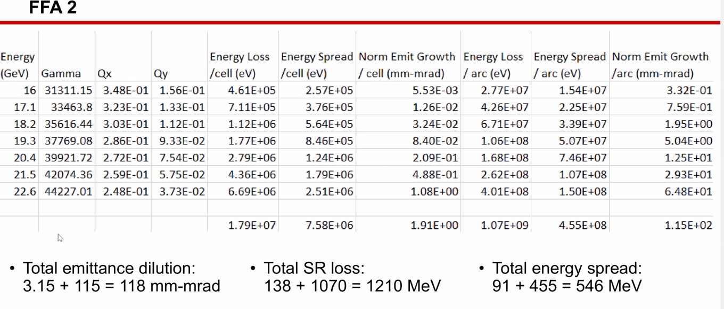
* Stephen had 0.8 GeV total loss, Kirsten gets 1.2 GeV
  + Muon1 might be “too realistic” – needs to be figured out
  + Get 40 MeV in the highest passes at CEBAF now – scales to the 4th power
    - 640 MeV as a very rough estimate – not out of line
    - We have about a 2/3 fill factor now
* 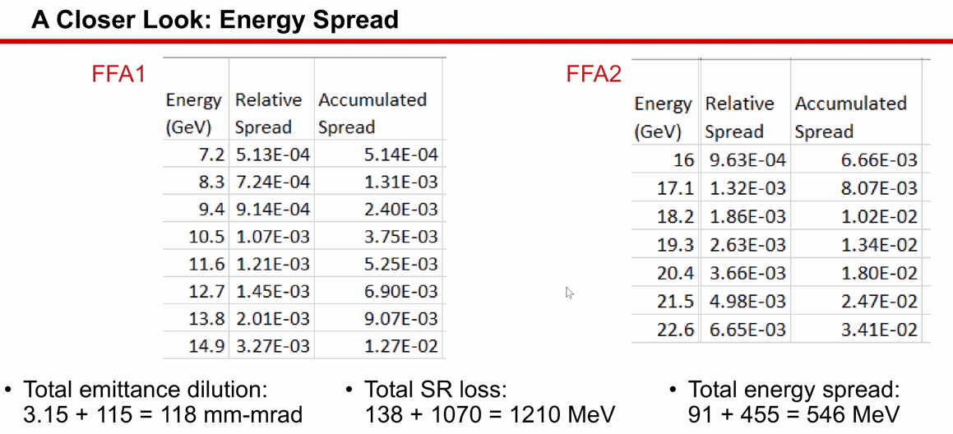
  + Energy spread accumulation – large number (compared to analytic number)
    - If SR is high, then spread is high, but this is all from radiation integrals
    - Will be more accurate once model improves
    - In extraction region and hall lines, we don’t have an energy acceptance more than ~1.5e-3
      * Could never get clean match through double-peaked line – reverted to 4 m
        + Smaller passes with double peak, but at 11 GeV will likely go back to single peak
        + Can’t figure out “why things don’t work”
        + Kitty has Hall lines in MadX format – please include in offline discussions
* FFA2 seems to have an energy spread/loss problem
  + Part of why Jay is pushing for 1 FFA topping out at ~20 GeV with 4 EM (higher fill factor) and 1 FFA arc
* How doing accumulated spread?
  + No compensation in arc, and no other sources, and no compensation between arcs.
  + Alex: the numbers are 2e-3 from his calculations – this is much, much too high.
  + 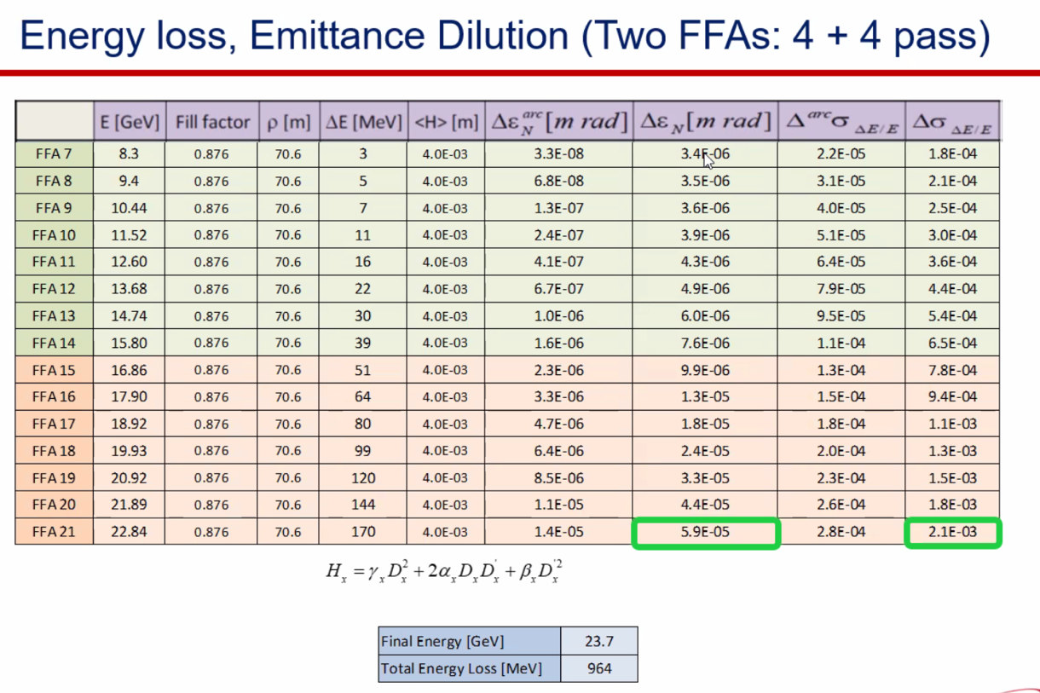
  + 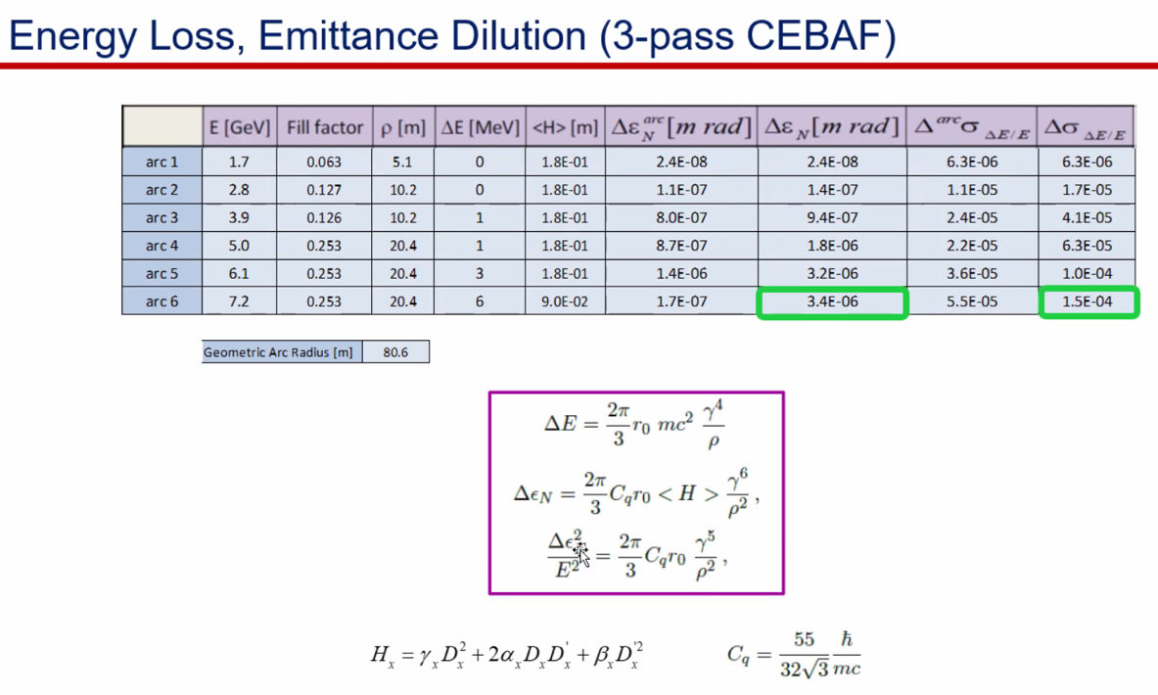
    - Kirsten: perhaps made cumulative the wrong way – simply added
      * Stephen, might need to add in quadrature
      * Alex: variance of energy spread, then take square root
  + Overestimated energy spread – will update spreadsheet

Conclusion

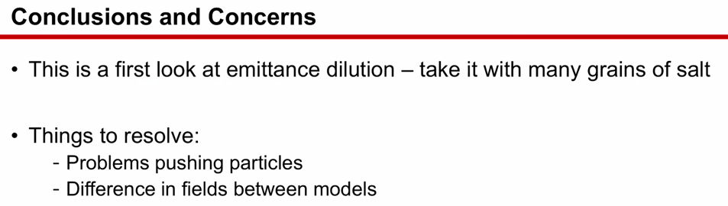

|  |  |  |
| --- | --- | --- |
| Action items | Person responsible | Deadline |
|  |  |  |

## Time allotted | 5 minutes | Agenda topic IPAC22 | Presenter All

* Ryan Poster on general FFA@CEBAF
* Vasiliy on FFA applications
* Stephen on magnet design

Conclusion

|  |  |  |
| --- | --- | --- |
| Action items | Person responsible | Deadline |
|  |  |  |

## Time allotted | 5 minutes | Agenda topic AOB | Presenter All

* Discussion regarding hall beam delivery lines
  + Still need new septa
  + Best anyone has done is 1.5 m of peak dispersion
* Need more studies for this.
* Jay will send around files. Kitty and Alex
  + ~1mm off at the pivot in X

Conclusion

|  |  |  |
| --- | --- | --- |
| Action items | Person responsible | Deadline |
|  |  |  |

## Special notes

Pathway to Repository: <https://jeffersonlab-my.sharepoint.com/:f:/g/personal/tristan_jlab_org/EqZ5MeS-nipCgPfZB5p0oS4B9Is67d3nQb9sLJI3Zyev9g>