FFA@CEBAF Working Group | Minutes

## Meeting date | time 5/20/2022 | 11 AM EST | Meeting location (virtual) <https://jlab-org.zoomgov.com/j/1614898082?pwd=TnUzMS81M2sxbDZIbERJU01tYkJCQT09>

|  |  |  |  |  |  |  |  |  |  |  |  |
| --- | --- | --- | --- | --- | --- | --- | --- | --- | --- | --- | --- |
| |  |  | | --- | --- | | Meeting called by | Alex | | Type of meeting | Weekly Meeting | | Facilitator | Alex | | Note taker | Ryan | | Timekeeper | Alex | | Attendees  Ryan, Alex B, Alex C, Todd, Kitty, Dejan, Kirsten, Scott, Randy, Jay, Eric, Stephen, Vasiliy, Spata, |

# Intro discussion

# Agenda topics

## Time allotted | 25 minutes | Agenda topic IPAC22 | Presenter All

* Ryan has rough draft in folder.
  + Please review ASAP
* Stephen almost has rough draft done.
* Vasiliy working on his.
* Overall DOE contract statement (change contract order as you wish):
  + Authored by Jefferson Science Associates, LLC under U.S. DOE Contract No. DE-AC05-06OR23177, Brookhaven Science Associates, LLC under Contract No. DE-SC0012704, and UT-Battelle, LLC, under contract DE-AC05-00OR22725 with the US Department of Energy (DOE). The United States Government retains a non-exclusive, paid-up, irrevocable, world-wide license to publish or reproduce the published form of this manuscript, or allow others to do so, for United States Government purposes.
* Papers must go through internal review, so let’s try to check them as soon as we can manage.
* Please upload drafts to the repository in the “IPAC22” folder when available
  + Including posters, if you want those reviewed.

Conclusion

|  |  |  |
| --- | --- | --- |
| Action items | Person responsible | Deadline |
|  |  |  |

## Time allotted | 25 minutes | Agenda topic Hall C Lines | Presenter Jay/Kitty

* 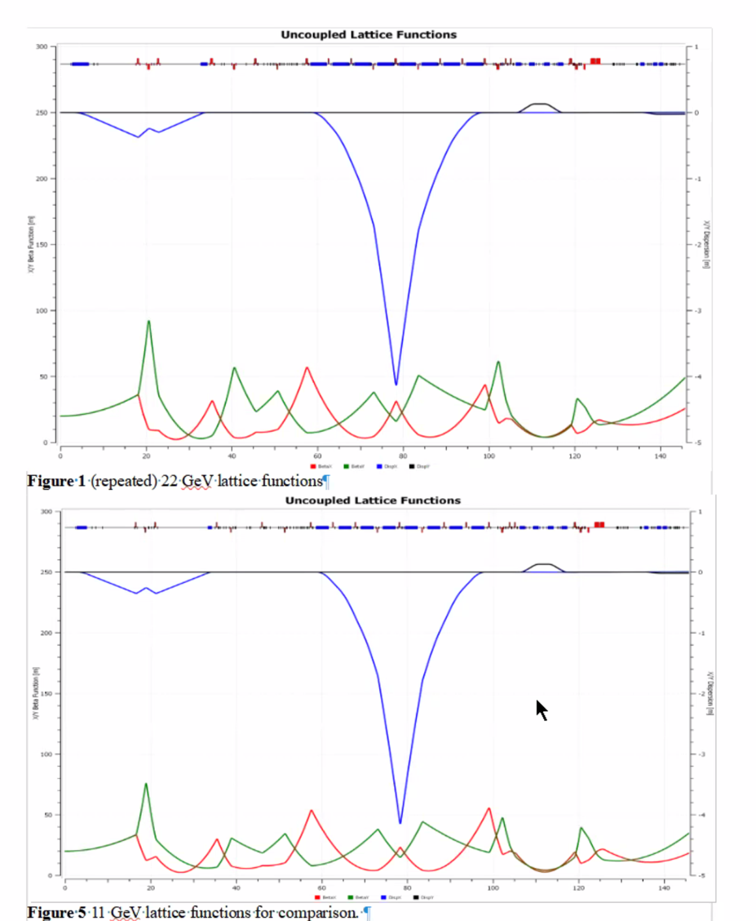
  + Bottom are existing 11 GeV lattice parameters, top is 22 GeV
  + Line goes from Lambertson, triplet, 1 m dipole to close dispersion, 4 quads with a harp in a bad spot, safety equipment, ARC with quads, 4 quads after arc for Compton, distributed triplet, quads into Moller (but used to focus at pivot as well)
  + Now, lambertson 60 cm longer, longer dipoles, longer quads
  + Done manually – cared about positions first
  + 4 m dispersion peak
    - Alternate optics has 2 x 1.5 m dispersion peaks
    - Do we still want this dispersion peak?
    - Look at 2-bump method with diagnostics?
  + Had to take out SR light monitor to fit a strong quad in the center of arc
  + Document sent out Wed
* 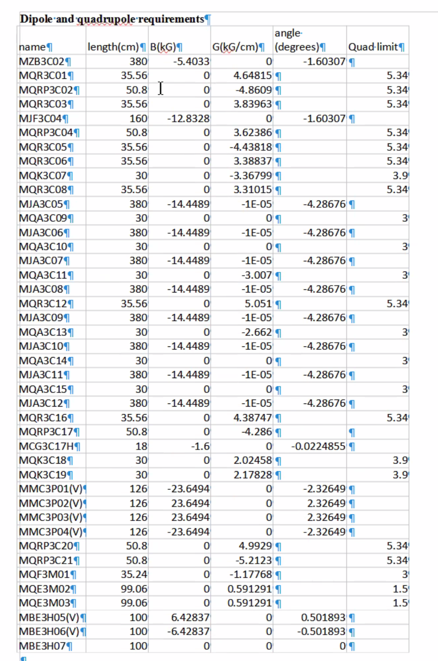
  + Will need further iterations (example, extending MQRP3C03 a bit)
  + Limited by steel
* The text of the document describes a lot of the details on this – reading through is encouraged.
* Cooling Lambertson will be *very* hard
* ZAs are absurdly hard to cool
* If we install this, everything will be a little lower for B and C
* Will look at 2 m ARC2 dipoles to re-use in Hall B
* Have to remember, a lot of the space between dipoles has been eaten up by lengthening the dipoles
* Two-peak design will shrink strength requirements on center quad
* Just wanted a scale for magnets for this iteration.
* Getting a good spot with double-peak is hard
  + No BPMs in right places for fast feedback
  + Can probably be made work with 1 m of dispersion
* Will iterate with Lambertson with much coarser look
* Dejan’s design:
  + 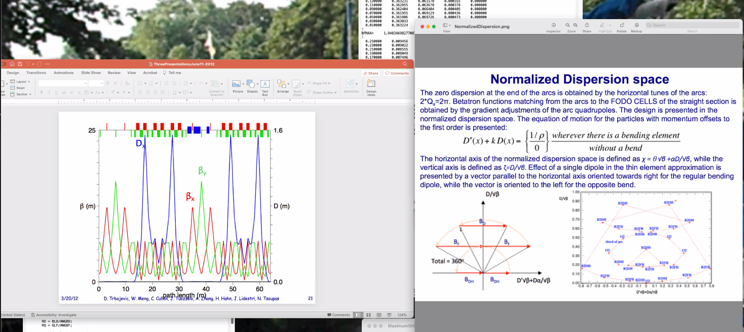
* 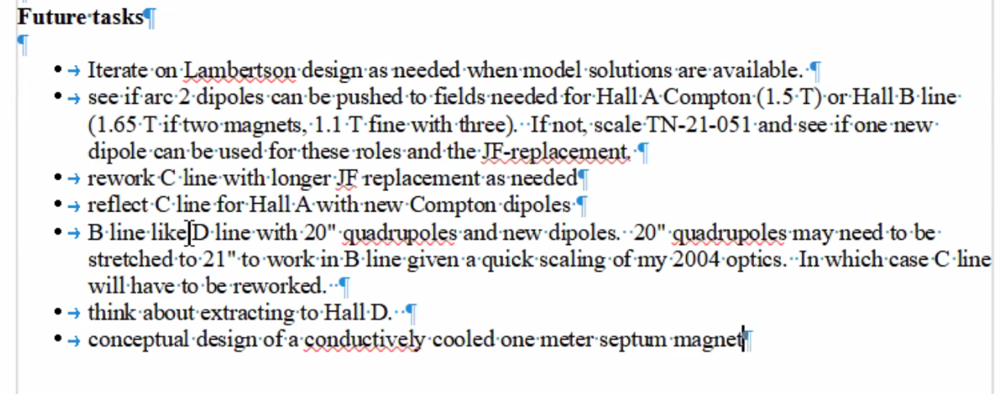

Conclusion

Really excellent first look to give realistic idea of what our magnet needs are.

|  |  |  |
| --- | --- | --- |
| Action items | Person responsible | Deadline |
|  |  |  |

## Time allotted | 5 minutes | Agenda topic AOB | Presenter All

* Mike Spata: the first reviews of the FOA are next week!

Conclusion

|  |  |  |
| --- | --- | --- |
| Action items | Person responsible | Deadline |
|  |  |  |

## Special notes

Pathway to Repository: <https://jeffersonlab-my.sharepoint.com/:f:/g/personal/tristan_jlab_org/EqZ5MeS-nipCgPfZB5p0oS4B9Is67d3nQb9sLJI3Zyev9g>