Hall C line at 22 GeV (and comments re Halls A and B)
Jay Benesch
Revised 21 May 2022

Discussion

The existing Hall C line was scaled to 22 GeV to obtain approximate dipole and quadrupole fields. The entrance location of the Lambertson and the exit of the JF dipole which closes the first horizontal dispersion region were left unchanged in Z; the JF is offset 1 cm in X in the attached because I couldn't get it closer. The entrance and exit of the 34.3° arc are also as close as I could get them to existing positions manually in OptimX. The beam at the pivot is off (-0.149,0,-0.015) cm (x,y,z) and the beam at the dump is off (0.296, 0, -0.357) cm. Arc dipoles are 380 cm steel vs 300 cm. A new quad with same profile and gradient limit as the QR, but 20" steel, is also needed and temporarily designated MQRP below. Lambertson replacement is assumed 380 cm as well, 150 cm longer than at present. JF replacement assumed 160 cm vs 100 cm now. PSS and MPS equipment is relocated one quad girder downstream of their present locations, as is the harp used for matching. The longer drift and 20" quad should allow for present matching software to be used. Short BPMs will be needed in the arcs given the 80 cm reduction in the gap between dipoles and the longer quads in some locations. I have not substituted the stronger MCG correctors, which are about 1.5 cm longer than the MBC and MBD, in the lattice but left sufficient room for them. First articles of the MCGs will soon be assembled and tested for the MOLLER beam line. The first Moller polarimeter quad must be replaced; TN-20-044 has the needed design. The two 8" bore Moller polarimeter quads are fine for beam transport; Dave Gaskell says he should be able to make them work for polarimetry with longer drift to detectors. No solution yet exists for the Hall C Compton polarimeter.

Comments re Halls A and B

The Hall A line will be a mirror of this one until the Compton chicane. Since I advocate scraping arcs 1 and 2 and moving the remaining arcs up one level, I will look at pushing the 2 m by 13 cm wide pole BRH (arc 2) magnets to ~1.5 T for use in the Hall A Compton. The same magnets may be capable of use in a Hall B layout made in 2004, like that in use for Hall D, with two or three 2m dipoles each at the top and bottom of the ramp. If the BRH cannot be pushed to high enough field for either purpose, a 190 cm version of the new Hall A/C arc dipole (TN-21-051) should suffice. In which case the 160 cm JF replacement should be common with these, as opposed to what is shown below. If the 2 m BRH can be pushed, it can be a direct substitute for the JF replacement if the drifts can be worked out. The "French bench" assemblies for energy measurement using superharps will be replaced with the shorter granite tables used in the C line.

The B plate of the Lambertson is 0.7" (1.778 cm) thick and is saturated at 11 GeV. Accordingly, in the extended Lambertson models currently being solved, I have increased the B plate thickness 35% to 2.4 cm (0.945") in addition to 65% increase in length. This is feasible because both Halls B and C have vertical chicanes. The B chicane is obvious. The C chicane is 2.2 cm at the end of the line because the pivot/floor was placed at the wrong height during original construction. Increasing the B ramp by 3.11 mm will be trivial. Increasing the C chicane height by 6.22 mm is well within the capability of the magnets in place now. The A beam was closest to the vacuum wall in the 6 GeV BSY recombiner so moving the B and C beams down by 3 mm and 6 mm should be feasible. A drawing showing distances from wall to each beam in the 11 GeV recombiner does not exist but has been requested.

Dipole and quadrupole requirements
name | length(cm) | B(kG) | G(kG/cm) | angle (degrees) | Quad limit
MZB3C02 | 380 | -5.4033 | 0 | -1.60307
MQR3C01 | 35.56 | 0 | 4.64815 |  | 5.34
MQRP3C02 | 50.8 | 0 | -4.8609 |  | 5.34
MQR3C03 | 35.56 | 0 | 3.83963 |  | 5.34
MJF3C04 | 160 | -12.8328 | 0 | -1.60307
MQRP3C04 | 50.8 | 0 | 3.62386 |  | 5.34
MQR3C05 | 35.56 | 0 | -4.43818 |  | 5.34
MQR3C06 | 35.56 | 0 | 3.38837 |  | 5.34
MQK3C07 | 30 | 0 | -3.36799 |  | 3.9
MQR3C08 | 35.56 | 0 | 3.31015 |  | 5.34
MJA3C05 | 380 | -14.4489 | -1E-05 | -4.28676
MQA3C09 | 30 | 0 | 0 |  | 3
MJA3C06 | 380 | -14.4489 | -1E-05 | -4.28676
MQA3C10 | 30 | 0 | 0 |  | 3
MJA3C07 | 380 | -14.4489 | -1E-05 | -4.28676
MQA3C11 | 30 | 0 | -3.007 |  | 3
MJA3C08 | 380 | -14.4489 | -1E-05 | -4.28676
MQR3C12 | 35.56 | 0 | 5.051 |  | 5.34
MJA3C09 | 380 | -14.4489 | -1E-05 | -4.28676
MQA3C13 | 30 | 0 | -2.662 |  | 3
MJA3C10 | 380 | -14.4489 | -1E-05 | -4.28676
MQA3C14 | 30 | 0 | 0 |  | 3
MJA3C11 | 380 | -14.4489 | -1E-05 | -4.28676
MQA3C15 | 30 | 0 | 0 |  | 3
MJA3C12 | 380 | -14.4489 | -1E-05 | -4.28676
MQR3C16 | 35.56 | 0 | 4.38747 |  | 5.34
MQRP3C17 | 50.8 | 0 | -4.286
MCG3C17H | 18 | -1.6 | 0 | -0.0224855
MQK3C18 | 30 | 0 | 2.02458 |  | 3.9
MQK3C19 | 30 | 0 | 2.17828 |  | 3.9
MMC3P01(V) | 126 | -23.6494 | 0 | -2.32649
MMC3P02(V) | 126 | 23.6494 | 0 | 2.32649
MMC3P03(V) | 126 | 23.6494 | 0 | 2.32649
MMC3P04(V) | 126 | -23.6494 | 0 | -2.32649
MQRP3C20 | 50.8 | 0 | 4.9929 |  | 5.34
MQRP3C21 | 50.8 | 0 | -5.2123 |  | 5.34
MQF3M01 | 35.24 | 0 | -1.17768 |  | 3
MQE3M02 | 99.06 | 0 | 0.591291 |  | 1.5
MQE3M03 | 99.06 | 0 | 0.591291 |  | 1.5
MBE3H05(V) | 100 | 6.42837 | 0 | 0.501893
MBE3H06(V) | 100 | -6.42837 | 0 | -0.501893
MBE3H07 | 100 | 0 | 0 | 0

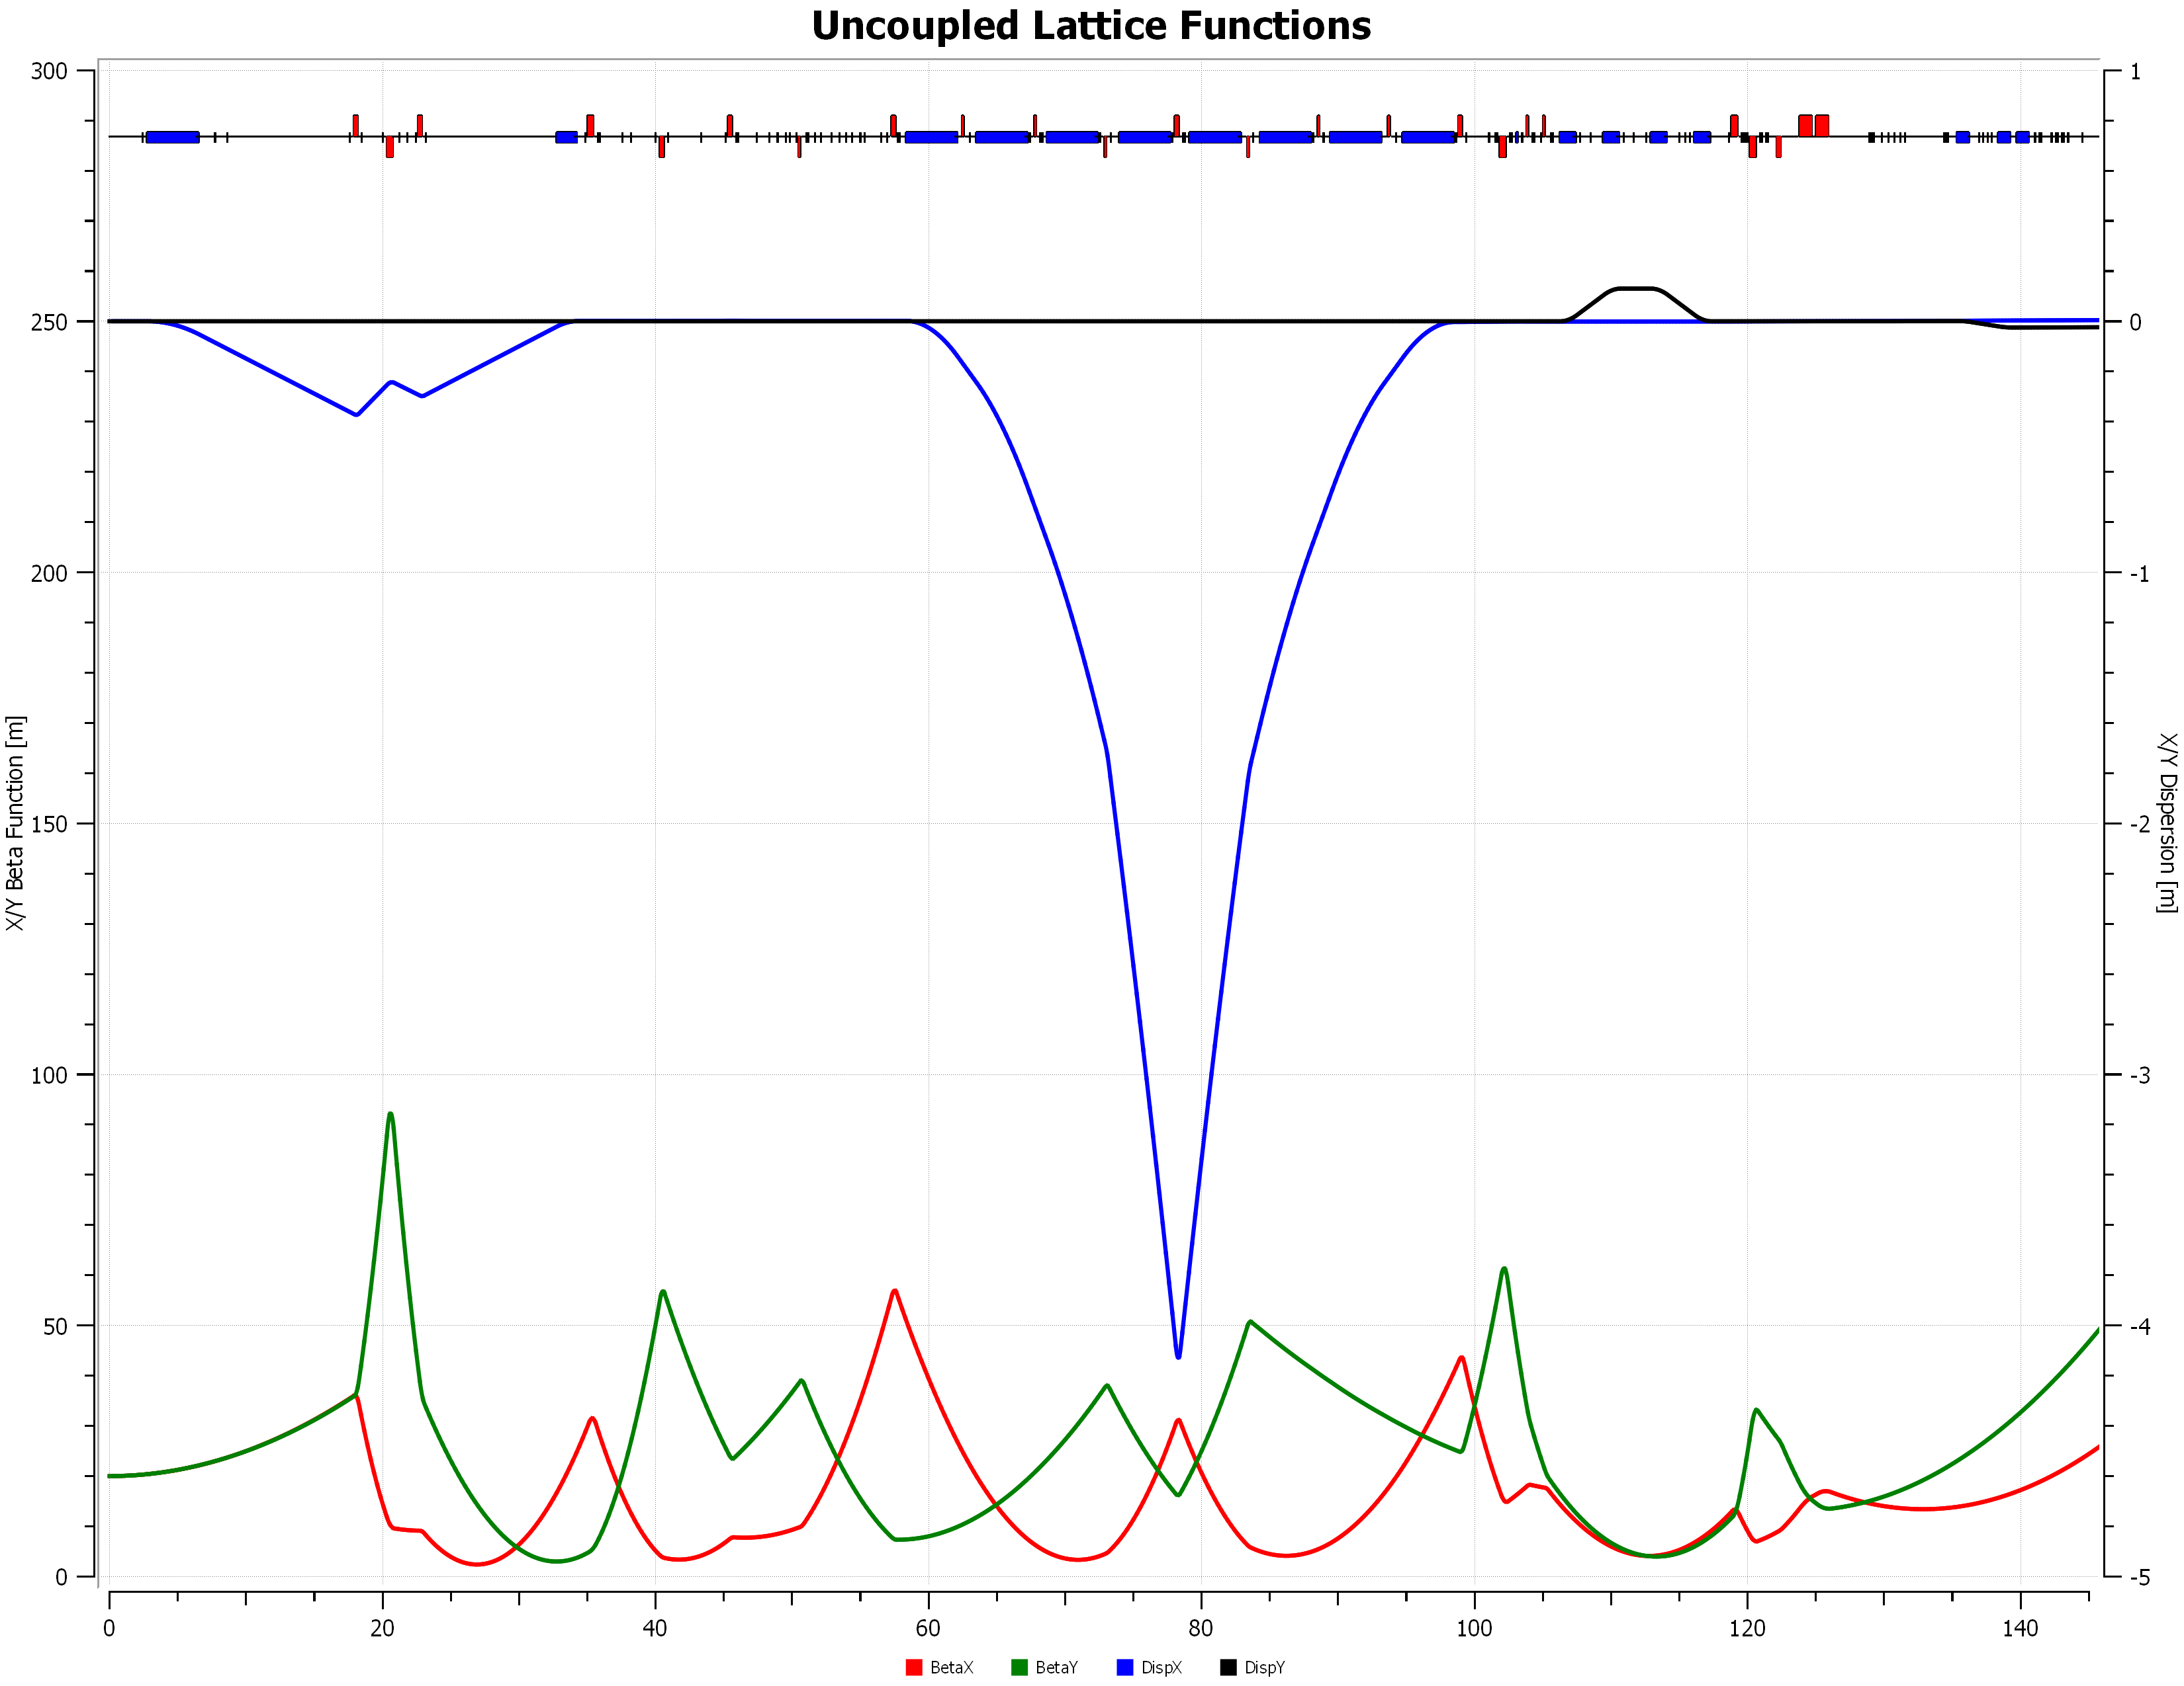
Figure 1. Beta functions and dispersion. Pivot at right edge of plot. Double-peaked dispersion pattern is possible in the arc but it has never empirically produced a good spot at the target so it was not used. Dispersion peak in that case is ~1.5 m versus 4.1 m here.

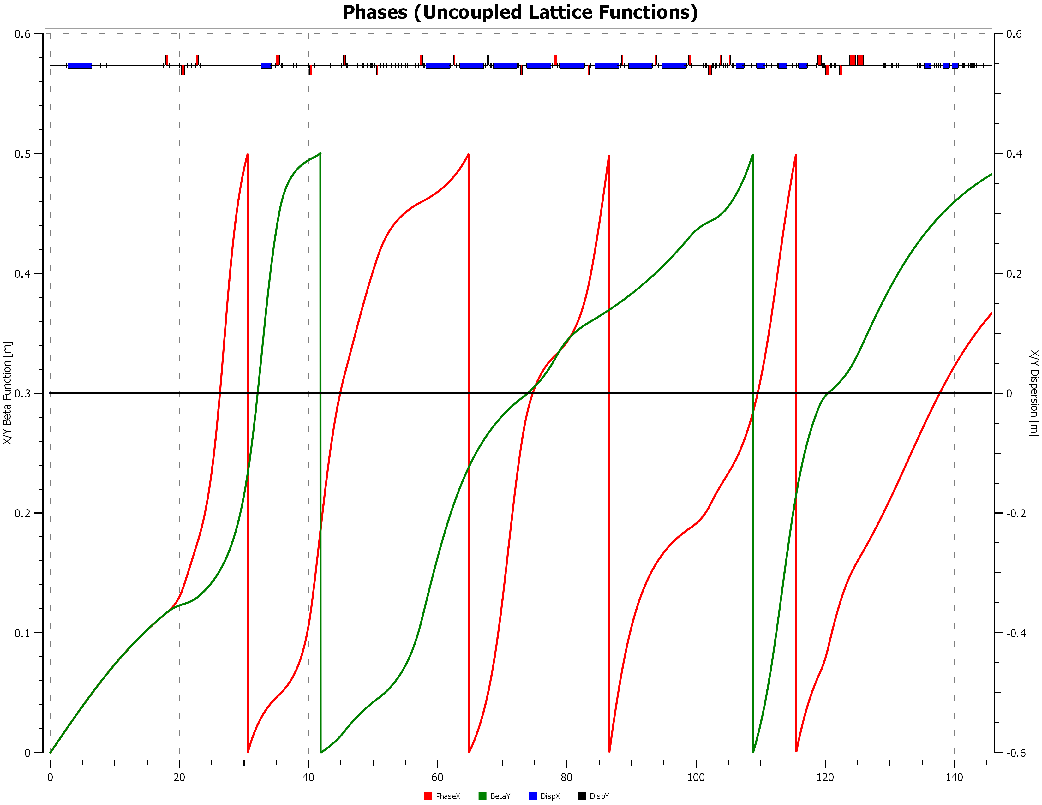
Figure 2. Phase advances.
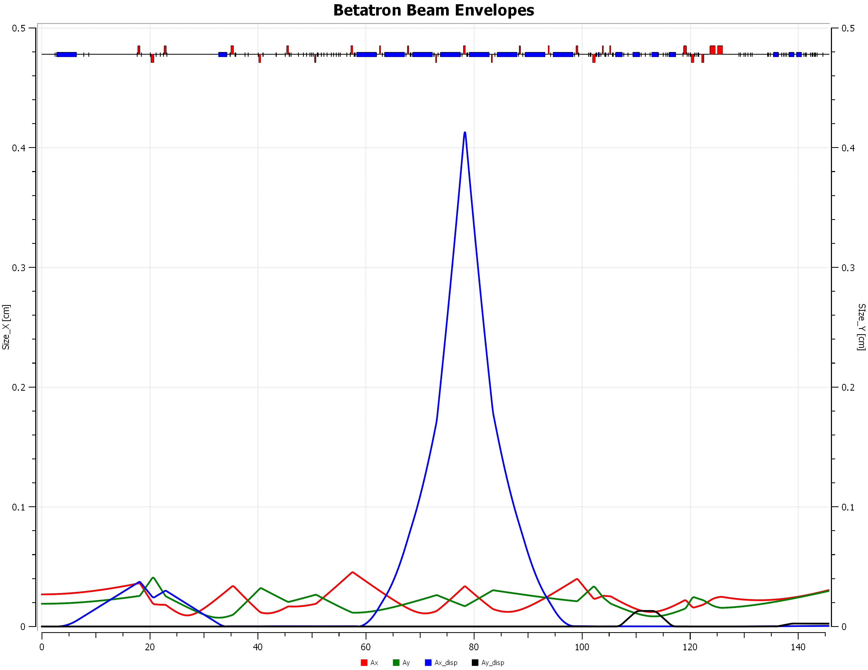
Figure 3. Beam envelopes assuming geometric emittance X 3.6E-9 m, Y 1.8E-9 m, dp/p 1E-3
Vertical scale max 5 mm. Beam pipe in quads 22 mm ID.
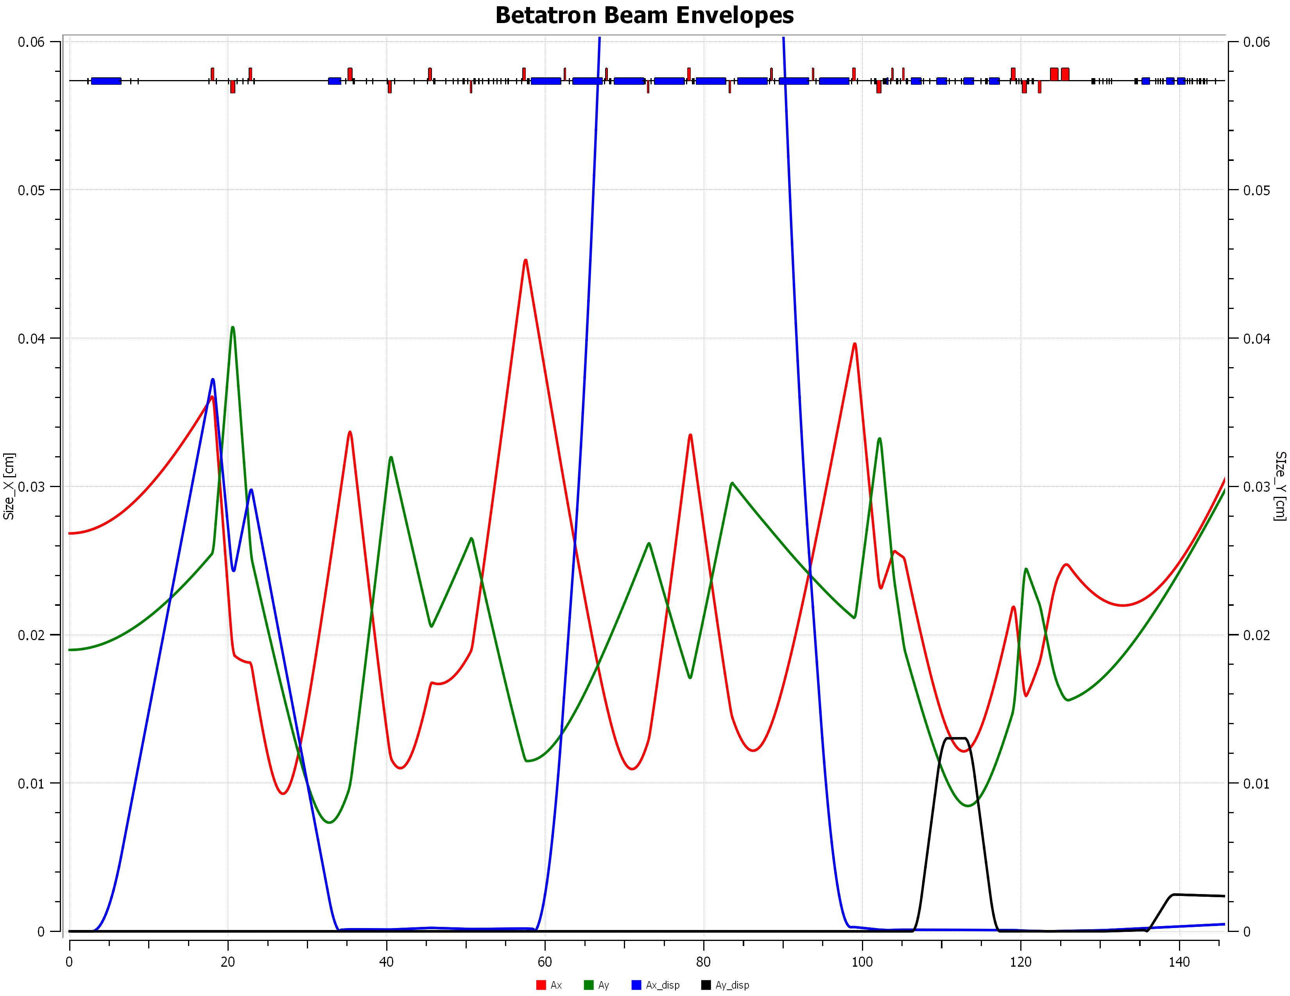
Figure 4. Same as Figure 3 except vertical scale maximum 0.6 mm
Figure 1 (repeated) 22 GeV lattice functions
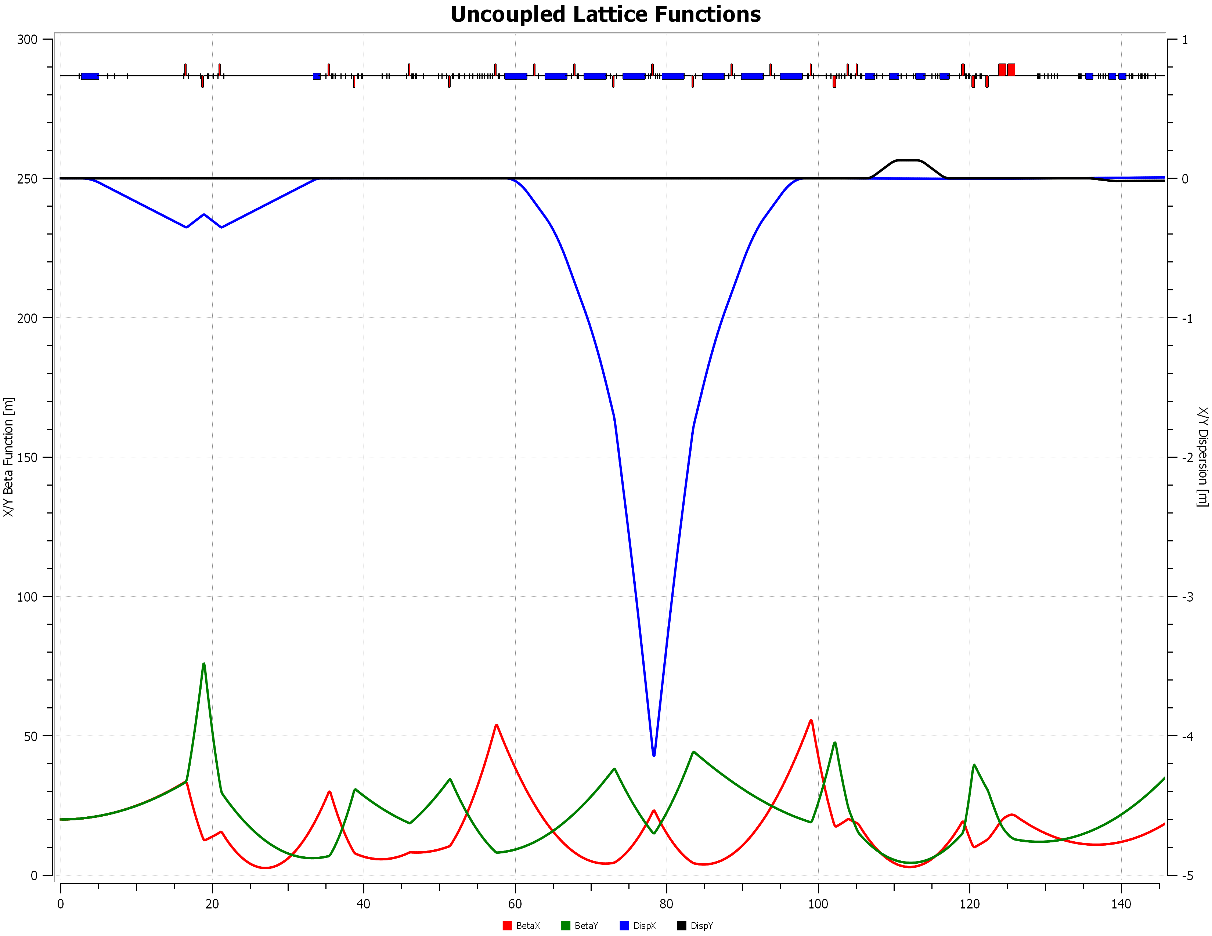
Figure 5 11 GeV lattice functions for comparison.

Conclusion

A preliminary lattice for the Hall C line at 22 GeV has been created. It is sufficient to define the required field and gradient strengths for new magnets. If the optics in the arc is changed to reduce peak dispersion, quadrupole lengths will need to be changed but the space between dipoles should still suffice. There is special apparatus in the Hall A line now to allow higher precision momentum measurement than Hall C. All of this will be scrapped when this line is mirrored for Hall A - there is insufficient room given the longer dipoles and quads. This is emphatically not a final design - a trained accelerator physicist should rework it. OptimX, MAD8 and MADX files are available upon request for existing 11 GeV and this 22 GeV design. Yves Roblin has a script to convert Optim to elegant.

The arc dipole assumed here is defined in TN-21-051 as mentioned above. The 20" quad assumes that the cooling scheme used for the QR can be extended from 14" without issue. The new MQF3M01 from TN-20-044 had cooling considered in conductor selection. The first try at a new Lambertson has been solved; the 380 cm length and 2.4 cm B plate should suffice. Major revisions are needed in that model.

The steel to steel distance of the new dipoles is 140 cm. Of this:
- 2*10 cm taken by dipole coils and connections
- 2*10 cm taken by bellows needed for alignment
- 10 cm BPM (standard is 20.32 cm)
- 20 cm vertical corrector
- 68 cm for 53 cm steel quad worst case
- 2 cm to spare
- OTOH, if one compares the needed BdL on page 2 and the 675A value in TN-21-051, the latter is 20% higher. One can cut the dipole length to 360 cm and be "only" 10% into saturation to free up another 20 cm if needed. At 380 cm length, about 5% into saturation at the BdL page 2.

Future tasks

- Iterate on Lambertson design.
- see if arc 2 dipoles can be pushed to fields needed for Hall A Compton (1.5 T) or Hall B line (1.65 T if two magnets, 1.1 T fine with three). If not, scale TN-21-051 and see if one new dipole can be used for these roles and the JF-replacement.
- rework C line with longer JF replacement as needed
- reflect C line for Hall A with new Compton dipoles
- B line like D line with long quadrupoles and new dipoles. 20" (50.8 cm) quadrupoles will need to be stretched to 53 cm to work in B line given a quick scaling of my 2004 optics. In which case C line will have to be reworked using the slightly longer quads.
- think about extracting to Hall D.
- conceptual design of a conductively cooled one meter SC septum magnet

