Extended Lambertson for FFA Try 1 - a qualified failure
Jay Benesch
21 May 2022

Abstract

A 380 cm long version of the Lambertson with 2.4 cm thick plate for the B beam was modeled. While coarser than I would have liked, the model took 6.6 days to solve on my PC. Finer grain models would likely take two weeks to solve on my Linux box. I have killed those after one week given what I learned from the model discussed below.

Conceptual error

I did not fully consider the effect of normal incidence on beam path. I should have remembered this from the 6 MeV dipole design but did not until a few days after I launched the models. I decided to let the coarser model go to completion so I could determine how best to rectify the errors.
- The A and C slots are centered over the B hole. This means that half of the pole is not used at all. The A slot should be displaced about half a cm to the right, not to the left as in the present Lambertson or centered as below, so the beam path remains within the best field region throughout. The C slot should be shifted to the left for the same reason.
- The slot angle in the present Lambertson is 0.6°. The angle in this model is 1.6°, the exit angle from the magnet. Again, given normal incidence and good field region, the angle should be smaller. See orbits below.
- Much more steel than needed.

Figures
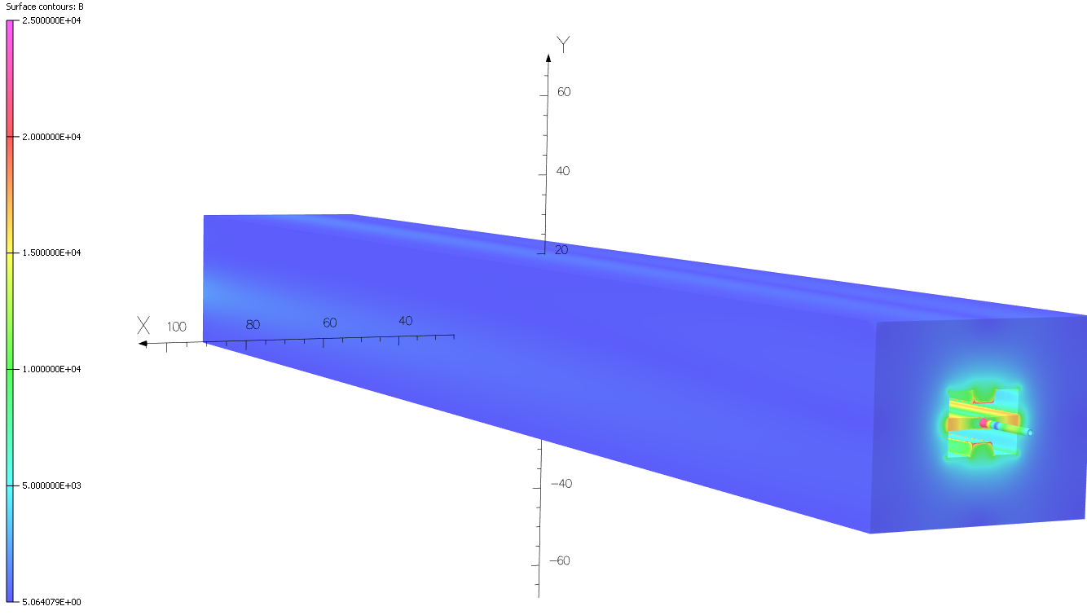
Figure 1. Field on surface of steel, entrance end.

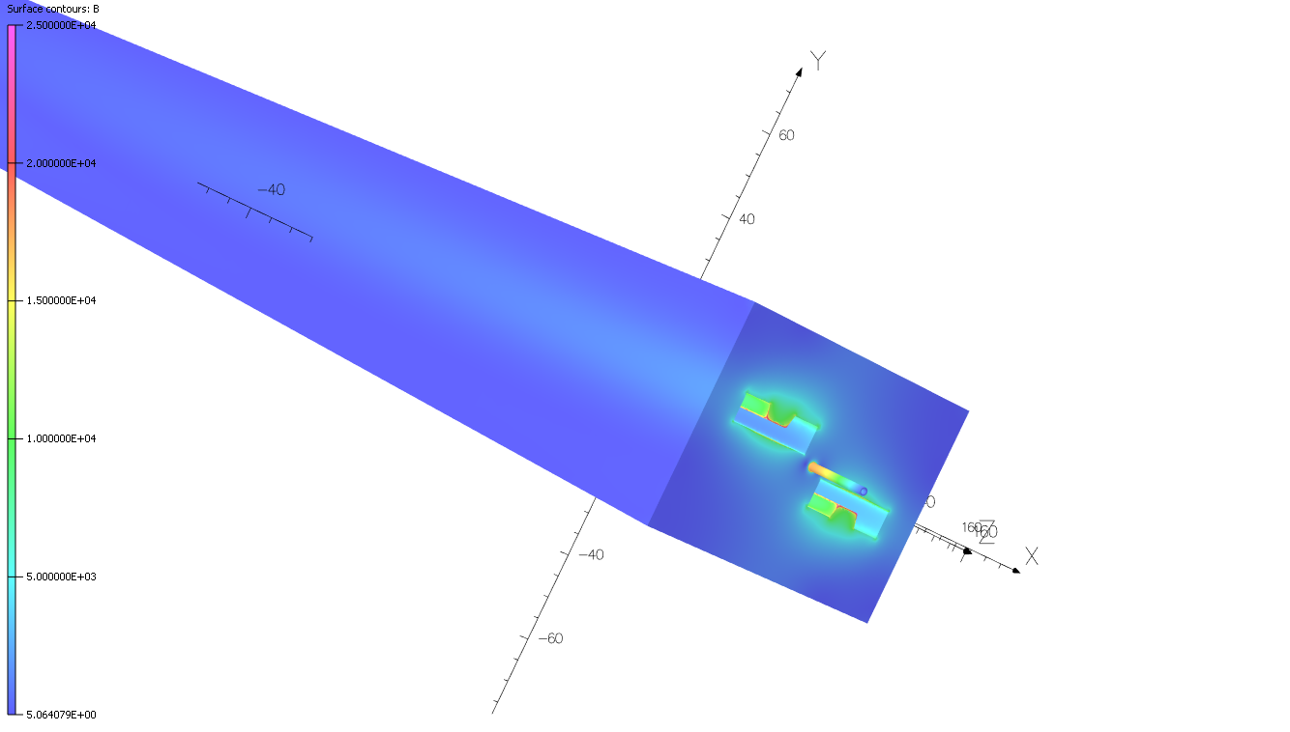
Figure 2. Field exit end of model
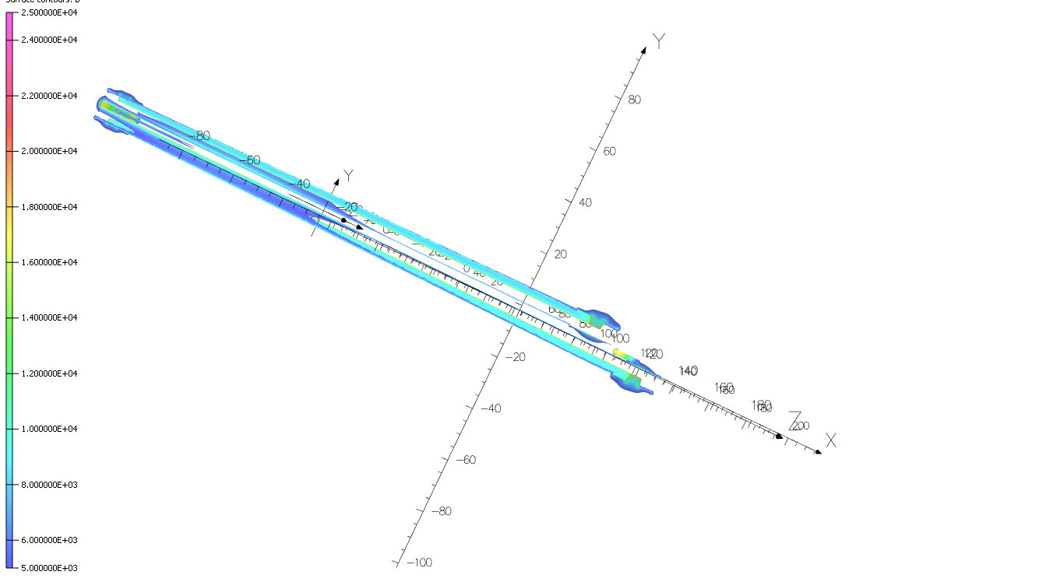
Figure 3. Steel with surface field 5-25 kG aka almost none

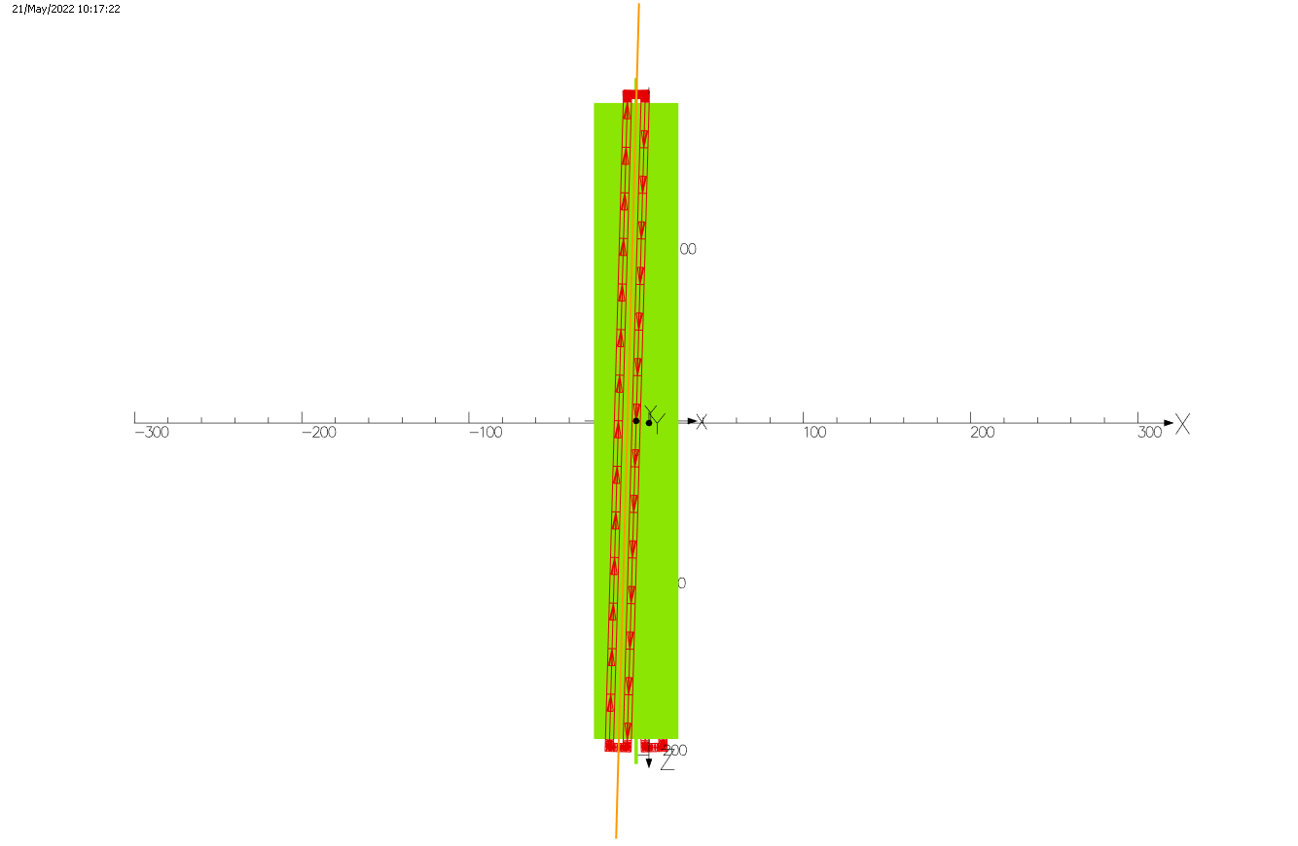
Figure 4. Line along which BdL was calculated, eyeballed. 1.774E6 G-cm. 2.053E6 needed for 22 GeV, so AT need to be increased by 16%. 19 GeV beams will be used for trajectories below.
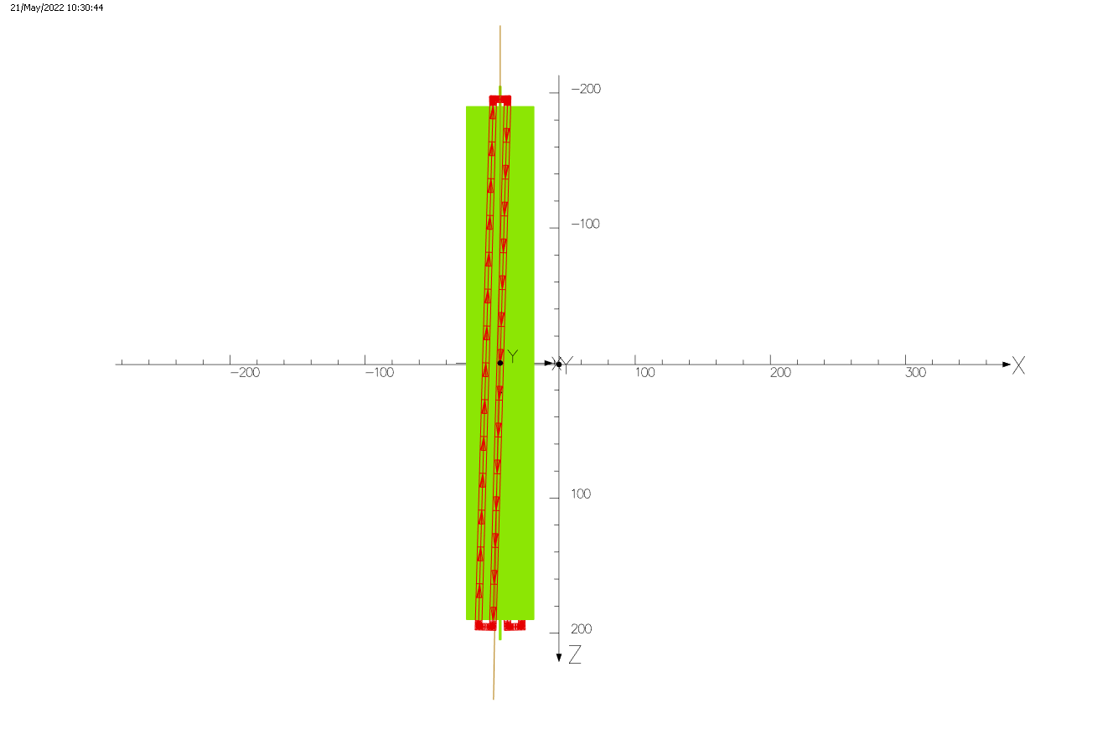
Figure 5. Trajectory of 19 GeV beam. Angle from start to end ~0.6° as in existing Lambertson
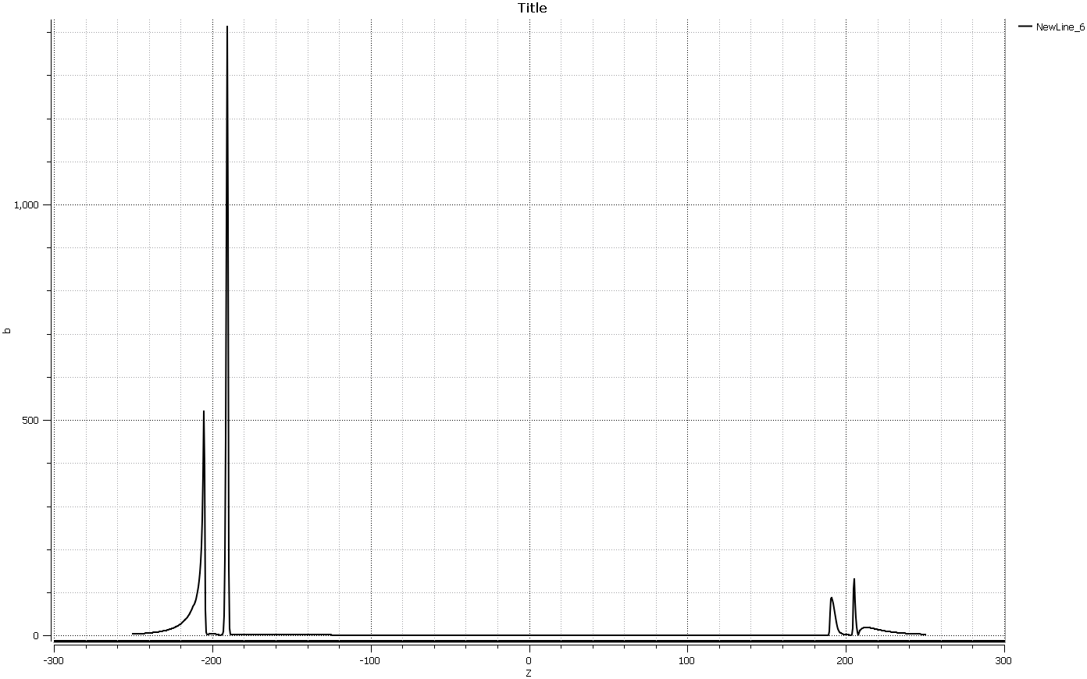
Figure 6. |B| through B hole. As barely seen in Figures 1 and 2 there are 15 cm long, 1 cm ID, 1.5 cm OD carbon steel tubes through which the B beam enters and exits the B plate. This figure and the one below show the tube should extend at least 20 cm and be at least 1.6 cm OD, 20% thicker wall.
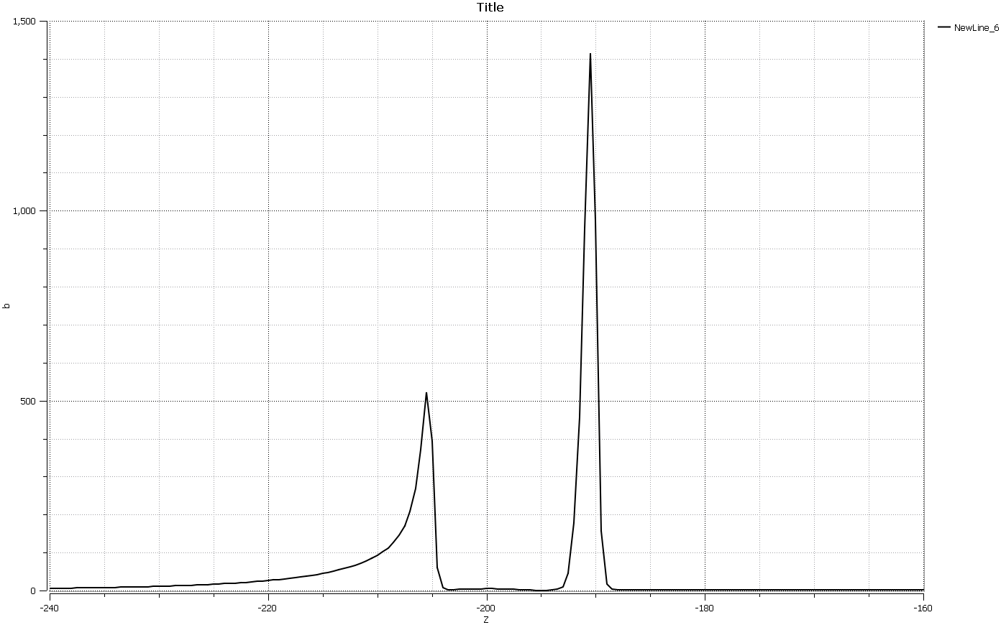
Figure 7. |B| near entrance. BdL along full line 5249 G-cm. BdL within [-185,185] only 146 G-cm so the thicker B plate is promising if the end effects can be mitigated.

Looking at my four decade old Ryerson stock book, I see one can buy round carbon steel mechanical tubing in 5/8" OD with 0.120" wall, ID 0.385" aka 1.588 cm OD, 0.3048 cm wall, 0.978 cm ID. Recall the plate is 2.4 cm thick. One could go to 3/4" OD with 3/16" wall, aka 1.905 cm OD, 0.794 cm wall, 0.9525 cm ID. Or perhaps 3/4" OD with 5/32" wall, aka 1.905 cm OD, 0.397 cm wall, 1.11 cm ID. The present B vacuum tube is 12 mm OD, 10 mm ID, stainless steel. Carbon steel half-tubes were clamped around the B stainless tube at the ends of the magnet in 2014 to lower stray field in the B beam path. See TN-15-005 for details including photos. Given that the beam pipes on either side of the Lambertson are at least 1" OD and the beams are going to be much larger than they are now, I'll go with 1.9 cm OD with 0.4 cm wall in the next model. 25 cm long, looking again at figures 6 and 7. Since the CF flanges and the rectangular vacuum tubes for the A and C beams are stainless, ME will have to find a vendor comfortable with welding carbon to stainless or have a carbon steel tube stub brazed into the CF flanges so like can be welded to like thereafter.

Conclusions

The try1 Lambertson model must be dramatically altered but has provided useful information, hence the title of this tech note.

