FFA@CEBAF Working Group | Minutes

## Meeting date | time 5/27/2022 | 11 AM EST | Meeting location (virtual) <https://jlab-org.zoomgov.com/j/1614898082?pwd=TnUzMS81M2sxbDZIbERJU01tYkJCQT09>

|  |  |  |  |  |  |  |  |  |  |  |  |
| --- | --- | --- | --- | --- | --- | --- | --- | --- | --- | --- | --- |
| |  |  | | --- | --- | | Meeting called by | Alex | | Type of meeting | Weekly Meeting | | Facilitator | Alex | | Note taker | Ryan | | Timekeeper | Alex | | Attendees  Ryan, Alex B, Kitty, Kirsten, Jay, Alex C, Todd, |

# Intro discussion

# Talks about rayTrace and CEBAF optics.

# Agenda topics

## Time allotted | 25 minutes | Agenda topic IPAC22 | Presenter All

* Ryan shows paper and poster for comments
  + Alex C recommends trying to make the main CEBAF image a touch smaller and re-organize a bit from there.
  + Kirsten will look to see if she has another option for the splitter line without caution tape.
  + Ryan working on including a table and moving pictures in his paper.
* Please, feedback on poster ASAP so they can be printed early.
* Ryan: Stephen’s paper and poster look good to me.
* Vasiliy very busy – will “unveil” next time hopefully.

Conclusion

|  |  |  |
| --- | --- | --- |
| Action items | Person responsible | Deadline |
|  |  |  |

## Time allotted | 25 minutes | Agenda topic Hall C Lines | Presenter Alex

* Looking at low dispersion version of Jay’s hall line.
* 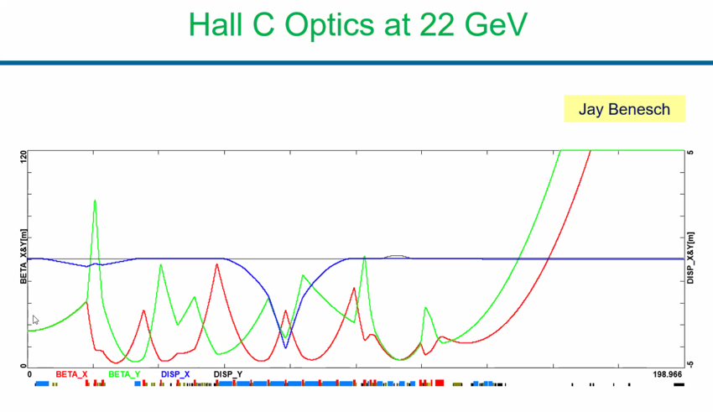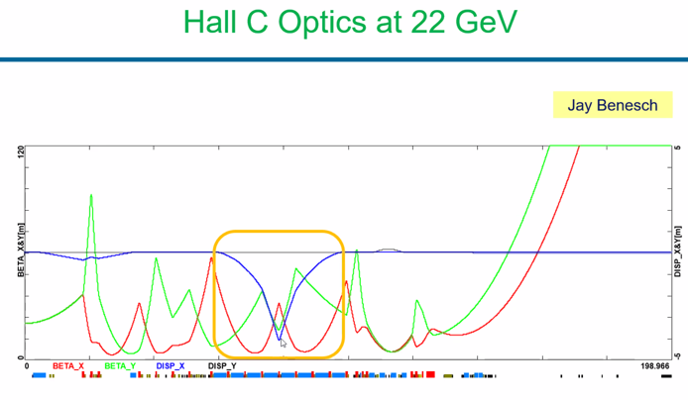
* 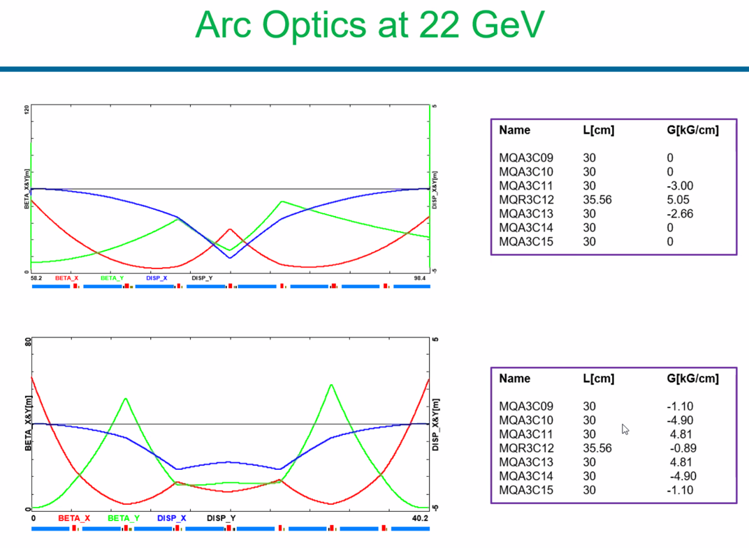
  + Center quad is a QR quad – standard
  + Other 4 QAs could be QRs as well if wanted (QAs and QKs are only good to 120 and QRs are good to 180)
  + Would need 14 inch quads in those slots and leave central QR to maintain flexibility
* 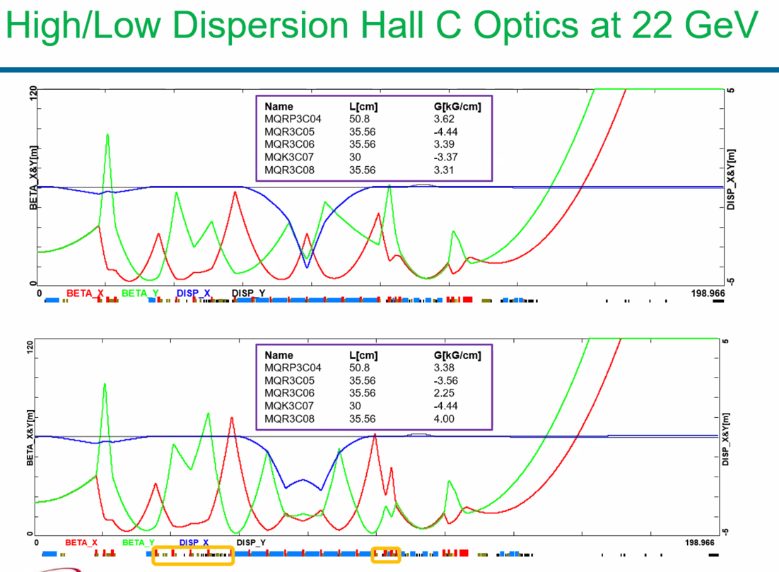
* 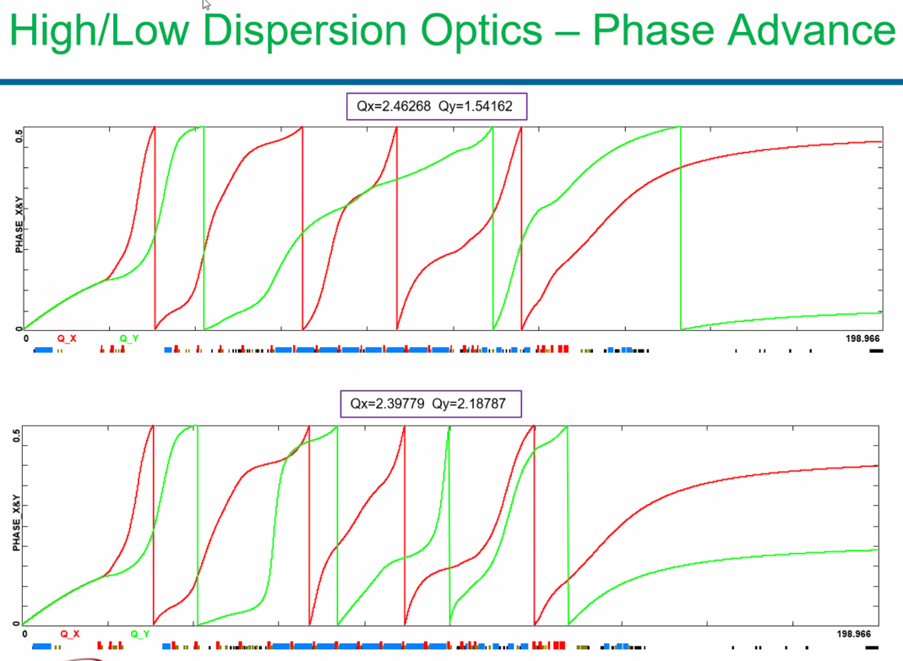
  + We’d need to look more at diagnostics and rasters
  + May need relocation of elements
  + Dithering coils are on girders 8 and 10 right now – not bad.
  + All diagnostics are just after the last few dipoles – also not bad.
* First look seems doable.
* Peak dispersion was ~2.7 m
  + 2e-3 – sigma still a few mm so maybe go down to 20 GeV b/c 22 mm ID beampipe
  + We could maybe shrink it a bit further with some massaging.
* Yves’ double peak goes to 1.6 m peak beta – but requires 53 cm quads everywhere.
  + Haven’t been using it, because couldn’t get decent focus at the pivot

Conclusion

We have an option if needed to go to this option as well.

|  |  |  |
| --- | --- | --- |
| Action items | Person responsible | Deadline |
|  |  |  |

## Time allotted | 5 minutes | Agenda topic AOB | Presenter All



Conclusion

|  |  |  |
| --- | --- | --- |
| Action items | Person responsible | Deadline |
|  |  |  |

## Special notes

Pathway to Repository: <https://jeffersonlab-my.sharepoint.com/:f:/g/personal/tristan_jlab_org/EqZ5MeS-nipCgPfZB5p0oS4B9Is67d3nQb9sLJI3Zyev9g>