FFA@CEBAF Working Group|Minutes

## Meeting date | time 6/3/2022 | 11 AM EST | Meeting location <https://jlab-org.zoomgov.com/j/1614898082?pwd=TnUzMS81M2sxbDZIbERJU01tYkJCQT09>

|  |  |  |  |  |  |  |  |  |  |  |  |
| --- | --- | --- | --- | --- | --- | --- | --- | --- | --- | --- | --- |
| |  |  | | --- | --- | | Meeting called by | Alex B | | Type of meeting | Weekly Meeting | | Facilitator | Alex B | | Note taker | Ryan | | Timekeeper | Alex B | | Attendees  Alex B, Ryan, Alex C, Kirsten, Jay, Scott, Stephen, Kitty, Vasiliy, Dejan, Andrei, Todd |

# Intro Discussion

# Agenda topics

## Time allotted | 25 minutes | Agenda topic Adiabatic Arcs | Presenter Vasiliy/Randy

* Vasiliy’s poster:
  + High-power hadron accelerator which uses FFA arcs
    - Can compensate with more passes
    - Mostly conceptual
    - It’s the first and only publication of the concept so far
  + Application to CEBAF energy doubling
    - Chose 5+3 option, West Arc
    - Used Stephen’s data, made FFA cell using Mad-X (consistent with BMAD)
    - Triplet cells
    - 26 cells used
    - Offsets and dispersions go down while beta steady
* 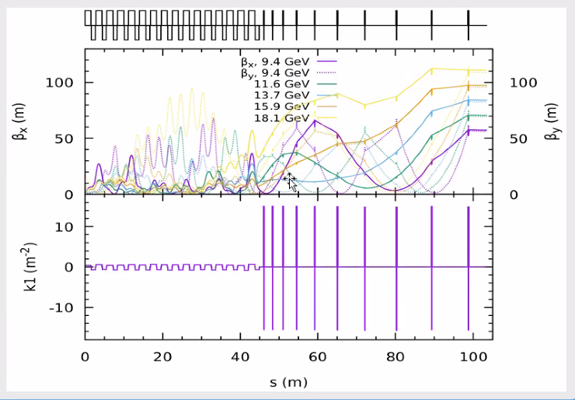
  + Jacobian solver in Mad-X – but didn’t like
  + Started again with clean slate
  + Same FODO, scaled focal strength
    - Scaled quads in triplets up by same values
  + Polynomial reduces space between triplets
  + Ran optimizer again, ok
    - If combine sections 1 and 2 should be ok
    - Initial guess was pretty close to the right answer
  + More work to be done, but individual betas behaving decently
* Not on poster:
  + 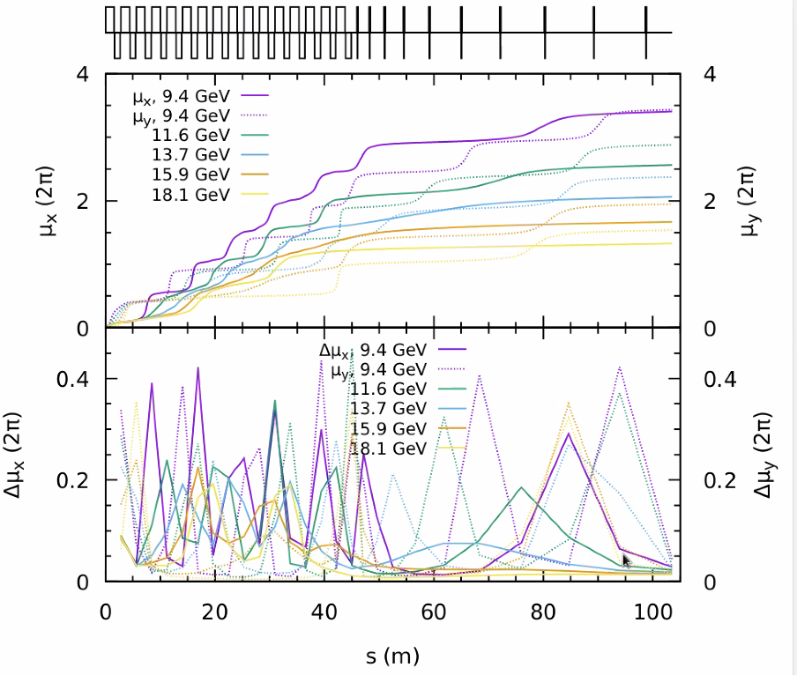
    - Phase advance per cell
      * Scott: This is reflecting the beta beating – in some ways it’s artificial, and accumulated phase advance would do a better job of showing what’s going on
      * Jumps not synchronized (in top plot) – shows that it’s doing the right thing in some sense
      * Spikiness in phase advance confuses the issue
      * There’s a redundancy in our linear variables. Phase advance is not some absolute number until you go into a truly periodic solution
      * If you pick a different set of initial beta functions, that whole spiky plot will change completely. The top plot will look a bit different, but the beginning/end would be the same. You’ll get the general trend
    - Looks regular
* How well does this cope with magnet errors (non-adiabatic)?
  + 1% error? Is there a correction algorithm?
  + Will need lots of diagnostics in this section.
* Having a long period section gives more freedom to control the phase advance.
* Scott: When matching at beginning and end, it’s beta that you care about the most, not phase advance
  + If only 1 plane, that’s true
  + If more than 1 plane, it’s tied to phase advance – have to have right phase advance
  + Middle cells don’t need to maintain phase advance.
  + Let phase advance float in the middle, and keep betas controlled – random idea
* Kirsten: this is transition from repeating cell that matches into linac optics?
  + Yes
  + Not accounting for TOF or spreaders optics yet.
  + Idea of this is to instead of having 4 splitters in the machine, use 2 on one side, and other side with a pair of these
    - IF we can get TOF and R56 in one spot, then adiabatic match in other side of CEBAF
* Need to take away higher energies – important to understand how we separate them in easiest possible way
  + Need to do TOF and R56
  + Better than CBETA here b/c 180-degrees (so maybe half to a third of CBETA TOF)
  + R56 is the biggest challenge
    - Must be connected to a chicane where you can adjust dispersion function as well
    - Need some quads too
    - Maybe each chicane works for several energies (3 maybe too much…2 maybe)
      * Can still add more dipoles for further separation
  + First attempt should be traditional chicane
    - More clever options might be less efficient – so check if it’s possible first
* Adding in splitters can also drop down the beta – might make arc matching easier
  + Add more quads
* Try to work with 2 sets of splitters to correct all of the TOF and R56, use adiabatic matching in other 2 spots.
* Jay – do we need to look at 3 passes through the injector (860 instead of 650 MeV) – would allow closer to a drift
  + 650 MeV was a minimum – but to make Dejan’s suggestion work, couldn’t we have a higher injection energy – then whatever we do with linac optics might work easier
    - For a drift linac (with no quads), it doesn’t really matter. Will look like a parabola
    - Will have a height of 250 m beta – too big.
  + Sparse quads?
    - The quads will mess up beta at lower passes and be invisible to higher
* We need to rethink the multipass optics in the linacs. Need to be revisited because the initial solution used very compact permanent magnets
  + We need to be able to scale the energy – won’t always be 1.2 GeV per linac
    - Will need electromagnets
* Kirsten: need a conversation about ARC diagnostics that we’ll need in the CEBAF FFAs
  + CEBAF may need more useful diagnostics
  + SL monitors, etc…
    - Moveable camera?
* Back to linac optics:
  + 9.6 m periodicity
  + 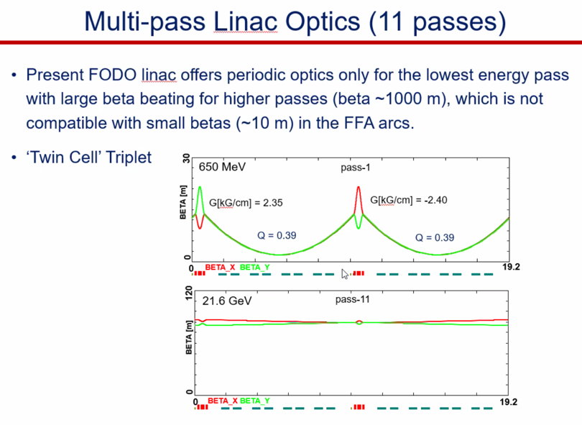
    - Scale triplet strength as we go up in E
    - Still enough phase advance, getting 80 m beta with periodic structure
    - This is input into Vasiliy’s matching.

|  |  |  |
| --- | --- | --- |
| Action items | Person responsible | Deadline |
|  |  |  |
|  |  |  |

## Time allotted | 25 minutes | Agenda topic IPAC22 | Presenter All

* Vasiliy’s IPAC contribution noted in the previous agenda section
* Ryan will print and carry Vasiliy’s paper, and present it at IPAC.

|  |  |  |
| --- | --- | --- |
| Action items | Person responsible | Deadline |
|  |  |  |
|  |  |  |

## Time allotted | 10 minutes | Agenda topic AOB | Presenter All

* 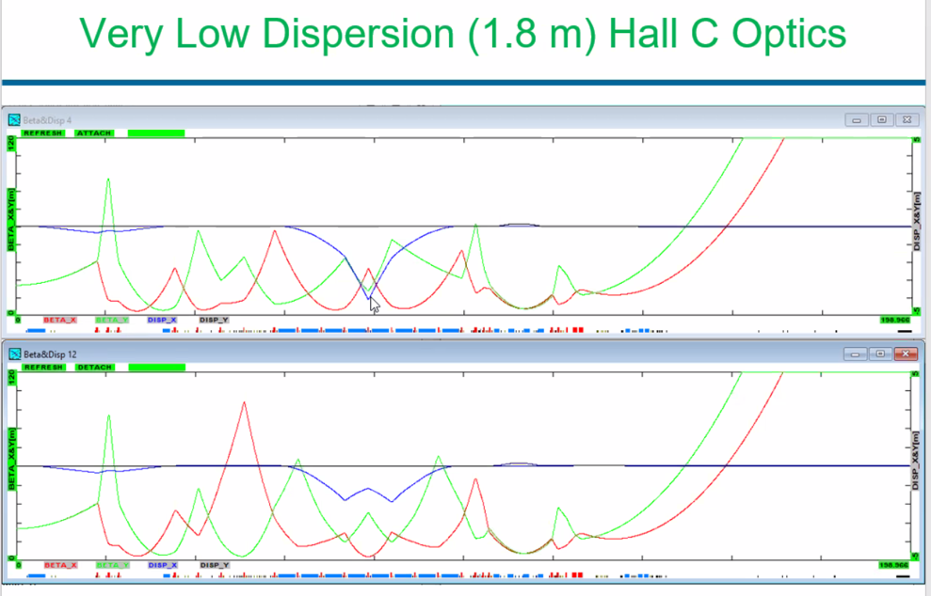
  + Peak dispersion lowered from 4 to 2.7 m
  + Realized unused quad strength
    - Got it down to 1.8 m
  + Horizontal emittances are much larger than vertical

|  |  |  |
| --- | --- | --- |
| Action items | Person responsible | Deadline |
|  |  |  |
|  |  |  |

## Special notes

Pathway to Repository: <https://jeffersonlab-my.sharepoint.com/:f:/g/personal/tristan_jlab_org/EqZ5MeS-nipCgPfZB5p0oS4B9Is67d3nQb9sLJI3Zyev9g>