FFA@CEBAF Working Group|Minutes

Meeting date | time 6/10/2022 | 11 AM EST | Meeting location  <https://jlab-org.zoomgov.com/j/1614898082?pwd=TnUzMS81M2sxbDZIbERJU01tYkJCQT09>

|  |  |  |  |  |  |  |  |  |  |  |  |
| --- | --- | --- | --- | --- | --- | --- | --- | --- | --- | --- | --- |
| |  |  | | --- | --- | | Meeting called by | Alex B | | Type of meeting | Weekly Meeting | | Facilitator | Alex B | | Note taker | Alex C | | Timekeeper | Alex B | | Attendees  Alex B, Alex C, Kirsten, Jay, Scott, Kitty, Dejan, Eric Voutier |

# Intro Discussion

# Agenda topics

## Time allotted | 25 minutes | Agenda topic Emittance Dilution Budget | Presenter Kirsten

* Particle tracking and radiation integrals with Bmad lattices
  + Sagitta shift helped us understand FFA lattices from Stephen
  + Assume the arc spans less than 180 degrees
  + Particle tracking uses the established CEBAF emittances
  + No longer getting a relative energy spread of 0.01
  + Kirsten has a spreadsheet with emittance data (below)

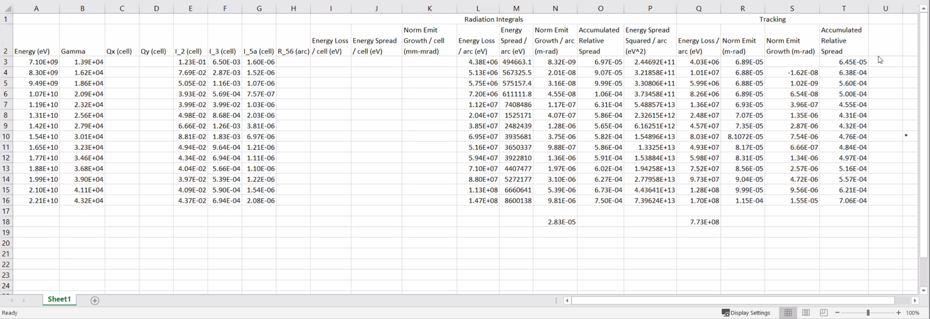

* Scott mentions that large energy gain is basically helpful for FFA arcs
  + Baseline is 1100 MeV per linac
* Simulation uses normalized initial emittance of 80 mm mrad
  + Different initial emittance may affect this substantially
  + Not completely conclusive which exact initial parameters should be used
* Not yet sure about consistency in Synchrotron radiation loss.
* Simulation agrees with energy loss to the order of magnitude
  + Radiation integral and beam tracking methods agree pretty well ~10%
  + More energy loss in particle tracking
* Energy cap seems to be 22.3 GeV, which indicates 1.2 GeV per Linac is too much
* Most of the emittance growth is in FFA2
  + Last three passes in FFA1 also contribute
* Simulation only considers arcs, no spreaders etc.
  + Future work should maybe assume 180 deg. for accuracy because splitters contribute a lot to emittance growth
* Per Scott, initial design will have one splitter line per arc
* Jay gives normalized emittance after 4 passes through the north Linac
  + Higher energies available also
* Discussion of FFA arcs at LHeC, optimization was very difficult.
* Energy spread expected in the CEBAG halls ~10-4
  + 3-4 GeV experiments want 2*10-5
* Verdict is that we can fit this emittance in the hall lines (probably)
* Small time of flight might allow us to reduce the number of splitters (Dejan)
  + Adiabatic matching could reduce it further
  + Scott urges caution about making assumptions
* Regardless, the emittance simulation is hanging together.

|  |  |  |
| --- | --- | --- |
|  |  |  |
|  |  |  |

## Time allotted | 10 minutes | Agenda topic AOB | Presenter All

* NO MEETING NEXT WEEK
* Bogden called Jay and asked if positrons could be handled by flipping the permanent magnets

|  |  |  |
| --- | --- | --- |
| Action items | Person responsible | Deadline |
|  |  |  |
|  |  |  |

## Special notes