FFA@CEBAF Working Group|Minutes

## Meeting date | time 6/24/2022 | 11 AM EST | Meeting location <https://jlab-org.zoomgov.com/j/1614898082?pwd=TnUzMS81M2sxbDZIbERJU01tYkJCQT09>

|  |  |  |  |  |  |  |  |  |  |  |  |
| --- | --- | --- | --- | --- | --- | --- | --- | --- | --- | --- | --- |
| |  |  | | --- | --- | | Meeting called by | Alex B | | Type of meeting | Weekly Meeting | | Facilitator | Alex B | | Note taker | Ryan | | Timekeeper | Alex B | | Attendees  Alex B, Ryan, Dejan, Kitty, Alex C, Todd, Kirsten, Randy, Andrei, Stephen, Jay, Doug, Eric, |

# Intro Discussion

# Agenda topics

## Time allotted | 25 minutes | Agenda topic SR in 1 ARC | Presenter Dejan

* 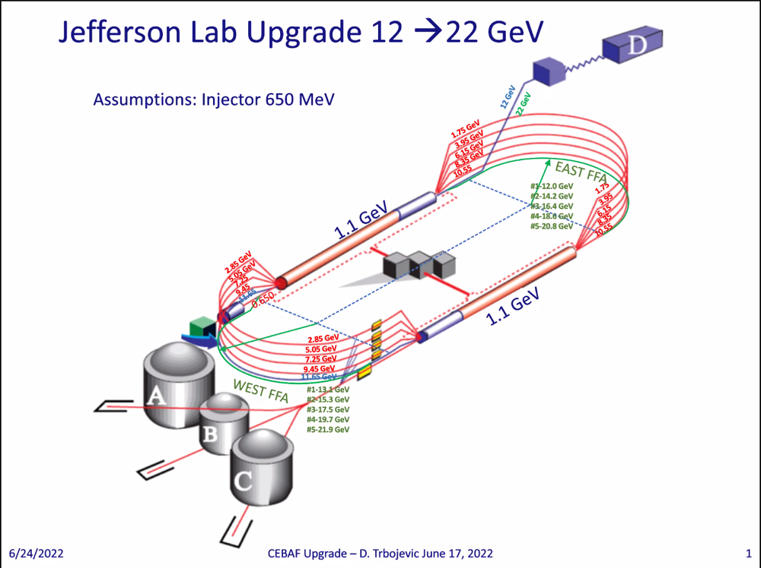
  + What we have now
  + 12 GeV to D, other experiments get 11 GeV
  + If take 12 GeV instead of going to Hall D and put FFA arc under present arcs.
* Would need to raise up the arcs to make some space.
* Optimized for SR loss and maximum field in magnets (1.5 T max)
* 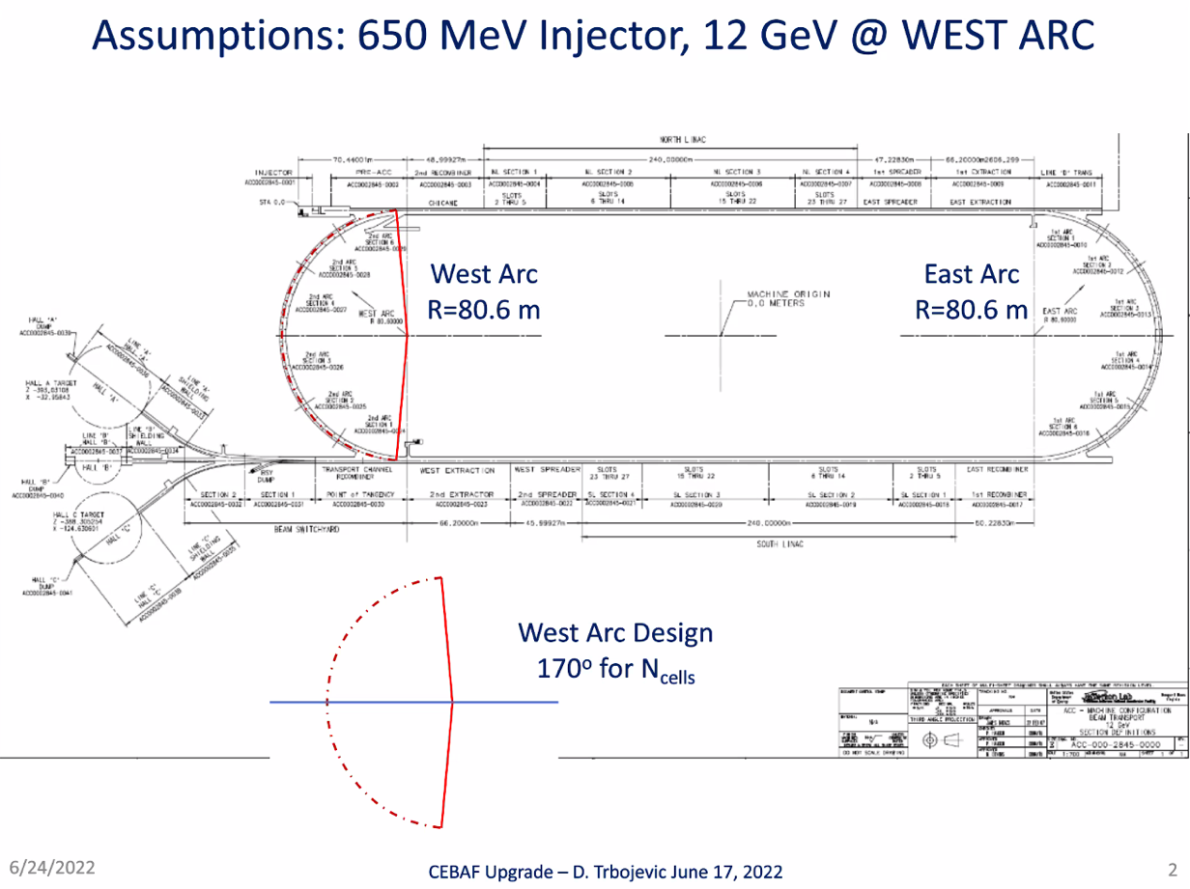
  + Play with length of cells to make it fit into 170 degrees
* Maybe a way to do a single-chicane splitter in one of areas of CEBAF for 5 TOF and R56 adjustments – discussion with Scott
* 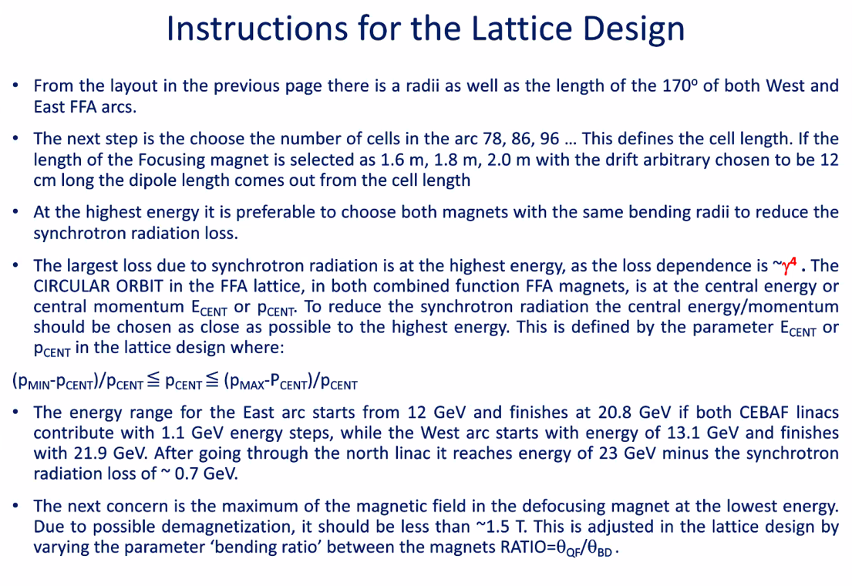
  + Will provide BMAD lattice, and we can probably all construct in “10 minutes”
  + This is the “recipe” for how Dejan did this.
* 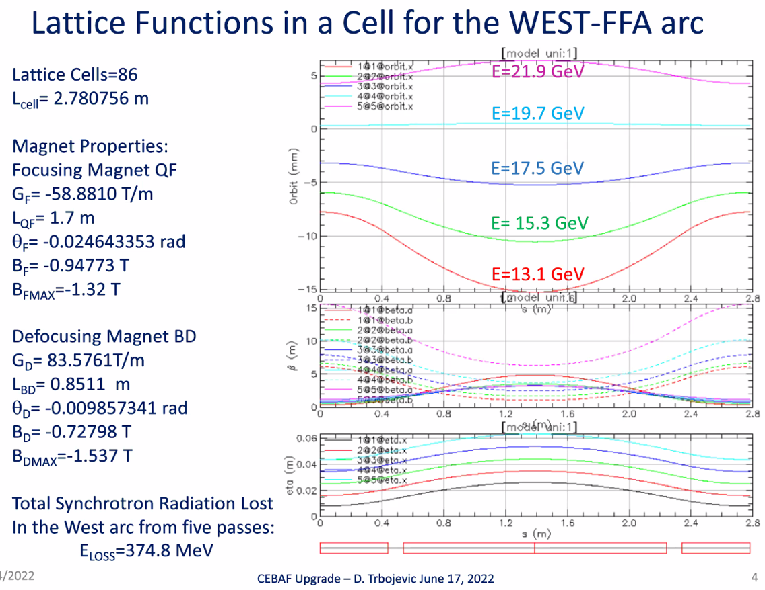
* 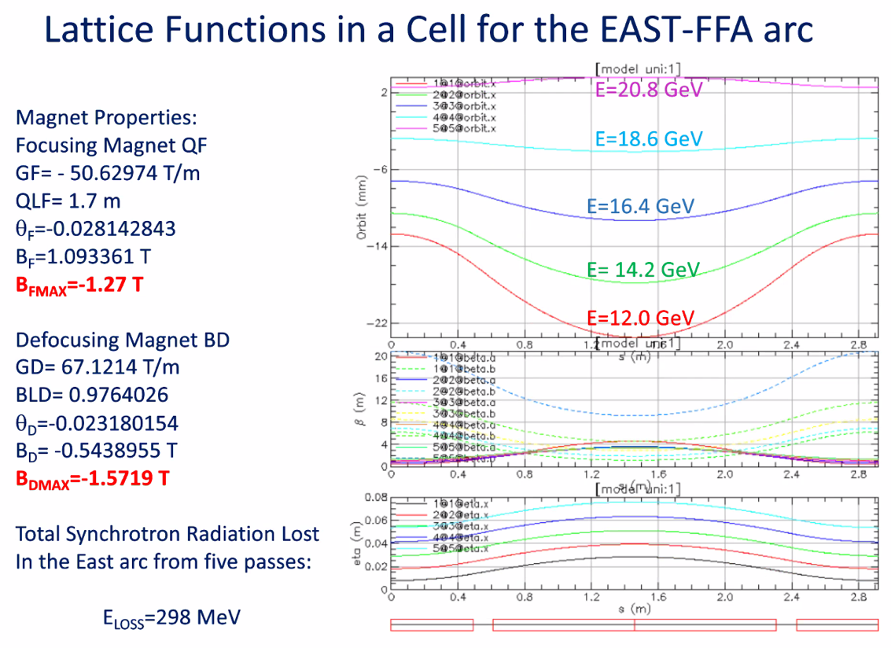
* 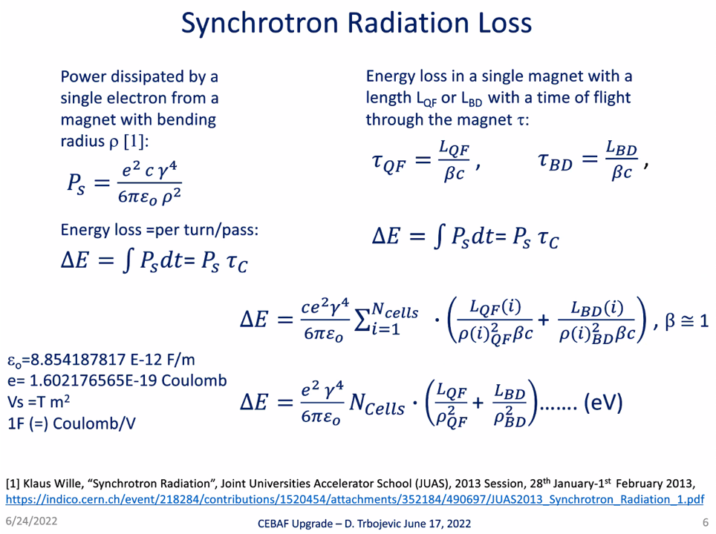
  + Pay attention of gamma^4 and radius in denominator
  + TOF: two cells – one is length of focus/beta_c, the other is defocus/beta_c
    - Get lost energy in eV
    - Epsilon is constant (Faraday/m)
  + Optimizing by reducing magnetic field also helps with SR loss
* 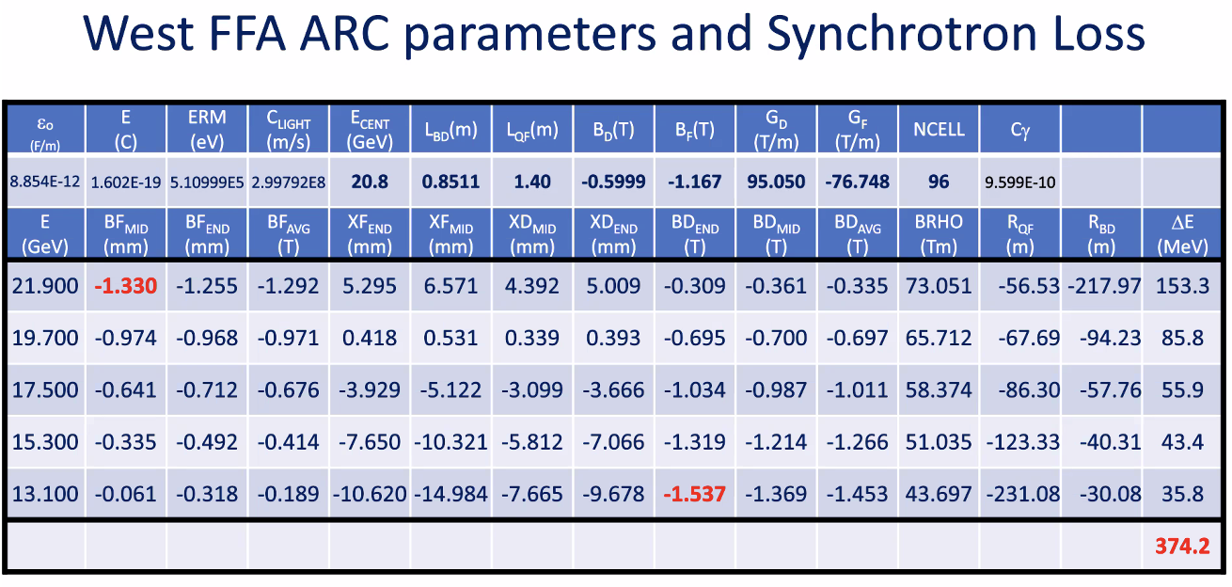
  + Stephen’s results agree
  + Energies wrong in table – will correct
* 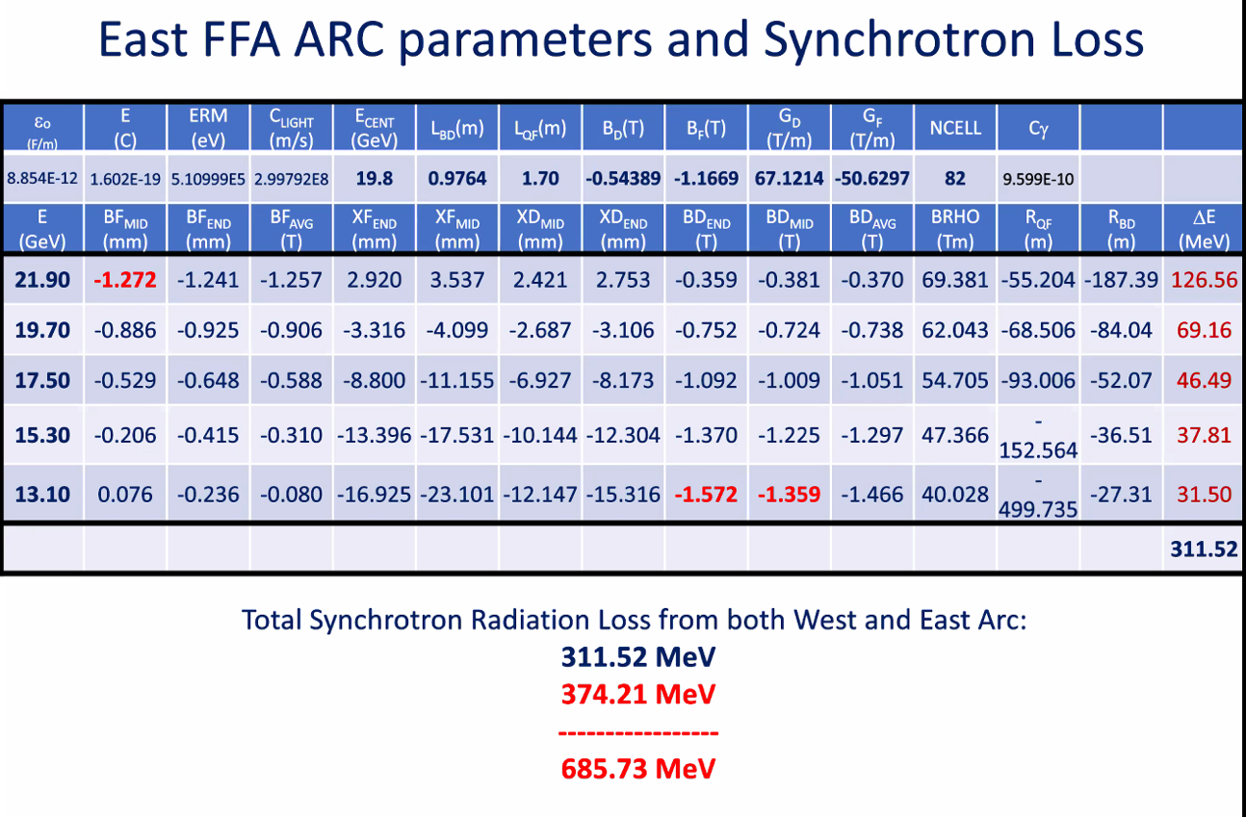
* 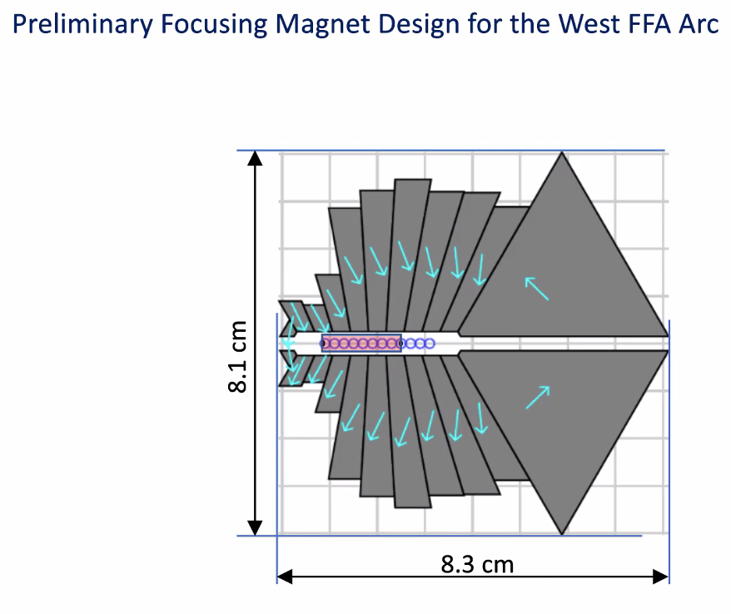
  + Dejan’s magnet rough idea – magnets can be built
* 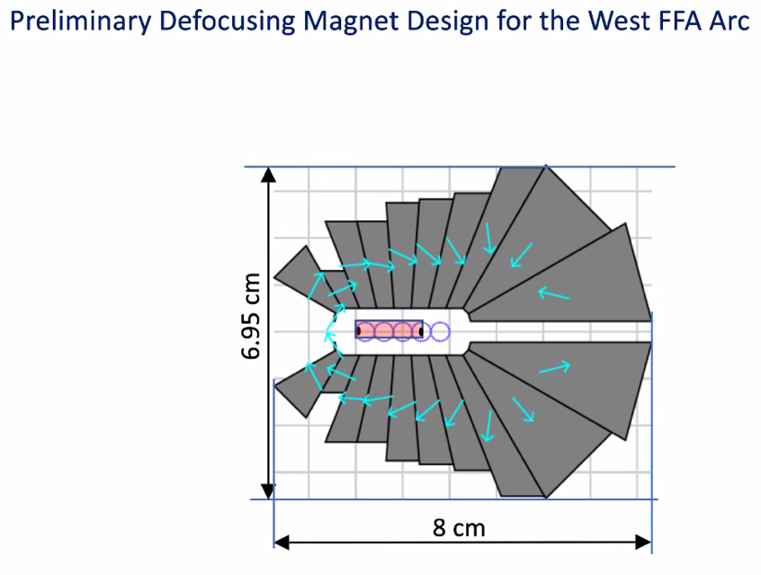
* Depending on what we decide (where and how to put ring) – we can have a solution with a single ring.
* Alex: tempting option
  + Do we have enough space for this under the current highest-E arc?
    - We would have to raise the arcs up a bit to get another ~10 cm
    - Jay: Hall D magnets coming out of NE spreader
      * 5th pass arc (ARC9) is 70 cm off with center line to floor. 40 cm of space.
      * D line is 20 cm off floor
      * Can we keep hall D line with this?
        + If we go behind, fields very high – but can be re-investigated (kicking left)
      * Maybe kick D left and back again (RF separator?)
  + Dejan looked at removing highest pass arc and running a 6 pass FFA.
* Stephen: Need energy tunability in magnet design
  + Probably a single FFA option may limit to 20 GeV
  + Yes, we need tunability
  + If we use 5 EM turns, makes it better – buys 1 less turn of energy range
  + We can’t have it all at once, so we need to be sure what we need.
* If we shut down D as part of upgrade, it’s easy. But if they remain, we need to kick the D beam left and thread through stands, etc…
* Need to add correctors to magnets for more space as well.
* Stephen: Had 3 EM and 2 FFAs – will look at 4 EM and 2 FFAs
  + Starting at 4 EM instead of 3 is a big help.
  + Ryan: removing the highest EM arc and putting in 1 FFA arc gives the option of a later upgrade, if needed.
* Do we need full energy tunability?
  + Jay – yes, likely.
  + 950-1100 for linacs will cover the gaps
    - This would make things worse on Dejan’s design, but was included in Stephen’s design earlier.
  + Dejan: if one needs tunability, can still be done with single FFA
    - Stephen, this depends on magnetic field
    - Dejan: to reduce magnetic field in magnets, they will become larger
      * Stephen, no – the become unrealistic
        + Things get better with higher E linac, don’t need tunability, etc…
  + Going only to 20 GeV may be easy with one FFA
* If we assume 1.1 GeV, halls can ask for reduction
* Stephen was working with 925-1090 MeV per linac – covers most gaps, assuming we can extract at the end of each FFA
  + Dejan has idea of extraction with adiabatic transfer
  + Jay: intermediate energy beams are the hard part
* Jay: Someone talk to Thia and get an idea of what span do we need?
  + 10% range enough? 15% range more appropriate?
  + Doug: Just want enough dynamic range to give halls high polarization
  + Play with Yves’ spreadsheet to see what we can get.
* Can Alex C take over some of Dejan’s investigation?
  + Sure
* Can we remove one pass and do that similar study?
  + 1 vs 2 FFAs
* Stephen: If you want upgrade: 4 EM then 1 FFA + 1 FFA later
* Alex C: The next month is tight, but will work on this!

|  |  |  |
| --- | --- | --- |
| Action Items | Person responsible | Deadline |
|  |  |  |
|  |  |  |

## Time allotted | 25 minutes | Agenda topic IPAC22 | Presenter Stephen/Ryan

* Stephen gave talk on FFA LHeC – good response! Might be worth getting some contact to see if to be pursued.
  + Maybe a white paper?
* Ryan: lots of interest in our work and the job
  + Mike Seidel talk mentioned Stephen’s magnet work in his talk on efficient accelerators and colliders

|  |  |  |
| --- | --- | --- |
| Action items | Person responsible | Deadline |
|  |  |  |
|  |  |  |

## Time allotted | 10 minutes | Agenda topic AOB | Presenter All

* LHeC discussion – using FFA arcs

|  |  |  |
| --- | --- | --- |
| Action items | Person responsible | Deadline |
|  |  |  |
|  |  |  |

## Special notes

Pathway to Repository: <https://jeffersonlab-my.sharepoint.com/:f:/g/personal/tristan_jlab_org/EqZ5MeS-nipCgPfZB5p0oS4B9Is67d3nQb9sLJI3Zyev9g>