FFA@CEBAF Working Group|Minutes

## Meeting date | time 7/1/2022 | 11 AM EST | Meeting location <https://jlab-org.zoomgov.com/j/1614898082?pwd=TnUzMS81M2sxbDZIbERJU01tYkJCQT09>

|  |  |  |  |  |  |  |  |  |  |  |  |
| --- | --- | --- | --- | --- | --- | --- | --- | --- | --- | --- | --- |
| |  |  | | --- | --- | | Meeting called by | Alex B | | Type of meeting | Weekly Meeting | | Facilitator | Alex B | | Note taker | Ryan | | Timekeeper | Alex B | | Attendees  Alex B, Ryan, Todd, Kitty, Joe, Alex C, Amy, Jay, Dejan, Stephen, Kirsten, Eric, Doug, Andrei, Vasiliy, Scott, |

# Intro Discussion

JLab to BNL delegation got news about permanent magnet costing.

Dejan is pushing hard on arcs.

We’d like to settle down on a new “baseline” or study case. Stephen asked some very key questions we need answered to do this. Some of these JLab (physics) must answer.

# Agenda topics

## Time allotted | 25 minutes | Agenda topic 4EM Arc SR Options | Presenter Dejan

* Makes some assumptions, but may be off. Something wrong with dp/p definition in example. Will redo everything how was done before.
  + Code benchmarking to make sure it makes sense.
* Dejan’s designs are based where orbit offsets are 0 are pure-circular orbits
  + In this case that’s not true, all orbits were stable and no codes saw a problem
  + Will redo “the old way”
  + Don’t know why MadX and BMAD found no problem – but Dejan thinks there’s a real problem
* Put folders up in shared area, with MADX and BMAD files and spreadsheets, etc…
  + Can run directly
  + Dated folders are “exercise folders”
    - Later, add them into the proper file format
* Jay: will raise question again at electroweak physics workshop
  + Will ask again
  + July 7 and 8, another workshop for higher energy
* Doug: buys 1090/linac, not 1200/linac
  + The problem with your question about energy is problematic as we ( physics ) needs to find the flagship physics. NOT the wishlist of a meeting.
  + But hopefully, we will converge quickly after these “town hall” meetings.
* What is important for physics (energies, etc…)
  + What tunability range, what max dp/p, max energy, etc…
* Todd came, would be good to have cost estimate for one lattice.
* 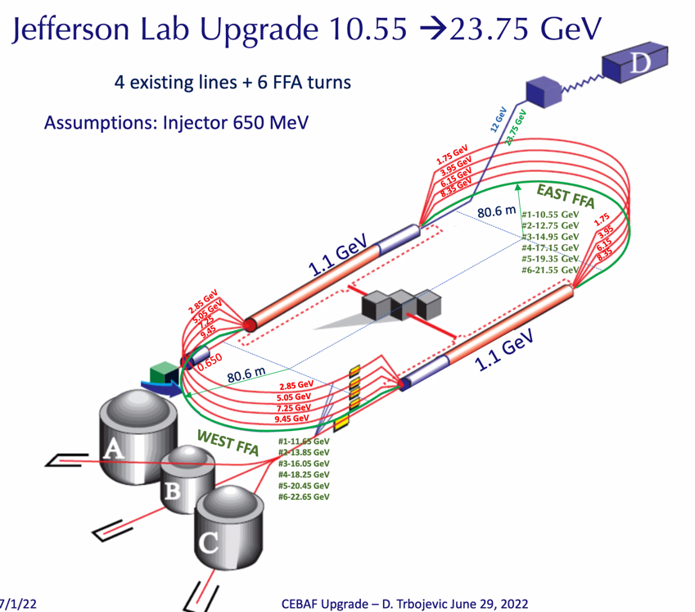
* Doug: why not kick Hall D beam out earlier? Does this make it simpler/less expensive?
  + Jay: question of how many beams through FFA. If put 5 beams through FFA in West arc, then yes, kick D out in TOF spreader at NE corner at 21 GeV and things are fine.
  + Dejan: all depends on what experiments need
    - Interesting methods for extracting from FFA easily – can show next time
  + Kirsten: It’s getting confusing as to where we are going. Too many options on the table, but it needs to be “downselected”
    - Alex B: these conversations started recently
    - Doug: very high level: we’d like all 4 halls (like)
      * After these meetings, sit with Thea and physics, and parse the wishes into a priority list
    - Alex B: we need to really narrow it down
* 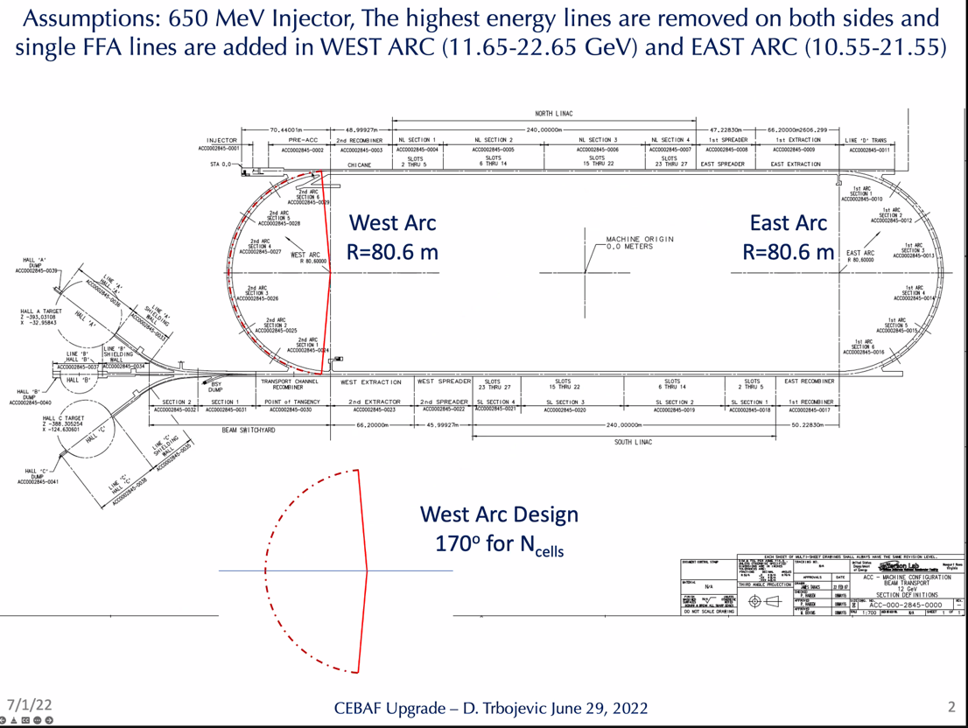
  + Placed cells into arc
  + Goes together with cost estimate. If # of cells is 98 in 1 arc – then multiply by 2 for number in arc for cost estimate
* 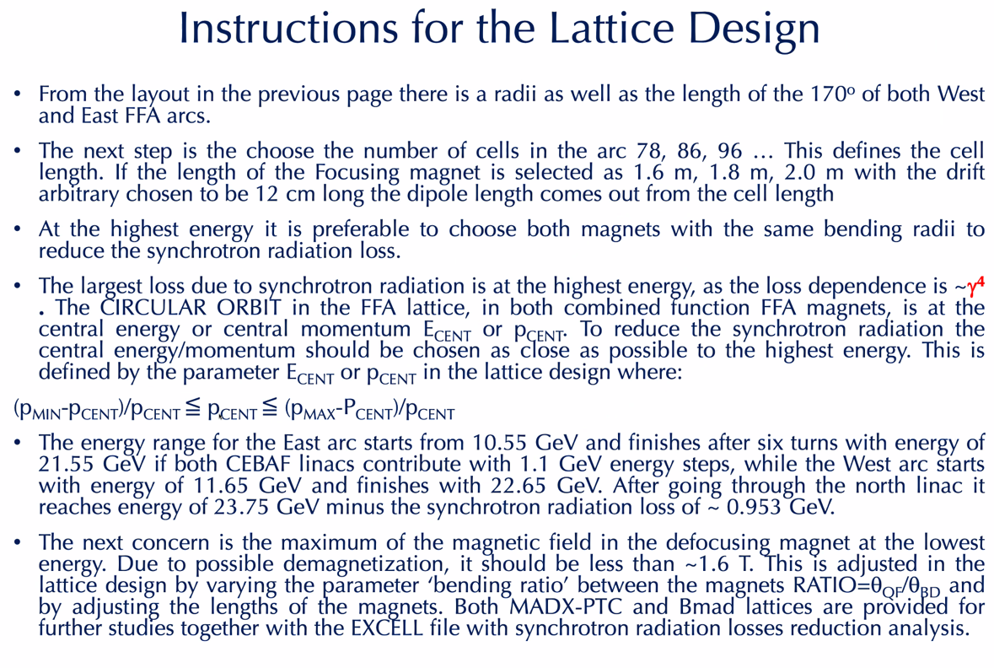
  + Pcent should have circular, but it’s not – so Dejan will re-investigate
* 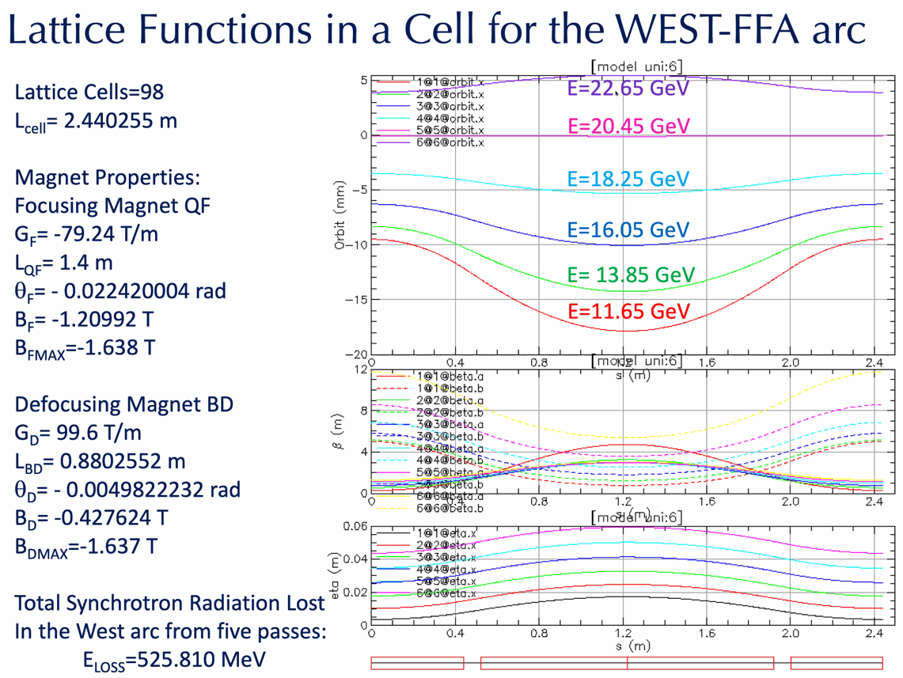
  + Max field 1.63 T
  + Orbits in the two magnets from 11.65-22.65 GeV
    - Major contributors to SR are the highest gammas
    - One is ~circular (20.45) and one is a bit curved
  + Orbits go between 6 mm and -17 mm
* 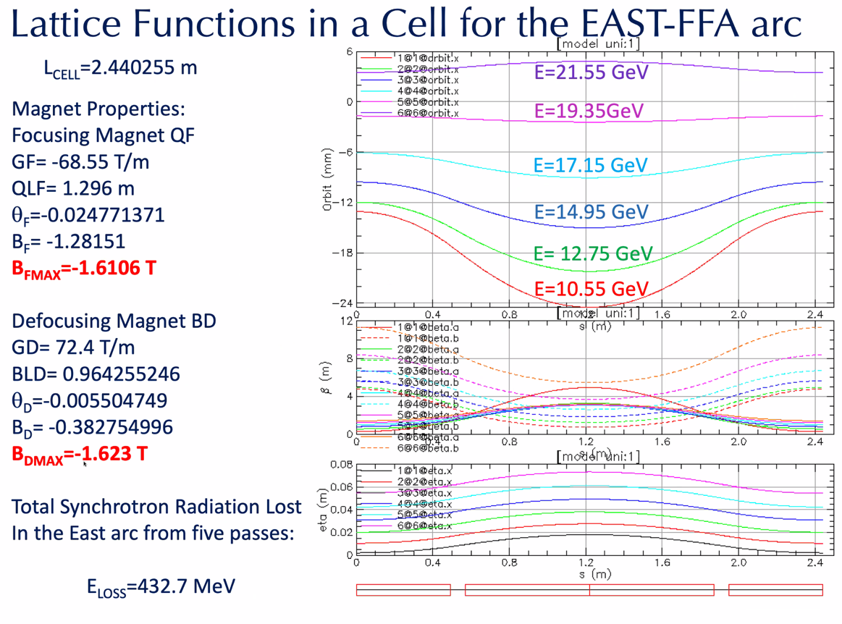
  + Optimized for SR
  + Would *like* to drop the gradient a bit
* 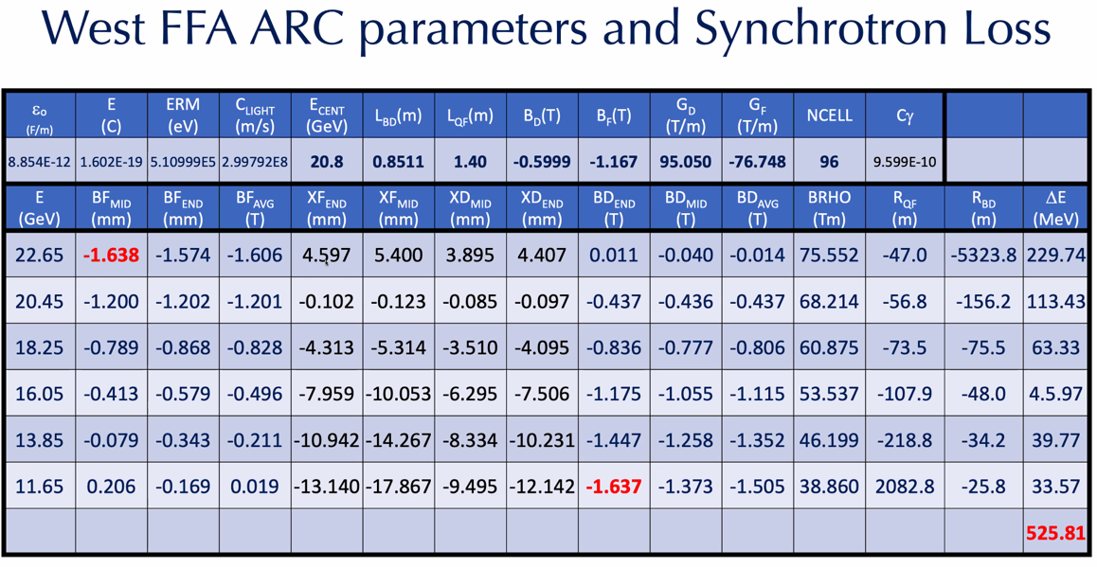
  + Put orbit offsets in magnets here, calculate magnetic field (linearly dependent on x, where gradient and initial bending is defined)
  + Read with caution, some needs to be redone (first line)
* 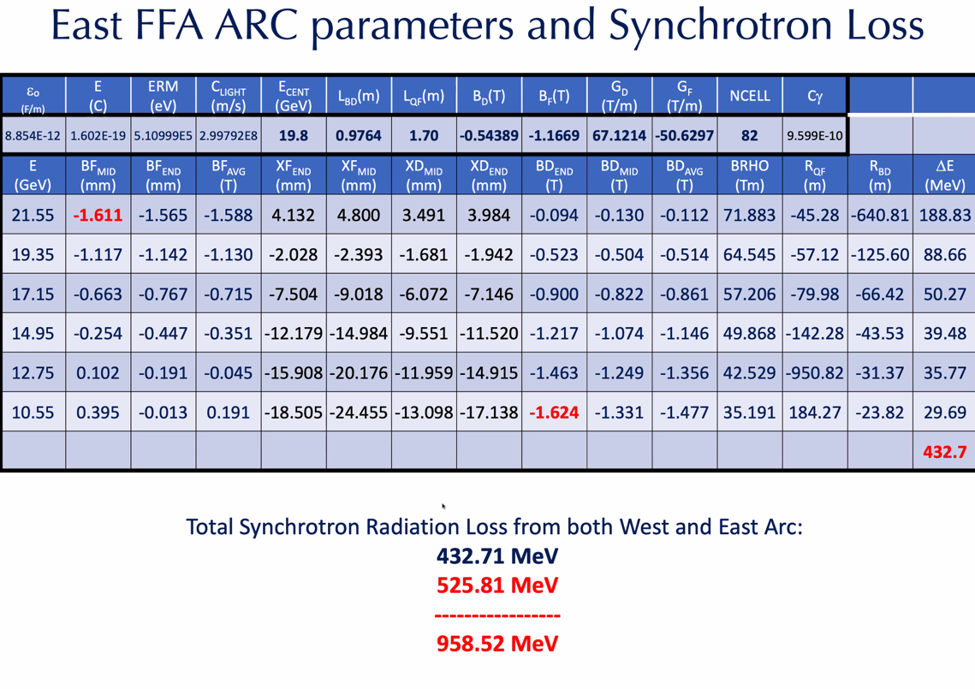
* 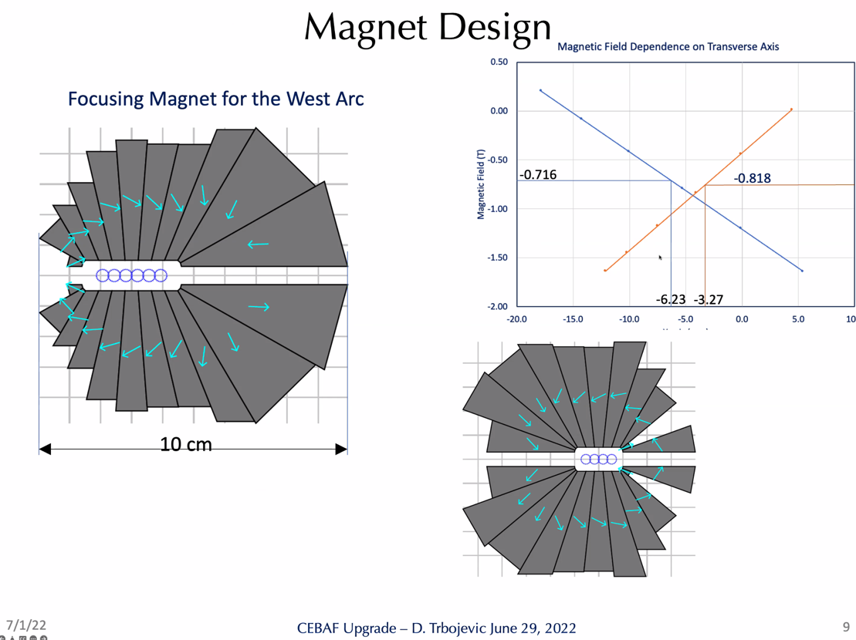
  + When offset is 0, both magnets need the same bending radii. In this case, it’s not true, but still got stable orbit. So will redo in the same manner as old designs
  + Good field shown in plot, where orbit offsets are moving
    - Magnet is 10 cm wide
  + Pipes are different sizes, so that might be too hard to deal with. Each magnet is about 1 m long, and it might be smarter to make the apertures the same size for both.
* High-level recap:
  + Last week, presented nice solution where we kept 5 pass cebaf, then added a 6th FFA pass on the floor
    - Complications with Hall D
    - Good SR (~650 MeV)
    - Got us to about 23 GeV for Hall D
  + Today, removed Arcs 9 and A(10) – and presented 4 + 6
    - Can we consider this? 4 EM passes, then 4 passes into FFA1, then another 3 passes in FFA2 in next phase?
      * Dejan – adiabatic change with large magnets, and insert permanent magnet dipoles to extract any orbit you want to use (tunability)
      * Anything between the two energies you can have – so get lowest energy into arcs, then you can extract at any turn after.
    - Stephen: with 1 FFA and the right assumptions, we can get to 20 GeV. If they are interested in >20 GeV, then we can do that with the second phase.
      * Dejan, no, it’s 21.8 after SR.
      * Jay: If we weaken the magnets to 1.5 T, then can get to 20 GeV with one FFA easily
    - Magnets are 10 cm for 6 passes – very small and nice
      * Stephen: 7 is too many in 1 FFA, magnets too strong
        + Wolfram advice: careful about which of these goes through DOE.

Likes things in 1 stage to get to usable energy, it’s good.

* + Let’s say Physics wants 22 GeV, and we don’t need to go above, then this might work
  + Jay: linac from 1050-1150, look at 5-6 passes in 1 ffa and get 10% tunability within FFA
    - If peak field is too high, then we’re still at 20 GeV
    - Alex: devil’s advocate: we’re struggling with 1090
      * Yes, but we’re refurbishing, so 1090 as a limit should be discarded
    - Refurbishing can get to 1400 per linac with ALL refurbished. It’s a 10 year plan.
      * Keeping it below this is reasonable
  + Jay: if energy spread is more than 1e-3 is there useful phyiscs?
* Dejan: 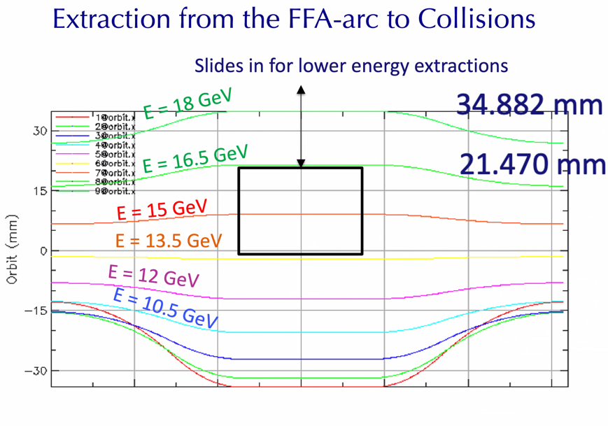
  + Extraction with moving permanent magnet
    - Would give no higher E beams.
* If you want to save the most money, use passes 2-5 as new 1-4 passes, then just change the BCOM and first steps of spreaders/recombiners.
  + All the other magnets remain.
  + Top shelf magnets are useless.
  + 4 EM passes with current 2-5 dipoles, then 1 FFA on the 5th shelf
  + Stephen: 4EM is nice for SR AND for future upgradability.
* Jay:
  + Assume 1050-1150
  + Current arc magnets from 2-5 move to 1-4 (4 total EM passes)
  + Phase 1 with Dejan’s new arcs (5-6 passes?)
  + Top energy of 22 GeV
  + 10% range in linacs
  + Phase 2 (if needed), another arc on the floor.
* Alex C: should we use Dejan’s new arc?
  + Yes.
* Important to do:
  + Random errors
  + What correction needed? Need to be reasonable with errors
* Jay: Tech note that shows multipole components of QA quads
  + Taken from spreadsheet from OCR hardcopy
  + Provides realistic range of quad strengths at various currents to see what’s in the real machine.

|  |  |  |
| --- | --- | --- |
| Action Items | Person responsible | Deadline |
|  |  |  |
|  |  |  |

## | 25 minutes | Agenda topic Injector/Positrons | Presenter Alex

* 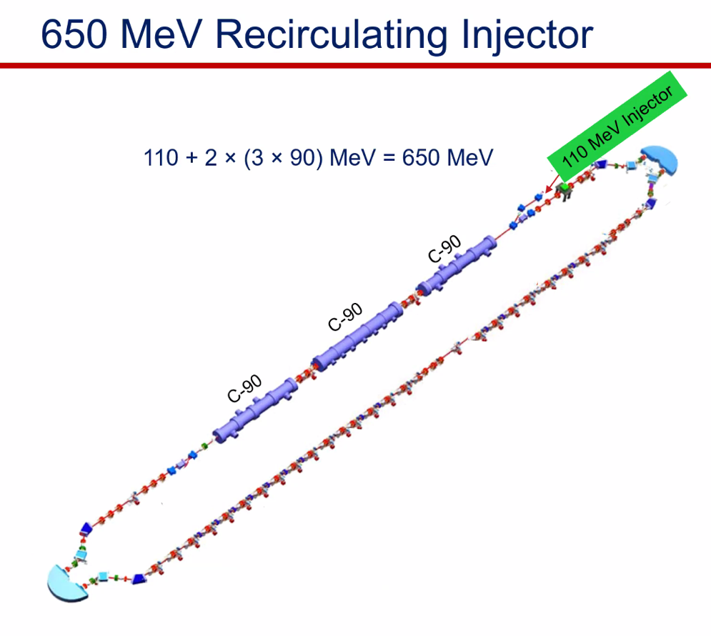
* 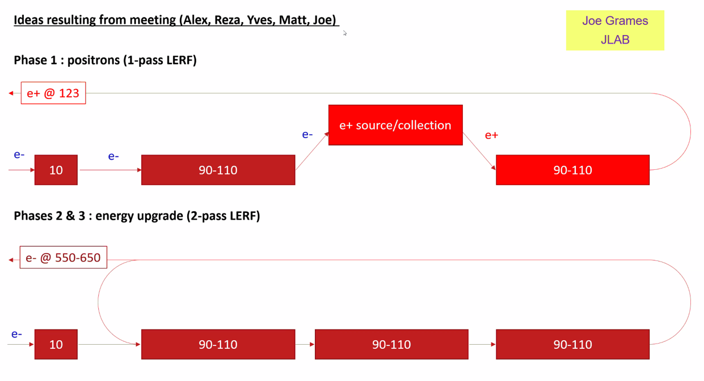
* How optimize positron program leading into the FFA upgrade?
* Joe:
  + The LERF/FEL building – bottom footprint looks similar to FEL
  + Wondering about gradient with 3 cryo – bottom picture seems mostly compatible
  + Backing up, what would positron capabilities look like?
    - Want to minimize cost and beamline changes
  + Still imagine 123 MeV positron injection
  + One option: have similar layout with 123 MeV e- drive beam
    - Need 30-40 m for positron collection
    - Top off energy with cryo
* 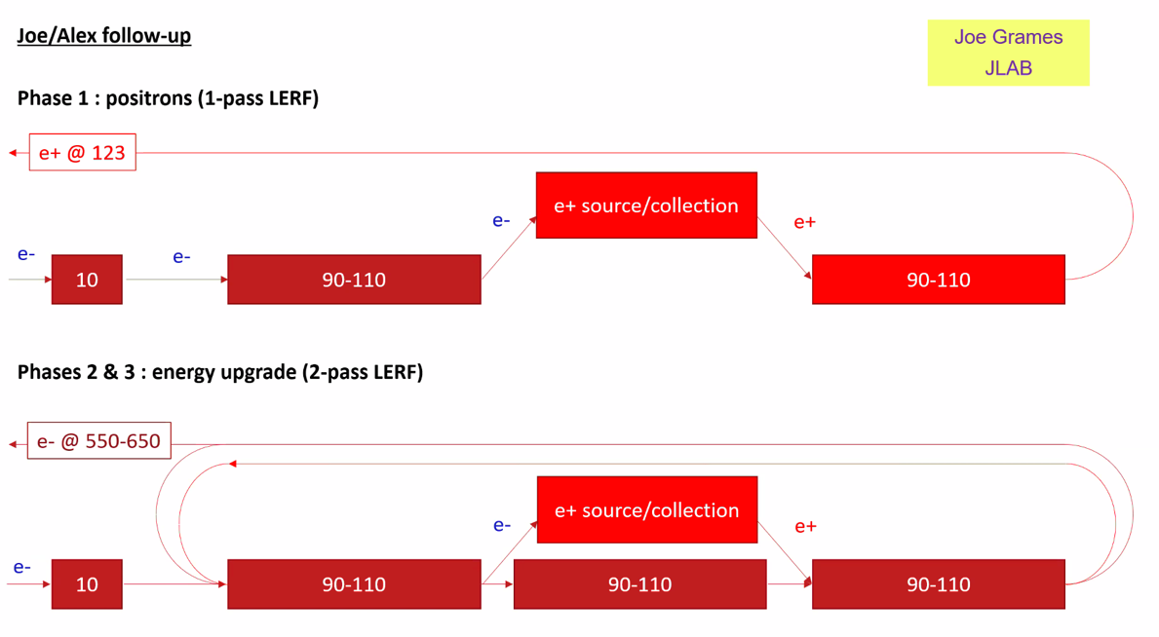
  + Plan B?
  + Maybe still make positrons later? At 650 MeV and still use EM CEBAF passes (9-10 GeV positrons, no use of FFAs)
* This is a cartoon, topology not right, etc… Just the high level idea
* Jay 2 things:
  + Don’t count on c100 more than 85 MeV (think about 3 passes instead of 2)
  + In Feb tech note, assumed 28 refurbished cryo so can turn down everything
  + Will update and make a new tech note about cryomodules
  + Alex B: If there’s a massive refub program, if we select the 3 best cryomodules and use them, make sense? – no
    - Turning C100s down from 200 W to 70-100 W of heat, can make it up with C50s
* If needed, there’s space to knock out the South wall of the LERF, giving ~20 m
* Joe: Front end of CEBAF is longer than FEL injector. When LERF becomes CEBAF injector, there *will* be space concerns (East Wall mainly).

|  |  |  |
| --- | --- | --- |
| Action items | Person responsible | Deadline |
|  |  |  |
|  |  |  |

## Time allotted | 10 minutes | Agenda topic AOB | Presenter All

|  |  |  |
| --- | --- | --- |
| Action items | Person responsible | Deadline |
|  |  |  |
|  |  |  |

## Special notes

Pathway to Repository: <https://jeffersonlab-my.sharepoint.com/:f:/g/personal/tristan_jlab_org/EqZ5MeS-nipCgPfZB5p0oS4B9Is67d3nQb9sLJI3Zyev9g>