FFA@CEBAF Working Group|Minutes

Meeting date | time 7/8/2022 | 11 AM EST | Meeting location https://jlab-org.zoomgov.com/j/1614898082?pwd=TnUzMS81M2sxbDZIbERJU01tYkJCQT09
 | Attendees  Alex B, Ryan, Dejan, Kitty, Amy, Randy, Scott, Stephen, Kirsten, Vasiliy,
  Meeting called by | Alex B
  Type of meeting | Weekly Meeting
  Facilitator | Alex B
  Note taker | Ryan
  Timekeeper | Alex B

Intro Discussion
Dejan talking about changing the linacs…maybe more like ERHIC. Dejan uploaded something into the July 8th folder on the sharepoint. See AOB section for more.

Agenda topics

Time allotted | 25 minutes | Agenda topic Baseline Questions | Presenter Alex
- New question from Stephen: where does FFA end, at A/B/C, or one more half to D?
  - Would end on West side, go through one more NL pass to D
  - Will get 8.5, 9.5, or 10.5 passes.
  - Old design from Stephen had 7 passes on E and 6 on W
    - 5 on both sides the new way would be fine.
    - 6 on both sides doesn’t account for SR loss or energy tunability.
    - Assume 1050-1150 MeV/linac, with nominal of 1100 MeV/linac
      - We currently struggle with 1090 MeV/linac right now.
- Scott: we’ll need to pay attention to the degradation of the linacs over time, even after the refurbishment.
  - They want to refurb mostly C-100s
- Maybe we can get a presentation from SRF to talk about this?
  - 1050-1150 has been “checked” with Jay and Bob Rimmer already.
- Scott: We need to base lowest energy on worst-case energy.
  - Do need to make sure we are maintaining energy ratios for spreaders/splitters as well.
- Ryan: what about degradation of permanent magnets along with the linacs?
  - Stephen: depends on radiation levels – can tell if have that data.
  - Scott: definitely have issues with wigglers losing strength (lead end usually) at the 3% level
  - Stephen: also depends on material grades
    - We can adjust magnet strength with cooling water as well.
- Scott: we should be very conservative.
- Stephen: The reason we had 2 FFAs with 925-1090 range, was hard. If you have a conservative lower and not-so-conservative high end, we’ll need 2 FFAs again.
- Scott: Another case for 2 FFAs:
  - If you have 2 FFAs, the splitters end up being more realistic. Fewer lines, less complication, less horizontal real estate to manage. Maybe better for R56 too.
  - Working with smaller E range, and more optimized for SR.
  - The single FFA – not really that difficult in grand scheme. Having 6 splitter lines without a large energy range is challenging.
- 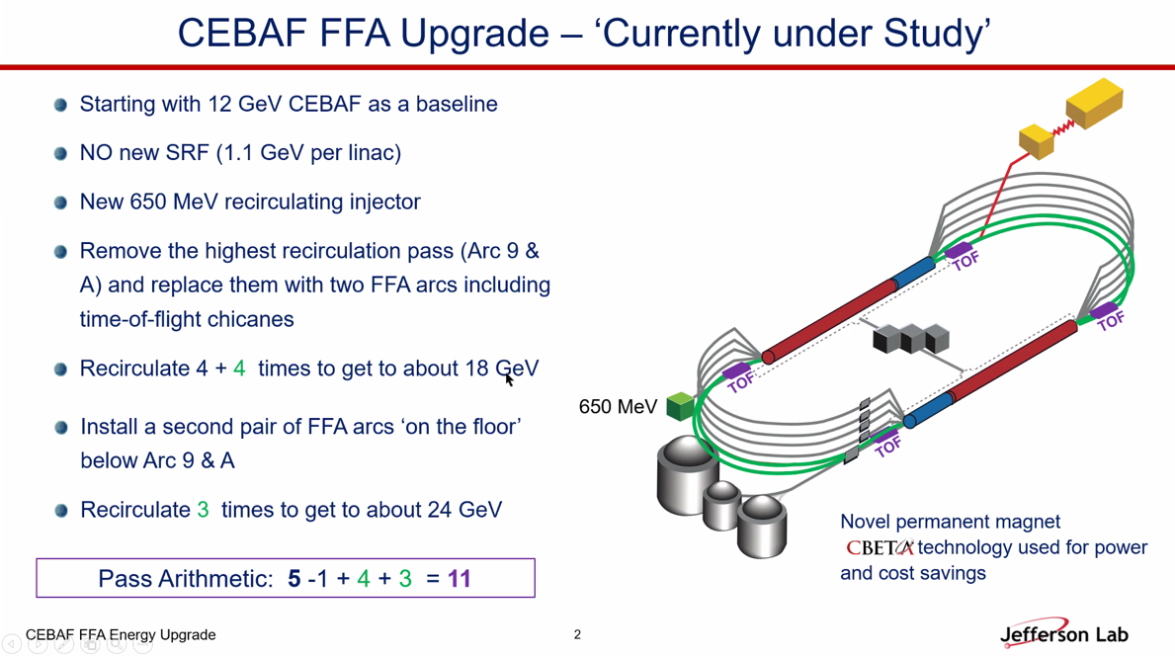
- 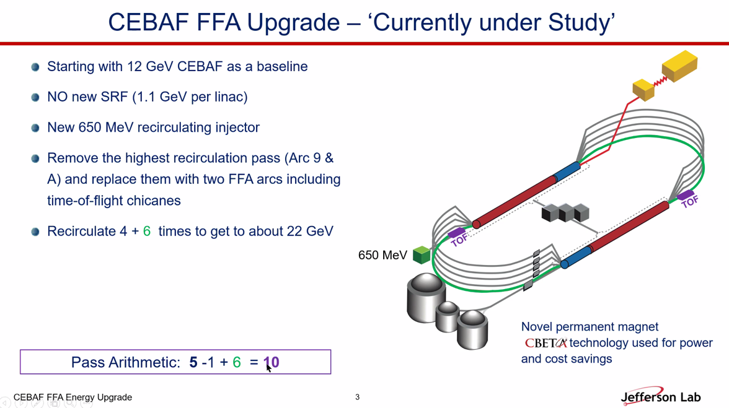
- Depends on users. If 22 GeV is enough, maybe 1 FFA. If they want more, then 2 might be smarter.
- If you go to two FFAs, you can make the magnets larger and safer with lower field.
  - Stephen likes 4 + 5 to get over 20, then have option of adding another later for further upgrades.
- Alex: cost and economy.
- Must finish Spreaders and Splitters for complete design
  - Ryan is working on this as a green-field re-design.
Action Items | Person responsible | Deadline
New Linac idea | Alex B
Spreaders | Ryan

Time allotted | 25 minutes | Agenda topic Single FFA Scheme | Presenter Dejan

- 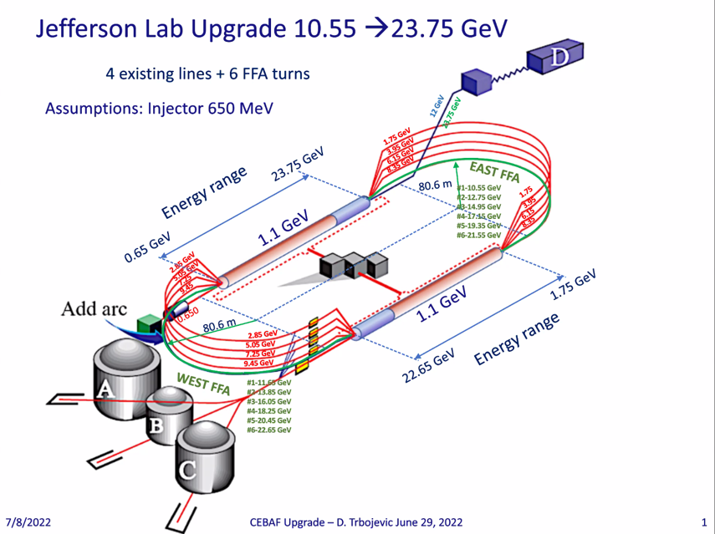
  - We have 2 linacs, one coming with 650 MeV energy, up to 1.75 GeV. SL starts at 1.75 GeV.
- 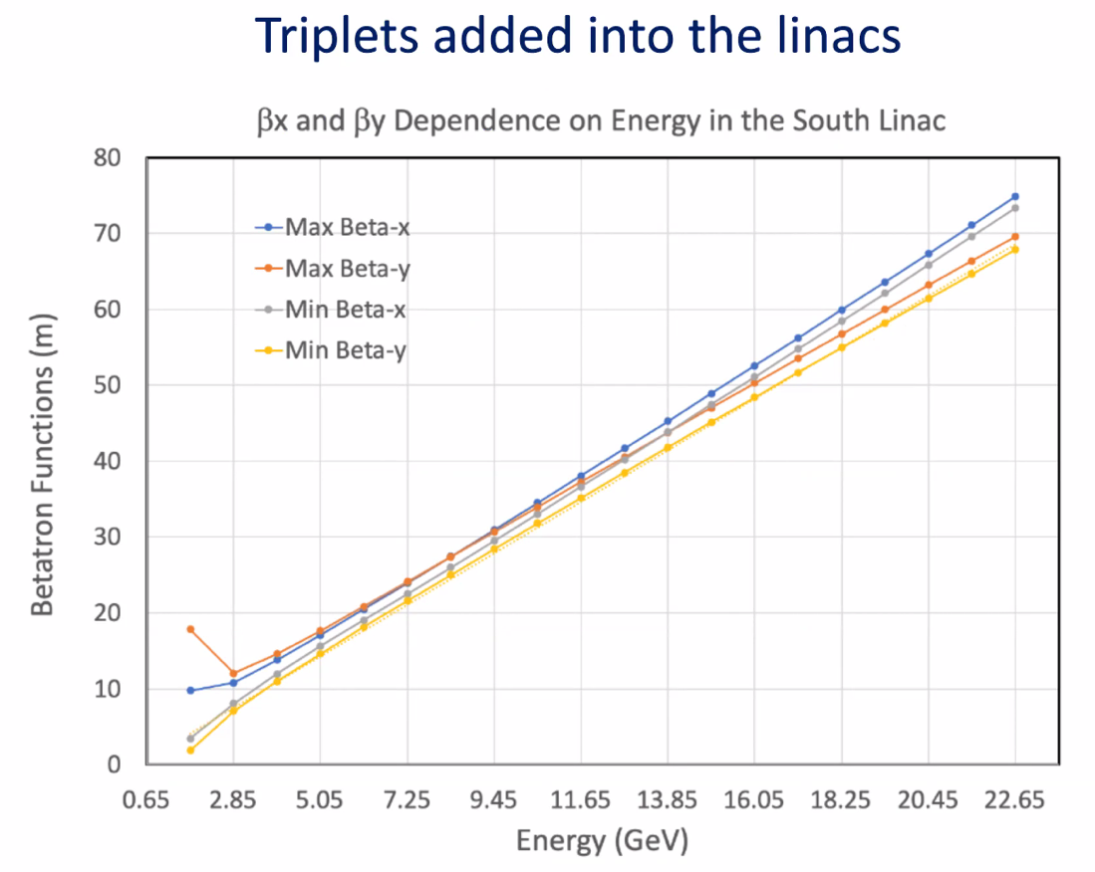
  - Tune per cell (9.6 m between triplets) is going from ~0.06 to 0.38.
  - Assumed highest possible gradients
  - Length of the cavities is about just shy of 7 m. Some warm-to-cold transitions.
  - This assumes permanent magnets again.
- Vasiliy had trouble fitting all the energies into the linac from the FFA arc
- If the beta values at the end are always the same, easier to match.
- 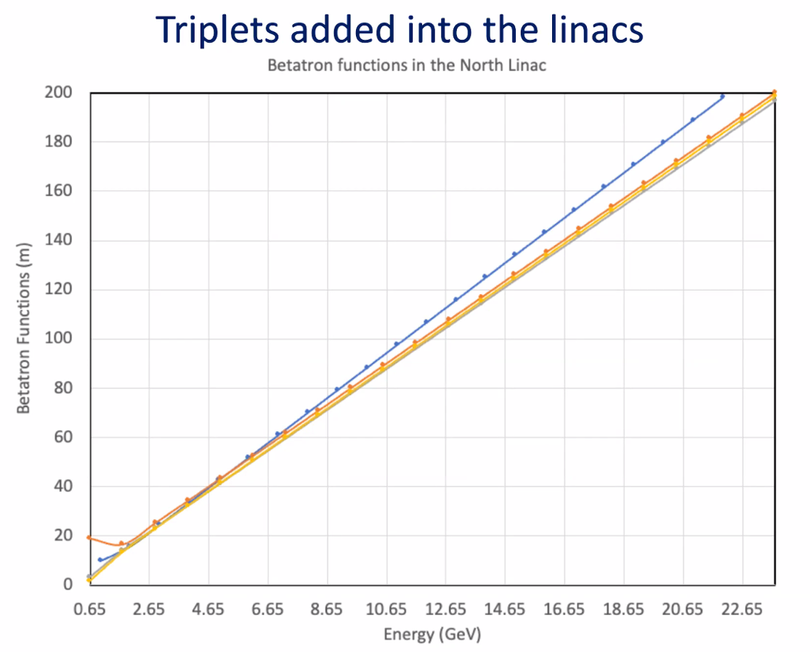
  - Blue is betax_max
- Vasiliy: lowering the size of the betas would be beneficial.
- Dejan: don’t care about middle of linac that much.
- Combine both triplets and final focus quads in the linacs to bring down the betas.
  - The absolute value matters less than the spread of the betas for each energy at the end.
- What happens to spreaders?
  - With single FFA, come out of BCOM, then it’ll replace the current EM 5th pass.
Action items | Person responsible | Deadline

Time allotted | 10 minutes | Agenda topic AOB | Presenter All
- Scott – one mistake we’re making is being matched into LINAC. If you didn’t have any focusing magnets, then you have a DoF available to you, what the beta-star is in middle (and that determines on the end). If you insist on being matched at a high energy to the triplets or FODO, you’ve lost DoF. At a very high E, you must be close. Effectively, you could give yourself that DoF, essentially treating the chain of magnets as a moderately perturbed drift.
  - Alex – doing this with ERL work
  - Can play with optics so that we have a “ratty looking parabola” in the higher energies, and control in the lower.
  - Still control beta at ends.
  - Might blow up betas to large numbers
    - Looked at this a bit, but abandoned before. Maybe re-investigate.
Action items | Person responsible | Deadline

Special notes

Pathway to Repository: https://jeffersonlab-my.sharepoint.com/:f:/g/personal/tristan_jlab_org/EqZ5MeS-nipCgPfZB5p0oS4B9Is67d3nQb9sLJI3Zyev9g

