FFA@CEBAF Working Group|Minutes

## Meeting date | time 7/15/2022 | 11 AM EST | Meeting location <https://jlab-org.zoomgov.com/j/1614898082?pwd=TnUzMS81M2sxbDZIbERJU01tYkJCQT09>

|  |  |  |  |  |  |  |  |  |  |  |  |
| --- | --- | --- | --- | --- | --- | --- | --- | --- | --- | --- | --- |
| |  |  | | --- | --- | | Meeting called by | Alex B | | Type of meeting | Weekly Meeting | | Facilitator | Alex B | | Note taker | Ryan | | Timekeeper | Alex B | | Attendees  Alex B, Ryan, Dejan, Alex C, Kirsten, Reza, Kitty, Scott, Randy, Amy, Stephen, Jay, Vasiliy, Todd, Andrei, |

# Intro Discussion

Kirsten – does anyone have any graphics I can use for NAPAC that are up to date? Several will provide.

# Agenda topics

## Time allotted | 25 minutes | Agenda topic FFA Arc Errors | Presenter Alex C

* Working on transposing Dejan’s lattice into the scheme for random errors. Can’t get SR integrals to match – will happen next week.
* Today, will show error resilience using Stephen’s original design for FFA2.
* Wrote code that automatically puts errors into BMAD lattices
* 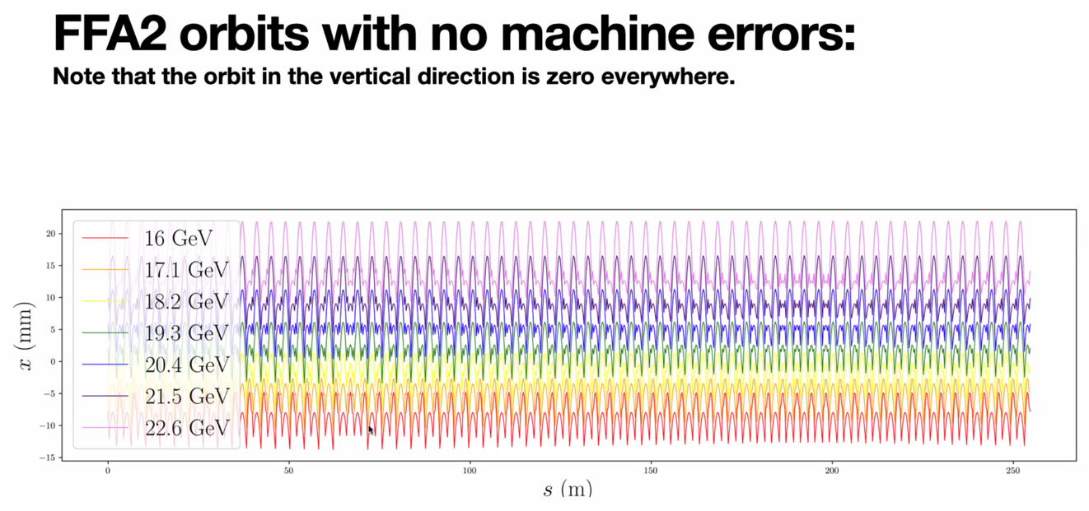
  + Radial deviation in the beam pipe for ideal case
* 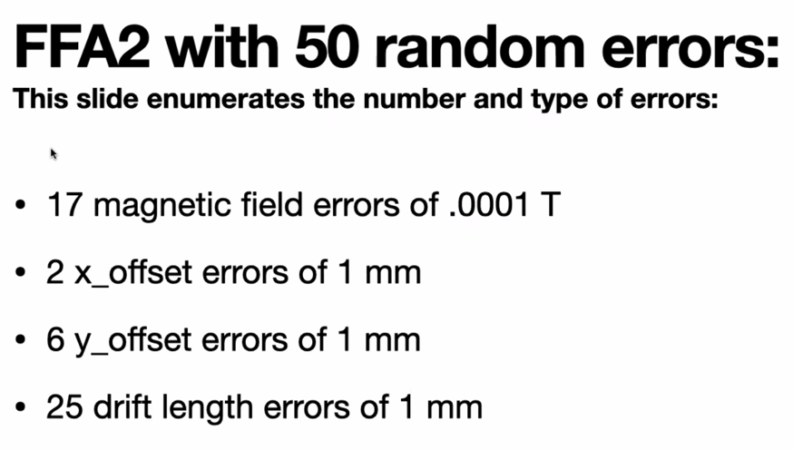
  + Errors are randomly assigned
* 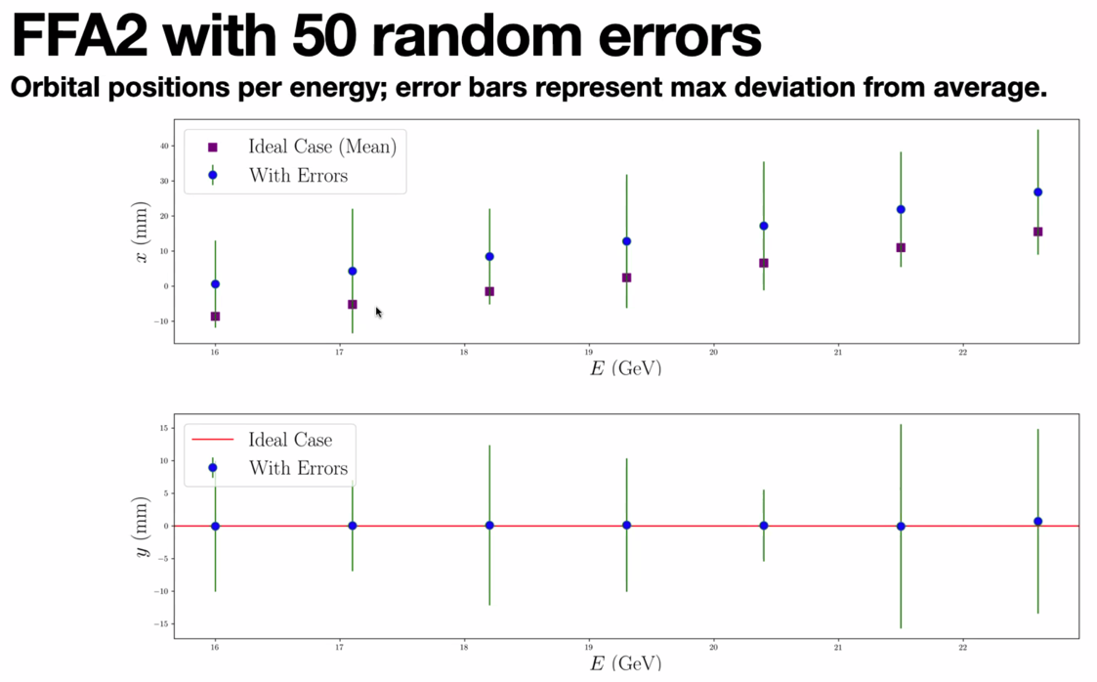
  + Purple is ideal, blue are with errors
  + ~10 mm movement, consistent across energies
* 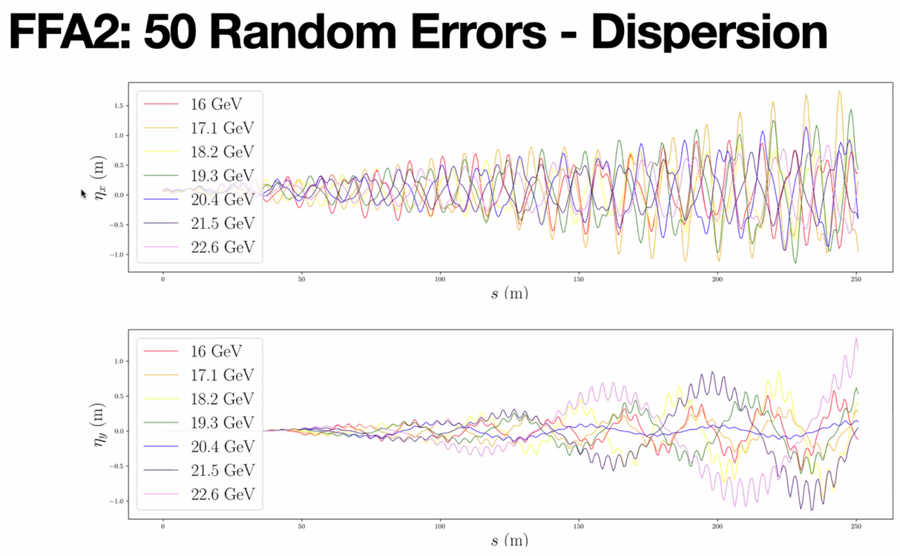
  + Ideal, between 3-12 cm – blows up to ~ 1 m
* 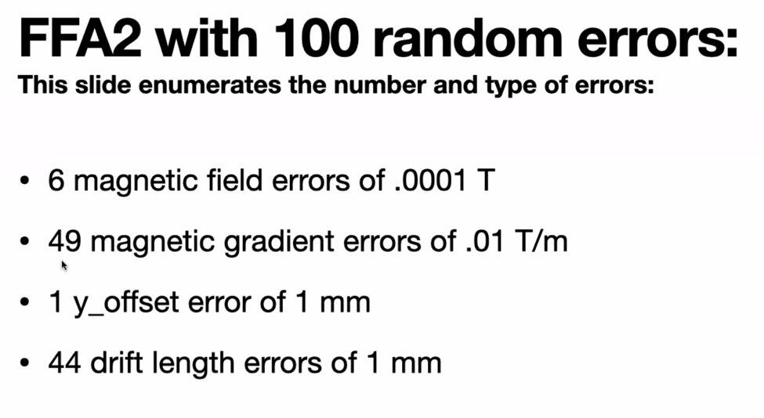
* 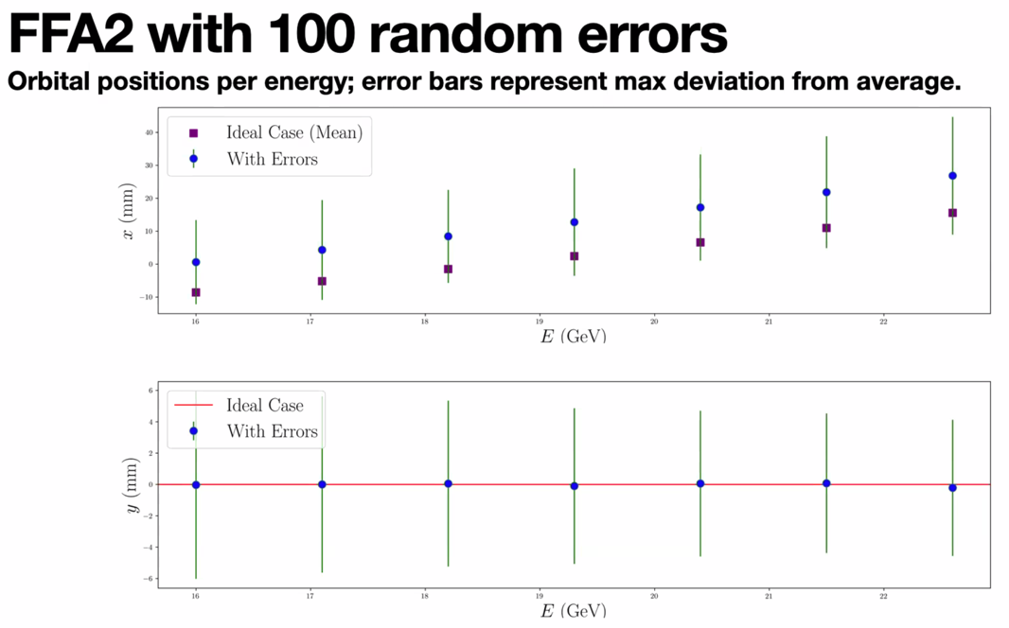
  + Very similar to 50 case, but not same plot!
* Q: is 1 mm ok?
  + Stephen usually does 0.25 mm offset
* Jay: decades ago, Halbach wrote tech notes about the errors one can expect due to machining in electromagnets. Might find. (Search for K Halbach). May have done the same for permanent magnets.
  + Fits very well in terms of allowed errors for fabrication.
  + Rather than sticking 1 error in one place, put a gaussian and look at what you get.
    - Halbach’s papers are function of lamination stamping or whatever
    - 5-10 um level on things that were 10 cm scale. 1 part in 10^4 not unreasonable.
* Dejan: there are many possibilities for errors. One is misalignment. The other is the error of the mag field.
  + Analyzed carefully in CBETA case and corrected with shims. Still had some gradient errors and dipole errors and it can all be measured.
    - Stephen emailed the assumptions used in CBETA.
    - Main thing is, the dominating is the transverse displacements. Dominated by surveys and assembly on beamline.
* All errors are randomized. So choose a total number, then it will randomize which errors are present, and how many of each.
* Scott: seems you have a very large offset
  + Seems systematically on one side (all errors on same side of ideal case)
  + Are signs of errors always the same? No (drift length specific question)
* Kirsten: I’ll usually say this much x/y offset, etc… and assign gaussian errors to everything
  + Alex C – that’s a pretty easy next step
  + There’s a BMAD thing “misalignment” that might work
  + Kirsten uses python script to assign errors, then read in the errors
* 1 mm is a really big number.
* Field errors on small side.
* Magnet gradient errors are reasonable-ish. Maybe slightly small.
* 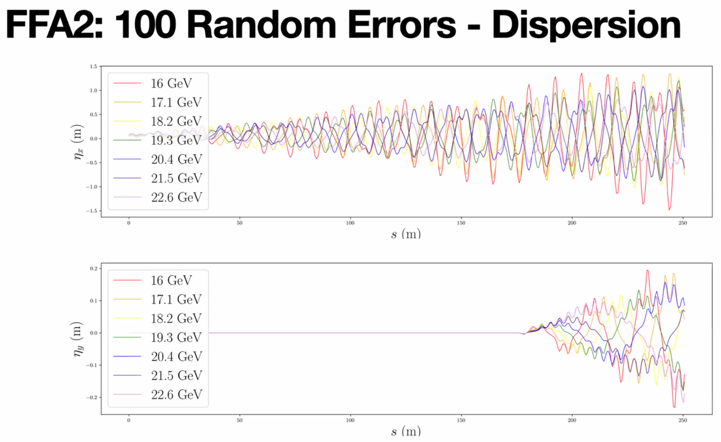
  + Only 1 y offset, and you can localize it easily!
* Small errors in drifts do almost nothing (maybe dispersion)
* Position of magnets are crucially important
* Fairly stable orbits (~10 mm)
* Will absolutely need correctors
* Need to limit drift errors in code.
  + Make these into longitudinal offsets on magnets, then add and subtract on drift as needed
* Need more analysis for correction schemes
* If you only have dipole correctors, you’ll fix one and screw up the other.
  + If you look at EOM that govern correctors, they are exactly the same for dispersion and orbit.
  + Point is: if dispersion error and orbit error are not in phase, then correction will fix one and destroy the other
    - To fix that, you give yourself quadrupole correctors to break that symmetry.
      * Jay, how many? 8 per arc?
        + Scott – that feels small. Every magnet had wired corrector frame around them, but we didn’t power quadrupole correctors correctly for this and focused on dipoles.
* Dejan: we did not connect the quad correctors because we measured every magnet. We need to find this out after we measure the magnets and conclude, do we wire them for quads or not?
  + Jay: then we need a sensible project manager that will allow that. We didn’t do this for 12 GeV, and just assumed the average.
    - Alex B: I can assure you, this will be different.
  + Stephen measured them 3 times and corrections. Won’t release the magnets until they “pass”
  + Jay: 1 unit is 10^-4 per inch for corrections on magnets with shims
* Todd: Stephen, did you do all the shimming?
  + Had some help with technicians, scripts, etc…
  + How long did it take for all the CBETA magnets (200 magnets)? 18 weeks (11/week avg) with small staff.
  + ~400 magnets in CEBAF design (over 1 m each).
    - Shimming won’t be a problem, likely.
  + Todd, probably 2-3 FTEs of labor at least.
* Dejan: vertical dispersion comes from matching of splitters to the arc. If that’s not perfect, it’s going to propagate. Then if there’s vertical misalignment, it’s worse.
  + Scott: the alignment from splitter wasn’t the only source.
* 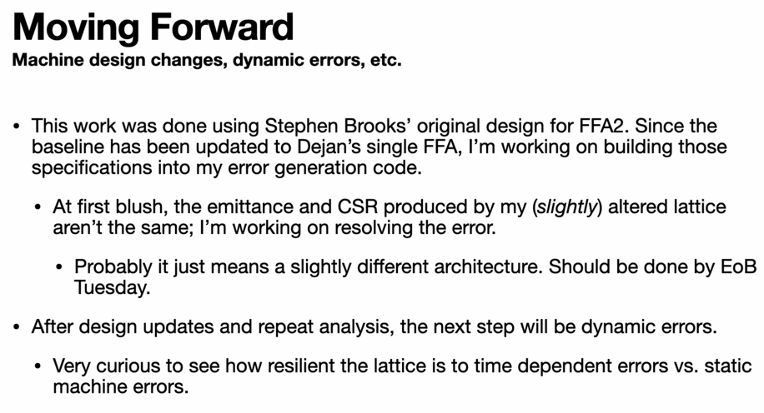
  + Trying to make it in the patch way. Dejan hates the patch method.
  + Dejan: worried about offsets being much smaller for higher E range. Won’t be symmetric as in example.
    - Plots just make them look symmetric.

|  |  |  |
| --- | --- | --- |
| Action Items | Person responsible | Deadline |
|  |  |  |
|  |  |  |
|  |  |  |

## Time allotted | 25 minutes | Agenda topic LINAC Optics | Presenter Alex B

* 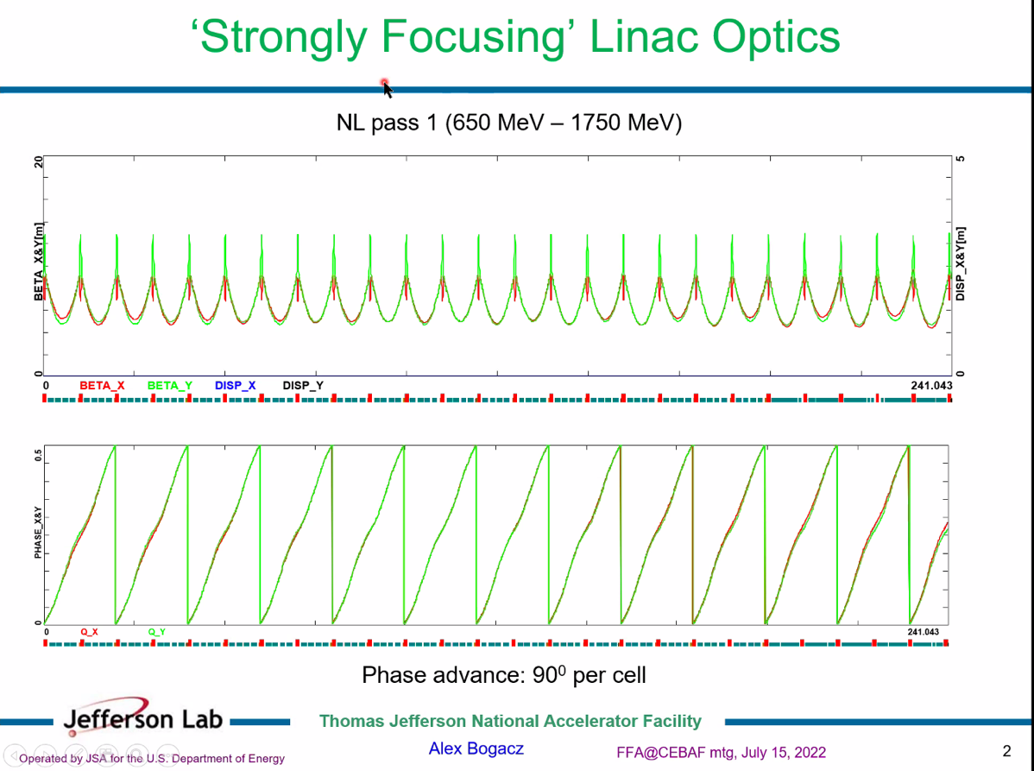
  + This is what we’ve been using so far.
  + Triplet focusing, entire NL with 25 cryomodules
  + Used regular triplets (not twin-cells)
* 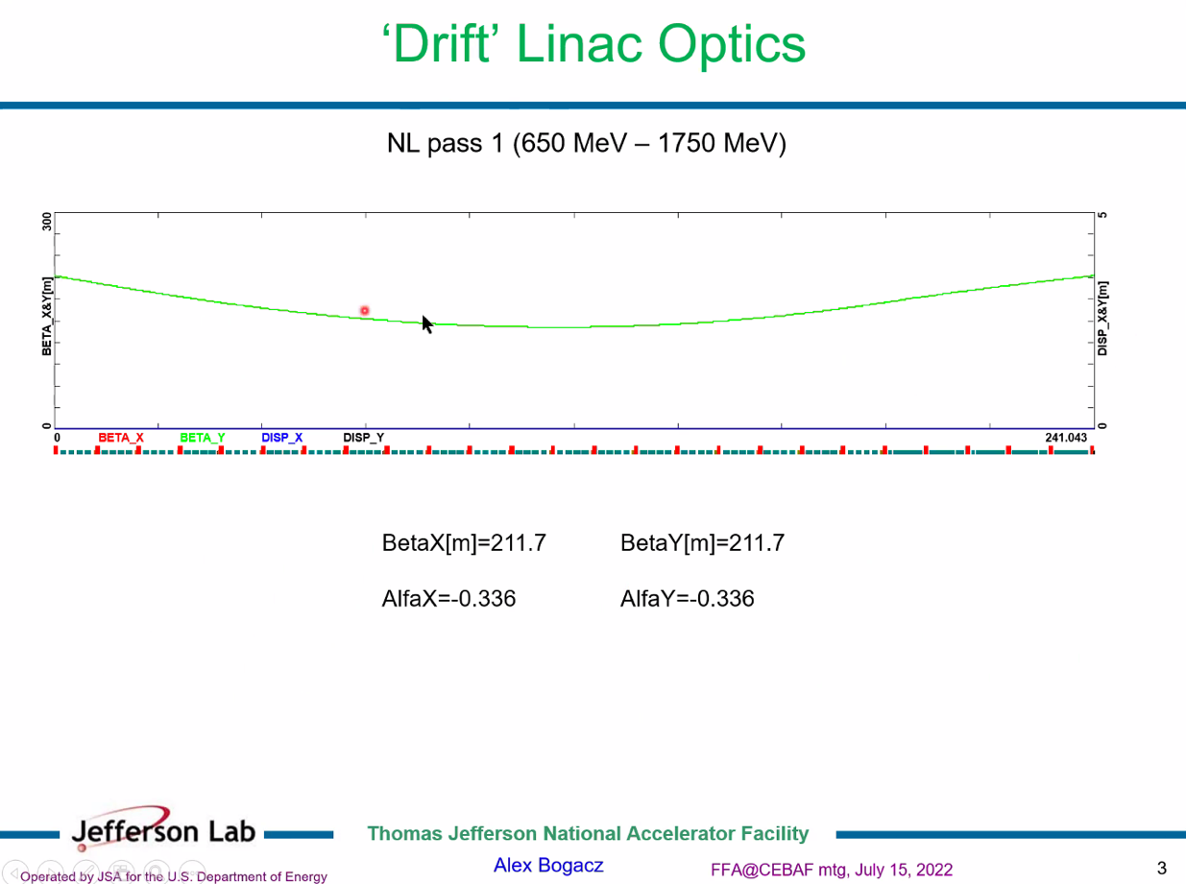
  + This is the other extreme, a drift linac
  + Beta and alpha same for both planes
    - Should be same for all other passes
  + Problem is, this is a very high beta for first pass
* 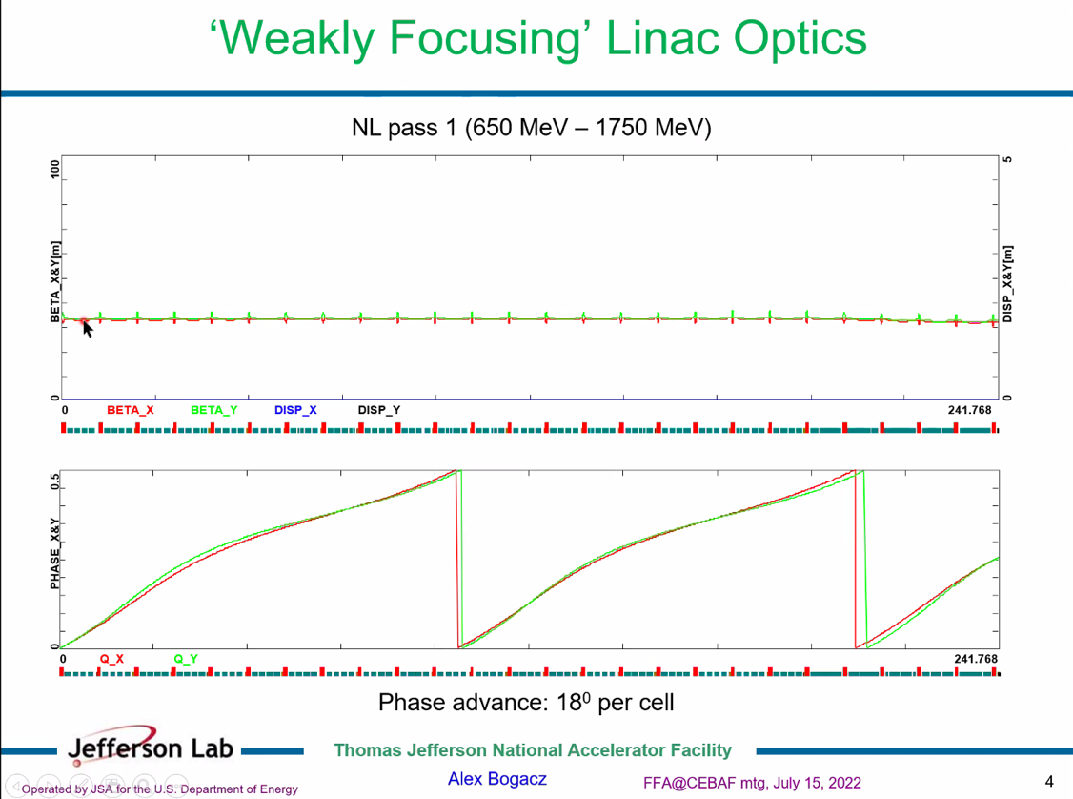
  + In-between option. Weak focusing
  + Gives ~30 m beta in both planes
  + 18-degrees per cell, still get 2.5*PI variation
* 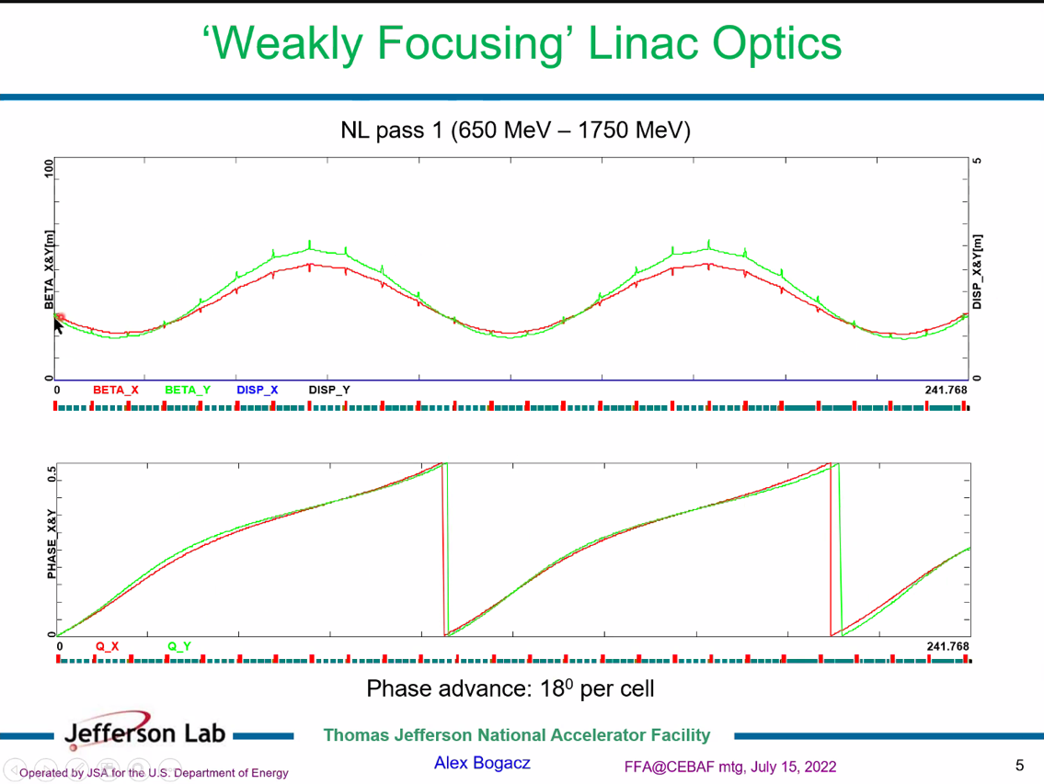
  + Since we only really care about beta at start and end, this works.
  + Could try to end at minima with some tuning
  + This becomes more interesting at higher E
* 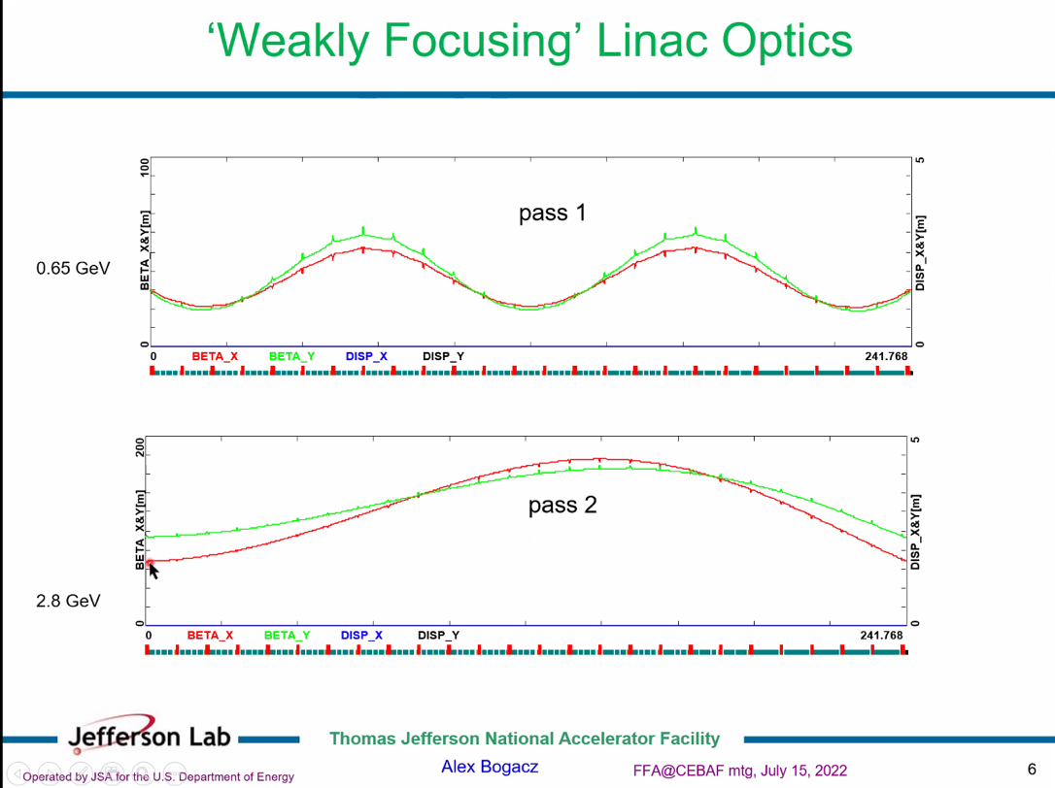
* 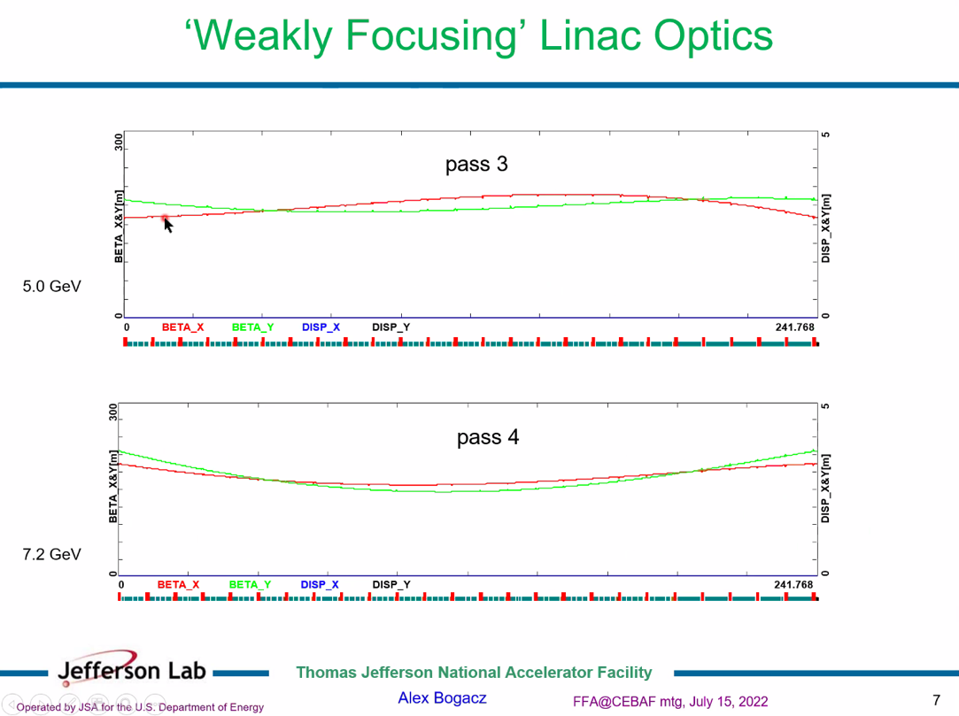
* 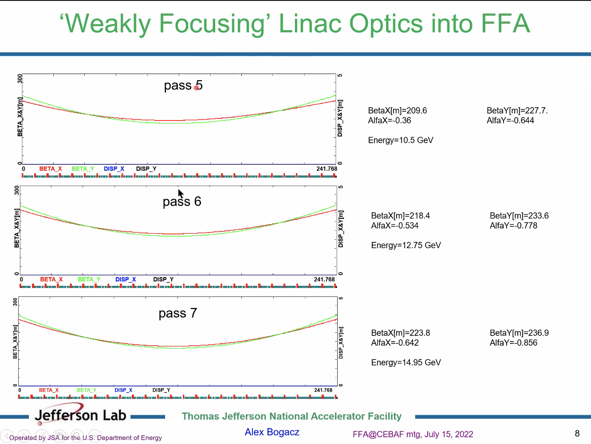
  + Approaching 200 m at higher E
  + Both planes agree pretty well on the ends
* 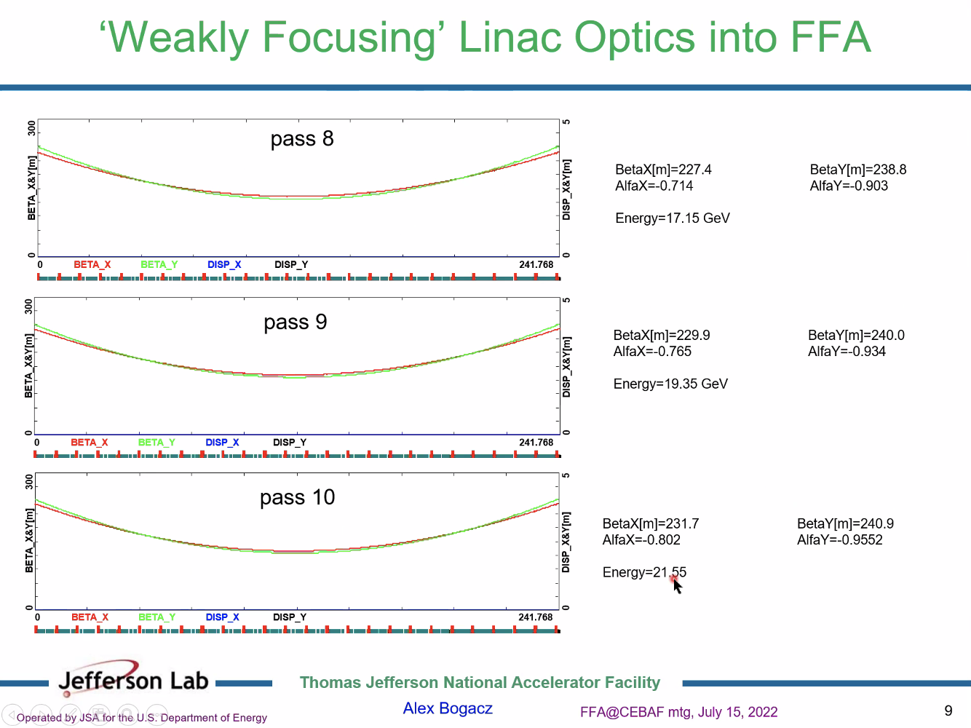
* FFA Passes give nearly same betas at ends.
* The price: the beta values are over 200 m
* This can all be improved upon.
* Next step: for lowest passes, keep passes flat (4 passes) and absorb in spreaders and recombiners
  + Pass 5 is already getting close to drift
  + Stronger initial phase advance, the spread of the betas will be larger
* Vasiliy, how would this impact your matching?
  + He’ll have to try. Interesting thing to try.
* Stephen: if you oscillate the kicks corresponding with a specific tune frequency, does this apply to beta?
  + Spatial modulation
  + If injection off, we see beta beating now
* Dejan: still don’t see final solution.
  + Stephen: what this doesn’t change anything
  + Will still need splitters on both sides.
  + Also have substantial pass length changes over course of year due to the expansion and contraction over 1 cm
    - Have doglegs for this
    - Will need splitters on each end to deal with pathlength variations seasonally as well as to use weak focusing.

|  |  |  |
| --- | --- | --- |
| Action items | Person responsible | Deadline |
|  |  |  |
|  |  |  |

## Time allotted | 10 minutes | Agenda topic AOB | Presenter All

|  |  |  |
| --- | --- | --- |
| Action items | Person responsible | Deadline |
|  |  |  |
|  |  |  |

## Special notes

Pathway to Repository: <https://jeffersonlab-my.sharepoint.com/:f:/g/personal/tristan_jlab_org/EqZ5MeS-nipCgPfZB5p0oS4B9Is67d3nQb9sLJI3Zyev9g>