FFA@CEBAF Working Group|Minutes

## Meeting date | time 7/22/2022 | 11 AM EST | Meeting location <https://jlab-org.zoomgov.com/j/1614898082?pwd=TnUzMS81M2sxbDZIbERJU01tYkJCQT09>

|  |  |  |  |  |  |  |  |  |  |  |  |
| --- | --- | --- | --- | --- | --- | --- | --- | --- | --- | --- | --- |
| |  |  | | --- | --- | | Meeting called by | Alex B | | Type of meeting | Weekly Meeting | | Facilitator | Alex C | | Note taker | Ryan | | Timekeeper | Alex B | | Attendees  Alex B, Ryan, Alex C, Stephen, Kitty, Andrei, Kirsten, Dejan, Randy, Vasiliy, Reza, Amy |

# Intro Discussion

Ryan gave LDRD “Defense” talk for the renewal. Went well.

# Agenda topics

## Time allotted | 25 mins | Agenda topic Weekly Focusing Linac | Presenter Alex B

* New alternative optics called “weakly focusing’
* 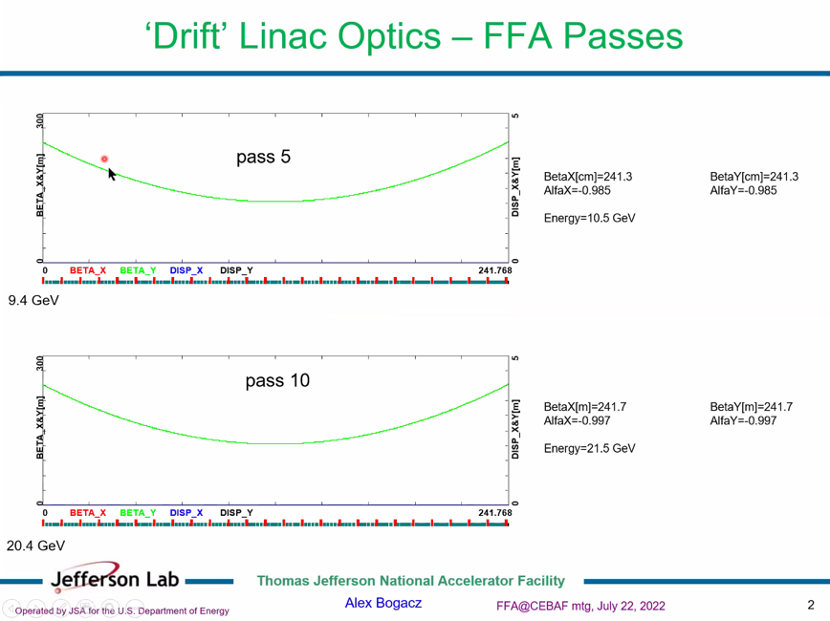
  + Drift linac at lower E
  + Beta is parabola in x and y – same values of beta and alpha feeding into the FFA arcs
    - Differs by ~4 mm
  + Don’t want 200 m of beta
* 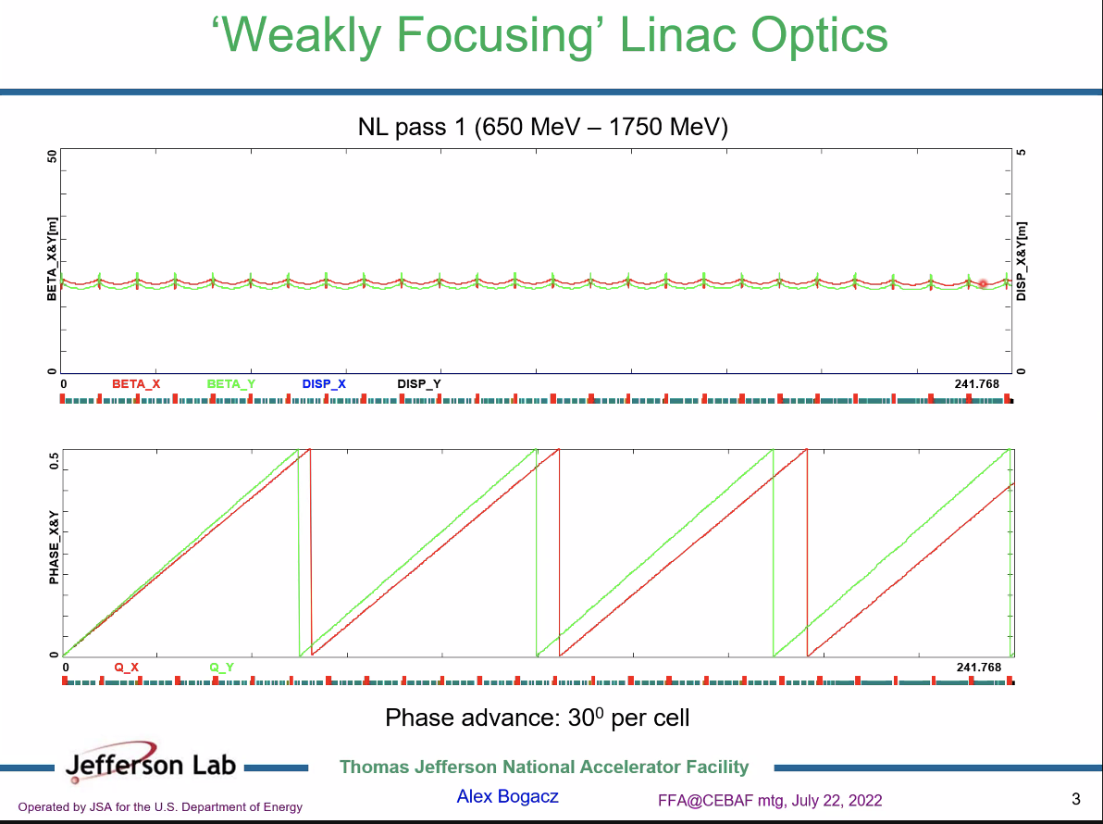
  + Last week, showed 18 degrees per cell, now 30 degrees per cell (optimum)
  + 1st pass on top
    - All cells matched with flat profile
* 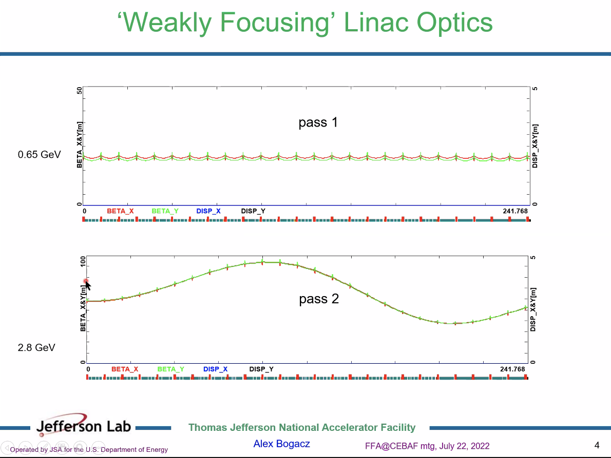
* 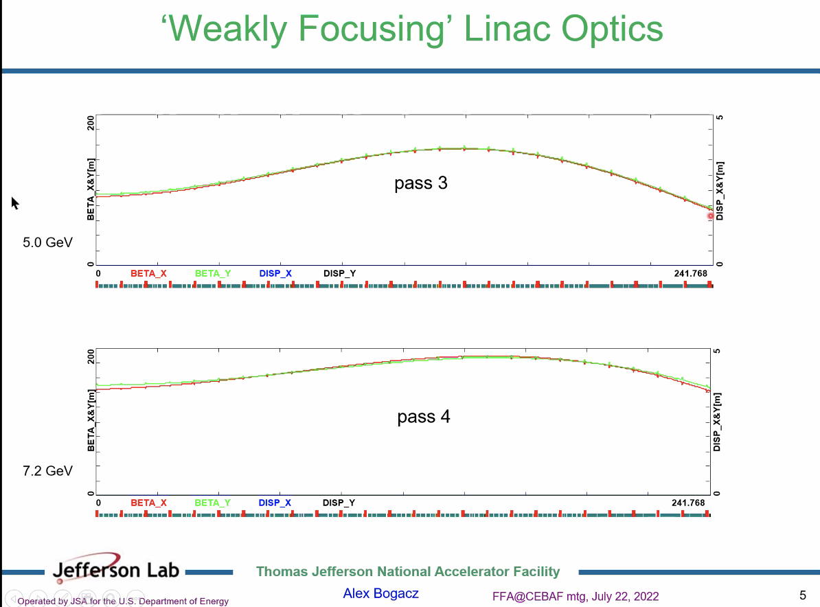
* 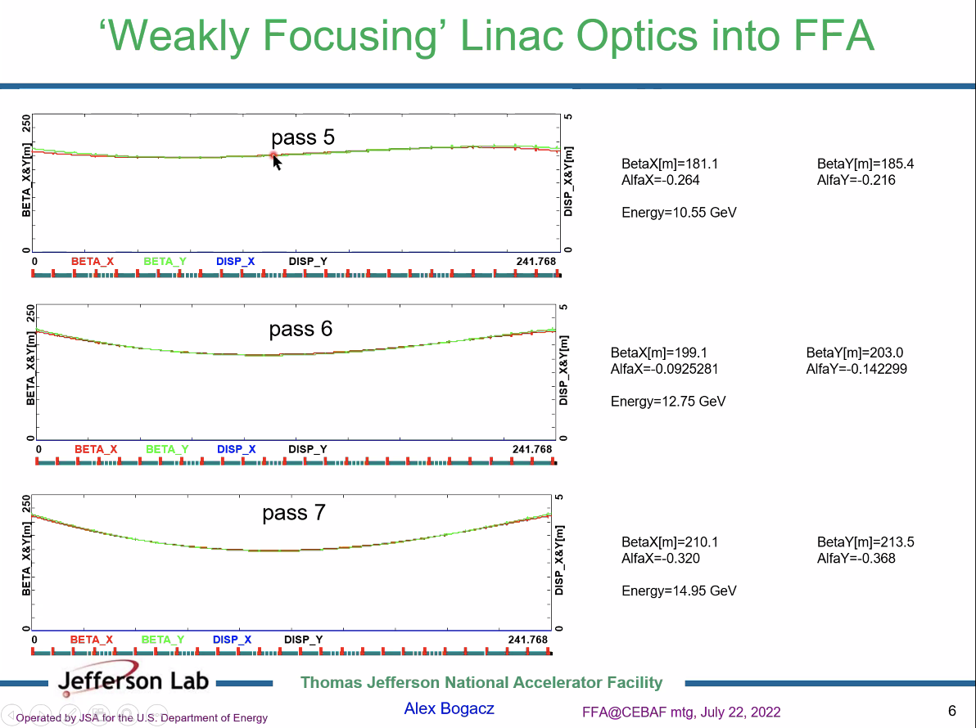
* 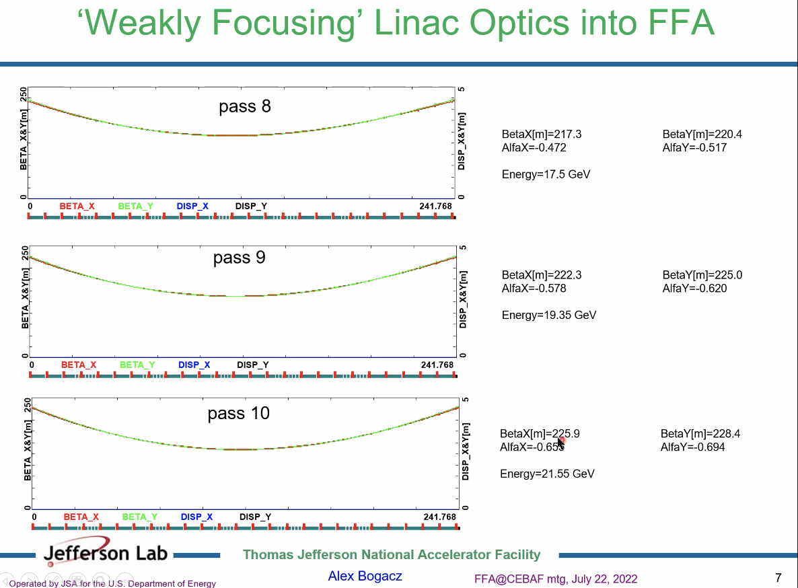
* 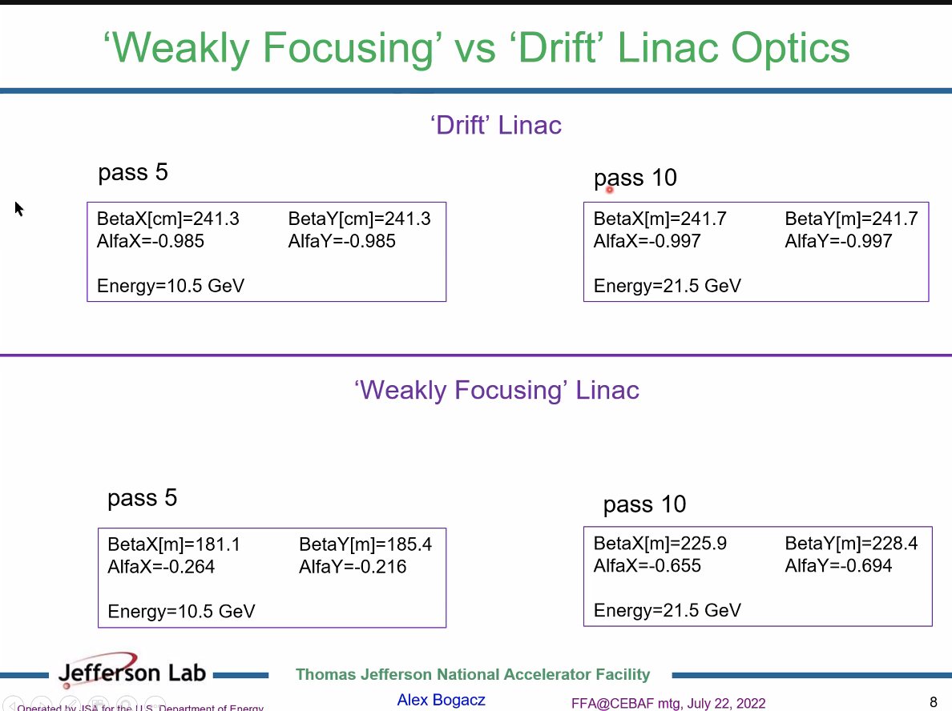
  + Beta and alpha seem decently controlled
    - 45 m difference in beta in WF linac
  + Can these values be used with Vasiliy for matching?
  + Values at end of LINAC
    - Has to go through spreader and splitters
* Can put small quads to match?
* We have to match down from 220 m to 20 m for Vasiliy
* 5th pass splitter will be for all 6 beams.
* 4 or 5 passes in one FFA is reasonable. 6 Might be possible, but unsure. Might be too crowded for splitters
* Both linac options are similar for optics at the end.
* Dejan: splitters – design magnets with open plane
  + Can create dipoles with more than 2 T field
* Stephen: maybe use a gradient magnet to separate out the passes further.
* Focus on 1 FFA first, then if we need more we can re-adjust.
* Vasiliy: So we need the spreader and splitter in between the arc matching and linac?
  + Yes.
* Dejan: forget about CBETA electromagnets in splitter – we’ll need to have open-aperture magnets with high field.
  + Stephen: we’ll need some EM for tuning
  + In small place with strong magnets, could use Sumerian Cobalt magnets (less susceptible to radiation damage)
    - All losses at CBETA were in the splitters, not FFA.

|  |  |  |
| --- | --- | --- |
| Action items | Person responsible | Deadline |
| Make Spreader 9+ | Ryan |  |
| Make splitter |  |  |

## Time allotted | 25 mins | Agenda topic Adiabatic Arc | Presenter Vasiliy

* To proceed to matching, need to know boundary conditions.
* We have arcs to large beta matching solution
* With spread out beams, the beta functions could be brought down
* Should focus on reducing length of matching section by reducing beta
* From linacs, we have a 45 m spread in the beta – perhaps we can mitigate this?
* The solution we have now is for the values presented above
  + We can assume the spread of the betas is reduced and see if it makes matching easier.
* The hard part for Vasiliy is the existence of the spread of betas.
  + Easiest way is to use quads in each energy line to match betas down from the linac values.
  + Try to match down to Vasiliy’s values.
* Area of splitters with free space, put quads for matching
  + 6 separated beamlines for 6 energies in single FFA

|  |  |  |
| --- | --- | --- |
| Action items | Person responsible | Deadline |
|  |  |  |
|  |  |  |

## Time allotted | 10 mins | Agenda topic AOB | Presenter All

* Stephen shows his magnet prototypes!
* 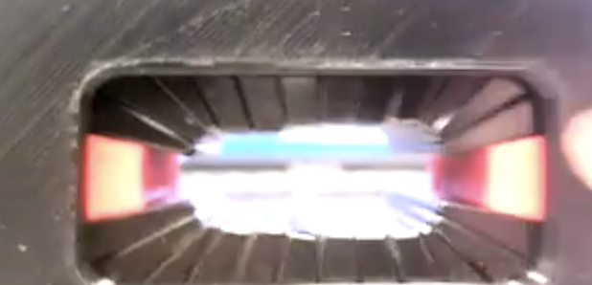
  + 1.68ish T inside good field region
  + 0.4 T on the edges
* Ordered more stuff to make longer ones.
* When you quote the area, is that the sum of the wedges?
  + Yes.
* 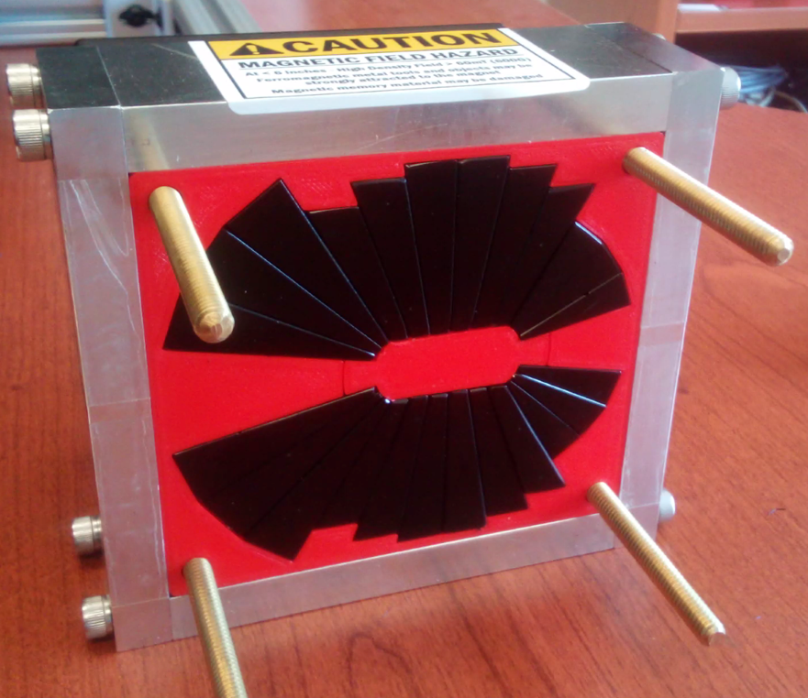
* 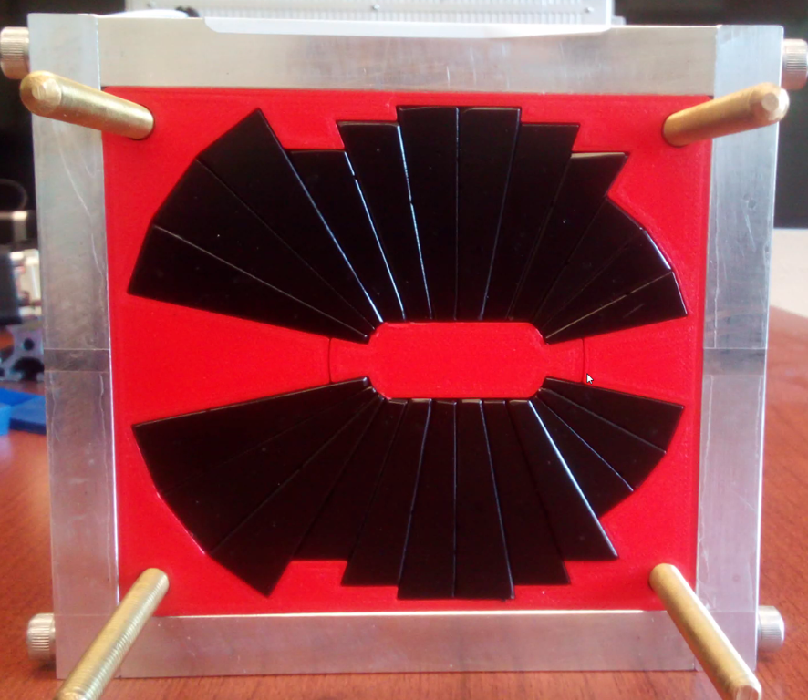
* General discussion on how assemble/stick together/measure, etc…

|  |  |  |
| --- | --- | --- |
|  | Person responsible | Deadline |
|  |  |  |
|  |  |  |

## Special notes

Pathway to Repository: <https://jeffersonlab-my.sharepoint.com/:f:/g/personal/tristan_jlab_org/EqZ5MeS-nipCgPfZB5p0oS4B9Is67d3nQb9sLJI3Zyev9g>