FFA@CEBAF Working Group|Minutes

Meeting date | time 8/19/2022 | 11 AM EST | Meeting location https://jlab-org.zoomgov.com/j/1614898082?pwd=TnUzMS81M2sxbDZIbERJU01tYkJCQT09
Meeting called by Alex B  Type of meeting Weekly Meeting  Facilitator Alex C  Note taker Ryan  Timekeeper Alex B | Attendees  Alex B, Ryan, Kitty, Jay, Scott, Stephen, Alex C, Dejan, Randy, Andrei, Reza, Vasiliy,

Intro Discussion
Alex Coxe will provide notes while Ryan is speaking. Thanks!
Alex B and Scott are working out requirements document for splitter design. Dejan’s group have concluded that all beams in one place, then start going ahead. Stephen has TOF corrections fall into place pretty well with arcs – very close for TOF correction.
Alex B will put requirements into the documents folder.

Agenda topics

Time allotted | 25 mins | Agenda topic SW Spreader Redesign | Presenter Ryan
- Spreader currently 46m
- SW same idea as NE spreader
- FFA lines together, drop back down after the bcom/septum magnets
- Total range of septum 26cm
- 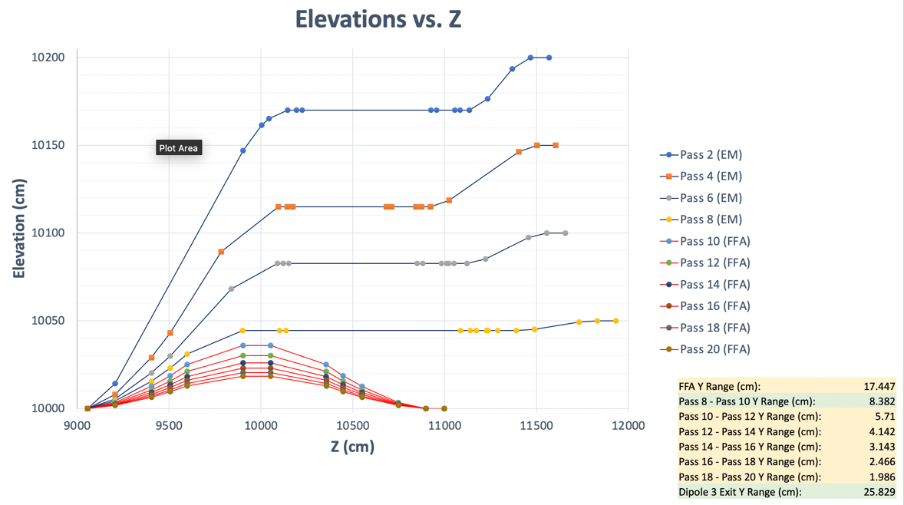
- Fixed lack of space between bcom/septum to get spacing +height correct
- Required really strong quads to close disp.
- Jay we’ll need new stands, so we should have extra vert. room
  - Dejan confirms architecture
- Current EM magnets can all handle the load increase
- Alex B confirms that spreader/splitter magnets are EM, checks that septa can handle all 6 FFA beamlines
- 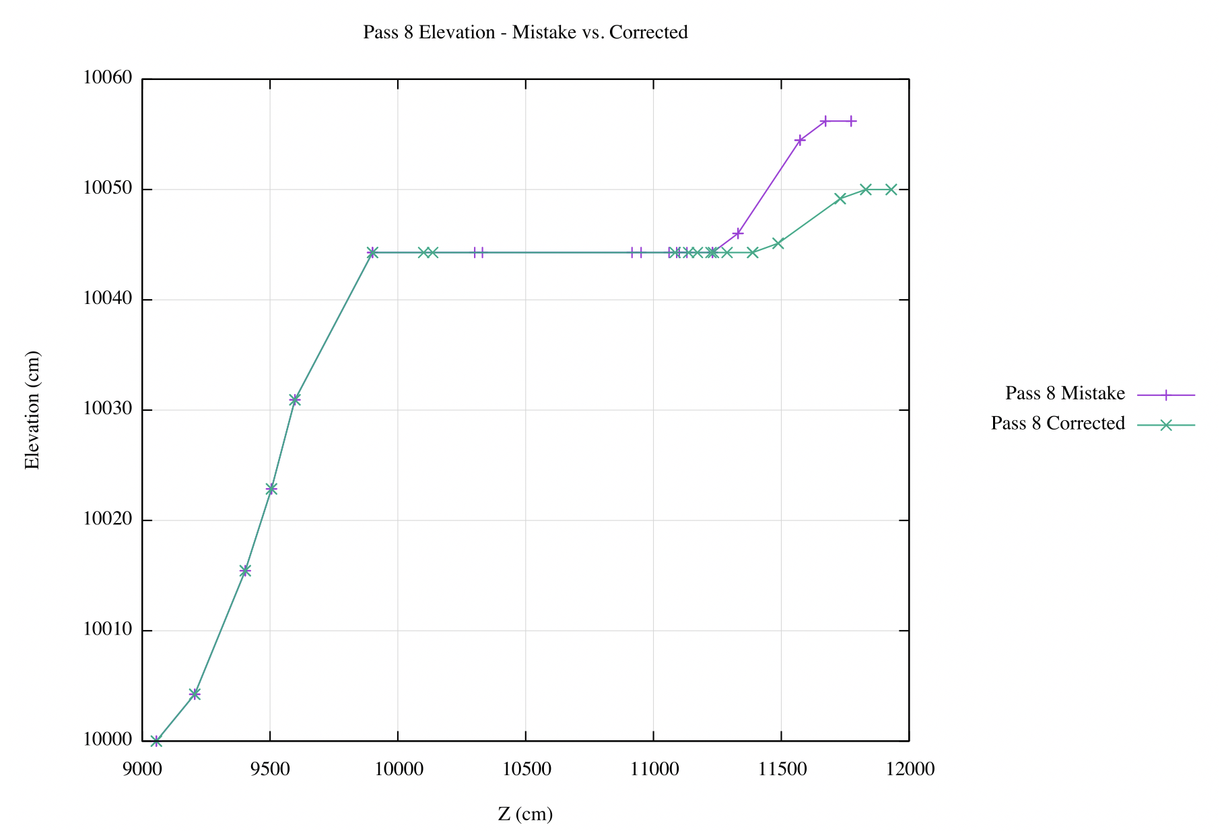
- Alex B asks about optics that go with the strong quads
  - They are difficult
  - Raised arcs fix the problem
  - Should fit, but TBD
- Scott asks about Twiss functions in spreaders.
  - Shown via OptiM plots
  - 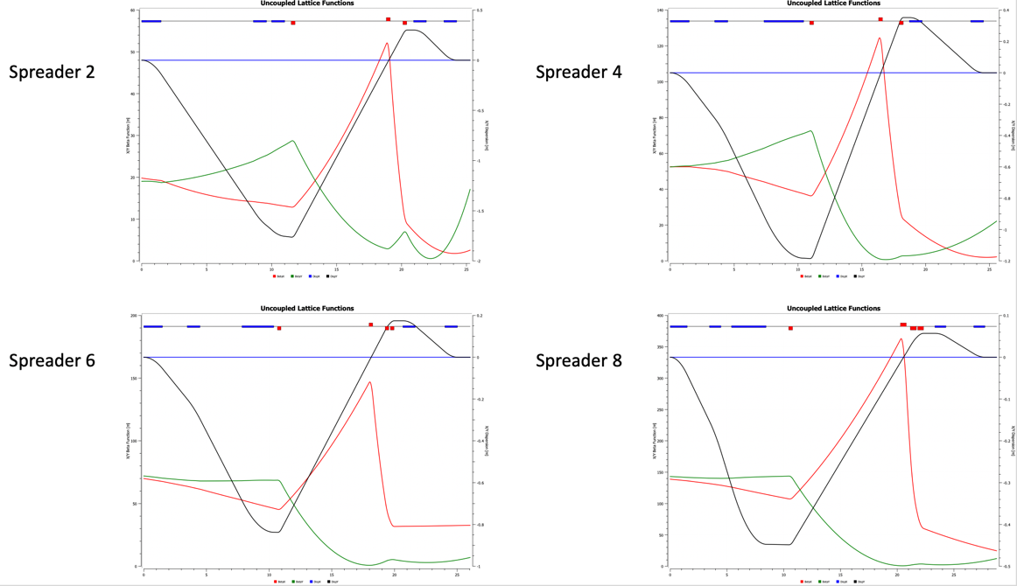
  - 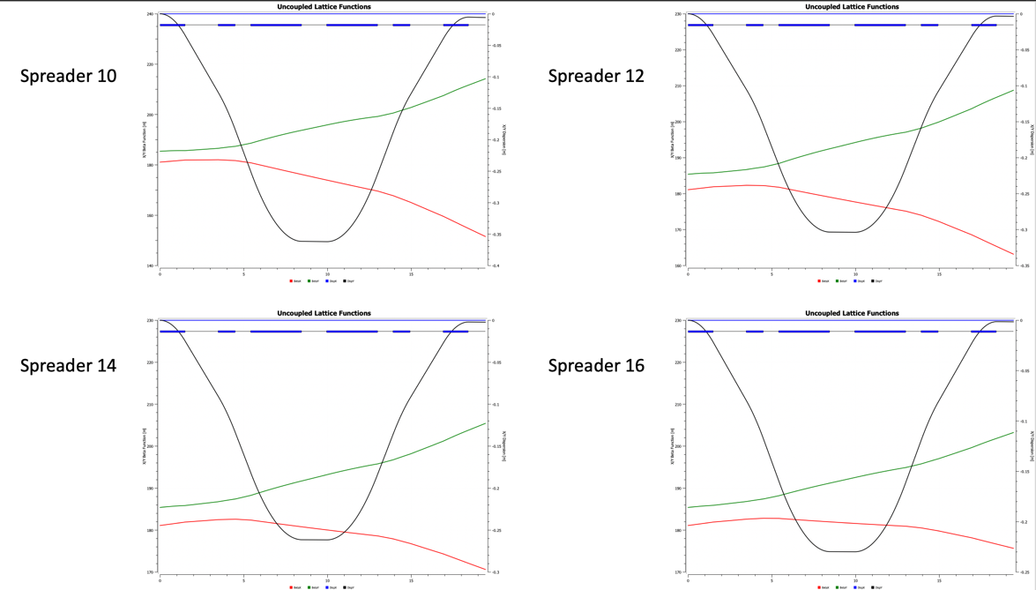
  - 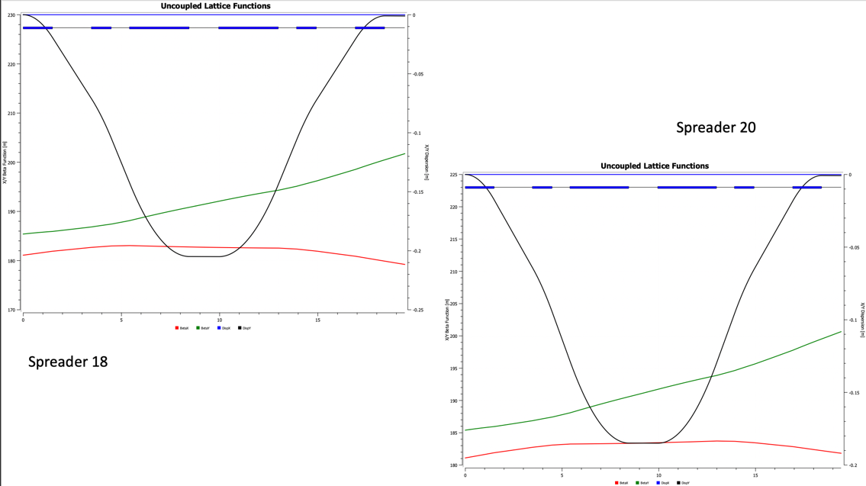

- Could put a quad after long drift to affect dispersion
  - Probably interferes with septum (Jay)
    - Ryan was worried about this and will move it
  - Magnetic shield extends 500 cm, space is pretty tight
    - Have to go 550cm from the exit of the first septum to fit anything
- Things are a lot easier with the additional headroom
  - Cooling apparatus & superconductor will require about 90cm+150cm+90cm
  - Jay supports moving up the last EM arc
- FFA spreader/splitter really is mirror image magnets
- A rounding error or something is a problem (per Alex B)
  - 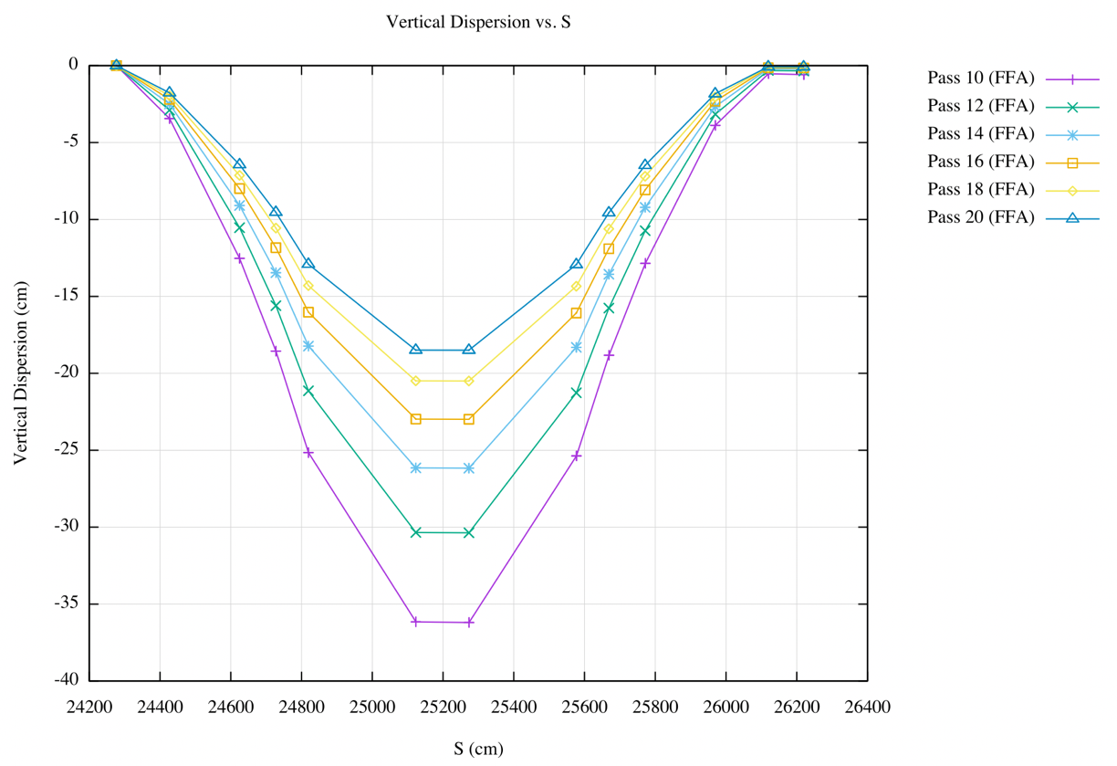
  - Ryan agrees, can’t find where, but thinks it’s from copy/paste from spreadsheet
  - Scott says the dispersion won’t be a problem if the magnets are mirror symmetric
    - They are, except possibly the edge fields and/or rounding.
- Need to correct betas going into the splitter
  - They grow too much: not wildly, but enough to justify correction
- Need to fine tune and iterate
- Dejan’s design:
  - 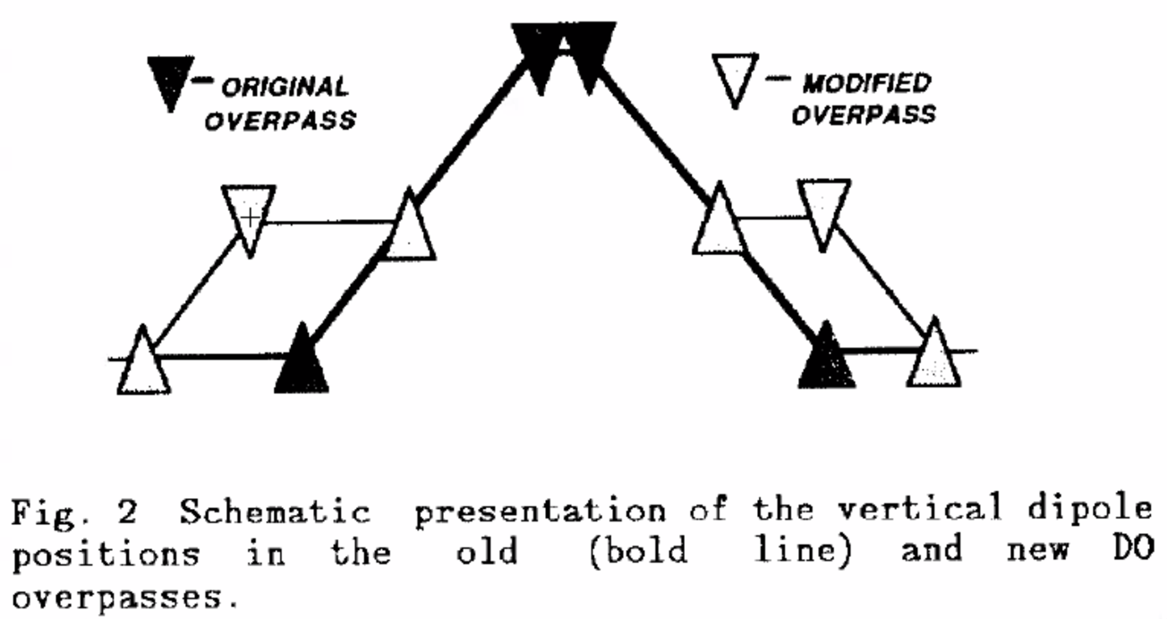
  - 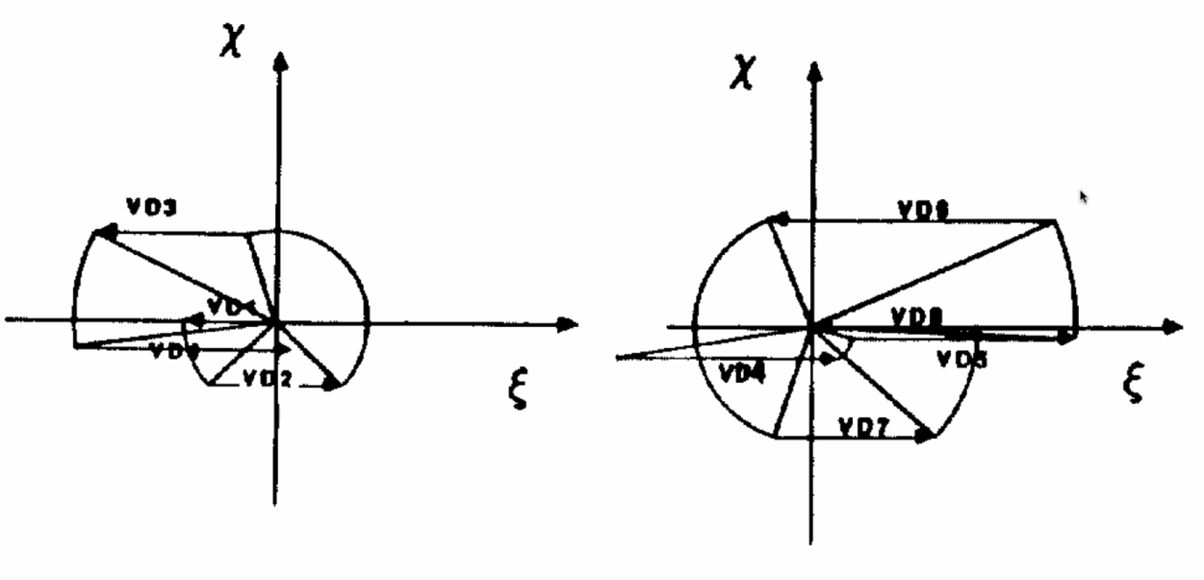
    - Scott: Creating phase advance hard b/c large beta functions
      - Quads strong at end b/c of this.
  - More useful for splitter
- Septa are horrible – will need SR in simulations, and to take into account multipole terms.
Action items | Person responsible | Deadline

Time allotted | 25 mins | Agenda topic Septum Magnets | Presenter Jay
- 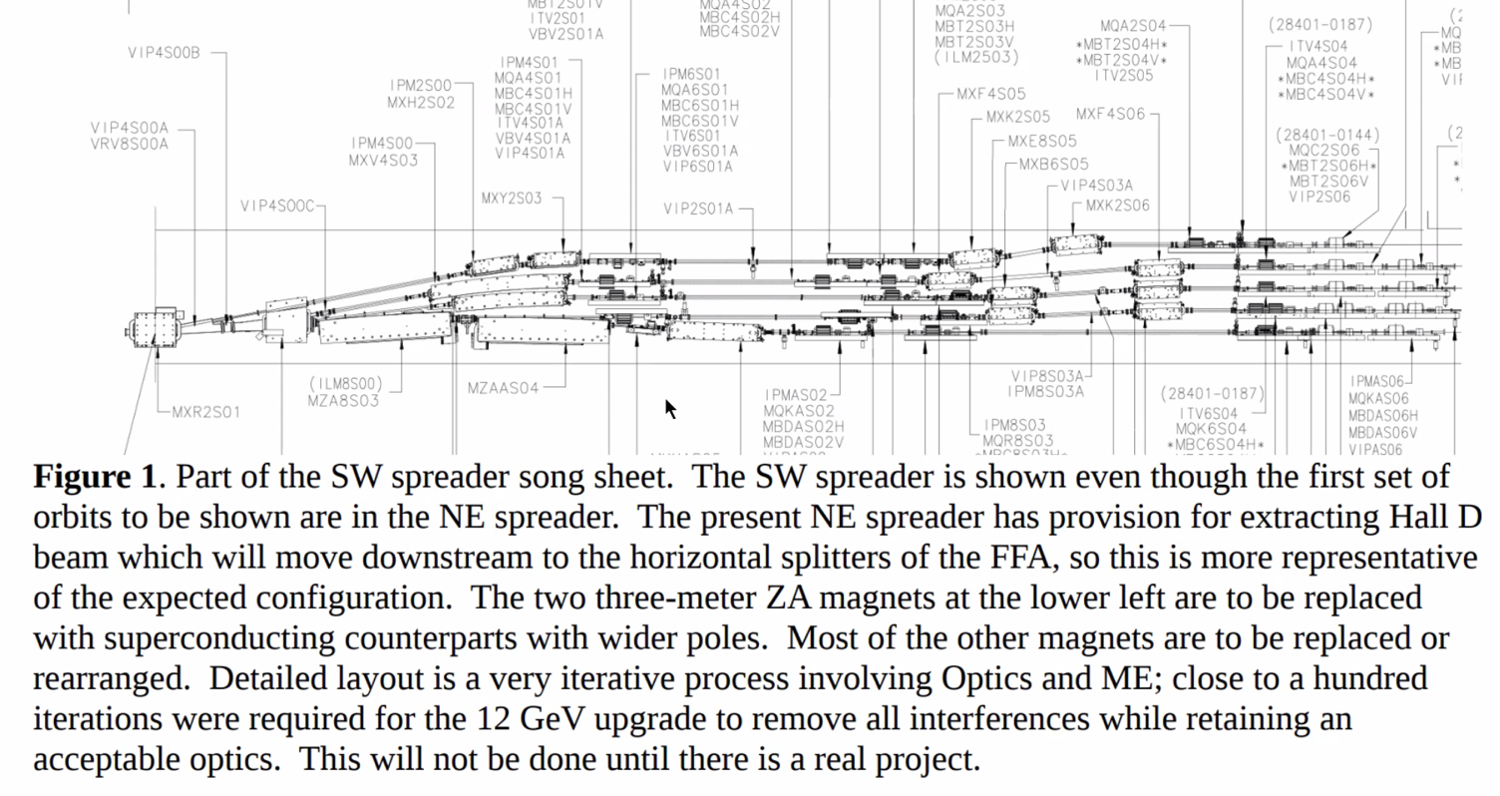
  - BCOMs bigger, septum moved downstream
  - All beampipes carbon steel to shield stray fields
  - 4th pass goes over second septum.
  - Currently an inverted quad
- In the model:
  - 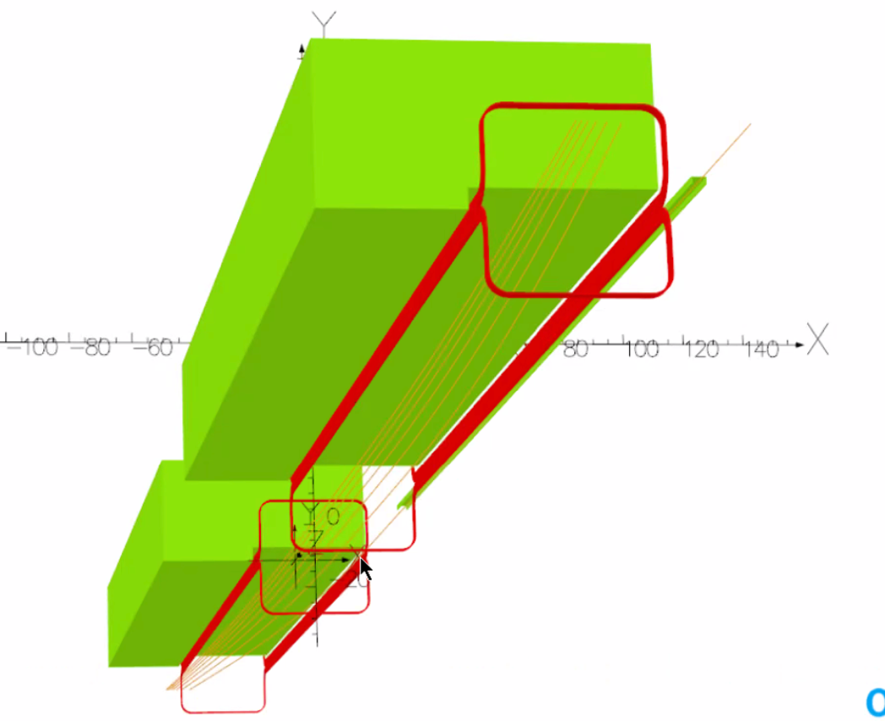
  - Need to shift it a little further
- Fields:
  - 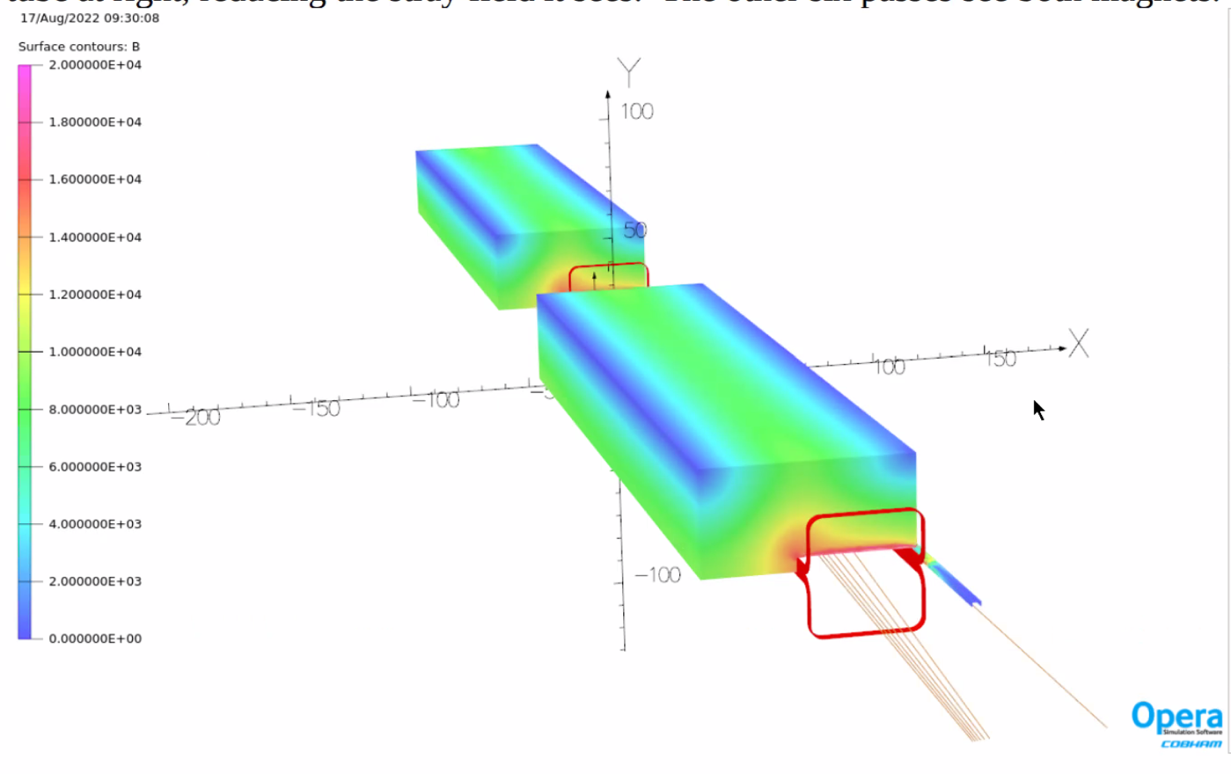
  - Flip this in your head – looks like horizontal bend, but ours will be vertical.
- 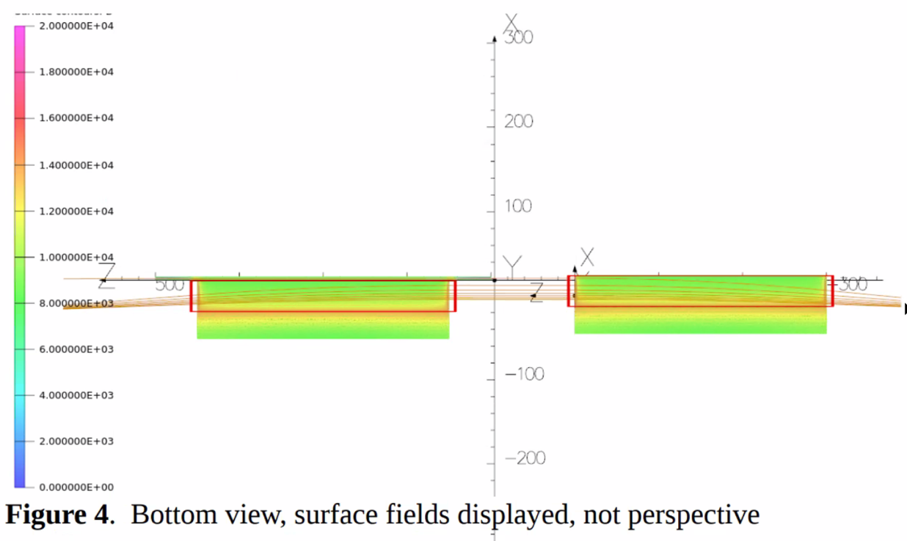
  - Beam coming from right, exits left.
- 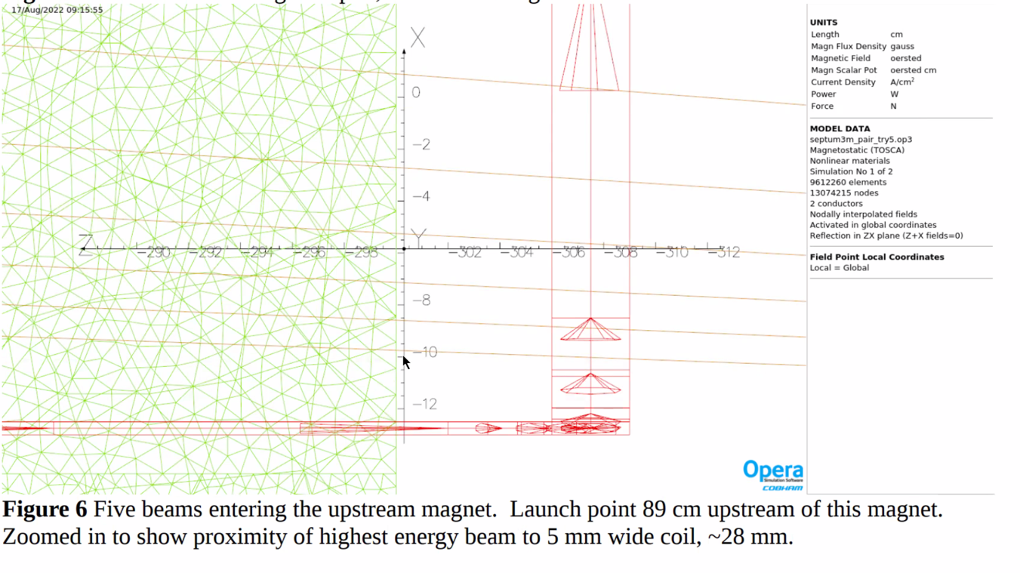
  - Beam enters on the right
  - 28 mm clearance
  - Assume 15 mm needed for cryostat
  - ~1 cm clearance between centroid and cryostat
- 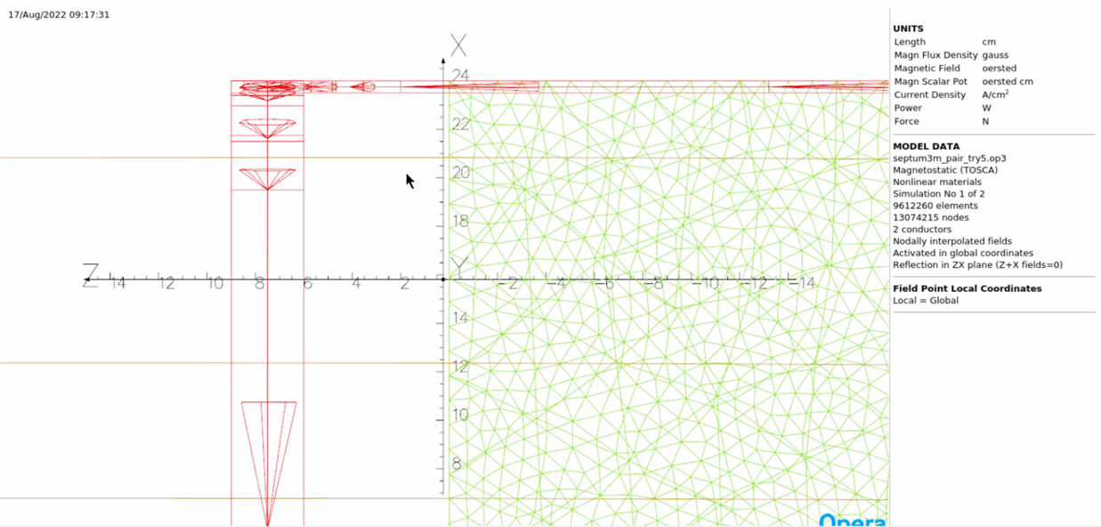
  - Exit
- 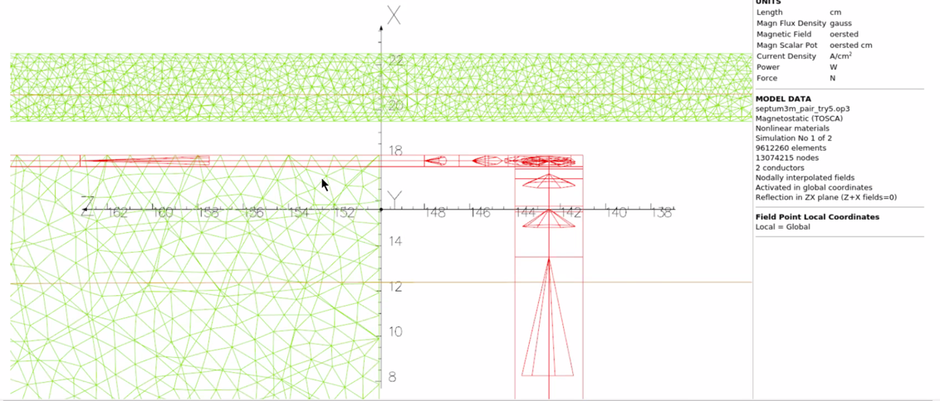
  - Entrance into second magnet
  - ~40 mm
- 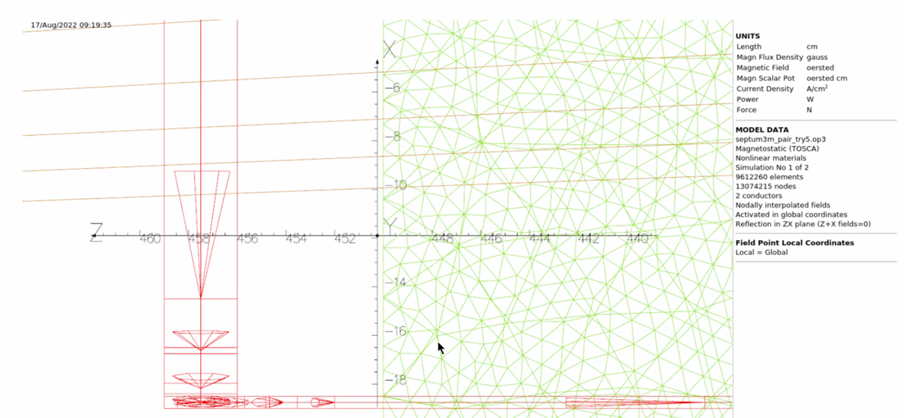
  - Plenty of clearance on 2nd dipole
- 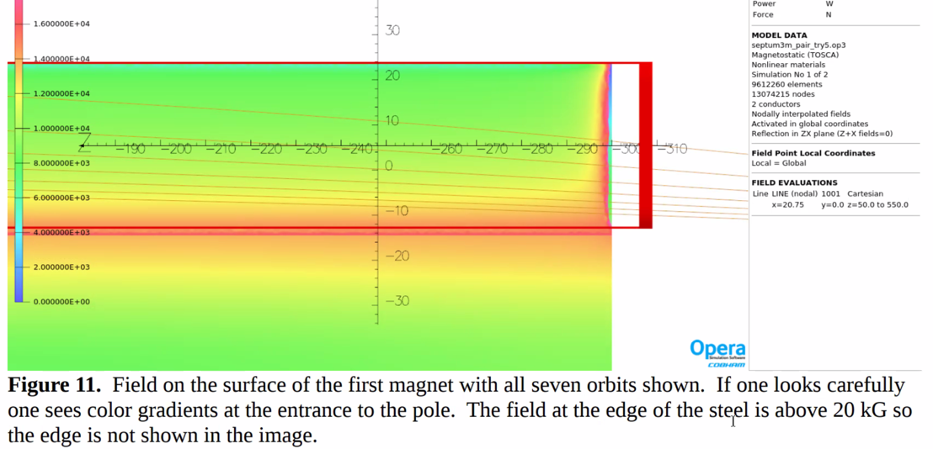
- Southwest Spreader
  - 3.5 more field
  - Would like to get rid of highest E beam.
  - More clearance within magnet than to recirculating beam
- Can shift things for clearances
- 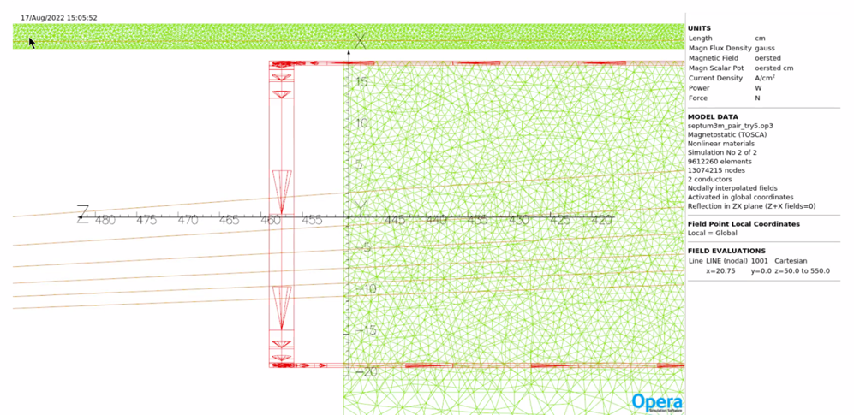
  - Exit
- 1.4 kG over most of distance – needs to shield beams
- Harmonics:
  - 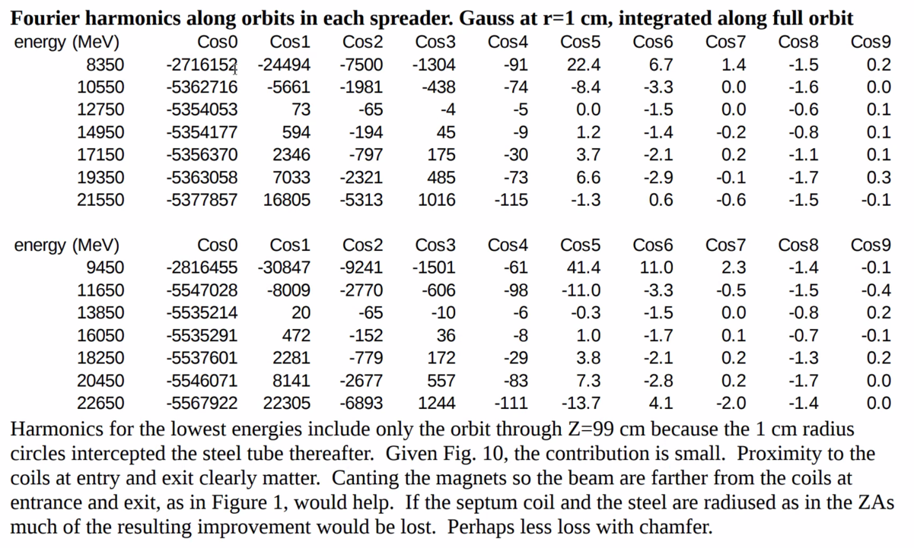
  - Lots of harmonic content
- For SW spreader, quad term is closer to conductor and over 1%
- 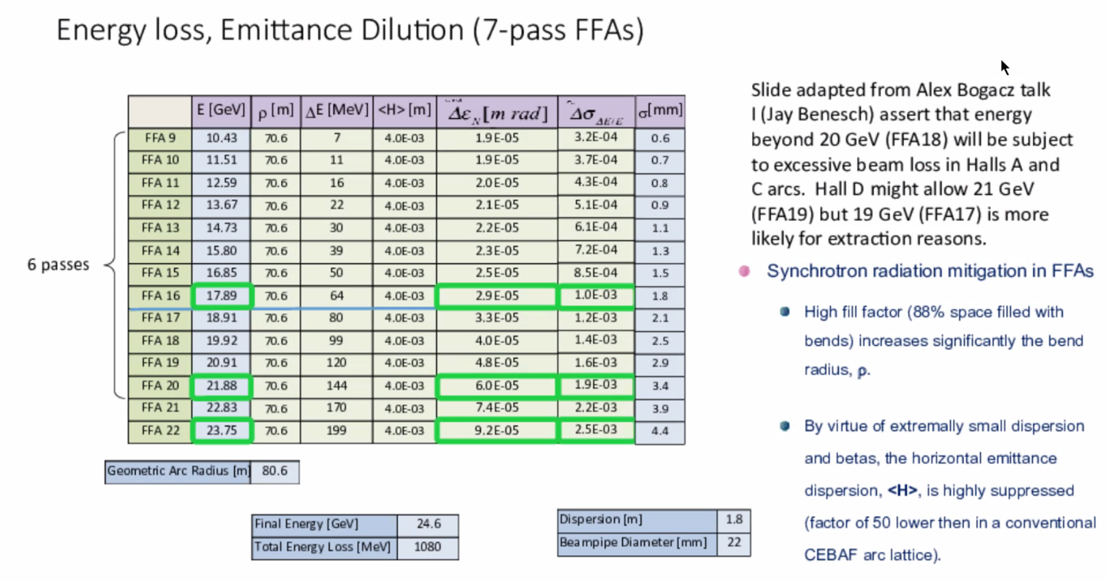
  - Presented at last high-E workshops
  - Should stop at A/B/C at 20 GeV
  - No plans at Hall D with more than 200 nm – only ~7 sigma with perfect steering, can probably get 5.5 passes in NL as we do now
  - Assertion: stop there. Don’t include last 3 half-passes.
  - Physically, because of hall line dispersion, that’s as high as we can get.
  - 5.5 passes in W arc so have half pass to Hall D (21 GeV)
    - Alex: if that’s the experiments want
    - Jay: they can live with it
  - 8 sigma – going to lose 10^-4 beam with perfect steering and no halo.
- Dejan: what cryostat?
  - 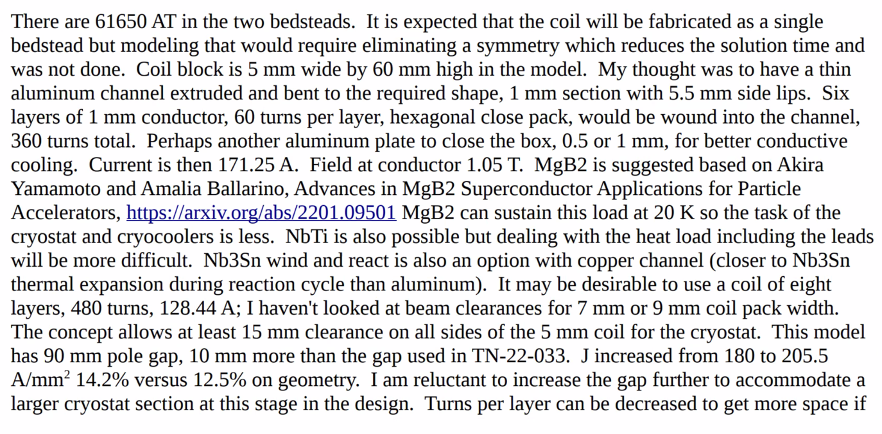
  - Our current setup is at the limits of what we can cool – can’t get 212 A/cm^2 with water
  - 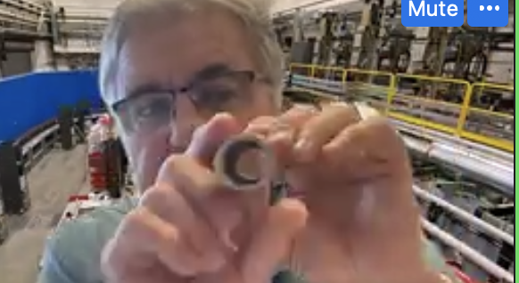
    - Diameter is 3 cm
    - If we can use SC magnets instead, can this be smaller?
    - Cosine-theta SC magnet
- Started looking at Mg-diboride
  - Niobium-Ti
  - Nb Tin wind and react might be best way to go given that one needs to keep it isolated from room temp, and we don’t have capacity in linac L-He refrigeration to extend lines 20 m to this location.
    - Just don’t have the 2K capacity.
    - 100 m + from 4K
- Real estate and existing He refrigeration, need conductive cooling.
  - No way to put in enough copper.
- Existing ZA – coil ~1” wide.
- Need conductively cooled SC – either 4K coolers, or same cryocoolers with 4-5 W of lift at 10-20 K.
- Field at conductor is only 1.1 T – not the issue
- Issue is that it’s conductively cooled and no room between beams
  - Need to worry about halo heating
  - No He gas to use as beam screen like at LHC
- No decent thermal analysis yet
  - Built one years ago
  - Know roughly how much space

Action items | Person responsible | Deadline

Time allotted | 10 mins | Agenda topic AOB | Presenter All
- Nothing extra this week.
 | Person responsible | Deadline

Special notes

Pathway to Repository: https://jeffersonlab-my.sharepoint.com/:f:/g/personal/tristan_jlab_org/EqZ5MeS-nipCgPfZB5p0oS4B9Is67d3nQb9sLJI3Zyev9g

