FFA@CEBAF Working Group|Minutes

## Meeting date | time 8/26/2022 | 11 AM EST | Meeting location <https://jlab-org.zoomgov.com/j/1614898082?pwd=TnUzMS81M2sxbDZIbERJU01tYkJCQT09>

|  |  |  |  |  |  |  |  |  |  |  |  |
| --- | --- | --- | --- | --- | --- | --- | --- | --- | --- | --- | --- |
| |  |  | | --- | --- | | Meeting called by | Alex B | | Type of meeting | Weekly Meeting | | Facilitator | Alex C | | Note taker | Ryan | | Timekeeper | Alex B | | Attendees  Alex B, Ryan, Jay, Vasiliy, Kitty, Kirsten, Alex C, Andrei, Stephen, Dejan, |

# Intro Discussion

JLab all staff scientist meeting this afternoon. Later, 3 town meetings all about our upgrade. NSAC got the charge to do this in July. User’s meeting on Sept 8th.

# Agenda topics

## Time allotted | 25 mins | Agenda topic Panofsky Correctors | Presenter Jay

* 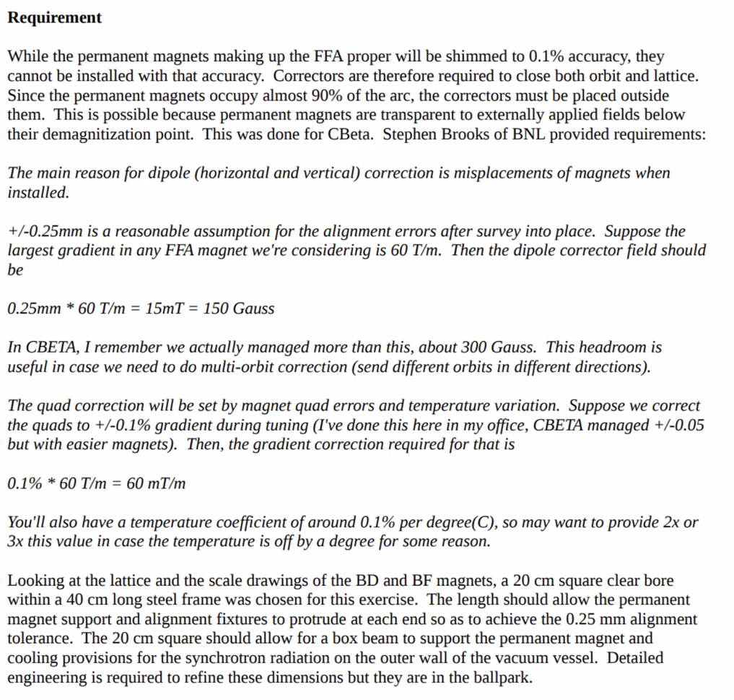
  + Italics is from Stephen
    - Based on gradients and alignment errors, need ~150 Gauss for dipoles (both planes)
    - Used all headroom in CBETA
    - Would want 2-3 x 60 mT/m
  + Magnet is pretty much “all ends”
  + Since permanent mags are longer, we need a provision for aligning permanent magnets
    - Assuming happens at each end
    - 20 cm square (b/c quad)
    - Allows support and alignment
      * May be +/- in size a little
* 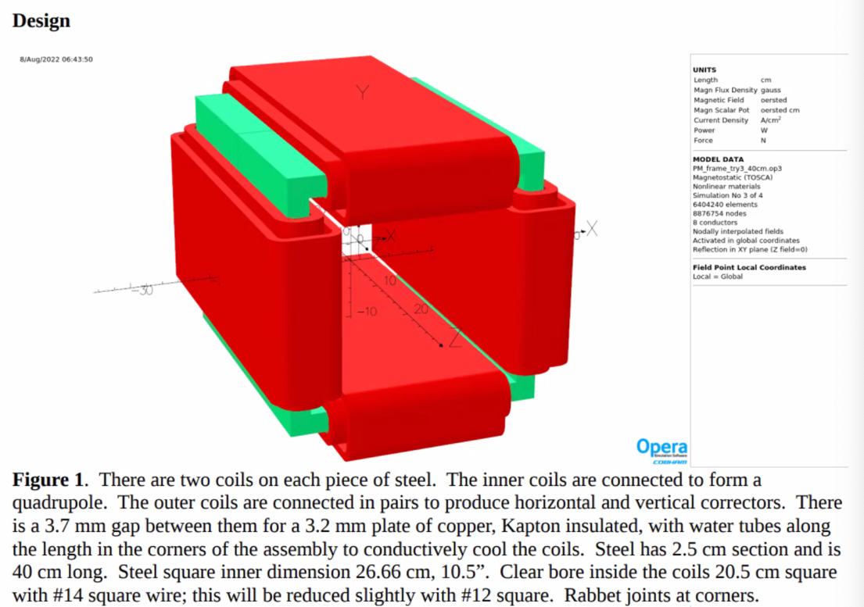
  + Could get a 250 W or more from quad, close to 500 W from each dipole coil
  + Getting to point where you want some cooling (even if conductive)
  + Need larger conductor
* 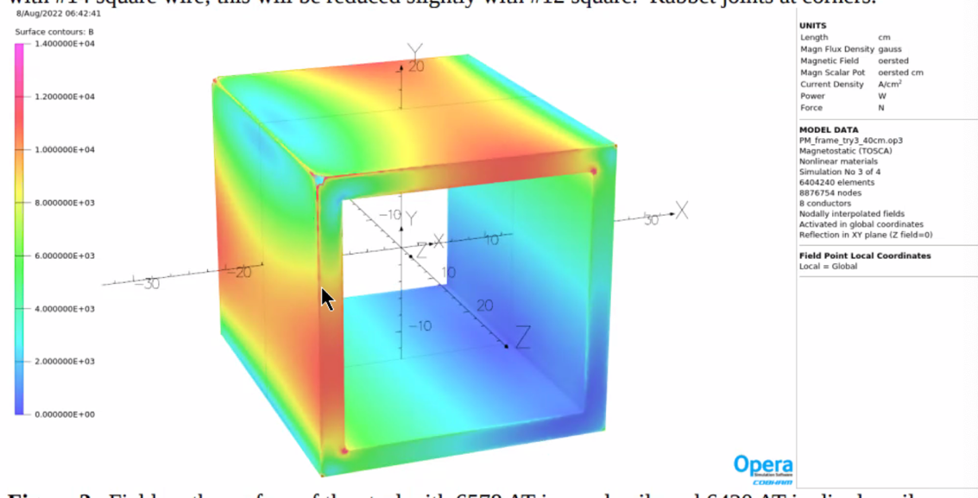
  + 14 kG at steel at max excitation
    - Reducing steel thickness isn’t an option
  + Chose 1 inch b/c we have it sitting in boneyard, so we could prototype
* 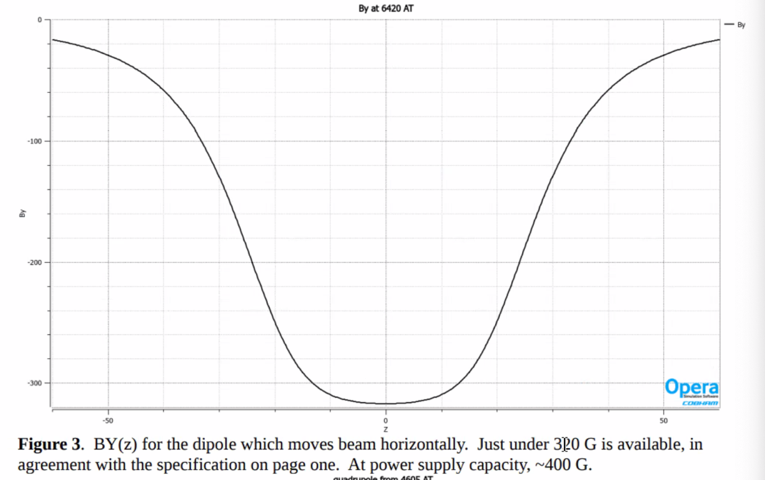
  + All ends
  + Can get up to 400 Gauss with this
* 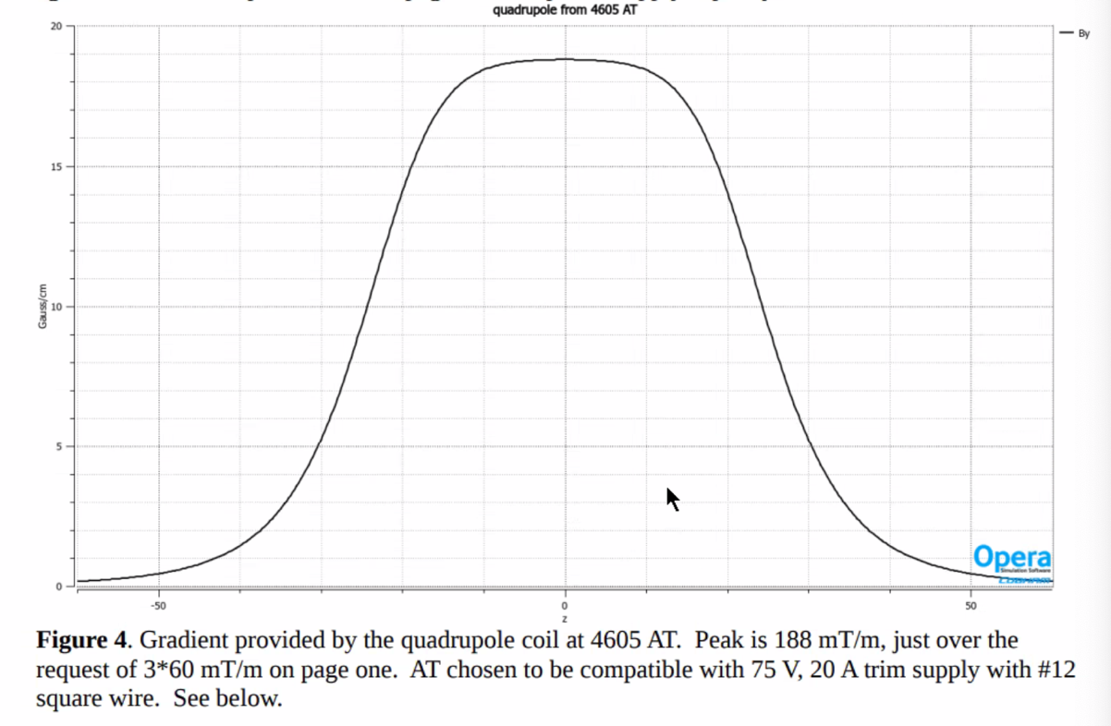
* 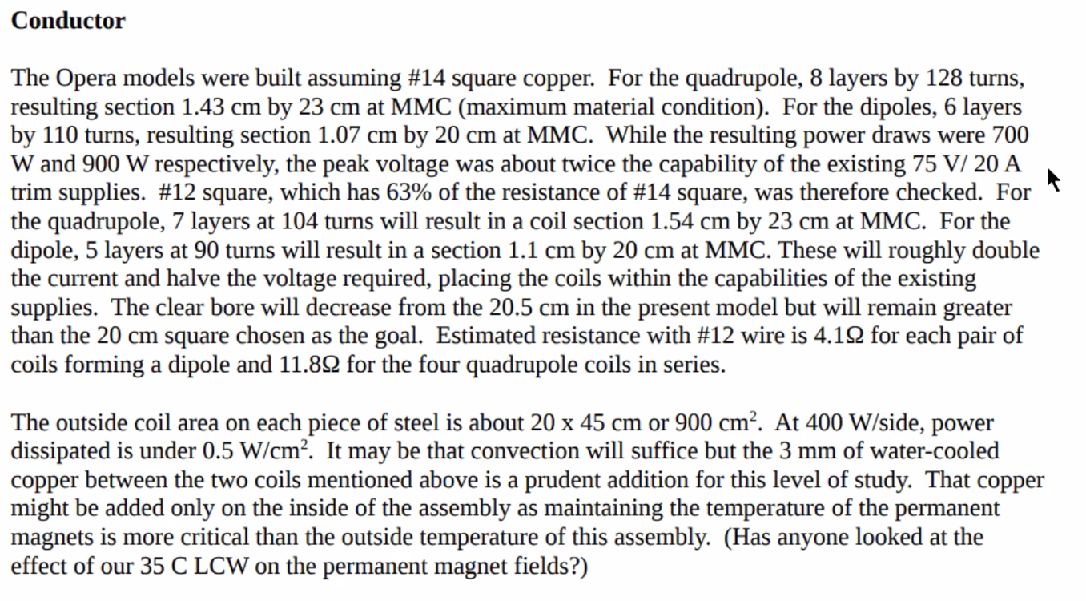
  + Can maybe do air-cooling, but there’s a gap there, so we can fit 1/8th inch copper for pipes with conductive cooling
  + 35C is the water temp for cooling – impact?
    - Dejan: yes, maybe.
    - Stephen: CBETA was about the same – might make the magnet a percent or so weaker.
      * Have some channels in the framing of the permanent magnets themselves as well as the cooling outside
    - Stephen: might be smart to get a chill plate separately and clamp it on.
* Space left for water cooling on inside and outside in the 1/8th inch gap (corners of box)
  + Can also do it adjacent to aluminum block
* 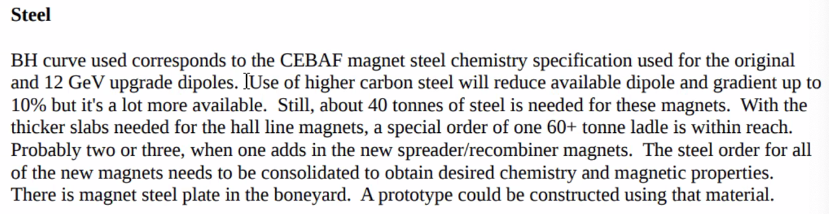
  + A ladle is 60-100 tons depending on vendor
  + Should be able to buy the chemistry we need, but should do it all at once to make sure we get BH curve needed for the magnets.
* Stephen: length? Roughly equal to length of permanent magnets, maybe a little shorter.
  + Chose 40 cm – typical alignment blocks are 4” squares
  + Assumed 60 cm permanent magnets
  + Depends on lattice – as long as *most* of the length has the corrector on it should be ok
  + If you make it longer, you just get the additional strength
  + Cooling needed if make it longer?
* Dejan: This is much higher energy
  + Very nice job – exactly like BNL lab did
  + Jay: just wanted something basic so engineers on costing had an idea
* If they’re a meter long, get 2.5 x integral shown
* You don’t want to go thinner in the steel – this is pushing the quads and 1 dipole at max (why it’s on two sides).
* Depends on how well we can align magnets and the overall quality.
* If it ends up only 1 T, you’re in linear regime and no issue
* Stephen: looks a lot like CBETA, and always want more headroom rather than less
* Alex C: Part of the MC correction scheme includes an optimal position parameter
  + Don’t know how long they’ll have to be – please keep me apprised, since my code accounts for where
  + Jay took 10 cm off each side of full magnet length thinking about alignment
    - Rounded assuming 60 cm dipole.
    - Made this 40 cm with steel, but more like 50 cm with coils
    - Subtract 15 cm from each end of each permanent magnet, and they’re in the middle
      * And *MUST* be in the middle
* Alex B: one corrector for each permanent magnet is assumed
  + Will depend on the number of cells to know total number
* At least make sure buildings have enough room for power supplies for each of these.

|  |  |  |
| --- | --- | --- |
| Action items | Person responsible | Deadline |
|  |  |  |
|  |  |  |

## Time allotted | 25 mins | Agenda topic Splitter Requirements | Presenter Alex/Scott

* Splitters will be most involved new system. Making requirements document
* 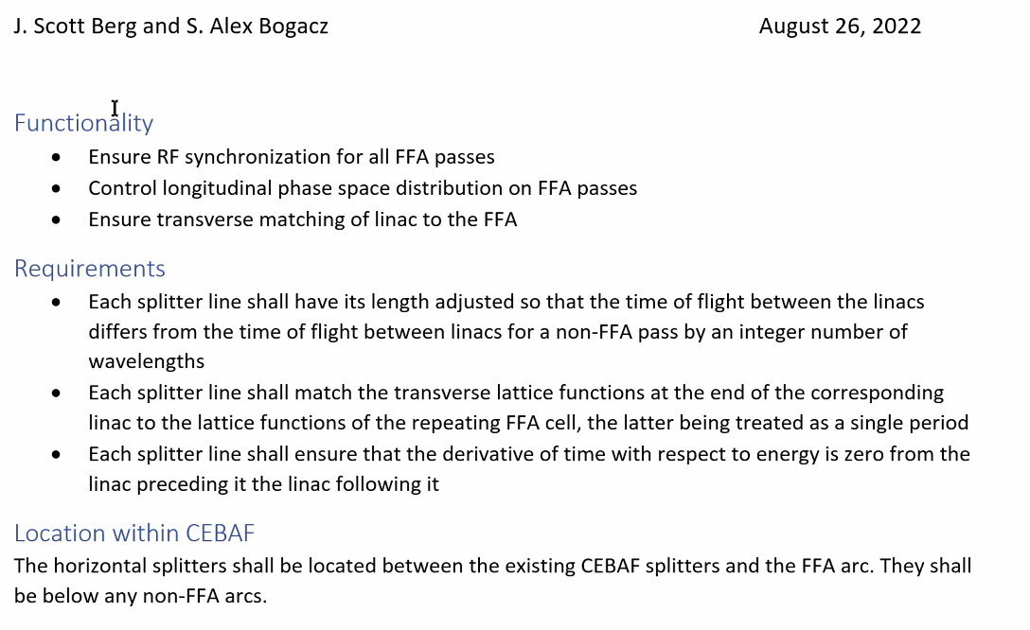
* 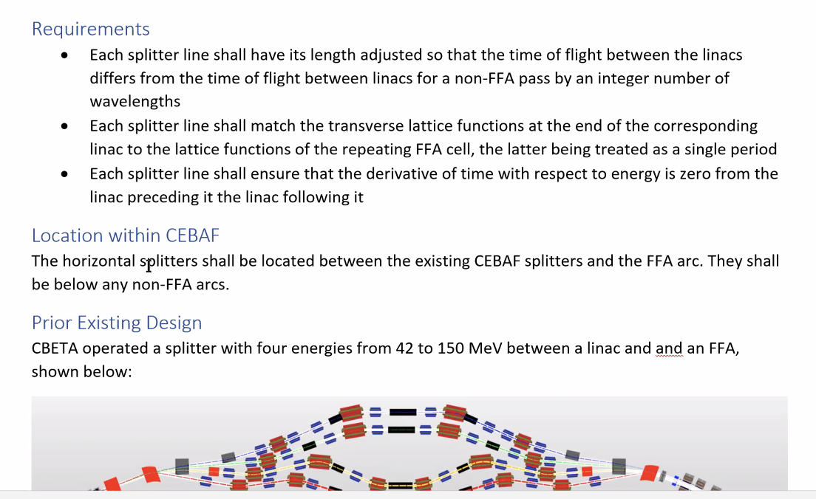
* 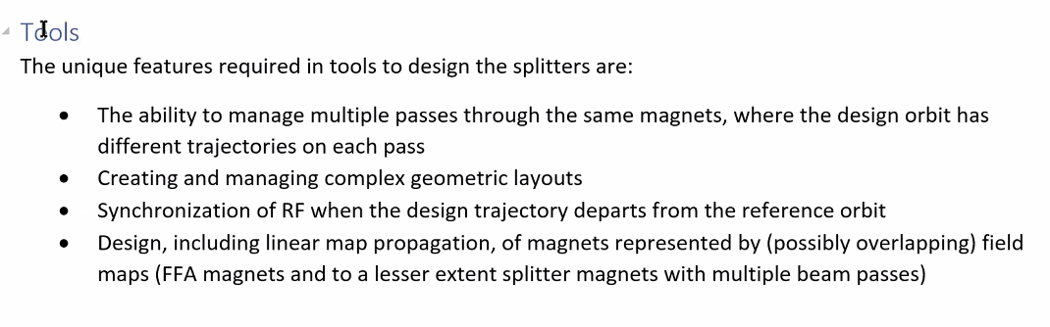
* 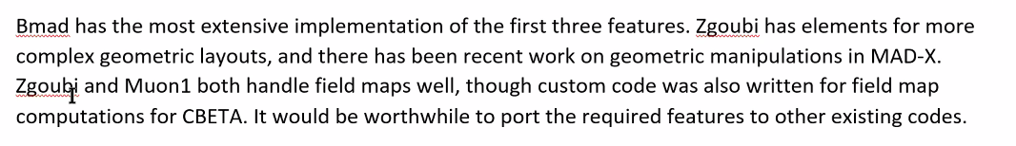
* 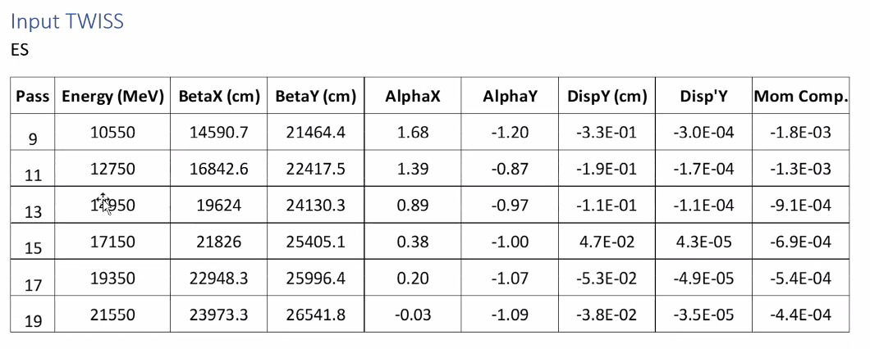
* More coming, and will update as the design is updated.
* Vasiliy – can you provide what we’ll be matching into?
* Dejan – could you please share the required path length and M56?
* Draft will be posted in presentations folder.
* TOF splitters give a lot of flexibility – at top E when exiting, we can independently correct path length and put in some momentum compaction
  + This may help address some of Jay’s concerns.
  + At 6-sigma, troublesome
  + We can do the same thing we do at CEBAF, and do longitudinal compression, trading bunch length for momentum spread
    - Rotate by quarter wave and help momentum spread.
    - Jay: Has to apply to EM passes as well
      * Alex: it’s mostly created by last two passes
      * Must be fully compatible with parity experiments as well
* We could add change log
* Numbers will be added/updated as we go
* We can add in dimensional limitations (longitudinal and transverse)

|  |  |  |
| --- | --- | --- |
| Action items | Person responsible | Deadline |
|  |  |  |
|  |  |  |

## Time allotted | 10 mins | Agenda topic AOB | Presenter All

* 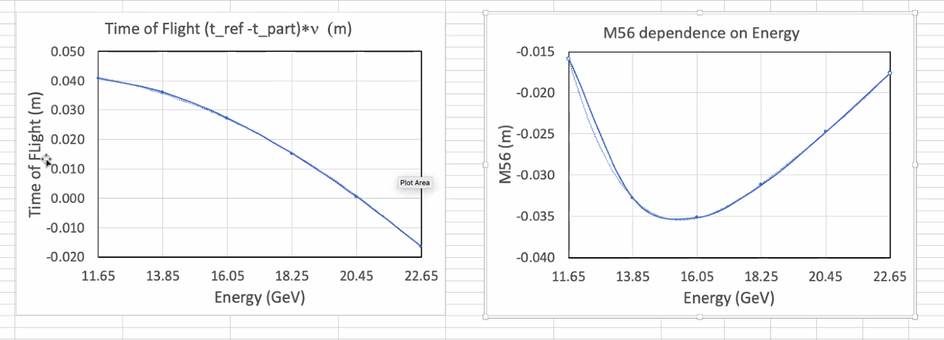
  + In meters, for 98 cells in one arc
  + TOF is usually t_part – t_ref, so this looks opposite than normal
  + Already TOF in first section was of this order from vertical spreaders
  + Spreaders give small negative M56 component
* Dejan will update and refine
* Andrei/Dejan spoke – good discussion and path toward having this mentioned in the NSAC
  + Getting reviewer comment removed (?)
* Andrei: there are plans – the first meeting is today internally
  + Next week, users meeting
  + JLab participate with town hall meetings arranged within long range plan

|  |  |  |
| --- | --- | --- |
|  | Person responsible | Deadline |
|  |  |  |
|  |  |  |

## Special notes

Pathway to Repository: <https://jeffersonlab-my.sharepoint.com/:f:/g/personal/tristan_jlab_org/EqZ5MeS-nipCgPfZB5p0oS4B9Is67d3nQb9sLJI3Zyev9g>

NO MEETING NEXT WEEK DUE TO LABOR DAY