FFA@CEBAF Working Group|Minutes

Meeting date | time 9/9/2022 | 11 AM EST | Meeting location https://jlab-org.zoomgov.com/j/1614898082?pwd=TnUzMS81M2sxbDZIbERJU01tYkJCQT09
Meeting called by Alex B  Type of meeting Weekly Meeting  Facilitator Alex B  Note taker Ryan, Alex C  Timekeeper Alex B | Attendees  Alex B, Ryan, Jay, Alex C, Stephen, Dejan, Randy, Kitty, Kirsten, Scott, Todd, Vasiliy

Intro Discussion
Thanks to Alex Coxe for taking notes while Ryan is speaking. They are added in below.

Agenda topics

Time allotted | 25 mins | Agenda topic Spreaders > BMAD | Presenter Ryan
- 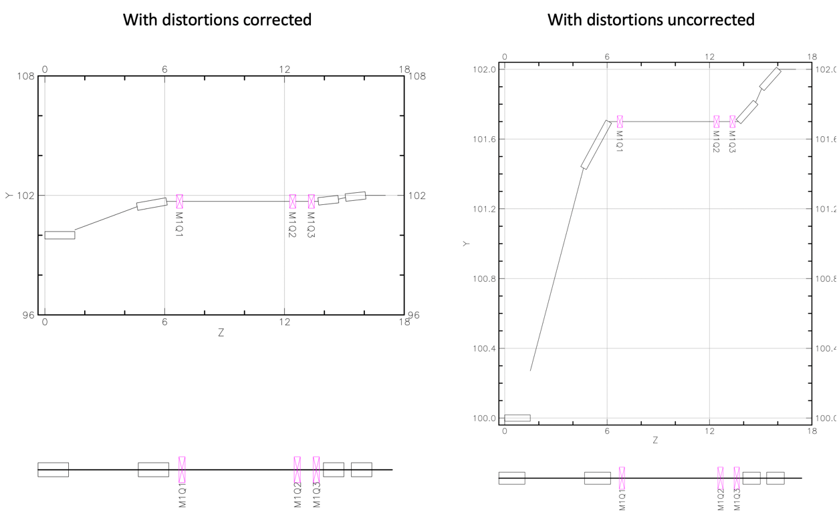
  - Glitches?
  - From patches, and magnet representations not accurate in transverse dimension
- Ryan working with Kelly on 3D model
  - Can it be done in BMAD?
    - Yes, but not 3D
    - Already working with Kelly
      - Some sort of permissions problem
- Design needs to be refined.
  - First pass looks good, optically, comparing BMAD and OptiM:
  - 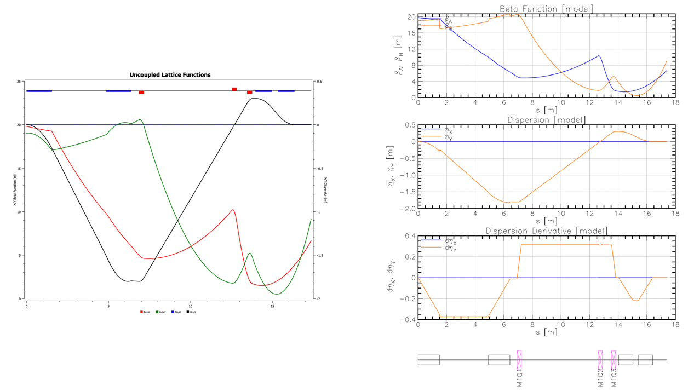
- Used overlay to make calculations more convenient
- Direct conversion from OptiM to BMAD complicated
- Quick backup: we are discussing the 1st pass vertical spreader
- Quick aside from Alex:
  - 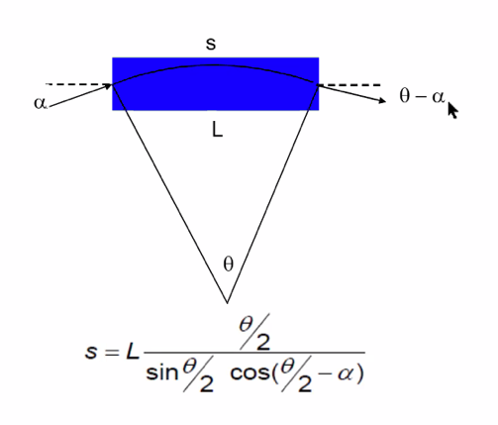
    - OptiM uses path length rather than steel length.
- 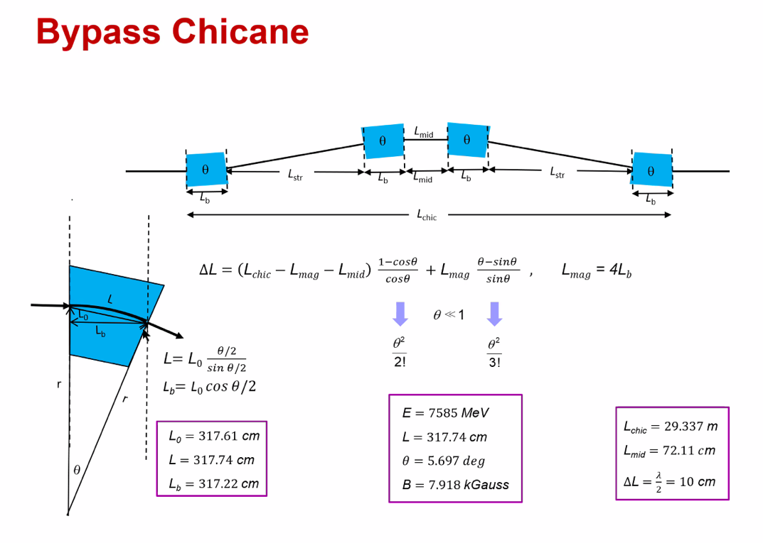
- 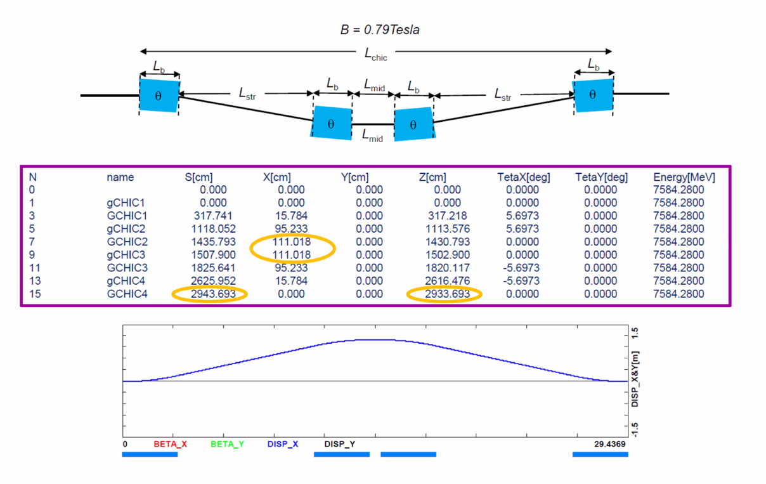
- Scott: key point on doing it in BMAD – for every pass, the magnets are the same magnets. When you do the OptiM files, you have to do calculation for every single pass.
  - This doesn’t happen in BMAD. You just lay them out.
  - All other passes go through common magnet.
  - The code does it right.
  - Now let’s put some fancy ends, or add in field maps, you just do it.
  - Purpose of patches is so that you can align coordinate systems with different patches
    - Snap it back to align with that line
    - Also tells you where the particles exit the magnet, and the angle they are exiting.
- Question about incoming beta – too large?
  - Based on weakly-focusing linac, first pass, so smaller
  - Negative M56?
    - Yes, and positive in arc. Spreader + ARC + Recombiner cancel out M56
    - EM arcs have tunability, so M56 not such a problem.
- Alex B: next steps?
  - Ryan: Keep iterating on Pass 1 with different methods
    - Then go through all EM passes, then FFA passes
    - Finding “right” method
Action items | Person responsible | Deadline

Time allotted | 25 mins | Agenda topic Adiabatic Arcs | Presenter Vasiliy/Randy
- Randy will present
- 650 MeV injector, 1100 MeV/linac
- 4 x EM passes, then 5-6 FFA passes
- Will upload the table to the shared repository
- Values are “wish” values, they’ll be the same as in ARC FODO cells minus dispersion and orbit offset requirements.
  - Can still increase beta functions using Dejan’s scheme
    - Phase advance must stay constant
    - Can probably increase by 2-3x
- Can iterate as needed
Action items | Person responsible | Deadline

Time allotted | 10 mins | Agenda topic AOB | Presenter All
- Stephen:
  - 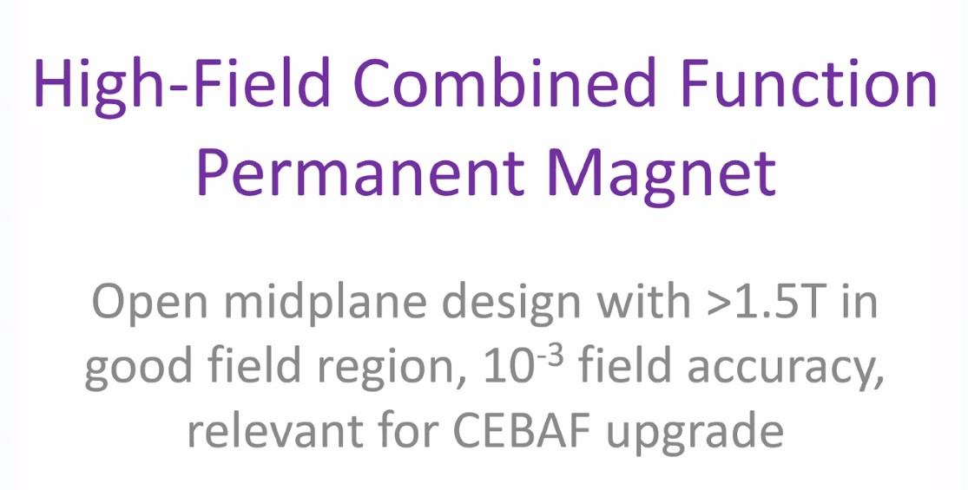
- 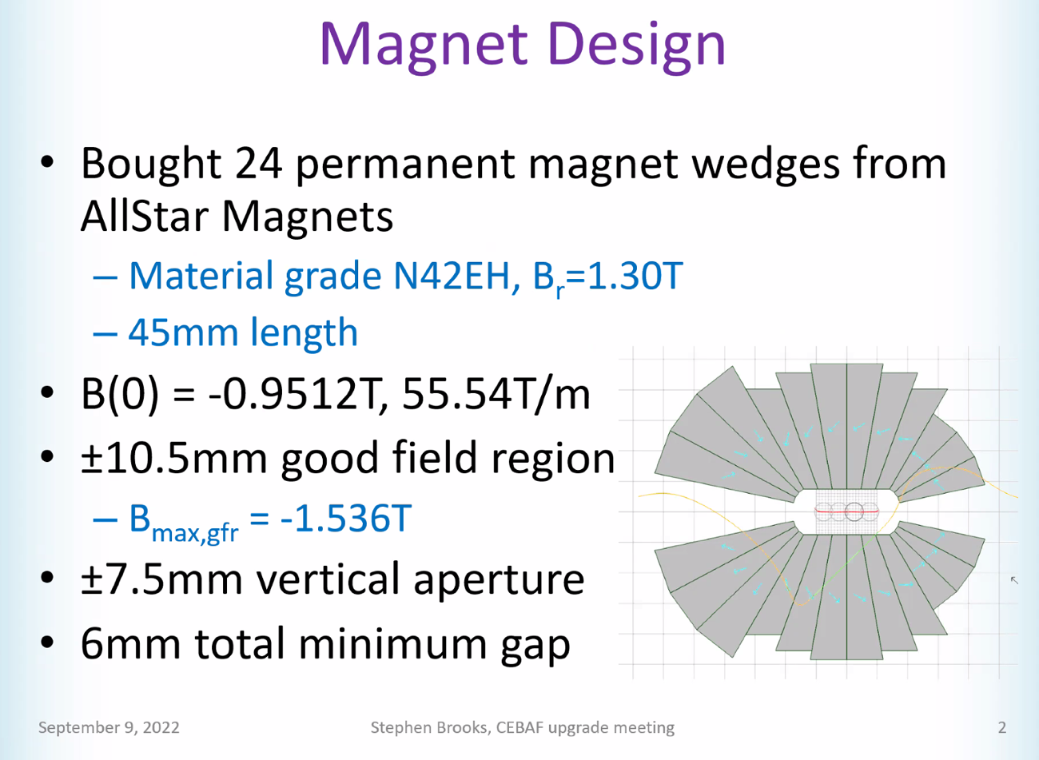
  - Similar to our FFA magnets
  - Aperture is most difficult part to get
  - Can maybe get 8 mm if cut off corners
  - 20 mm vertical aperture was very expensive, so shrank it down for affordability
- 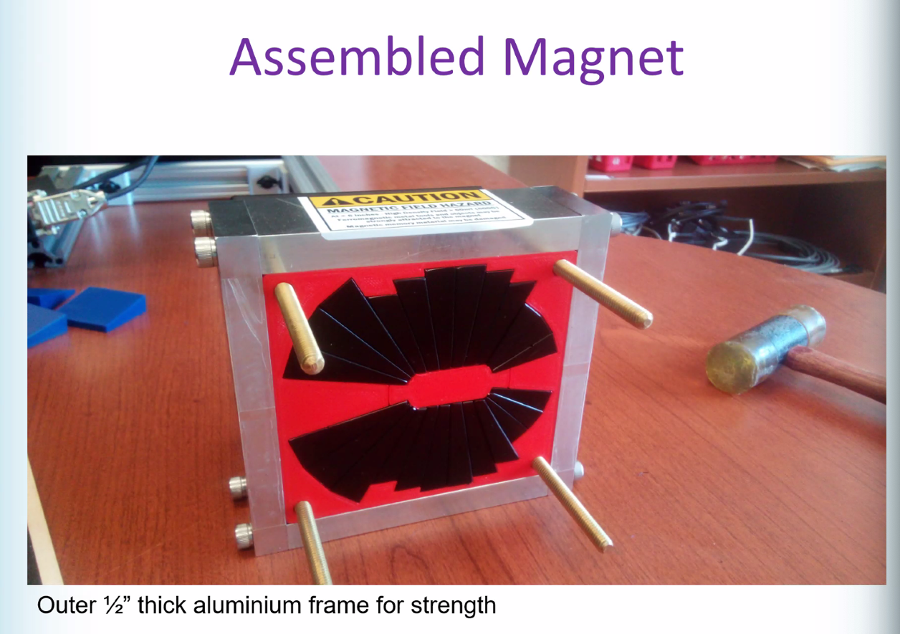
  - This has plastic plug to hold things in place
- 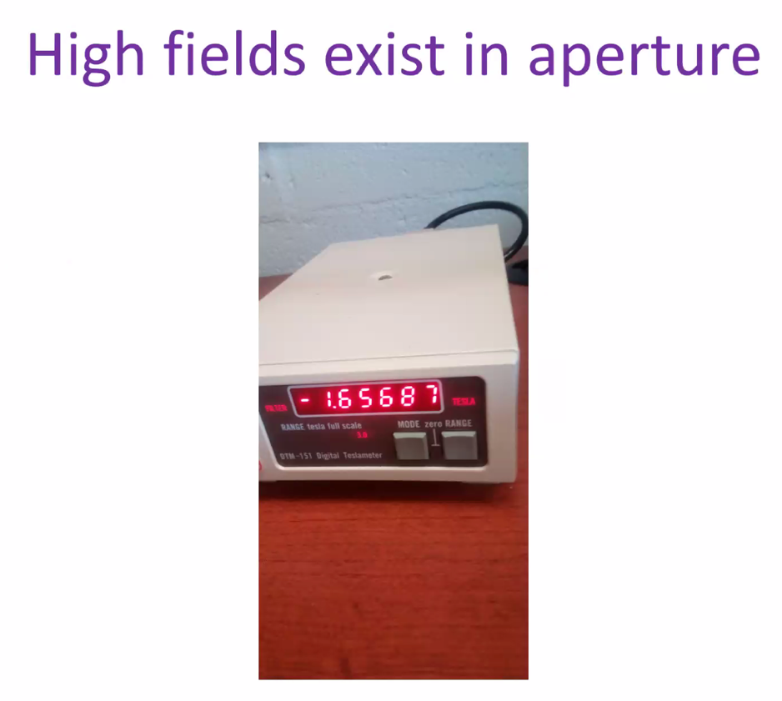
- 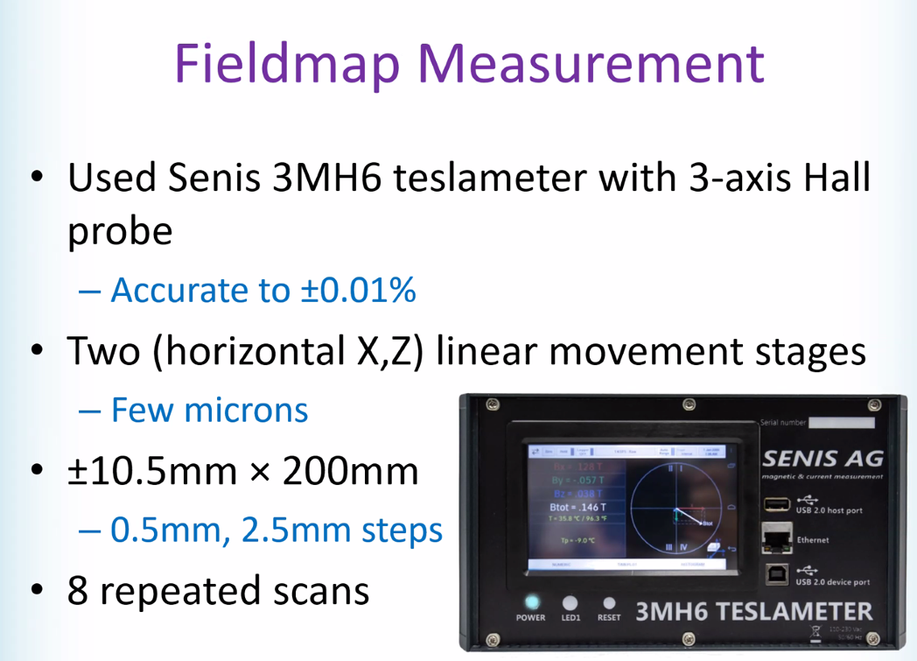
- 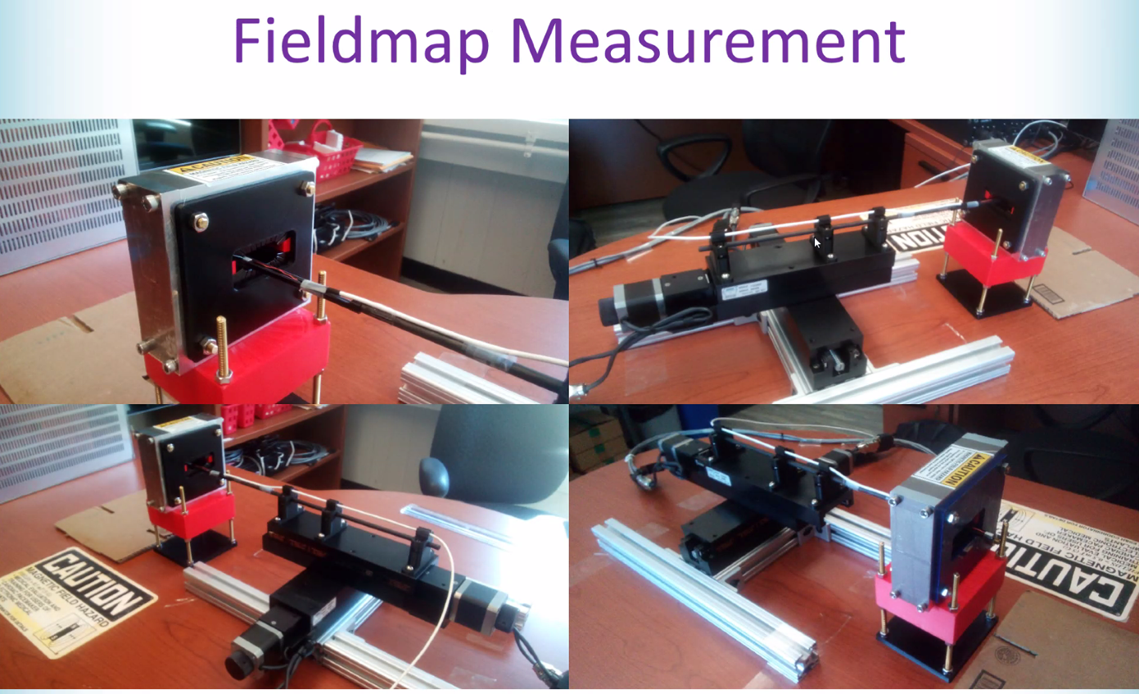
- 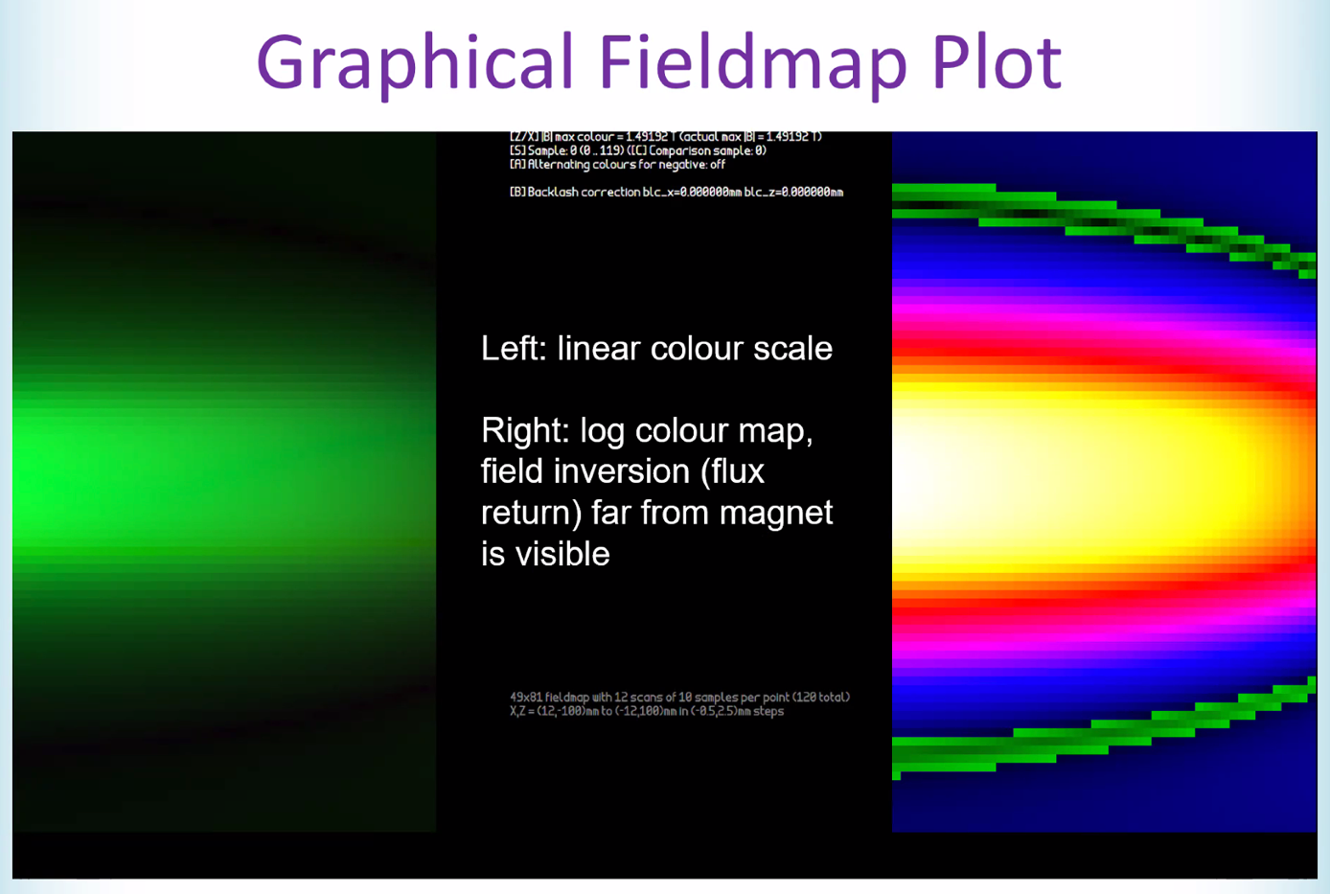
  - Sign change at green part on right (negative sign on some of fringe field)
- 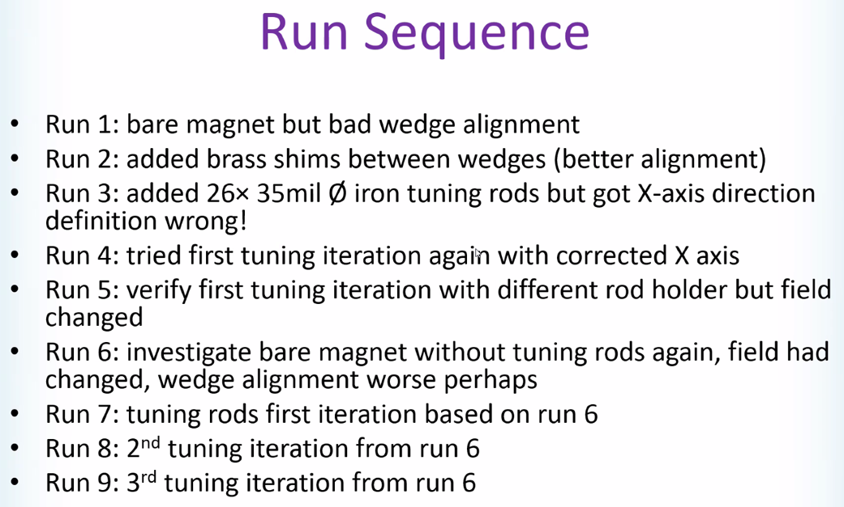
- 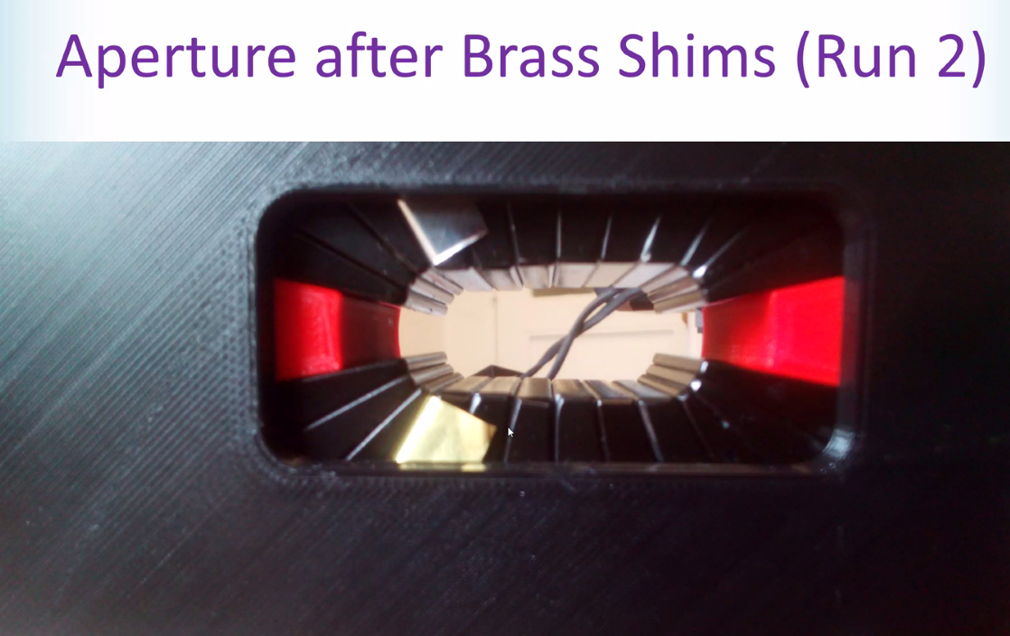
- 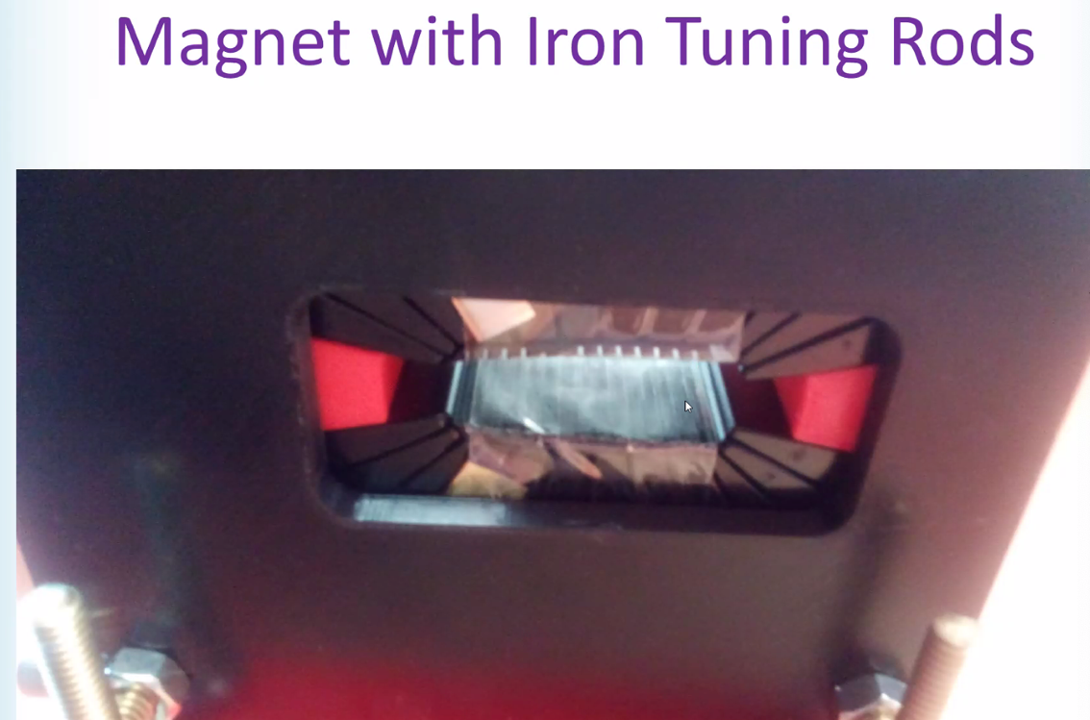
- 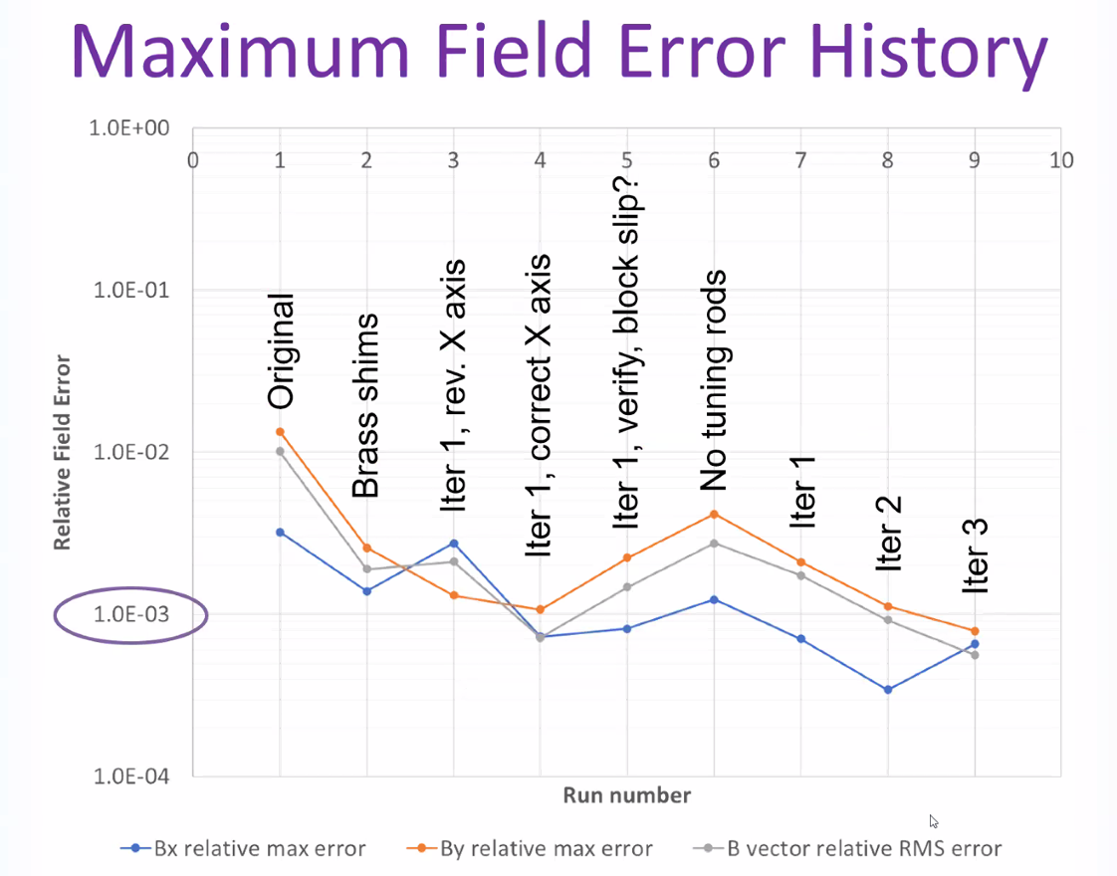
  - Orange and blue are field error
  - Brass shims helps the field from wedges falling in
  - Iterations based on revised measurements (No Tuning Rods on plot)
    - Kept improving
    - All errors below 10^-3
  - Short magnets, you don’t get to full field, and tuning isn’t so strong
- 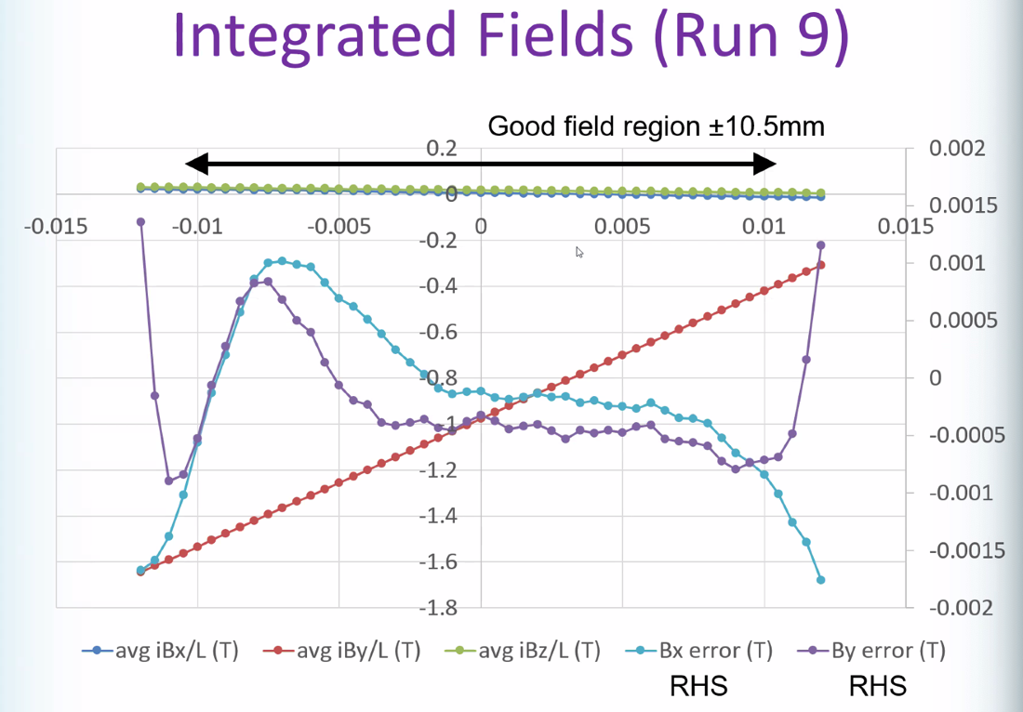
  - Red is integrated By field (B/L)
  - Ignore last 2-3 points – they are outside good field region
- 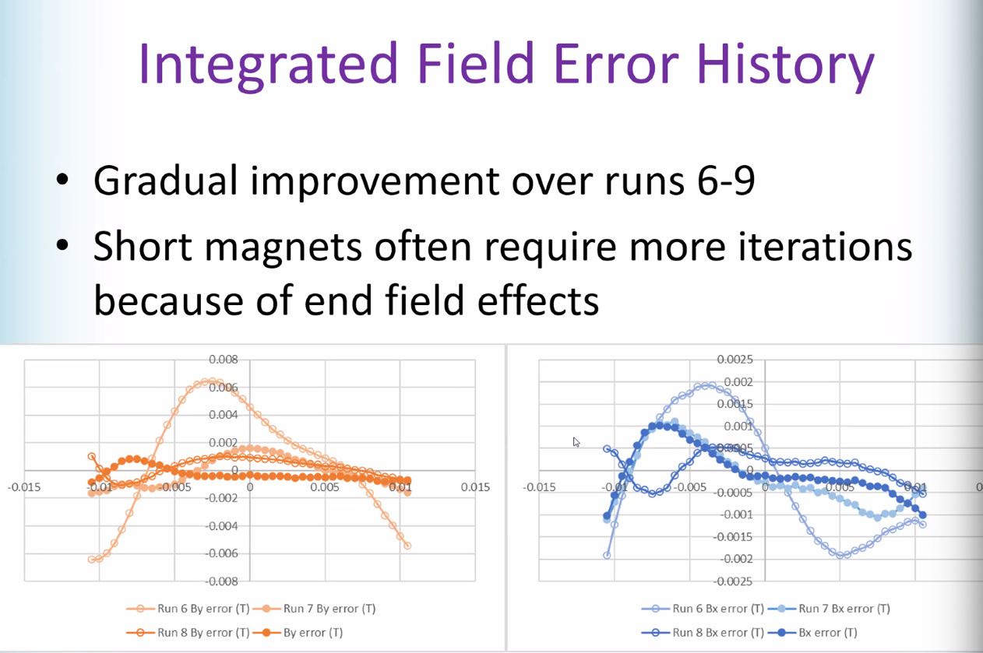
  - Scale different
- Probably more accurate if epoxied wedges, but didn’t b/c don’t have many and need to reuse
- Would be better with metal, etc…
- Temp variation and thermal coeff come into play as well.
- Scott: in later iterations (slide 15), looking at errors, they look non-polynomial. Odd kinks in behavior
  - Is your method to decide on shim placement based on polynomial?
    - Just put in measured field, then optimized
    - Point-by-point
- Jay: Senis (sp?) probe has accuracy issues at this level.
  - Stephen:
    - 10^-4 is level of accuracy
    - Probably see positioning errors as well
    - Enough to get magnet to the level we typically need
- By hand?
  - Some plastic cartridges, but yes. Can get to ~0.5 mm by eye.
  - Jay: make sure starting from corrected field each time
    - Had a patent application (later stolen at GE) for work like this
    - Objective function changes by iteration
    - Can sent patents in name and ones swiped by others.
  - Stephen shimming in 1D (integrated)
  - Jay/GE was doing 3D shimming
- Slight issue with this method: takes up space in aperture
  - Has ideas to improve (wires between tape, for example)
 | Person responsible | Deadline

Special notes

Pathway to Repository: https://jeffersonlab-my.sharepoint.com/:f:/g/personal/tristan_jlab_org/EqZ5MeS-nipCgPfZB5p0oS4B9Is67d3nQb9sLJI3Zyev9g

