FFA@CEBAF Working Group|Minutes

## Meeting date | time 9/16/2022 | 11 AM EST | Meeting location <https://jlab-org.zoomgov.com/j/1614898082?pwd=TnUzMS81M2sxbDZIbERJU01tYkJCQT09>

|  |  |  |  |  |  |  |  |  |  |  |  |
| --- | --- | --- | --- | --- | --- | --- | --- | --- | --- | --- | --- |
| |  |  | | --- | --- | | Meeting called by | Alex B | | Type of meeting | Weekly Meeting | | Facilitator | Alex B | | Note taker | Ryan, Alex C | | Timekeeper | Alex B | | Attendees  Alex B, Ryan, Alex C, Dejan, Kitty, Kirsten, Stephen, Reza, Scott, Todd, Vasiliy, Andrei |

# Intro Discussion

FFA Workshop. BNL sending Dejan, Scott, Stephen, F. Meot. JLab sending Alex and Alex.

We had a nice JLab publicity article: <https://www.jlab.org/news/stories/accelerating-future>

FFA LDRD at JLab will hopefully be renewed: we find out this month. BNL is not funded for this work, so we need to think of other ways for this to be funded at BNL after Stephen’s LDRD ends.

Hopefully, we’ll be able to get this on the LRP, and get funding.

Reza: register for NSAC if want. Today is the last day.

# Agenda topics

## Time allotted | 25 mins | Agenda topic FFA Arc Correction | Presenter Alex C

* Not a ton to say so far.
* Reorganized lattice files for E and W arcs in patch geometry.
  + Happy to share if you want to see the files.
  + Alex B: maybe share in a folder in the shared directory?
    - Ok
* Thinking about correctors:
  + How to get diagnostics and correction scheme working
* Markov Chain MC simulation is current thought
  + Can be tough, because all the optics and machine errors, very high dimensional space
    - Get auto-correlation problem
  + Stephen: why correlated if random errors?
    - Want to systematically create specific types of errors, so we can hammer it down
  + If random errors only, we may not be able to see how the errors impact each other
  + A lot is in the linear regime, because mall iterations
* Stephen: position errors – what if they’re not random, but have a lower frequency spectrum
  + Alex C – this would make it much easier
    - Thinking of a way to create lots of statistics
    - Representative examples of lattices with errors, then pick a couple of arbitrary correction schemes using various amounts of correctors/diagnostics, then apply ML to see what gets pulled out
* Errors on BPMs? Yes
* BPM placement? Not yet – just early.
* Alex B: you’re using classic algorithms – metropolis, thermal annealing
  + We should trim it?
  + I think that’s the direction we should be going
  + Start a test model to start implementing.
  + Our BPMs measure to 200 microAmps
  + Button BPMs – similar?
* 300,000 electrons per bunch
* Kirsten: we had charge minimum for a decent signal on our buttons. If we run below charge minimum, will need new design.
  + Reza: 2 picocoulomb at 1497 MHz is equivalent of 3 mA
* Right now for time structure, we have 4 bunches for A/B/C/D
  + Reza: not putting electrons in all available bunches, but remembers this number b/c trying to design injector for positrons – want to start with 1 mA/hall. If you have 3 halls, that’s 3 mA and therefore 2 pC.
    - Right now, we are running at most at 80 microAmps – only to Hall A or C. Hall B and D are receiving nA.
    - To fit all at the same time, running at frequency of 1/6 of main machine (250 MHz) – 6 empty buckets to fill. Fill 4 for all halls running, 2 empty.
* Small buttons will need a fairly large dynamic range.
* Reza: for example, we are only B and D running. Our BPMs aren’t working. If there’s a drift in the energy until the BLM says so. Use tune (low rep rate but high enough charge in bunches for diagnostics)
  + In past, we ran to a dump with a witness beam. Not anymore (?)
  + System is stable, we can get away with it. Couldn’t do this in the past.
* Stephen: Does Alex C have an idea of what the correction algorithm looks like?
  + Normally, put errors on design (random), then track, then get vector of BPM measurements (with noise as well), track, enter into correction algorithm, sometimes loop several times.
* Kirsten: Alex C wouldn’t have the same response matrix issues we had?
  + Before, we could correct a bit at the beginning, but by the end, things weren’t matching well
  + Any algorithm will figure out the response matrix
  + Stephen used “semi-empirical” method – NN/ML will be fully empirical.
* Stephen: establish pipeline, then put in different algorithms
  + Seeding errors: independent random errors
  + Wiggle the correctors, see the response
* Dejan: for each energy, there’s a specific phase difference b/w correctors and BPMs – useful for correcting them specifically.
  + Unique for FFAs
  + What would a corrector do at a specific energy?
* Will be doing multiple energy correction simultaneously.
* Dejan: didn’t have time to correct all the energies during commissioning.

|  |  |  |
| --- | --- | --- |
| Action items | Person responsible | Deadline |
|  |  |  |
|  |  |  |

## Time allotted | 25 mins | Agenda topic Req. Doc | Presenter Alex B

* Requirements document for splitters.
* 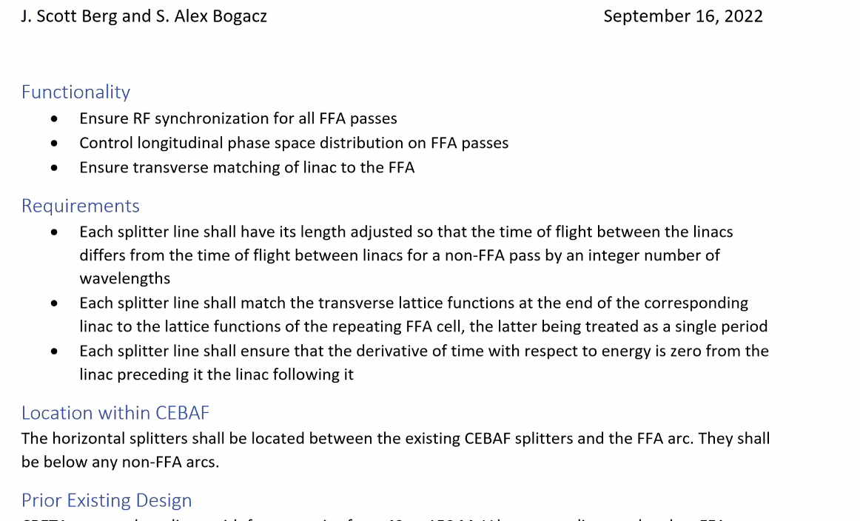
* 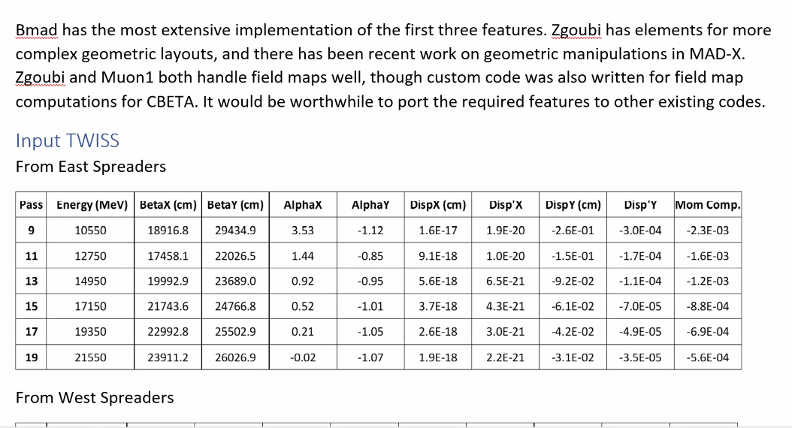
  + Scott: let’s step back a little.
    - 2 things:
      * For a requirements document, you’re being a bit over-enthusiastic in over specifying things. We have some flexibility in how we do this. The requirement is that we are matched to the linac. How we choose to do that is up to us and will evolve. We want to retain the flexibility.
      * Issue of vertical dispersion. We can attempt to design the last splitter pass so it comes out with no dispersion/dispersion prime, or we can design the splitters so they will be able to remove the last vestiges of vertical dispersion. That is the question before us in this design document. Not having done the work, I can’t give a solid answer as to how straightforward the dispersion removal will be. May be easy, may not.
        + Ryan is still chasing down the dispersion. Some errors that crept in that we’re hunting down.
    - “we shall design spreader so that beam is meshed to entrance/exit of linac”
    - “we shall design vertical spreader so that pass that goes into FFA so that there is no vertical dispersion”
    - Table over-specifies, too precise, etc…
* Reza: the requirement documents never accept 0. You need errors.
* Mom Comp only useful for ring
  + Maybe M56 instead?
  + It’s per unit length number
  + Let’s not make tables of exact numbers. Put in bounds for quality of match, etc…
* Table of example parameters is ok (Stephen)
* Scott – can we use m instead of cm?
  + Yes
* 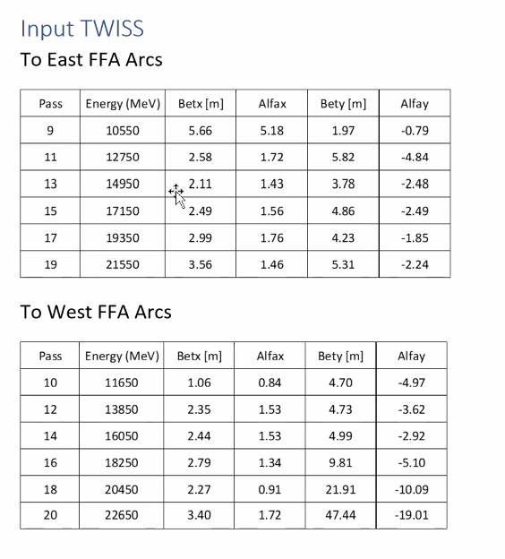
  + These are from the adiabatic matching end
  + Reasonable “wish list” so to speak. Ballpark to aim for. Must have a matching section.
  + What are the margins/errors on this?
    - Would be better to quote them in middle of quad where alphas are 0. Right now, it seems to be based on FODO.
    - Would be easier to match with 0 slope alpha
      * Cut off half of last quad to make alphas 0.
* Might want to look into half-quad solution so we can minimize alpha and disp’ to make the jump.
  + In CBETA, had half a quad to make alpha closer to 0
* Can still amplify beta-functions while suppressing dispersion.
  + Phase advance per cell has to stay somewhat constant.
* Need to look at advantages/disadvantages of adiabatic transition. We have a finite amount of real estate
  + If you can do it in the tunnel without taking up splitter space, it’s attractive
* Dejan presented analytical matching of dispersion function and all orbits with 3 elements years ago in England.
  + Fit all orbits into one orbit
  + Please put this in shared folder
  + First done by Mike Craddock – shows you really don’t need adiabatic matching. Problem is beta matching
* Ryan: should we put in bounds on dimensions where we place them.
  + Scott: Depends how much you want to constrain yourself.
  + Have to check with facilities/safety.
  + Kirsten: pick a number and ask facilities to give a better number
  + Jay would be good person to do this.
* Dejan:
  + 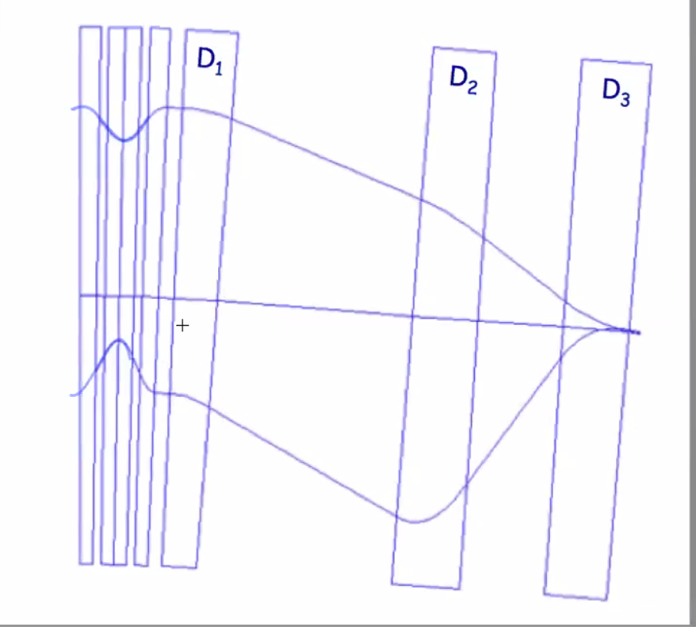
    - FFA on left. 3 magnets then merge the orbits into one place.
* Put newest version in shared folder (Requirements Documents subfolder).
  + Still need the quantitative information into a way that it’s useful to guide design. We have access to add things in
* Alex B: Scott, would you mind owning this?
  + Scott – probably should not be responsible. But I can add information. Should be a CEBAF person that owns it.
  + In the sense of getting to next level and grooming the info, could Scott take a pass on it?
    - Sure.
* Ryan and Jay can look into space on the floor that’s allowed.
* If you want bounds on the level of the match, discuss what CEBAF experiences are for matching accuracy, etc…
  + Alex B will provide that.
  + Want single metric for “match” quality
  + Dispersion defined in terms of amplitude of 1 at sigma-delta
    - Fractional amplitude
  + There’s an equation (Scott remembers
    - Ryan – will try to put this together

|  |  |  |
| --- | --- | --- |
| Action items | Person responsible | Deadline |
|  |  |  |
|  |  |  |

## Time allotted | 10 mins | Agenda topic AOB | Presenter All

|  |  |  |
| --- | --- | --- |
|  | Person responsible | Deadline |
|  |  |  |
|  |  |  |

## Special notes

Pathway to Repository: <https://jeffersonlab-my.sharepoint.com/:f:/g/personal/tristan_jlab_org/EqZ5MeS-nipCgPfZB5p0oS4B9Is67d3nQb9sLJI3Zyev9g>

NO MEETINGS FOR THE NEXT TWO WEEKS. NEXT MEETING IN OCTOBER (TENTATIVELY 7TH).