FFA@CEBAF Working Group|Minutes

## Meeting date | time 10/14/2022 | 11 AM EST | Meeting location <https://jlab-org.zoomgov.com/j/1614898082?pwd=TnUzMS81M2sxbDZIbERJU01tYkJCQT09>

|  |  |  |  |  |  |  |  |  |  |  |  |
| --- | --- | --- | --- | --- | --- | --- | --- | --- | --- | --- | --- |
| |  |  | | --- | --- | | Meeting called by | Alex B | | Type of meeting | Weekly Meeting | | Facilitator | Alex B | | Note taker | Ryan | | Timekeeper | Alex B | | Attendees  Alex B, Ryan, Dejan, Kirsten, Alex C, Andrei, Jay, Kitty, Randika, Scott, Stephen, Vasiliy, Reza |

# Intro Discussion

Dejan/Alex discussion about layout. No orbit matching before FFA arcs after splitters, with no adiabatic section.

Scott: Limited space. Want small beta functions due to matching. Need more space with higher beta function. Adiabatic transition takes up a lot of space. Matching in splitters doesn’t turn out to be difficult part. Only case want adiabatic transition, two corners with splitters and two corners with adiabatic transition. But our default setup should be splitters in 4 corners. If that’s easy, and we have headroom, maybe then do adiabatic transition.

Dejan: look at length available, know where it is in the tunnel. How much space to we have until the arc?

# Agenda topics

## Time allotted | 25 mins | Agenda topic New Baseline | Presenter Alex B

* Baseline is clear:
  + 6 pass FFA with single FFA going to 22 GeV
* JLab Costing with engineering, etc…
  + +/- 20% costing for both options (2 FFAs to 24 GeV)
    - Reasonable for simplicity and cost effectiveness, as well as user indication: 22 GeV is fine
* Stephen will “massage” magnet design accounting for 6 passes, SR loss, minimizing size, etc…
  + Will also account for energy losses, etc…
  + Optimize E and W arcs separately
  + Need to know energy tunability as a percentage
    - Jay: if possible, assume 1000 MeV and 1100 MeV
      * Equivalent of extra half turn.
    - Stephen will revisit and see what is feasible, etc…
  + Ideally, the users want continuous tunability
    - Which need tunability, where extracted, and energy range?
* Alex C – what’s the minimum acceptable E to the users would be?
  + Jay: Hall C only looked up to 20 GeV (likely only a little more in A/B)
    - SR radiation means you only have 8-sigma in beam pipe.
  + Workshop looking at 22 GeV
    - Options
      * 20 to A/B/C, 21 to D
      * 22 to A/B/C, 23 to D
* We start at baseline, and re-investigate if needed.
* If Stephen could revise the spreadsheet with 6 passes in 1 FFA arc, that would be useful
* Dejan: Need dynamic aperture study
  + Stephen: Not DA, but energy spread

|  |  |  |
| --- | --- | --- |
| Action items | Person responsible | Deadline |
|  |  |  |
|  |  |  |

## Time allotted | 25 mins | Agenda topic SR Emit. Dilution | Presenter Kirsten

* Let’s put numbers in the discussion.
* “New Problems with BMAD” – there was an update that broke a few things.
  + Particles gain energy in FFA! (HA!)
    - keV level gain
  + Running with one version, behaving
  + Updated, and particles gain energy in arc
* 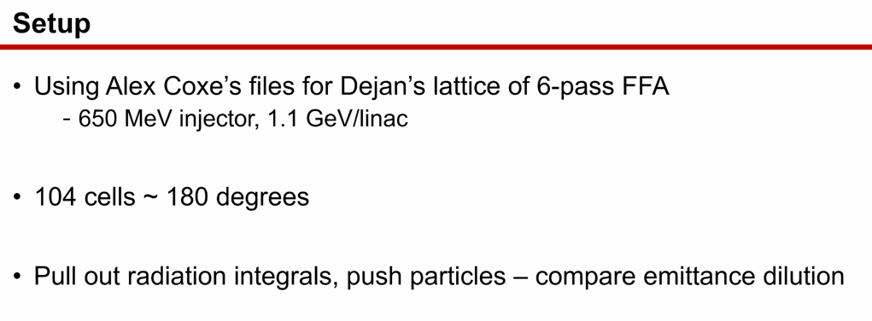
* 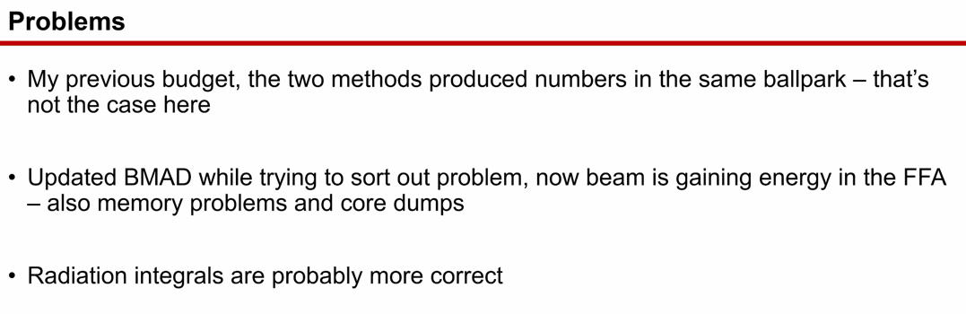
* Radiation numbers about the same as before. But the particle tracking is broken.
* 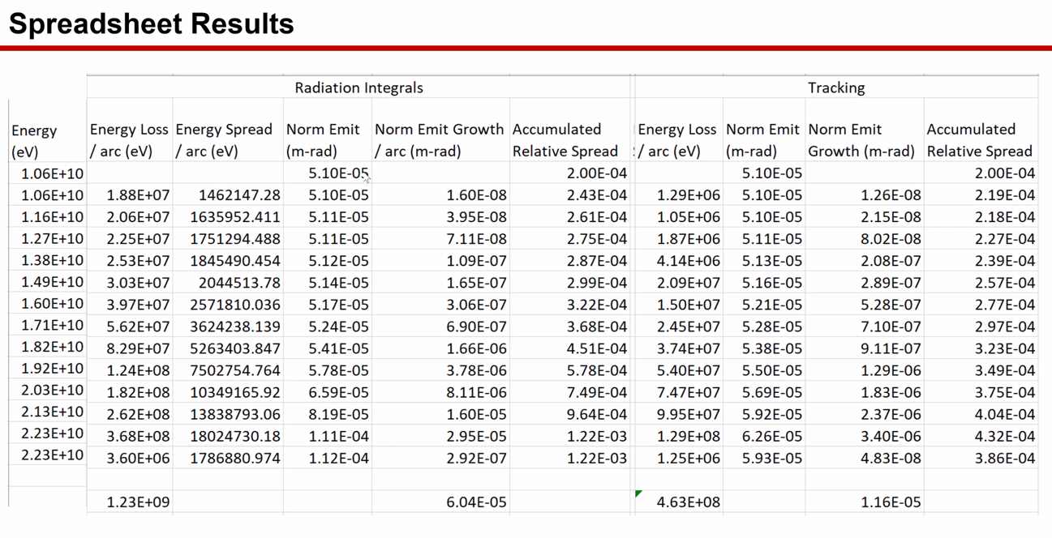
  + Bottom line (starting with 2.23E+10) can be ignored (for comparison)
  + Radiation integrals side is “more correct” version of things.
* Lose about 1 GeV overall (from Rad Int).
* Emittance takes off in second half, but similar to before
* Last time, likely better (2 FFA case)
  + 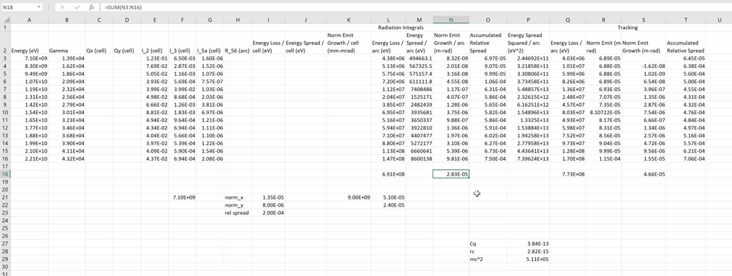
* Energy spread on order of 1E-3 – a lot
  + Last time, it was 8E-4 – better, but not low
  + Less energy loss
* SR Loss was one reason we went to 2 FFAs in the first place, so not surprising.
* Current numbers, don’t trust tracking:
  + 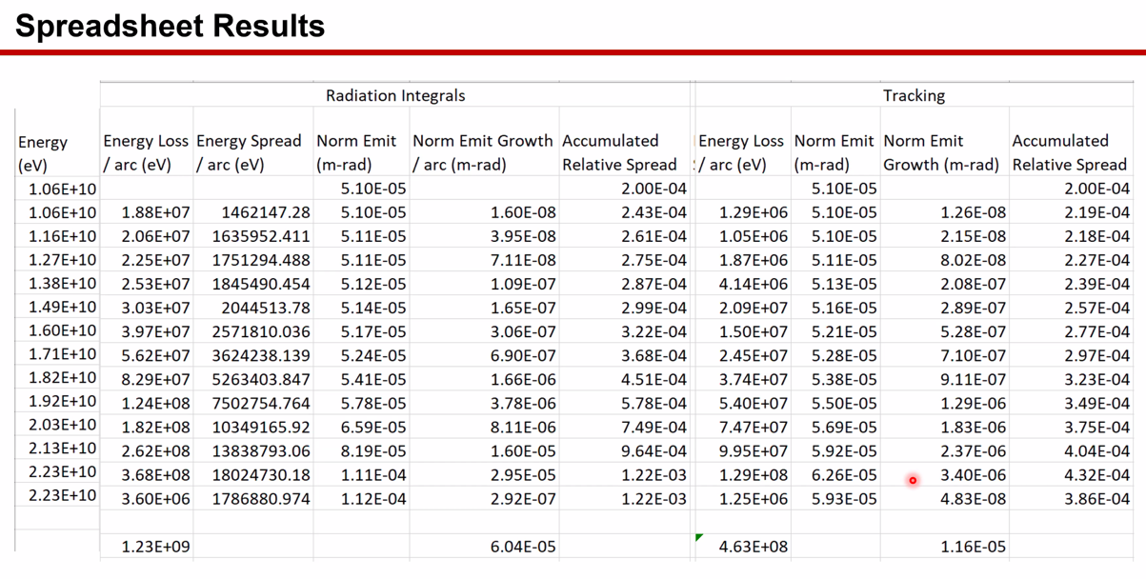
  + Seems to behave significantly better, if you believe the particle tracking
  + Order of magnitude lower, so highly suspicious.
* 110 vs 60 if using radiation integrals
* 1E-3 vs 4E-4 comparing
* Energy loss seems a bit low on tracking
* Believe the integrals for now
* Will sort out tracking problem(s)
* Other question that came up:
  + 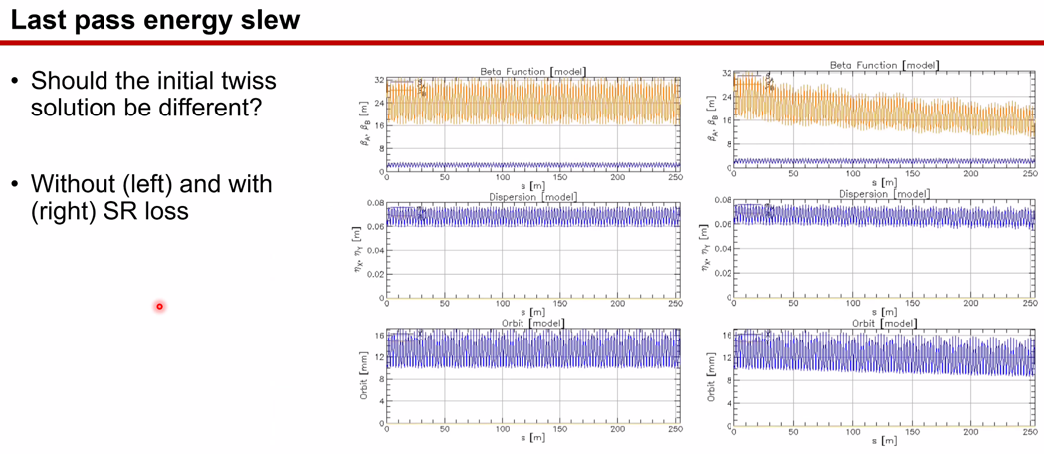
    - Beta w and w/o SR loss
  + Do the initial Twiss need to be different?
    - Stephen: I wouldn’t worry about this yet.
    - Scott: beam energy changes really slowly, and it’s low enough compared to betatron oscillations, it sort of adiabaticly matches.
    - Stephen: will be nasty with magnet errors and energy spread at the same time.
* Déjà vu for Jay/Alex: when doing 12 GeV we start seeing noticeable SR losses
  + Considered doing something with power supplies to adjust
  + Jay: we put in SR coils which added to the dipole field at front of arc, subtracted from the end of the arc, in every magnet in Arcs 8/9/10
    - We never actually used them! Detailed analysis said where to put them
    - Analysis ignored, put in non-ideal places
    - Corrector strengths could accommodate.
* Based on last set, assume radiation integrals are in the right ballpark – can we live with it?
  + Alex B – pretty consistent with fixed radius calculation
  + Jay – if this is real at 22 GeV, and 1.8 m, then 2.2 m sigma, and 10 sigma in beam pipe (without steering allowance)
* Dejan – total of ~958 MeV loss
* Kirsten gets 1.23 GeV for 180 degrees (104 cells) from radiation integrals
* Dejan – 180 degrees is fine without adiabatic matching section
* Alex B – elegant can be used to check this as well
  + Kirsten – possible to put FFA into elegant, can try a spot check while attempting to sort out the particle tracking in BMAD
    - If a matter of running Dave’s translation script, shouldn’t be problem
    - Know enough to get around
    - Yves is also an elegant expert, so could reach out if needed.
* Assume radiation integral numbers are not precise, but right ballpark.
  + Any alterations will then require update
* Kirsten will be making bug report and sending to Dave

|  |  |  |
| --- | --- | --- |
| Action items | Person responsible | Deadline |
|  |  |  |
|  |  |  |

## Time allotted | 10 mins | Agenda topic AOB | Presenter All

* 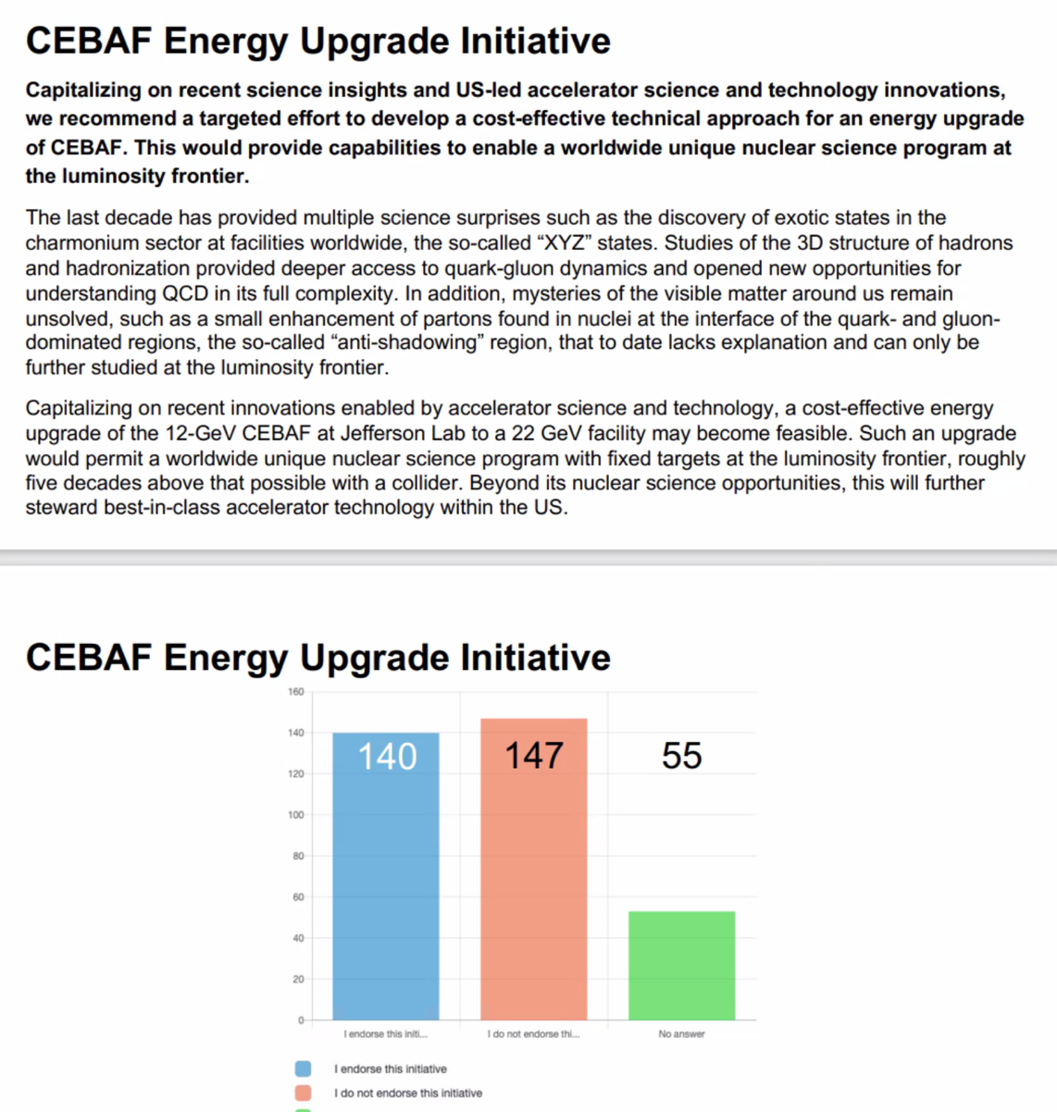
  + Not so good.

|  |  |  |
| --- | --- | --- |
|  | Person responsible | Deadline |
|  |  |  |
|  |  |  |

## Special notes

Pathway to Repository: <https://jeffersonlab-my.sharepoint.com/:f:/g/personal/tristan_jlab_org/EqZ5MeS-nipCgPfZB5p0oS4B9Is67d3nQb9sLJI3Zyev9g>