FFA@CEBAF Working Group|Minutes

## Meeting date | time 10/21/2022 | 11 AM EST | Meeting location <https://jlab-org.zoomgov.com/j/1614898082?pwd=TnUzMS81M2sxbDZIbERJU01tYkJCQT09>

|  |  |  |  |  |  |  |  |  |  |  |  |
| --- | --- | --- | --- | --- | --- | --- | --- | --- | --- | --- | --- |
| |  |  | | --- | --- | | Meeting called by | Alex B | | Type of meeting | Weekly Meeting | | Facilitator | Alex B | | Note taker | Ryan | | Timekeeper | Alex B | | Attendees  Alex B, Ryan, Alex C, Donish, Dejan, Stephen, Jay, Kitty, Kirsten, Randika, Vasiliy, Reza |

# Intro Discussion

Hello to Donish, welcome!

# Agenda topics

## Time allotted | 25 mins | Agenda topic Orbit Merging | Presenter Dejan

* 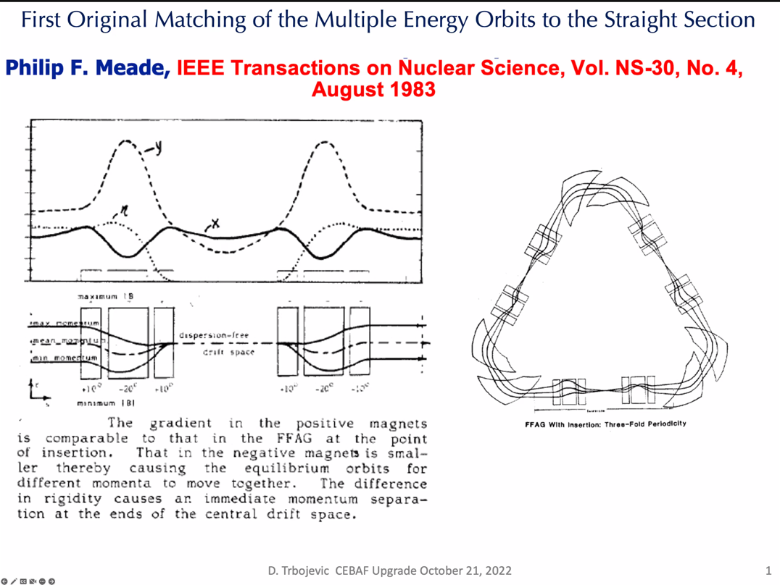
* A different way of matching FFA straight sections. Not the way done first. Phil Meade came up with the idea.
* Left in picture above shows pretty much everything you need to know about matching into the straight section.
  + 3 magnets: 10deg, -20deg, 10deg
  + Merging of multiple momentum orbits into single orbit with those 3 magnets
* Beam offset contributes to bending
* Differs from adiabatic merging, which slowly changes
* Did this analytically:
  + 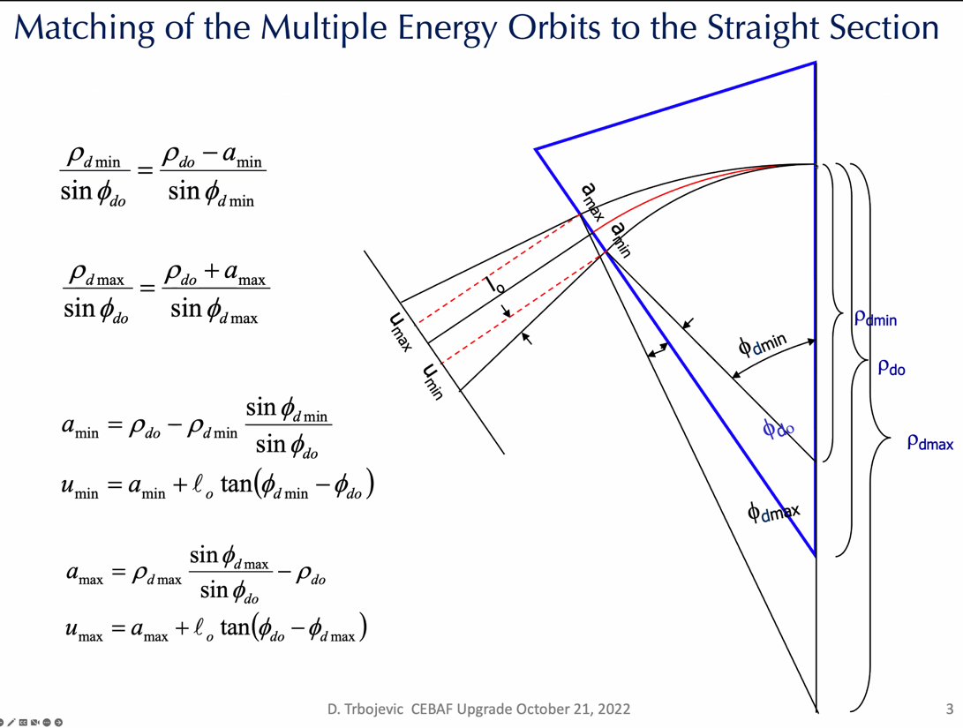
  + Bending sector magnet (first magnet)
* 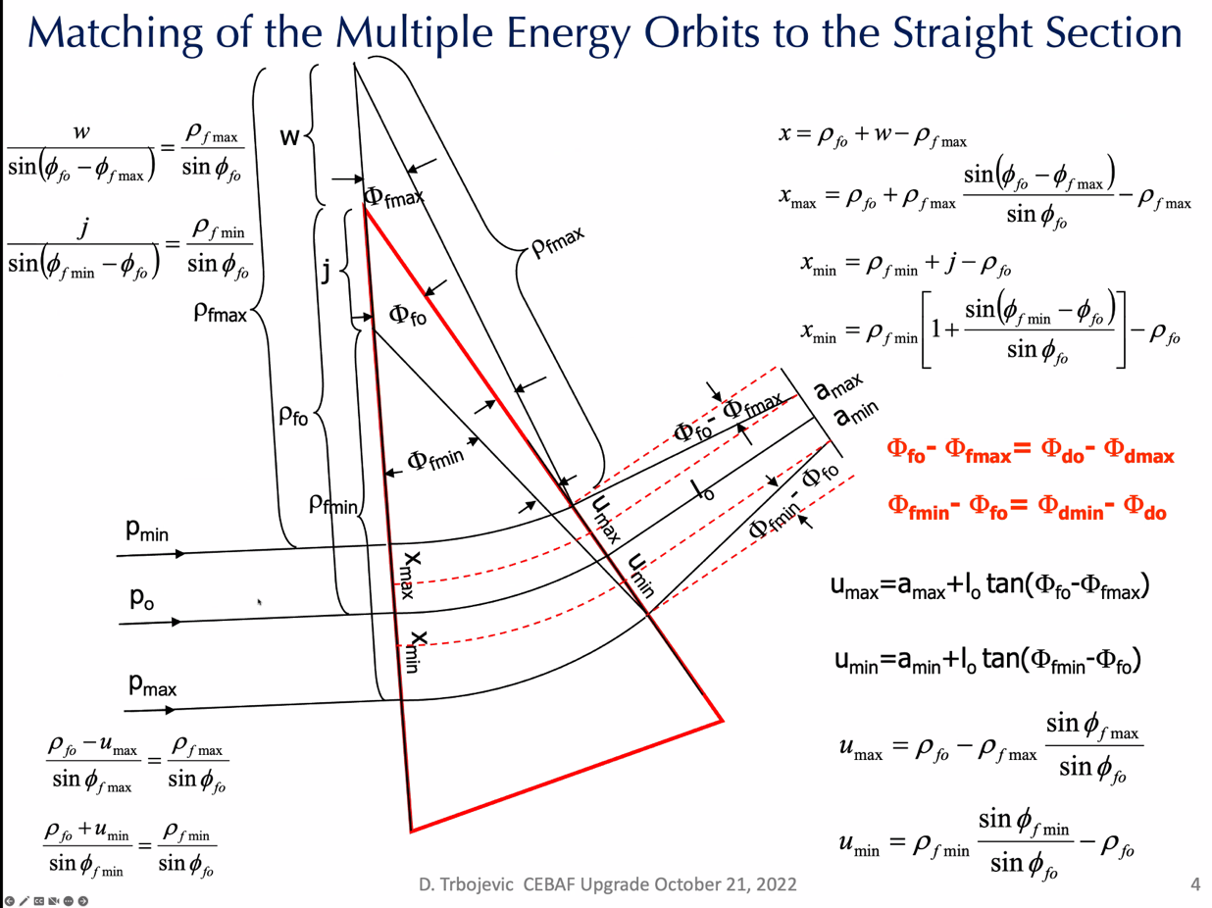
  + Next magnet does the opposite of the first
* 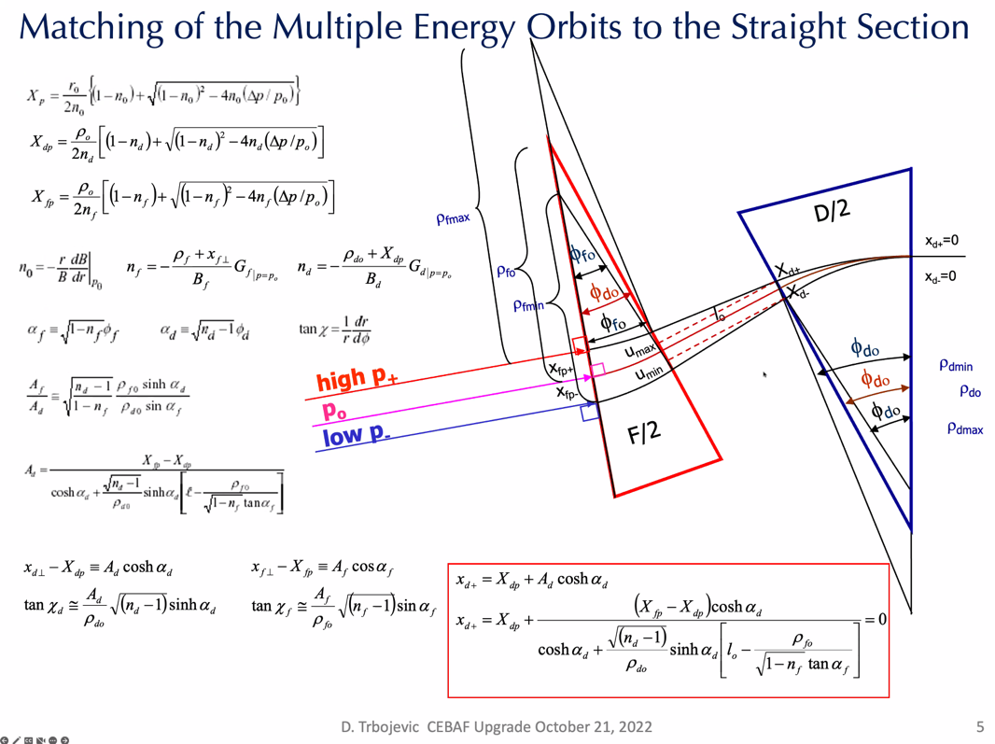
  + Can do it with 2 magnets.
  + If you care about beta, then you may need more magnets
  + You can get exactly the merging of the orbits
* 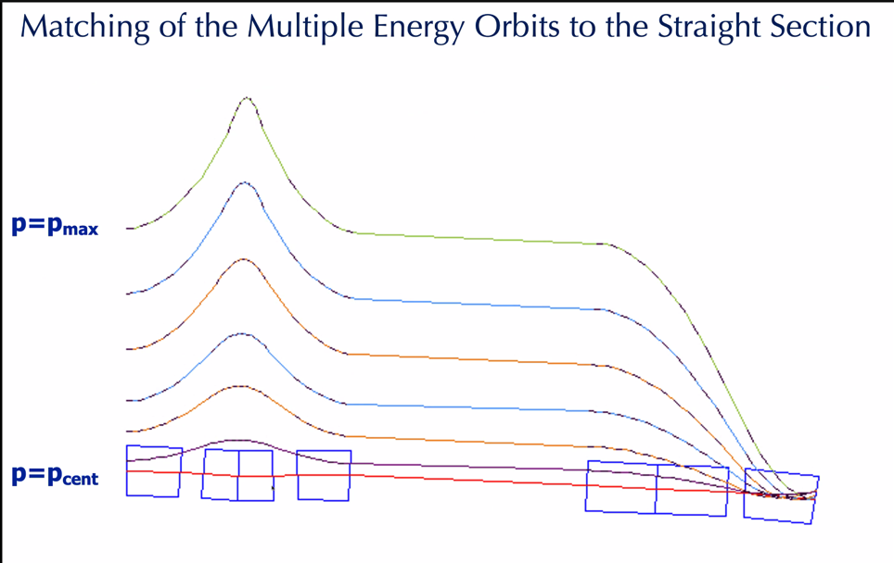
  + Applied in FFA
  + Not perfect yet – just trial and error, no fitting
* 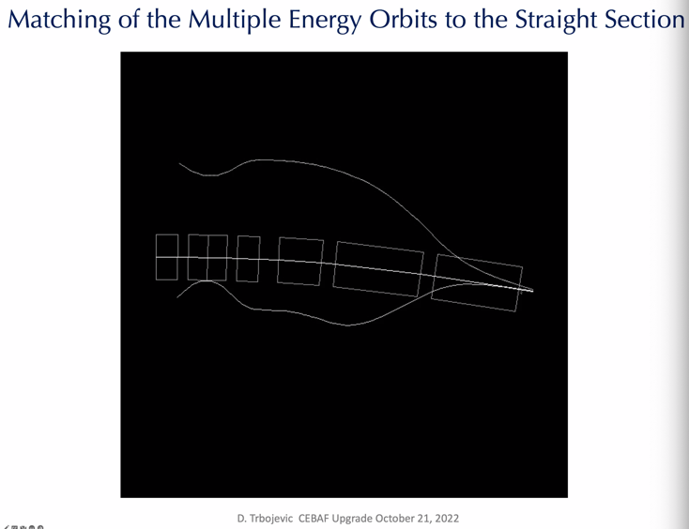
* 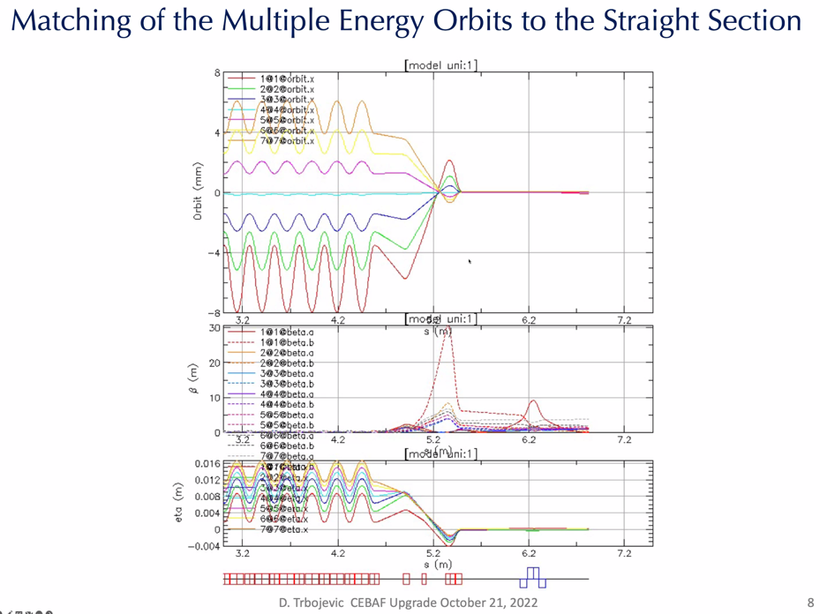
  + Matched in straight section as well
  + Not sure got perfect values of beta, but works
* 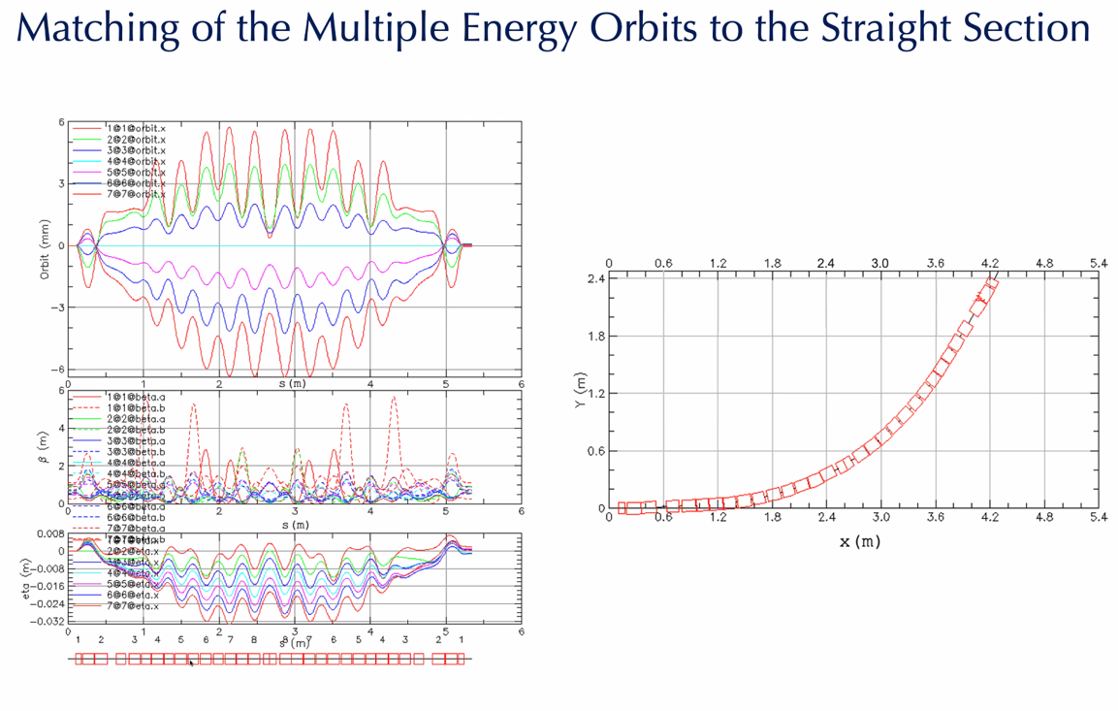
  + Using only 3 magnets for this
  + Orbits merge
  + Proton therapy in this case
  + Achromatic from beginning to end
  + Symmetric around center point – triplets on each end
  + Beta in middle is zero
* CBETA case:
  + 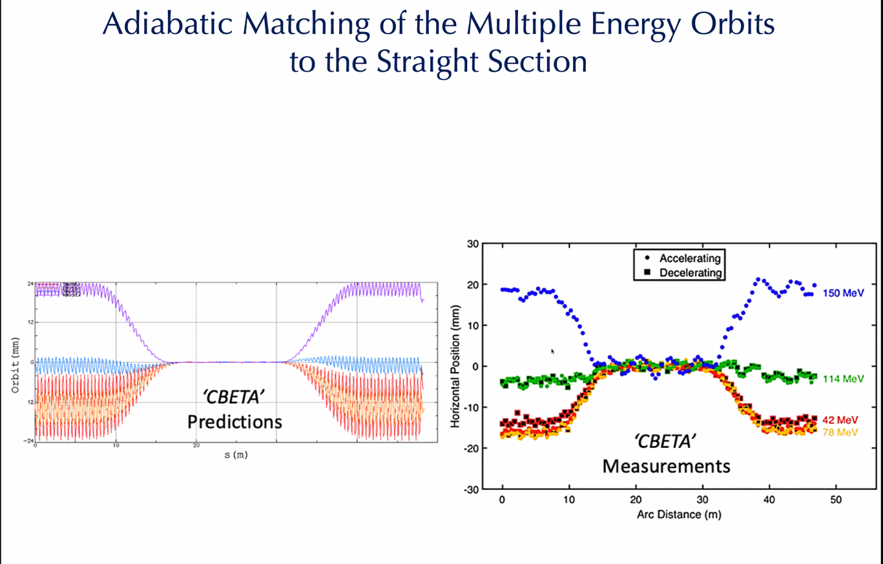
    - Lots of magnets, adiabatic
    - Magnets no different than in arcs
    - If you move magnets away from each other adiabatically, betas increase
* Another beamline for radiotherapy:
  + 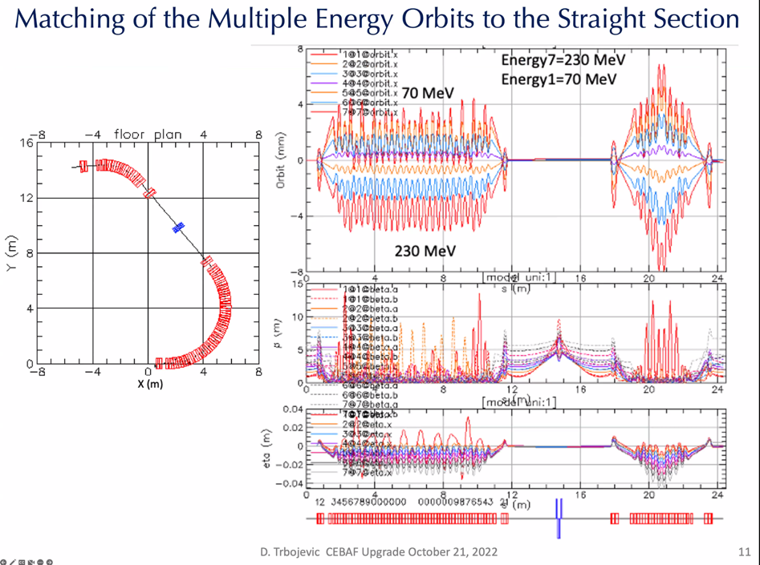
  + Quads in middle
  + Beta symmetric in straight section
  + 70-230 MeV
* 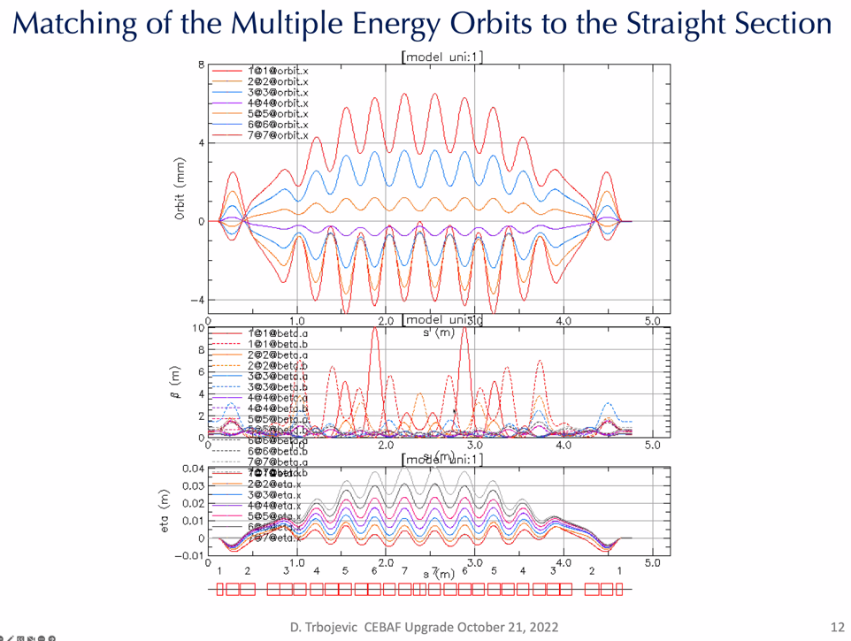
  + Not stable for alphas at end
* 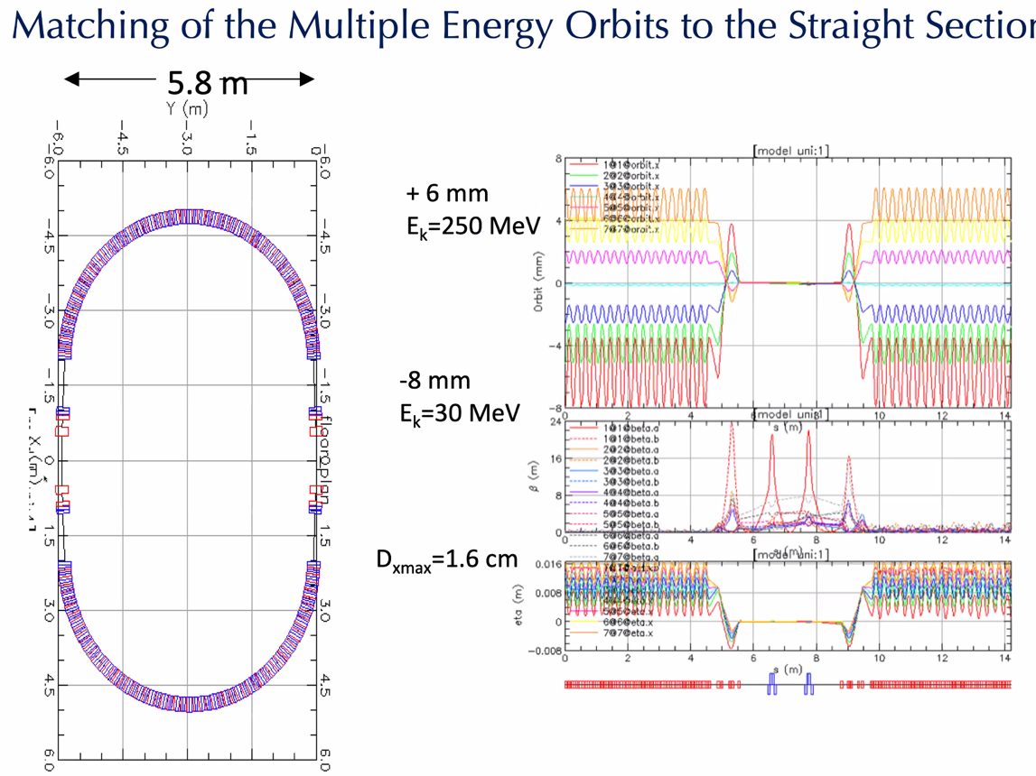
  + Radii equal
  + Beta functions – not a periodic solution. Just tracking
    - Left not equal to right
* Alex B: So where do we go?
  + Combination of adiabatic and triplet?
  + Dejan: Definitely need to get from 1-2 m up to 100 m
  + How do this in spreaders?
  + Splitters will need to do part of this beta matching
    - Maybe deamplify from other end?
* All depends on how much room we have. Maybe we don’t need adiabatic merging of orbits. Can do it more shortly with this method.
* We have to make beta functions up to a reasonable value compared to that coming out of the linac
* Jay: Geometry in the existing tunnel will likely constrain us to a more compact method than the adiabatic option.
  + Alex B: the adiabatic match may be bent at the ends. So if we can get into 180 degrees with periodic cells, it will work better with coinciding with our present arc footprint
* What’s Vasiliy/Randi’s take on this?
  + If we don’t have space for adiabatic matching. This approach looks really attractive.
  + Tried it, but wasn’t successful
  + Range of E is +/-30%, but have done 10 – 250 MeV spread as well.
  + Dejan: You’ve gotta be close to the solution to start fitting in BMAD. If you apply the main idea given by Phil Meade, you’ll come up with a solution.
  + If you start with analytic solution and put it into BMAD, then you’ll be close.
* Need to go LINAC > Spreader > Splitter > Merge
* Stephen: we probably shouldn’t bother with adiabatic matching, since we can handle a lot of the beta control in the splitter
* Will revisit spreaders next meeting to make sure all the values are up to date.
* With BMAD files from Dejan, don’t change the central energy.
  + Alex C: changed this for one of the Arcs – wasn’t clear what it was supposed to be.
  + Dejan: important parameter, and defines perfectly circular orbit. Best solution is not the highest E on circular orbit. Optimum solution is somewhere in the middle. Manipulate central energy so that the surrounding energies are making about the same amount of SR.
  + Can we call this a reference energy?
    - Good point.
    - Scott B likes a different method
    - Dejan does things in different universes. 6 universes WRT reference energy. Does it with MadX-PTC, and other codes.
  + Kirsten: how are the SR values coming out of BMAD?
    - When BMAD calculates from reference energy not the actual energy of the beam.
    - Have to look at other presentation (excel file)
      * Shows this work here in spreadsheet, manually
        + Radius in single element
    - If just pulling out radiation integrals, ok.
  + Stephen: in that file, E-cent determines B-rho, which determines dipole fields.

|  |  |  |
| --- | --- | --- |
| Action items | Person responsible | Deadline |
|  |  |  |
|  |  |  |

## Time allotted | 25 mins | Agenda topic SR Spreadsheet 6-Pass | Presenter Stephen

* 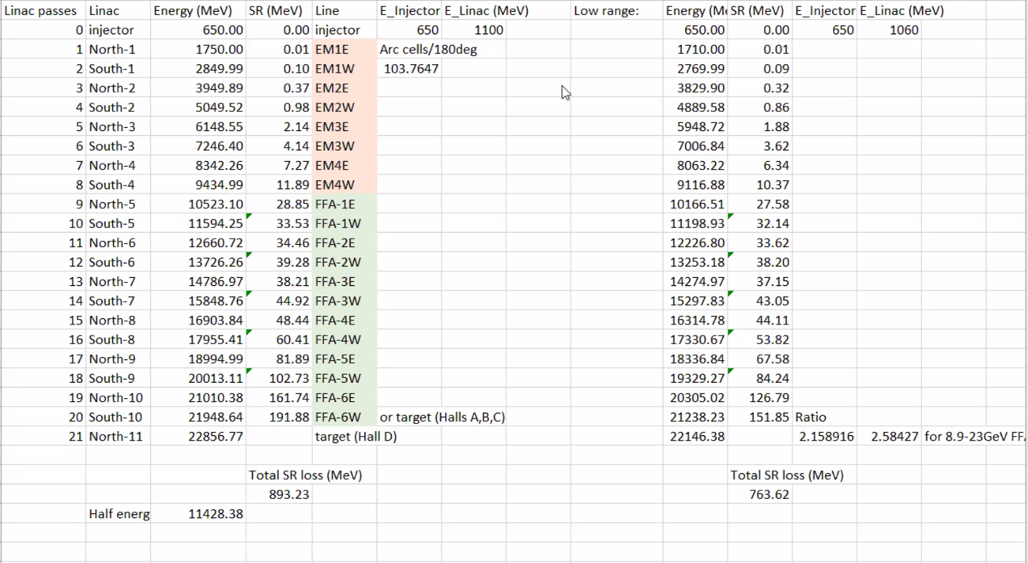
  + Once sorted central/reference energy, got this.
* SR Loss in volts per cell:
  + 4 EM turns, 6 FFA turns
* This is less than Dejan’s
* Estimate SR assuming energy stays same in arc
  + Another version looks at the halfway point – small difference
* Almost self-consistent
* Will upload spreadsheet – this is currently most accurate.
* Going to correct detectors? Yes
  + 21.95 in A/B/C
  + 22.86 in D
* We should re-adjust the magnets to get to 23 GeV
* 10.5 GeV at first FFA, 21 GeV top energy at east end
  + Tune limits matter
    - Dejan uses 0.04, and beta goes to 15-16 m
      * Need to watch beta_y as well
      * Highest E no more than 0.38
      * Already below 0.4 at the lowest E
* If want adjustability, need larger energy range
  + This will require changing the magnetic fields
* Jay: 1000-1100, but if you can to 1050-1100, then that’s what we will have to live with.
  + Maybe we can knock more off mag field with some optimizations.
  + One might fit 22 into A/B/C if these numbers are right.
  + Might need to maintain linacs at a smaller energy range

|  |  |  |
| --- | --- | --- |
| Action items | Person responsible | Deadline |
|  |  |  |
|  |  |  |

## Time allotted | 10 mins | Agenda topic AOB | Presenter All

* Do users know that they’ll have lower current?
  + Yes
  + Also, dumps will stay limited
* Jay: Septum magnet tech notes
  + Present next time?
  + 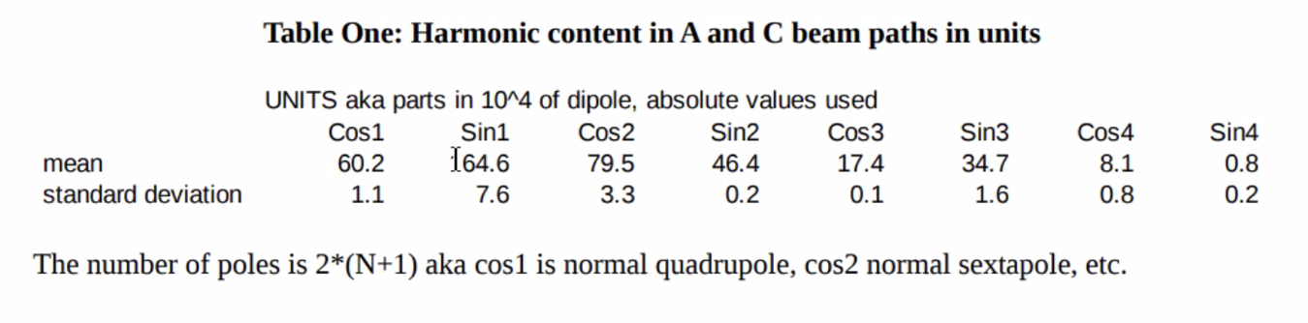
    - Fractions of sum of field
  + 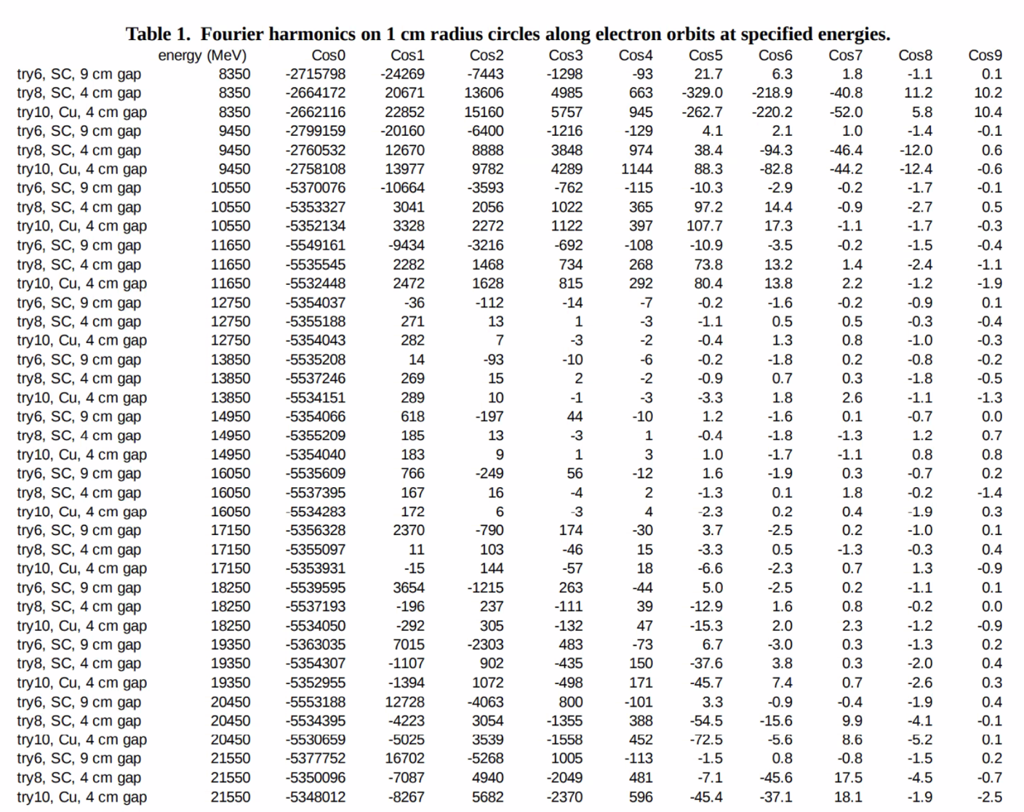
  + Number of amp turns drop by more than half, can do it with copper!
    - No need for SC!
  + For each model, the harmonics don’t change much in amplitude. No matter how you do it, the amplitudes of the harmonics are similar. Sextupole different.
    - No skew terms on this (up/down symmetry forced)
    - Alex: should we be worried about higher?
      * Octupole, probably. Higher? Not sure
    - If we save money using copper, is the kG on the decapole going to be a problem?
  + Will change table so that dipole (cos0) will be 10000 and everything will be in units instead of absolute.

|  |  |  |
| --- | --- | --- |
|  | Person responsible | Deadline |
|  |  |  |
|  |  |  |

## Special notes

Pathway to Repository: <https://jeffersonlab-my.sharepoint.com/:f:/g/personal/tristan_jlab_org/EqZ5MeS-nipCgPfZB5p0oS4B9Is67d3nQb9sLJI3Zyev9g>

NO MEETING NEXT WEEK!