FFA@CEBAF Working Group|Minutes

## Meeting date | time 11/04/2022 | 11 AM EST | Meeting location <https://jlab-org.zoomgov.com/j/1614898082?pwd=TnUzMS81M2sxbDZIbERJU01tYkJCQT09>

|  |  |  |  |  |  |  |  |  |  |  |  |
| --- | --- | --- | --- | --- | --- | --- | --- | --- | --- | --- | --- |
| |  |  | | --- | --- | | Meeting called by | Alex B | | Type of meeting | Weekly Meeting | | Facilitator | Jay | | Note taker | Ryan/Jay | | Timekeeper | Jay | | Attendees  Ryan, Jay, Kitty, Kirsten, Donish, Scott, Stephen, Dejan, Vasiliy, |

# Intro Discussion

BMAD on ACE – proxy changed? Problems started roughly last week.

Thanks to Jay for helping with notes while Ryan presented.

# Agenda topics

## Time allotted | 25 mins | Agenda topic 6-Pass Magnets | Presenter Stephen

* Lots uploaded to the SharePoint
* Wanted magnets that are compatible with Dejan’s lattice in some way
* Got magnets that look ok.
* West arc magnets are a bit larger since higher energy
* 16 mm for total height
* 12 cm wide
* Only got these with some difficulties
* Field errors:
  + 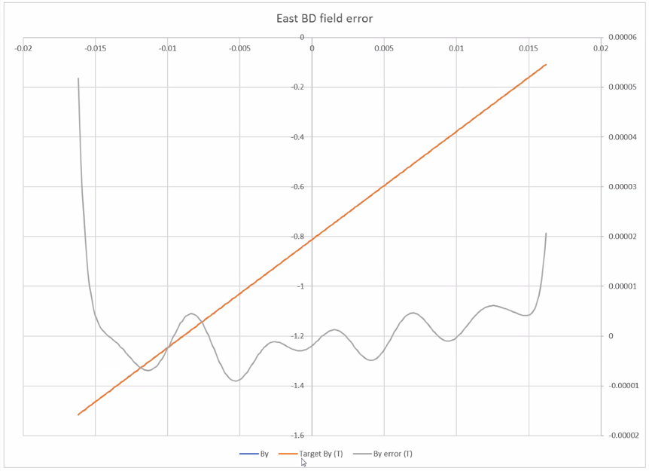
    - Grey is error
  + 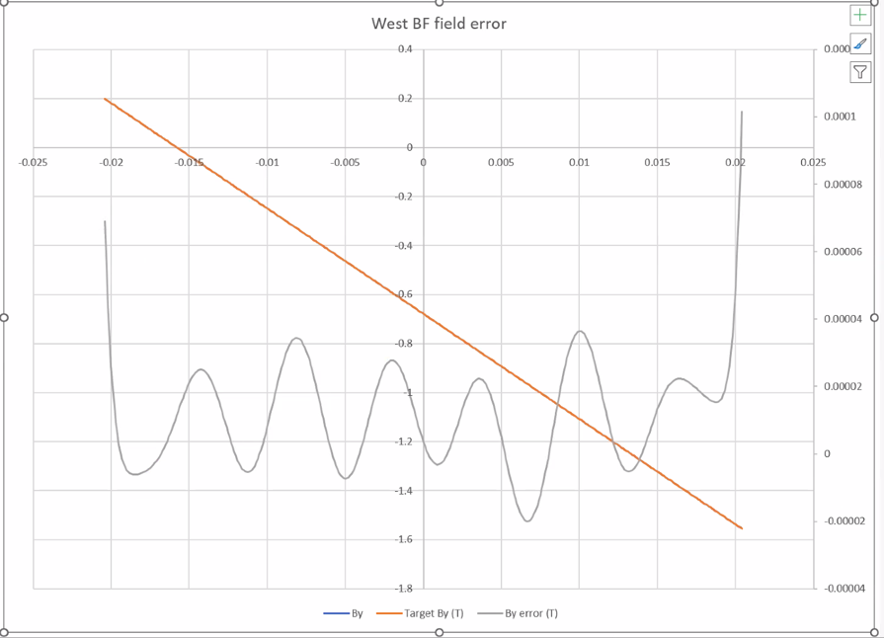
* 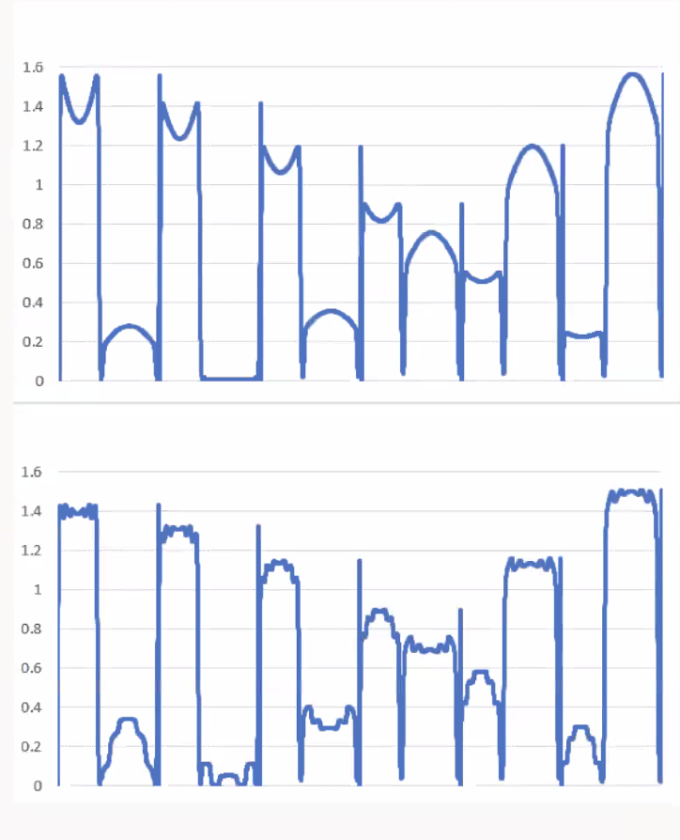
  + These are field orbits – plots of actual field in 6 orbits.
    - Top plot is original design
    - BD has the inverted parabolas, BF standard parabolas
  + What happens if magnet follows orbit to some degree? Can follow any orbit
    - Try to make magnet follow orbit of highest field – basically cut off the peak
  + Bottom plot splits magnets into 6 sections, shift sections mm scale
    - Peaks essentially removed, looking at average instead
  + Peak fields higher than expected
  + 2 ways look at max field. One looks at max orbit, one looks at orbit range
  + Getting larger numbers than expected (in BD for example)
* Looking at parameters spreadsheet, looked at min and max
  + Hit max field while exiting
  + If you treat it as a hard edge magnet, you get to the max value.
* New magnets drop from peak of 1.7 T to less than 1.6 T
* Scaled magnet gradient to 0.6 of what they were, so dimensions adjusted a bit
  + Longer cell length and orbit excursion
* Magnets less than 100 cm^2
* Used real energies (with SR loss), instead of nominal
* Still want to widen the open plane gap, if possible
* Muon1 folder shows elements split into 6 pieces. Angles are now 0, and there are half corners (drift with angle and no length).
  + Has input files and listing of components so can see what is going into simulations/design
  + Opticsmatch spreadsheets go into more analysis, comparing options, etc…
  + Also has outputs for beam tracking
* Files in Presentations>2022-Nov4>muon
* Higher gradient gives shorter cells by sqrt relation (98->76 cells for example)
* Dejan used sector bends in his version
* May have improved SR loss – but TBD. Likely very similar.
* Dejan wants to show the resolution of the M56
  + Number of cells in arc and calculate parameters of cell (dispersion, offsets), you get M56 at end of file.
    - Corresponds directly to the momentum compaction for that energy divided by circumference in first column in MADX-PTC.

|  |  |  |
| --- | --- | --- |
| Action items | Person responsible | Deadline |
|  |  |  |
|  |  |  |

## Time allotted | 25 mins | Agenda topic Spreaders | Presenter Ryan

* Showed spreadsheet with version 3 of NE Spreader and version 2 of SW Spreader.
* 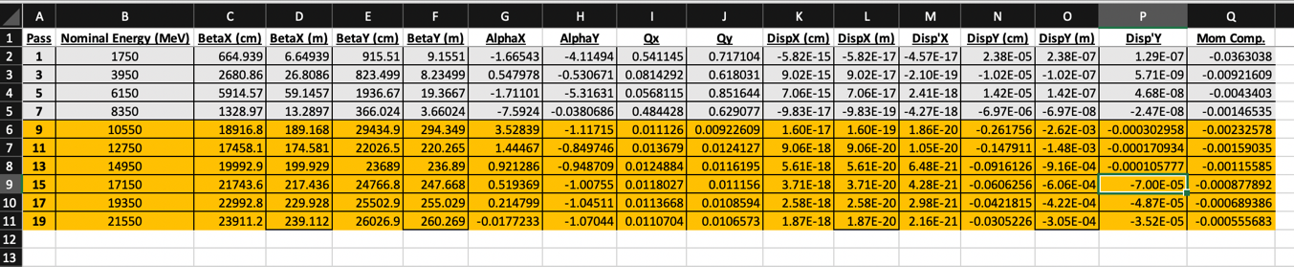
  + NE V3
  + Grey is EM passes, Yellow is FFA passes
* 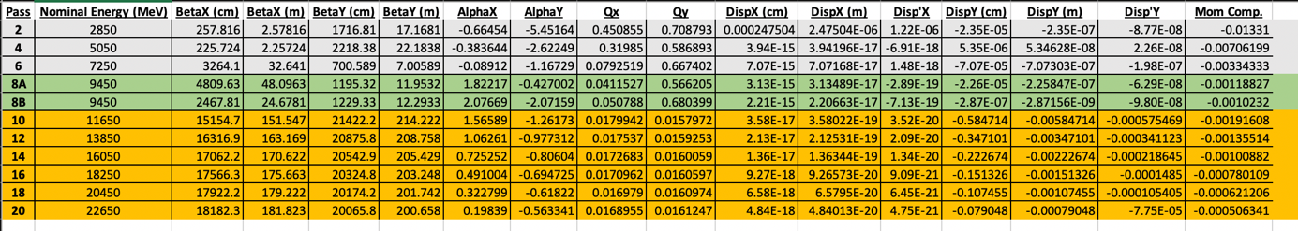
  + SW V2
  + Grey and Yellow same. Green shows two options for pass 8 (raising arcs vs stronger quads)
* Mostly been working on NL into SL.  SL Version 3 is clearly better for intermediate passes.
* 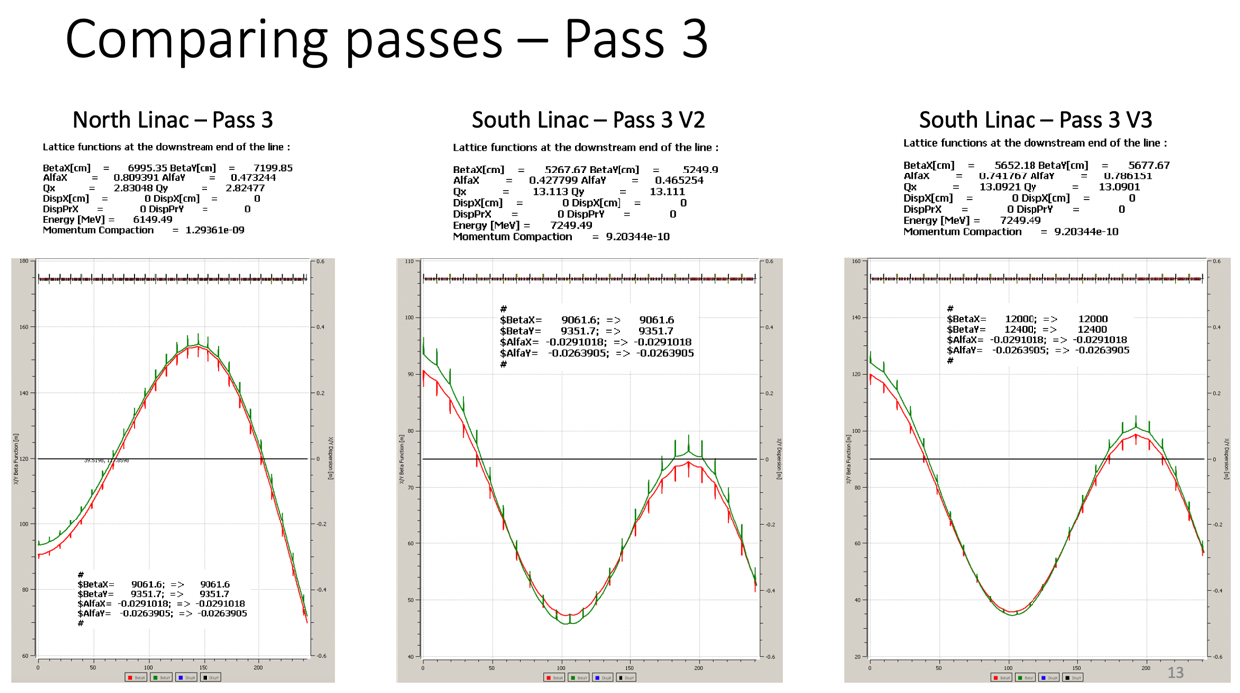
* 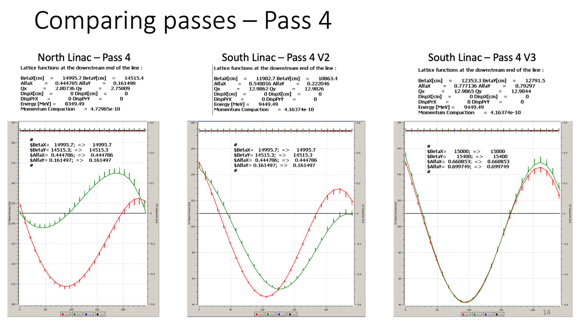
* 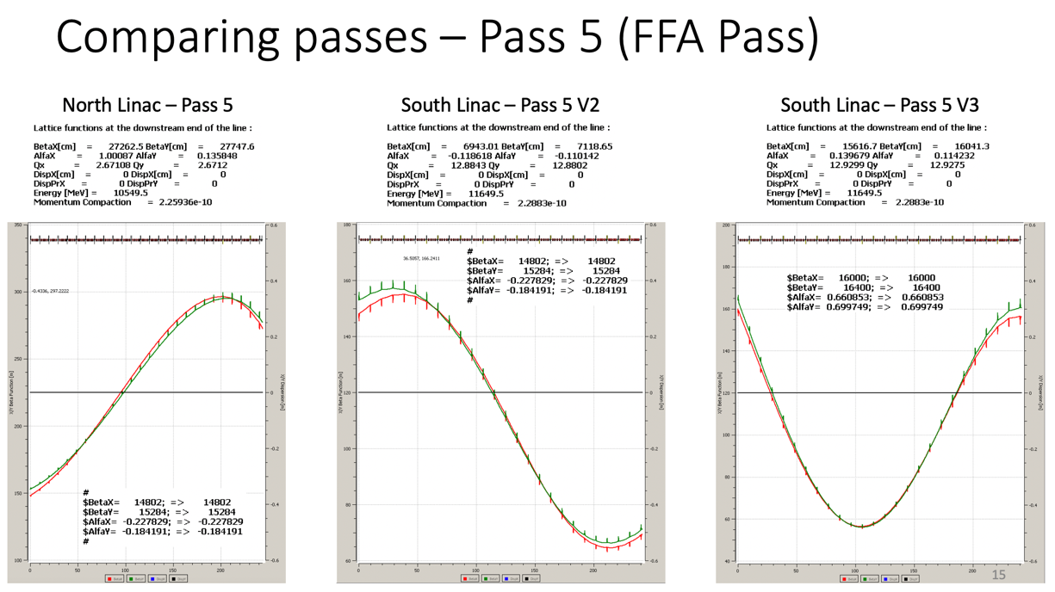
* 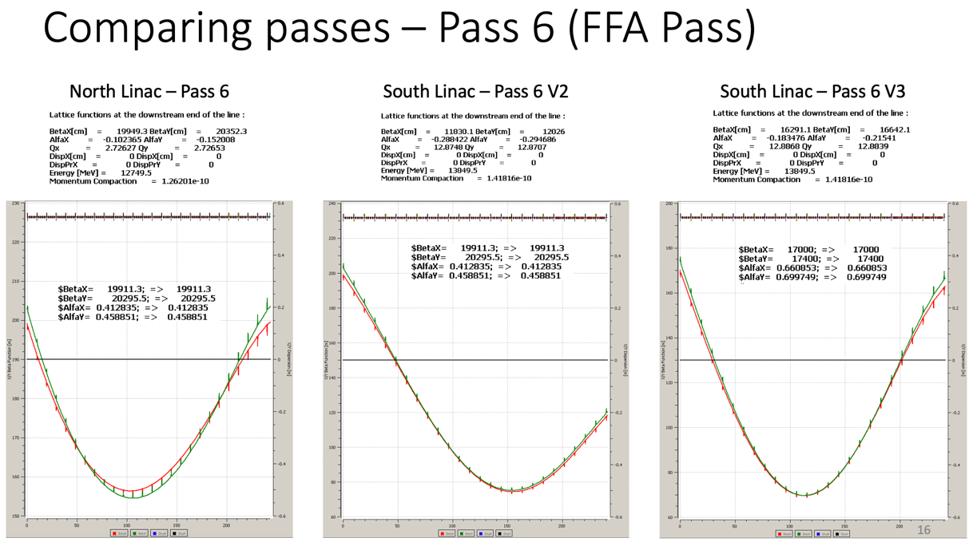
* 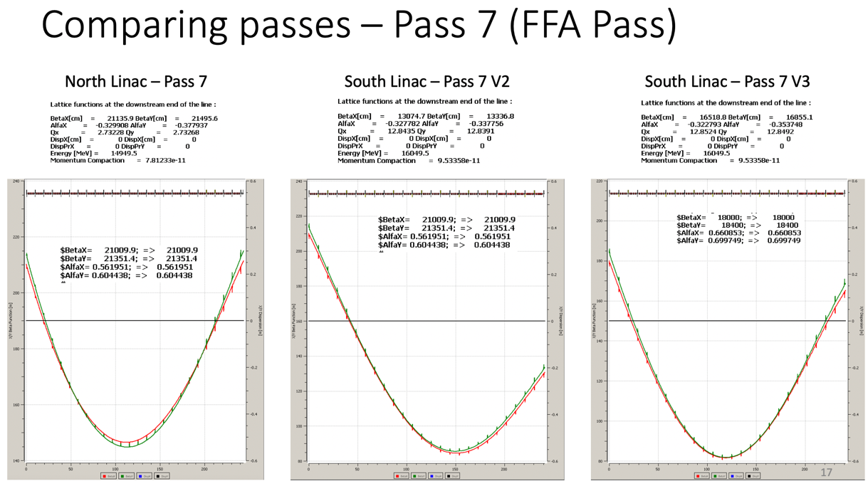
* 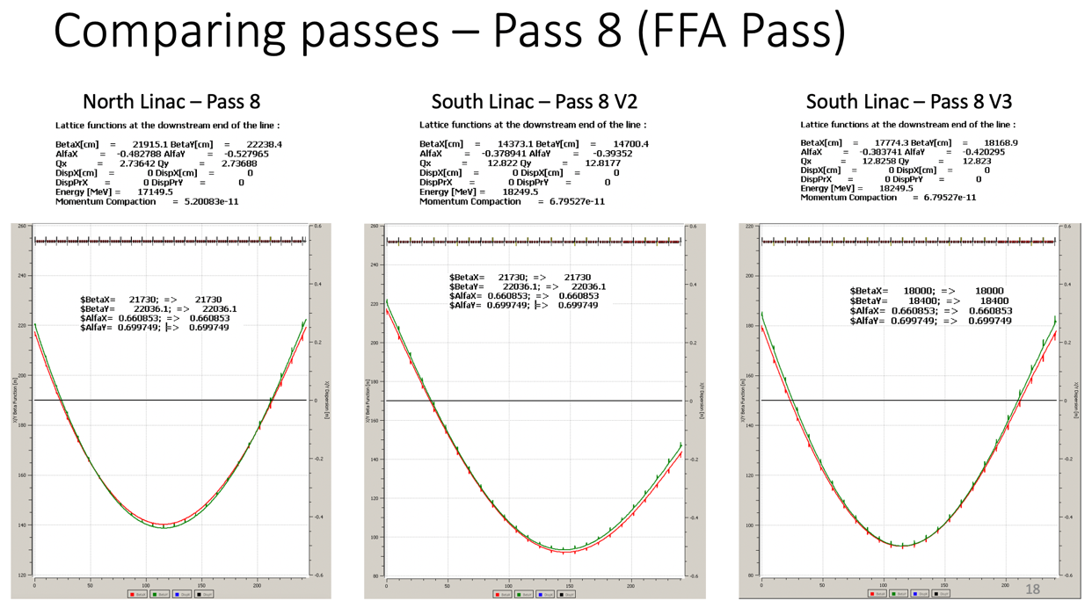
* 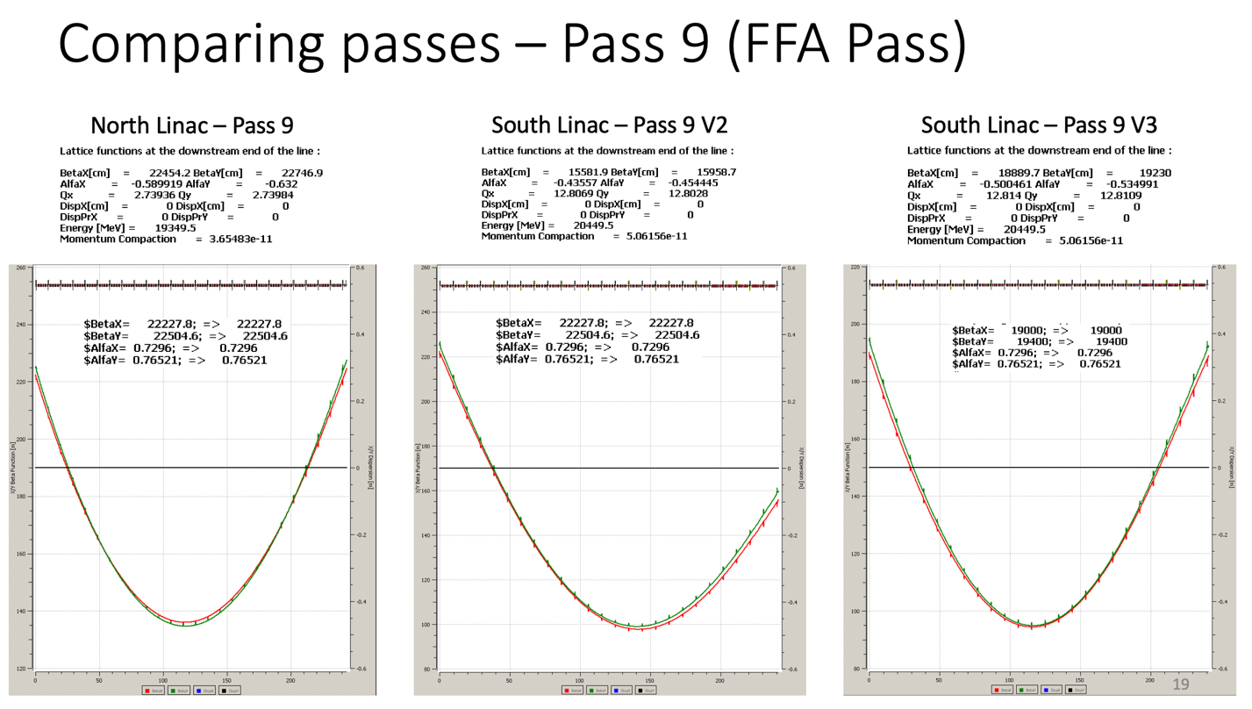
* 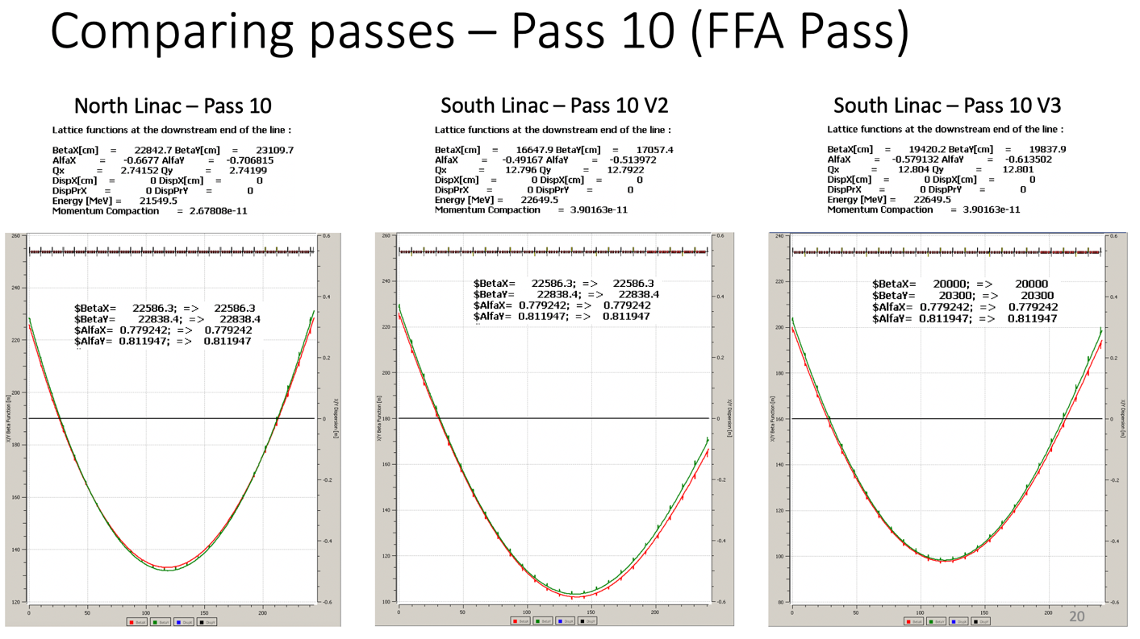
* Negative drifts will have to be removed at some point
  + In both NL and SL, but more in SL
* May be able to tune splitters to improve beta values match at end of each linac
  + 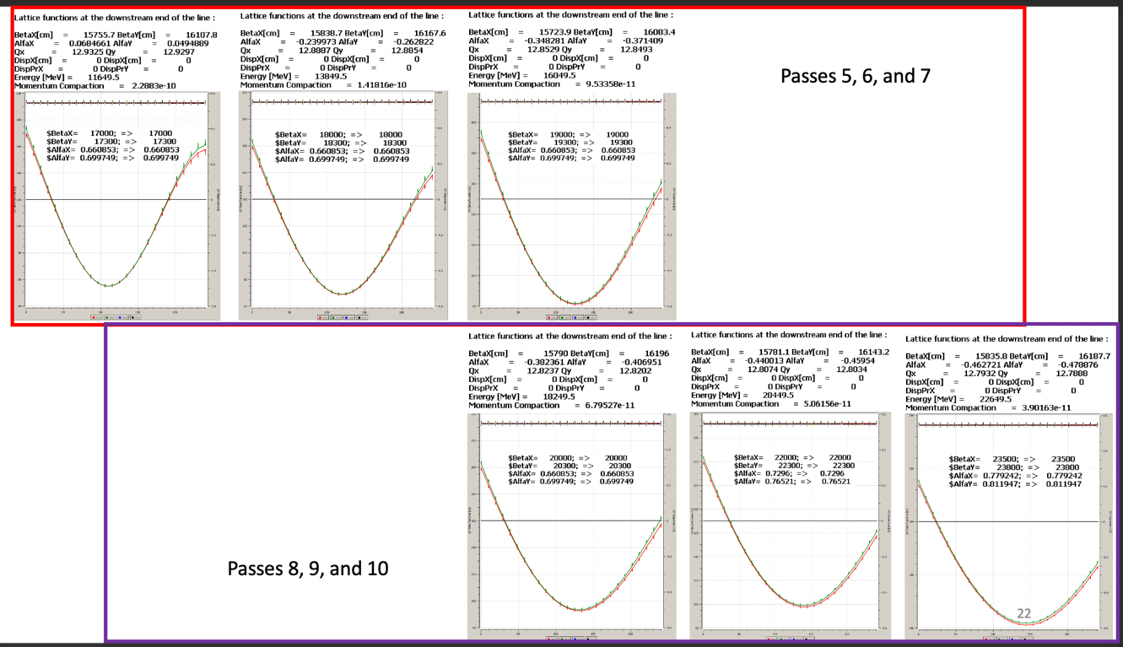
  + Unsure if possible, or necessary
  + If can change input Twiss for each pass, can make all match at end of linac
* Need beam match data exiting vertical spreader and entering FFA to design splitters
  + Likely to change as we iterate
  + Now have a version of output from spreaders, and a version around the FFA line, so can determine what the splitters will match from and to.
* Try to get to H separation quickly rather than having a triplet before splitter.  (Jay- that triplet will have to have large aperture, so long)

|  |  |  |
| --- | --- | --- |
|  | Person responsible | Deadline |
|  |  |  |
|  |  |  |

## Time allotted | 10 mins | Agenda topic AOB | Presenter All

* Scott to Kirsten: still having SR problems? Some bugs fixed.
  + Problem about gaining energy got fixed
* Another problem related to quads – doing radiation wrong
  + Kirsten hasn’t noticed this problem from October version.
* Kirsten will run through 3 different versions of BMAD and report to David Sagan.
  + Comparing package manager and tarball versions with different Linux versions
* Work in progress…
* Package manager version seems OK for now. Just maybe don’t use radiation.

|  |  |  |
| --- | --- | --- |
|  | Person responsible | Deadline |
|  |  |  |
|  |  |  |

## Special notes

Pathway to Repository: <https://jeffersonlab-my.sharepoint.com/:f:/g/personal/tristan_jlab_org/EqZ5MeS-nipCgPfZB5p0oS4B9Is67d3nQb9sLJI3Zyev9g>